Software Requirements Specification
GraduPredict Graduate Placement Prediction System
BS Computer Science Final Year Project
Version 1.0 | October 2026

Document Purpose
This document defines the software requirements for a web application that estimates graduate placement likelihood from academic and employability information. It gives a single student a bounded, testable implementation scope and gives supervisors a basis for acceptance testing.

1 Introduction

1.1 Product Scope
GraduPredict accepts a student profile, validates it, calculates a placement probability with Logistic Regression, assigns an outcome and risk category, stores approved results, and provides dashboard, history, export, and model-information views.

1.2 Intended Users
User | Responsibilities
Student or counselor | Enter valid profile data, review the estimate, and save appropriate records.
Project administrator | Train the model, maintain data and model files, and verify database and application operation.
Supervisor or examiner | Evaluate requirements, design, model workflow, testing evidence, and viva demonstration.

1.3 Constraints and Assumptions
The implementation is designed for one developer and local or Streamlit Community Cloud deployment. It uses a binary target. The included dataset is for demonstration; final reported research results must come from the selected and documented Kaggle dataset. The estimate supports counseling and does not make hiring decisions.

2 Overall Description
The system is a standalone Streamlit application. Prediction parameters are read from a version-portable JSON file. Saved results are stored in SQLite. The interface has four pages: Dashboard, New Prediction, Prediction History, and About Model.
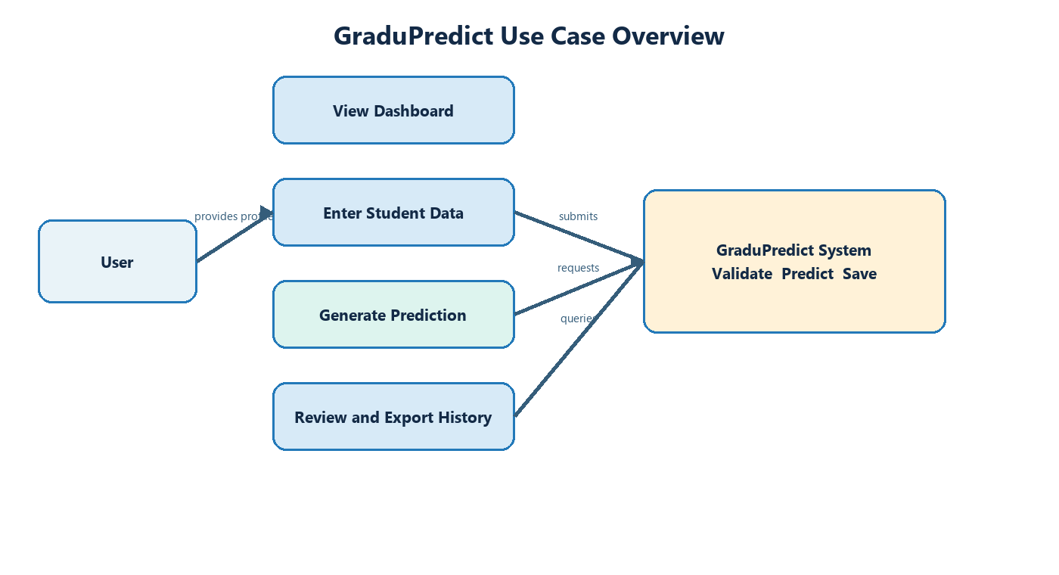

3 Functional Requirements
ID | Name | Requirement | Acceptance test
FR 01 | Navigation | The system shall display Dashboard, New Prediction, Prediction History, and About Model pages. | All four pages open without errors.
FR 02 | Data entry | The system shall capture student ID and eleven numeric or binary model inputs. | All fields accept values within their defined ranges.
FR 03 | Validation | The system shall reject missing student IDs and values outside interface limits. | An explanatory message appears and prediction is not saved.
FR 04 | Prediction | The system shall calculate a probability from the stored Logistic Regression parameters. | A probability from 0 to 1 is returned.
FR 05 | Classification | The system shall label the result Likely placed or At risk and assign Low, Medium, or High risk. | Labels agree with configured thresholds.
FR 06 | Result display | The system shall show outcome, probability, risk, and a responsible-use note. | All result elements appear after a valid request.
FR 07 | Persistence | The system shall save an accepted result to SQLite. | A row with student ID, result, probability, risk, and timestamp is created.
FR 08 | History | The system shall display saved results in descending order. | Newest record appears first.
FR 09 | Filtering | The system shall filter history by outcome. | Only matching rows remain.
FR 10 | Export | The system shall export the displayed history as CSV. | Downloaded CSV contains displayed columns and rows.
FR 11 | Dashboard | The system shall summarize counts, recent records, and model accuracy. | Metrics update from saved data and model metadata.
FR 12 | Model information | The system shall present the algorithm, target, metrics, data note, and limitation. | The About Model page contains every item.

4 Data Requirements
Field | Type | Rule
ssc_percentage | Numeric | Required model feature
hsc_percentage | Numeric | Required model feature
degree_percentage | Numeric | Required model feature
employability_score | Numeric | Required model feature
internships | Numeric | Required model feature
projects | Numeric | Required model feature
communication_rating | Numeric | Required model feature
technical_rating | Numeric | Required model feature
backlogs | Numeric | Required model feature
work_experience | Numeric | Required model feature
training_completed | Numeric | Required model feature
student_id | Text | Required and nonblank
placed | Binary | Training target only

5 Nonfunctional Requirements
ID | Area | Requirement
NFR 01 | Usability | A new user shall complete a prediction without training within three minutes.
NFR 02 | Performance | A local prediction shall normally appear within two seconds after submission.
NFR 03 | Portability | The project shall run on Windows, Linux, Kaggle notebooks, and Streamlit hosting with Python 3.10 or later.
NFR 04 | Compatibility | Model parameters shall use JSON rather than a version-sensitive pickle.
NFR 05 | Privacy | The system shall avoid names, contact details, and protected hiring decisions.
NFR 06 | Maintainability | Prediction, interface, training, and persistence responsibilities shall be separated.
NFR 07 | Reliability | The database shall be initialized automatically if it is missing.
NFR 08 | Reproducibility | Training shall use a documented random seed and saved feature order.

6 Acceptance Criteria
The project is accepted when the model can be trained, the application starts, valid input produces a result, invalid input is rejected, a result can be saved, history can be filtered and exported, and the supplied automated prediction tests pass.

7 Requirements Traceability
Requirement group | Implementation | Verification
FR 01 to FR 06 | app.py and prediction.py | Manual interface demonstration and unit tests
FR 07 to FR 10 | app.py and gradupredict.db | Database record and CSV inspection
FR 11 to FR 12 | app.py and placement_model.json | Page inspection
NFR 03 to NFR 08 | requirements, JSON model, README, training script | Clean setup and file review

