

**INSTITUTE FOR ADVANCED COMPUTING AND SOFTWARE DEVELOPMENT AKURDI, PUNE**

Documentation On

**“Plant Disease Detection using**

**Convolution Neural Network”**

PG-DBDA FEB 2020

Submitted By:

**Group No: G-16**

MohammadShoaib Nadaf-1328

Shruti Thorat - 1347

Mr. Prashant Karhale Mr. Akshay Tilekar Centre Coordinator Project Guide

**INDEX**

|  |  |
| --- | --- |
| Table Content | Page No |
| Introduction | 4 |
| Purpose | 5 |
| Scope of Project | 5 |
| Software Life Cycle Model | 6 |
| Overview of Document | 9 |
| Overall Description | 10 |
| Functional Requirements Specification | 12 |
| Non-Functional Requirements | 12 |
| Plan of Project Execution | 13 |
| System Design | 14 |
| Model Building | 15 |
| Algorithm Research and Selection | 15 |
| Implementation | 17 |
| Result | 18 |
| Future Scope | 19 |
| Conclusion | 20 |
| Reference | 21 |

**Abstract**

Convolutional neural network models were developed to perform plant disease detection and diagnosis using simple leaves images of healthy and diseased plants, through deep learning methodologies. Training of the models was performed with the use of an open database of 19,721 images, containing different plants in a set of 15 distinct classes of [plant, disease] combinations, including healthy plants. Several model architectures were trained, with the best performance reaching a 93.6% success rate in identifying the corresponding [plant, disease] combination (or healthy plant). The significantly high success rate makes the model a very useful advisory or early warning tool, and an approach that could be further expanded to support an integrated plant disease identification system to operate in real cultivation conditions.

**Introduction**

Since the past days and in the present too, farmers usually detect the crop diseases with their naked eye which makes them take tough decisions on which fertilisers to use. It requires detailed knowledge the types of diseases and lot of experience needed to make sure the actual disease detection. Some of the diseases look almost similar to farmers often leaves them confused. Look at the below image for more understanding.

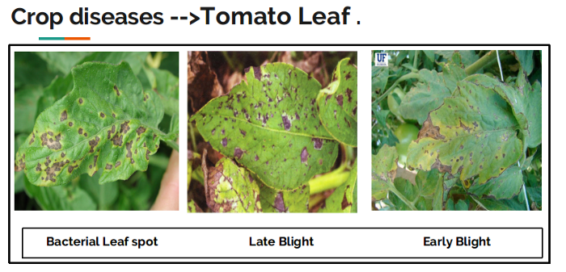

They look the same and almost similar. In case the farmer makes wrong predictions and uses the wrong fertilizers or more than the normal dose (or) threshold or Limit (every plant has some threshold fertilizers spraying to be followed), it will mess up the whole plant (or) soil and cause enough damage to plant and fields.

## So, How to prevent this from happening?

To prevent this situation we need better and perfect guidance on which fertilizers to use, to make the correct identification of diseases, and the ability to distinguish between two or more similar types of diseases in visuals.

This is where **Convolution Neural Networks**comes handy. In short CNN.

**Purpose**

Detection of plant disease through some automatic technique is beneficial as it reduces a large work of monitoring in big farms of crops, and at very early stage itself it detects the symptoms of diseases i.e. when they appear on plant leaves.

Project deals with the real time detection of diseases that affect the plant and the area affected using Convolutional neural network (CNN) Model.

Convolutional neural network models were developed to perform plant disease detection and diagnosis using simple leaves images of healthy and diseased plants, through deep learning methodologies. So that appropriate fertilizers can be used to prevent further damage to plants from pathogenic viruses.

**Scope of the project**

Plant diseases cause a major production and economic losses in the agricultural industry. The disease management is a challenging task. Usually the diseases or its symptoms such as coloured spots or streaks are seen on the leaves of a plant. In plants most of the leaf diseases are caused by fungi, bacteria, and viruses. The diseases caused due to these organisms are characterized by different visual symptoms that could be observed in the leaves or stem of a plant. Usually, these symptoms are detected manually.

With the help of CNN, Automatic detection of various diseases can be detected with the help of CNN. CNN plays a crucial role in the detection of plant diseases since it provides best results and reduces the human efforts. The CNN could be used in the field of agriculture for several applications. It includes detection of diseased leaf, stem or fruit, to measure the affected area by disease, to determine the colour of the affected area. Tomato cultivation is one of the most remunerative farming enterprises in India. The naked eye observation by the experts is approach usually taken in identification and detection of plants. This approach is time consuming in huge farms or land areas. The use of CNN techniques in detection and identification of Different plant diseases in the earlier stages and thereby the quality of the product could be increased. These systems monitor the plant such as leaves and stem and any variation observed from its characteristic features, variation will be automatically identified and also will be informed to the user.

**Software Life Cycle Model**

In order to make this Project we are going to use Classic LIFE CYCLE MODEL. Classic life cycle model is also known as WATER FALL MODEL. The life cycle model demands a Systematic sequential approach to software development that begins at the system level and progress through analysis design coding, testing and maintenance.



**The Classic Life Cycle Model**

The waterfall model is sequential software development process, in which progress is seen as flowing steadily downwards (like a waterfall) through the phases of conception initiation, Analysis, Design (validation), construction. Testing and maintained

**System Engineering and Analysis:**

Because software is always a part of larger system work. Begins by establishing requirement for all system elements and Then allocating some subset of these requirement to the software system Engineering and analysis encompasses the requirement gathering at the system level with a small amount of top level design and analysis.

**Software requirement Analysis:**

The requirement gathering process is intensified and focused specifically on the software Requirement for the both system and software are discussed and reviewed with the customer. The customer specifies the entire requirement or the software and the function to be performed by the software.

**Design:**

Software design is actually a multi-step process that focuses on distinct attributes of the program data structure, software architecture, procedural detail and interface of the software that can be assessed or quality before coding begins .Like requirement the design is documented and becomes part of the software.

**Coding:**

The design must be translated into a machine readable form. The coding step performs this task. If design is programmed in a detailed manner, coding can be accomplished mechanically.

**Testing:**

Once code has been generated programmed testing begins. The testing process focuses on the internals of the software ensuring that all statement have been tested and on the functional externals hat is conducting tests to uncover the errors and ensure that defined input will produce the results that agree with the required results.

**Unit testing:**

In computer programming, Unit testing is software Verification and validation method where the programmer gains confidence that individual units of source code are fit to use A unit is the smallest testable part of an application. In procedural programming a unit may be an individual programmed, function, procedure, etc. while in object-oriented programming, the smallest Unit is a class, which may belong to a base/super class abstract class or derived/child class.

**Benefits:**

The goal of unit testing is to isolate each part of the program and show that the individual parts are correct. A unit test provides a strict written contract that the piece of code must satisfy.

**Documentation:**

Unit testing provides a sort of living documentation of the system. Developers looking to learn what functionality is provided by a unit and how to use it can look at the tests to gain a basic understanding of the unit API.

**Limitation of unit testing:**

Testing cannot be expected to catch error in the program –It is impossible to evaluate all execution paths for all but the most trivial programs. The same is true for unit testing. Additionally, by unit testing only types the functionality if the units themselves.

**Maintenance:**

Software will undoubtedly undergo change after it is Delivered to the customer .Change will occur because errors have been encountered because the software must be able adopted to accommodate changes in its external environment because the customer requires functional or performance enhancement enhancements. The classic life cycle is the oldest and most widely used paradigm or software engineering

**Overview of document**

The next chapter, the Overall Description section, of this document gives an overview of the functionality of the product. It describes the informal requirements and is used to establish a context for the technical requirements specification in the next chapter. The third chapter, Requirements Specification section, of this document is written primarily for the developers and describes in technical terms the details of the functionality of the product. Both sections of the document describe the same software product in its entirety, but are intended for different audiences and thus use different language

|  |  |  |
| --- | --- | --- |
| **Activity** | **Work Accomplish** | **Proposed Duration** |
| Collection of Data Sheet and Document | Study of data | 5 days |
| Searching and Viability of the various CNN models | Analyse the model | 4 days |
| Analysing model for the project | Implement the algorithm | 15 days |

**Overall Description**

**Data:**

|  |  |  |
| --- | --- | --- |
| **Name** | **No of Classes** | **Class Names** |
| Bell Pepper | 02 | Pepper bell Bacterial spot  Pepper bell healthy |
| Potato | 03 | Potato Early blight  Potato Late blight  Potato healthy |
| Tomato | 10 | Bacterial spot  Early blight  Late blight  Leaf Mold  Septoria leaf spot  Spider mites  Target Spot  Yellow Leaf Curl Virus  Mosaic virus  Healthy |

**Imports:**

* **Matplotlib:**

Matplotlib is a collection of command style functions that make matplotlib work like MATLAB. Each pyplot function makes some change to a figure. We have used it to show visualizations of analysis.

* **Numpy:**

Numpy is used to for mathematical operations. This package provides easy use of mathematical function.

* **TensorFlow:**

TensorFlow is open-source software library for dataflow and differentiable programming across a range of tasks. It is a symbolic math library, and is also used for machine learning applications such as neural networks.

* **Keras:**

Keras is an open-source software library that provides a Python interface for artificial neural networks. Keras acts as an interface for the TensorFlow library. Up until version 2.3 Keras supported multiple backends, including TensorFlow, Microsoft Cognitive Toolkit, R, Theano, and PlaidML.

* **Glob:**

The glob module is used to retrieve files/pathnames matching a specified pattern. The pattern rules of glob follow standard Unix path expansion rules

**Data Pre-processing:**

* The dataset is divided into 80% for training and 20% for validation.
* First, augmentation settings are applied to the training data.
* set height and width of input image.
* The settings applied include flipping (horizontal), shearing of range (0.2) and zoom (0.2). Rescaling image values between (0 –1) called normalization. All these parameters are stored in the variable “train_datagen” and “test_datagen”.

**Requirement Specification**

**Initial nonfunctional requirement will be:**

* Getting the large datasets which can provide developer enough data to train the model.
* Maintain the minimum variance and bias so the model is successfully work.
* Avoid the underfitting and overfitting.

**Initial functional requirement will be:**

* Selecting the appropriate algorithms.
* Determining the appropriate input format to algorithm.
* Train the model.
* Test the model.

**Hardware Requirement:**

* Processor: Intel Dual Core and above
* RAM: Minimum 4GB
* OS: Windows, Linux

**Software Requirement:**

* Anaconda Navigator
* Jupyter NoteBook / Visual Studio Code

## Plan of Project Execution

## Feasible study phase

* Study of different distributed algorithms.
* Different types of plant images are studied and corresponding. After detail study, labelling in done by segregating the images and with different diseases

## Requirement analysis

* The database is pre-processed such as Image reshaping, resizing and conversion to an array form.
* There is a huge database so basically the images with better resolution and angle are selected. After selection of images we should have deep knowledge about the different leaves and the disease they have. Huge research is done from plant village organization repository.

## Design phase

* Designing algorithm and graphs for getting more accuracy and satisfaction.
* Adjusting the Images in categories so that our model identifies the diseases.

## Implementation phase

* CNN has different layers that are Dense, Dropout, Activation, Flatten, Convolution2D and MaxPooling2D these all will implement.

## Testing phase

* After the model is trained successfully the software can identify the disease if the plant species is contained in the database.
* After successful training and pre-processing, comparison of the test image and trained model takes place to predict the disease.

## Deployment phase

* After follow all above steps then deploy the model on the Internet so that our Famer’s can use it for more production in the farming growth.

**System Design**

**Flowchart of the System:**

The flowchart of the algorithm is represented in Figure

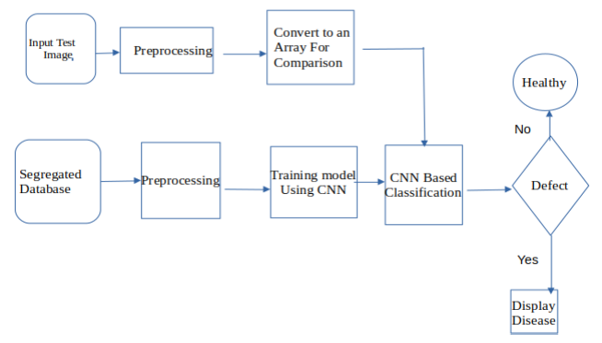

The above flowchart describes the working flow of the project. First pre-processed the data and selected the model. Then algorithm was later implemented in python and deployed on web. The model was later tested against raw images.

**Model Building**

**Algorithm Research and Selection:**

For this classiﬁcation problem, following deep learning model was used:

**Convolution Neural Network**

It is well known for it’s widely used in applications of image and video recognition and also in recommender systems and Natural Language Processing (NLP). However, **convolutional** is **more** efficient because it reduces the number of parameters which makes different from other deep learning models.

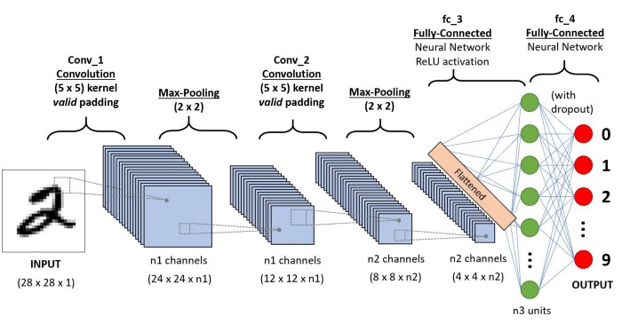

# Main Steps to build a CNN (or) Conv. net:

1. Convolution Operation
2. ReLU Layer (Rectified Linear Unit)
3. Pooling Layer (Max Pooling)
4. Flattening
5. Fully Connected Layer
6. **Convolution Operation:**

**Convolution** is the first layer to extract features from the input image and it learns the relationship between features using **kernel or filters** with input images.

**2**. **ReLU Layer:** ReLU stands for the Rectified Linear Unit for a non-linear operation. The output is ƒ(x) = max(0,x). we use this because to introduce the non-linearity to CNN.

**3. Pooling Layer:**it is used to reduce the number of parameters by down sampling and retain only the valuable information to process further. There are types of Pooling:

* Max Pooling.
* Average and Sum pooling.

4. **Flattening:**we flatten our entire matrix into a vector like a vertical one. So, that it will be passed to the input layer.

5. **Fully Connected Layer:**we pass our flatten vector into input Layer .we combined these features to create a model. Finally, we have an activation function such as softmax or sigmoid to classify the outputs.

**Short information about Activation Functions:**

These functions are needed to introduce a non-linearity into the network. Activation function is applied and that output is passed to the next layer.

* **Sigmoid:** The Sigmoid function used for **binary classification** in logistic regression model. While creating artificial neurons sigmoid function used as the **activation function**. In statistics, the **sigmoid function graphs** are common as a cumulative distribution function.
* **Hyperbolic Tangent:** In neural networks, as an alternative to **sigmoid function**, **hyperbolic tangent function** could be **used** as **activation function**. When you backpropage, derivative of **activation function** would be involved in calculation for error effects on weights.
* **ReLU :** ReLU is the max function(x,0) with input x e.g. matrix from a convolved image. ReLU then sets all negative values in the matrix x to zero and all other values are kept constant.
* **Softmax :** Used in multiple classification logistic regression model. In building neural networks softmax functions used in different layer level.

# Implementation

To implement the idea of disease detection and to train the machine accordingly requires lot of steps which are mentioned below: -

1. Label Data for input like Training Data, Testing Data and Valid Data in different folders.
2. Import all libraries like NumPy, Pandas, Matplotlib, Tensorflow, Convolution2D, MaxPooling2D, Flatten, Dense, Sequential Model, ImageDataGenerator, image, random etc.
3. Assign paths of the folders where training and testing data are available.
4. Assign Dictionary to write all the diseases name in a sequential way.
5. Add Convolutional Layer with 32 Filters each of filter size 3*3 and apply Relu activation function.
6. Add Maxpooling layer for extracting the features from convolutional layer.
7. Repeat Step5 and Step6.
8. Add Flatten Layer to convert 3D Array to 1D Array.
9. Add Hidden Layers or Dense Layers with 512 neurons and activation function is relu
10. Add Hidden layer or Dropout layer with value 0.25
11. Add Hidden Layers or Dense Layers with 128 neurons and activation function is relu.
12. Add Output Layer with 15 neurons and Activation function Softmax.
13. Apply Compile function to compile all the layers with loss function categorical_crossentropy and optimizer='Adam'.
14. Model Fit Function is used to fit all variables like training set, steps per epoch=516, epochs=15, validation data=test set etc.
15. Start Training, minimum time taken to train data in this dataset will be 3 hours.
16. After the model gets trained, apply path of the folder where valid images are available.
17. Apply Predict function to predict the valid image to get output.

While implementation of the following steps some acute procrastinated discussion took place, which have been mentioned in the discussion part

**Results**

**Training Accuracy**

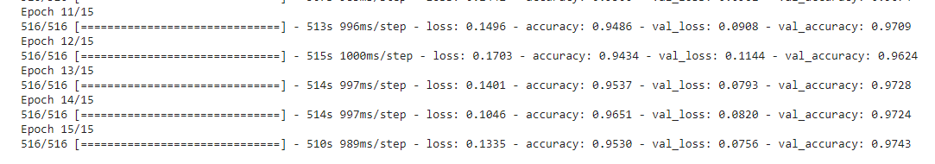

**Testing Accuracy**

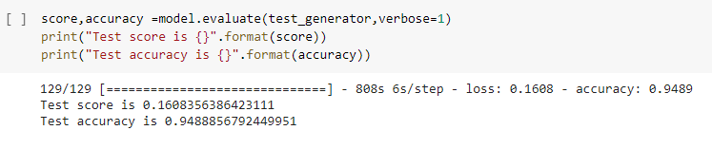

|  |  |
| --- | --- |
| Training Accuracy | 97.43% |
| Testing Accuracy | 94.88% |

**User Interface:**

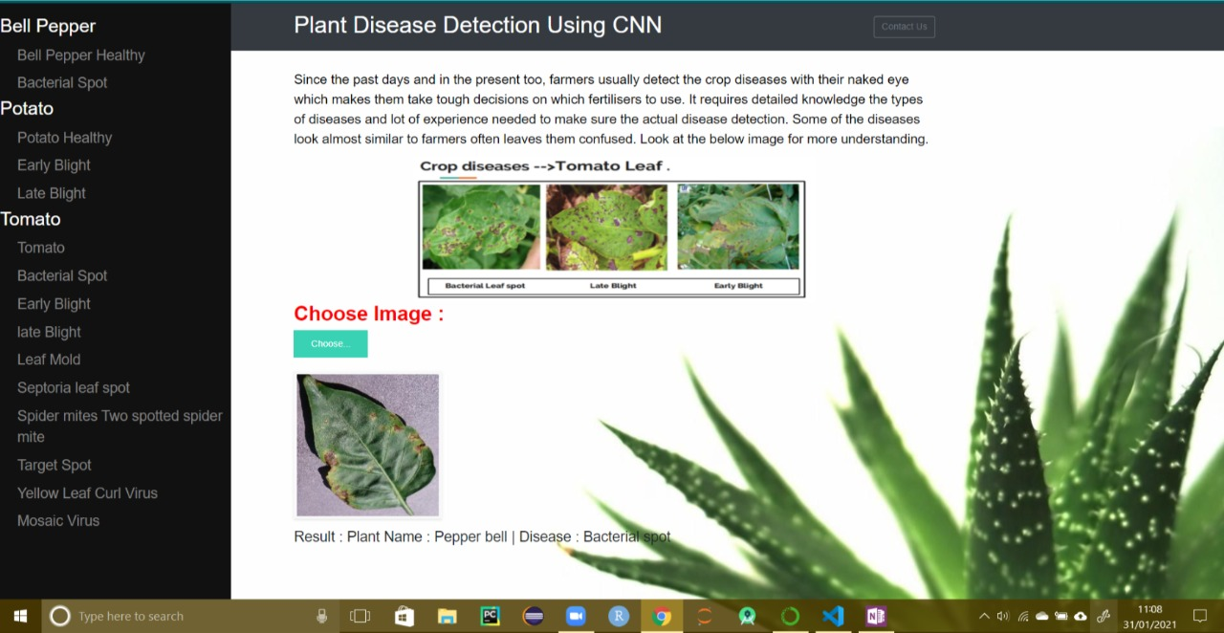

**Future Scope**

* Real Time Detection using drones on the green fields
* Ordering fertilizer from ecommerce site.
* Mobile application for personalized use
* Setting reminder for pesticides/watering etc.
* Advising on best practices.

## ****Conclusion****

* This system has utilized deep learning capabilities to achieve automatic plant disease detection system. This system is based on a simple classification mechanism which exploits the feature extraction functionalities of CNN. For prediction finally, the model utilizes the fully connected layers.
* The system has achieved an overall 94% testing accuracy on publically accessible dataset,
* It is concluded from accuracy that CNN is highly suitable for automatic detection and diagnosis of plants. This system can be integrated into mini-drones to live detection of diseases from plants in cultivated areas.

.

**Reference**

1. Machine Learning with Python Cookbook: Practical Solutions from Pre-processing to Deep Learning
2. Hands-On Machine Learning with Scikit-Learn and Tensor-Flow: Concepts, Tools, and Techniques to Build Intelligent Systems
3. "PlantVillage", Plantvillage.psu.edu, 2020. [Online]. Available: https://plantvillage.psu.edu/. [Accessed: 31- Jan- 2020]
4. S. Mohanty, D. Hughes and M. Salathé, "Using Deep Learning for
5. Image-Based Plant Disease Detection", Frontiers in Plant Science, vol. 7, 2016. Available: 10.3389/fpls.2016.01419
6. <https://www.tensorflow.org/tutorials/images/cnn>
7. <https://www.tensorflow.org/learn>
8. Overview of Research on Plant Leaves Disease Detection using Image Processing Techniques : https://rb.gy/aynrzm