Report on Assignment
EECS 6466: Software Defect Detection, Tolerance and Repair
Submitted by: Md. Ehsan Shahmi, S#222297790
Github Repo of the Assignment

- Environment set-up:-
For the assignment, we have used Jupyter Notebook and Anaconda. We needed several dependencies and libraries to work with. The set of libraries used are given in Fig. 1. Each of them is installed separately, had they not come with the installation of Jupyter.
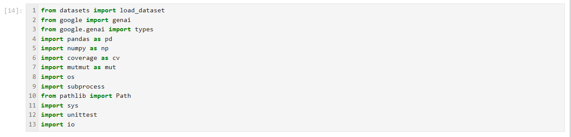
Fig. 1: The dependencies and libraries utilized.

Firstly, we downloaded the Human-Eval dataset. We have used “git clone” into our repository directly to get and see the folders associated with it. Our repository looks like Fig.2. In our workspace, we have loaded the dataset directly using libraries. We loaded it into two types of objects: a Dataset dictionary object and a pandas dataframe object to work upon the dataset.
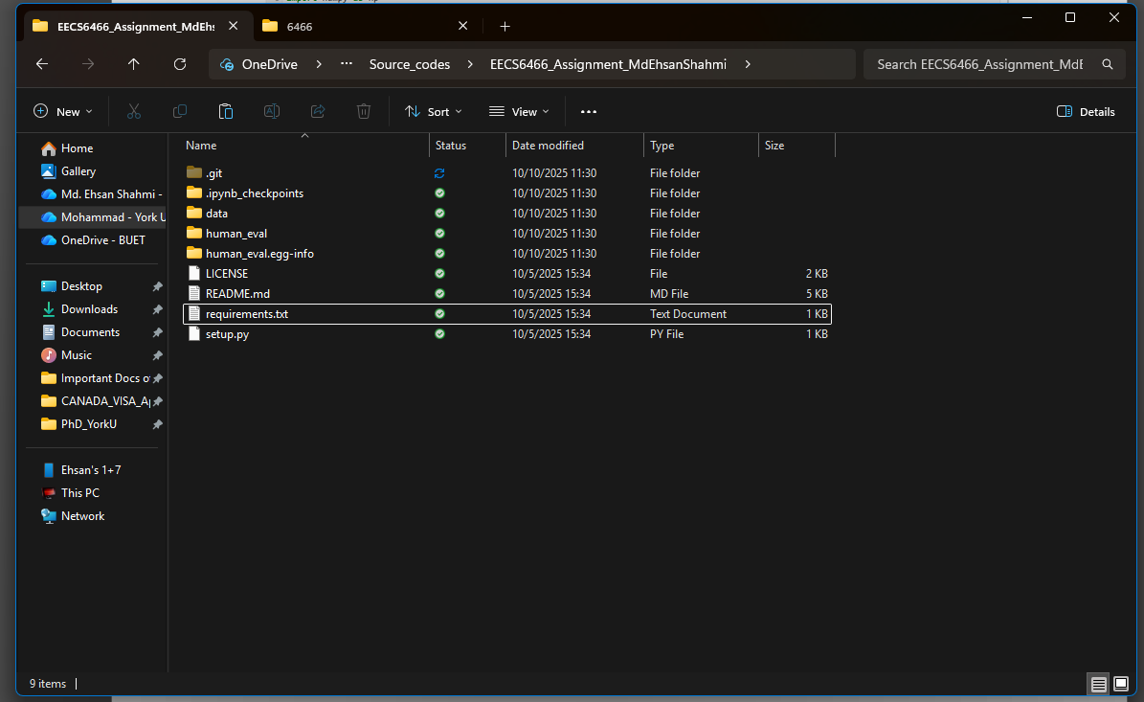

Fig. 2: A screenshot of the repository containing the Human-Eval dataset.

It is really easy to work with the dataset as a pandas dataframe object. After loading into the workspace, we also store the dataset in a .csv file in our repo. Loading the dataset in the workspace shows that the dataset has 5 columns: task_id, prompt, canonical_solution, test and entry_point.

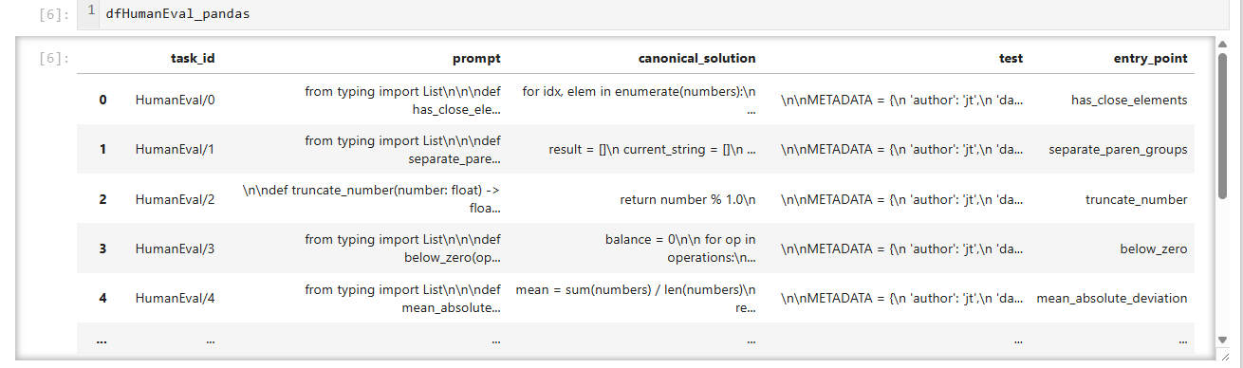
Fig. 3: Screenshot of the dataset loaded in the workspace, as a dataframe
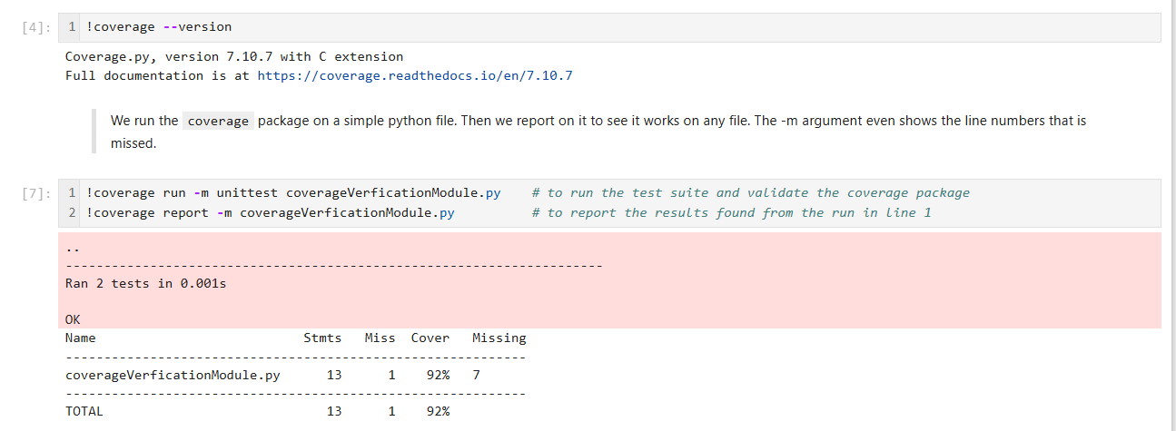
After dataset, we install the packages of coverage and mutmut using the simple command line statement: pip install coverage and pip install mutmut. After installation, we have tested the working of the coverage library, using displaying its version as well as creating a simple python file (“coverageVerificationModule.py”) and execute on it to the coverage percentage of the test cases inside the file. These are provided in Fig 4 and Fig 5.

Fig. 4: The verification of the coverage library
We have installed the latest coverage library which is version 7.10.7. In our example, we show the process of running coverage using a shell command, that can also be run in the Jupyter notebook.
We have also tested the installation of mutmut package. Similarly the result of mutmut running was also tested in the workspace as well as its version, which is version 2.4.4.
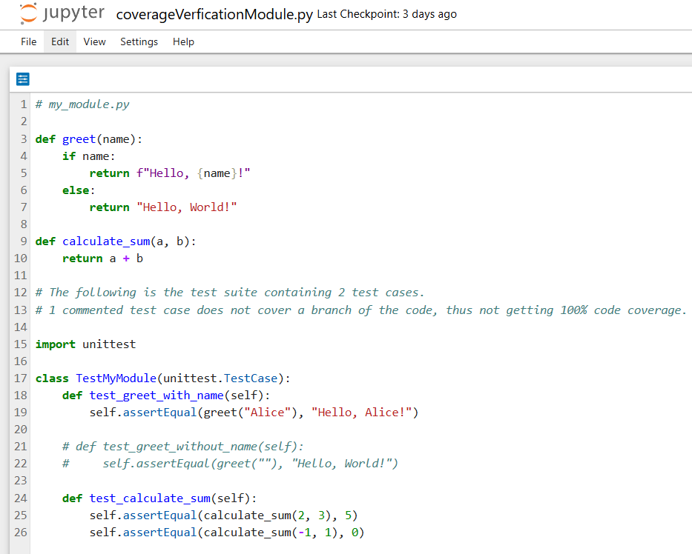

Fig. 5: coverageVerificationModule.py file to test the coverage library
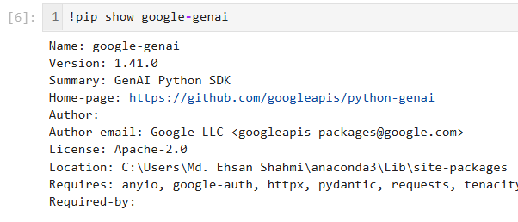
Finally, we have installed and used the Large Language Model (LLM) gemini-2.5-flash to carry the main work. Using pip install google-genai, we downloaded the library to fetch anything to the LLM for our assignment. We have used version 1.41.0. In addition, a free API is created by us from the website of Google AI. This API is needed to send the prompts to the LLM directly from our workspace. However, the free API version allows around 250+ requests per 24 hours. We have set-up our API globally, so that we don’t need to do this multiple times.

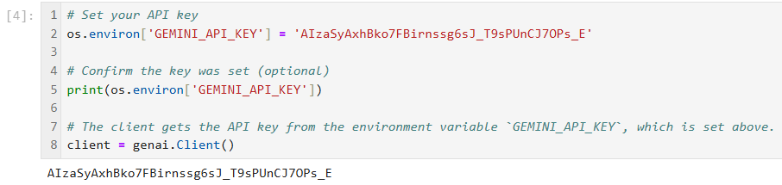
Fig. 6: The version of the LLM used and tested the installation
Fig. 7: The generated free API from the website
Additionally, we have also the LLMs operation against a simple provided prompt and see the generated result. This is displayed in the workspace directly.

- Test Generation (Part 1):-
The task was to instruct the LLM to generate 10 test cases for each problem of the dataset. We were instructed not to provide the ground truth solution of the dataset to the LLM. We created a simple prompt and fed it into the LLM. The provided prompt from us is as follows:
"Using Python standard unittest format, create 10 test cases as a complete test suite for the following prompt. Do not create the solution function of the prompt in any way.”

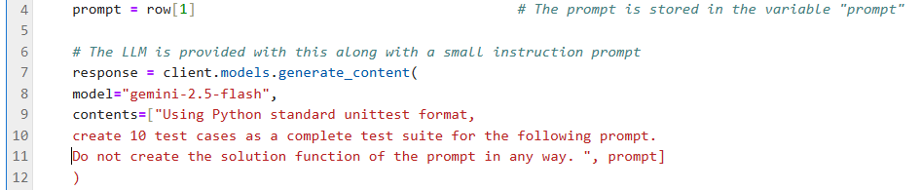
Along with our provided prompt, we also supplied (as a concatenation) the LLM the prompt given in the dataset for each problem. This is displayed in Fig. 8.
Fig. 8: Providing the LLM the dataset prompt and our own prompt, without giving the ground truth.

We have saved the generated result in a directory for generated test cases as suites for each problem. We run this above for all the problems of the dataset. Hence, we are created with a directory of 164 generated test suites.

Additionally, for the next instruction for evaluation, we concatenate the ground truth provided solution in the dataset with the generated test suites by the LLM. This ground truth solution can be denoted as the System under Test (SUT) for Part 1 of this assignment. We did this concatenation with the help of LLM itself. Then we did some cleaning to make a runnable python file. These files are needed for the evaluation part of the assignment. The cleaned finalized appended files ready for evaluation are stored in the directory “prompt_canonical_testSuite\”, where each file is named as “test_prompt_canonical*.py”. Here the * denotes the serial of the problem number from the dataset.

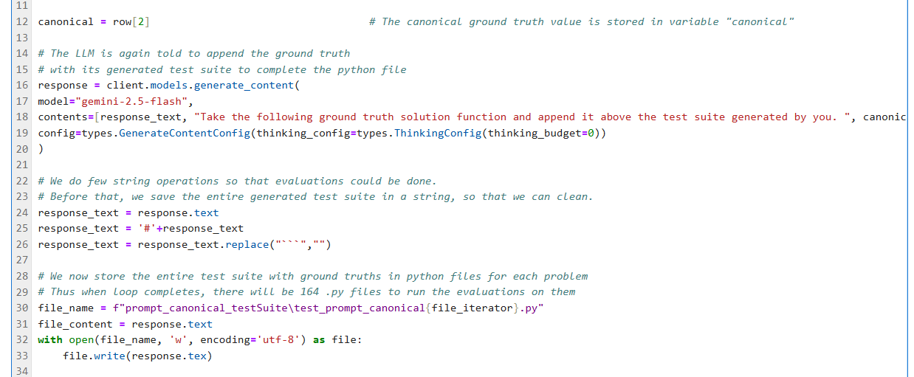
Fig. 9: Appending the ground truth and the test suite generated by LLM and saving
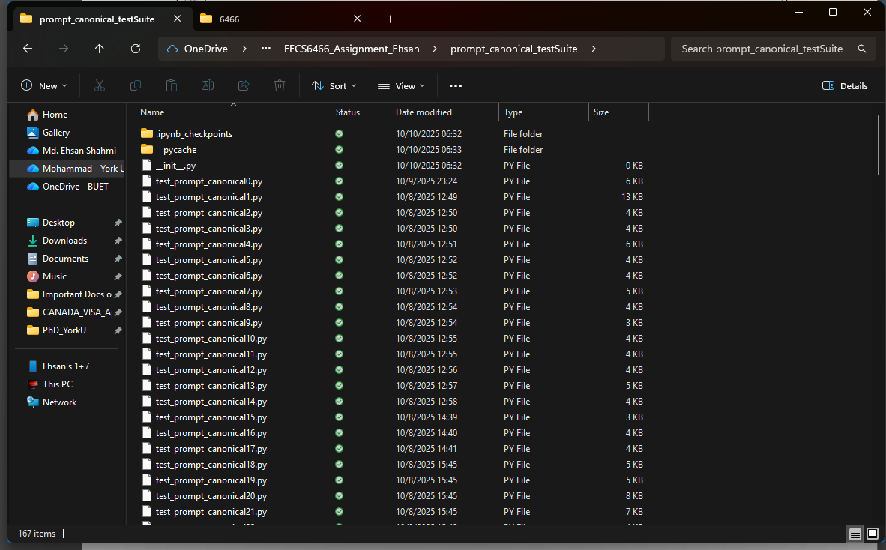
We run the above steps for each problem of the dataset, with the help of utilizing a variable “file_iterator”. All the steps are shown in the provided workspace.

Fig. 10: The directory containing all test suites appended with the ground truth solutions

- Test Evaluation (Part 1):-
Firstly, we test the validity rate of the test suite. This is done by just running the above 164 python files. For each problem, we loaded the file name and run it using the unittest.TestRunner method. We note down the number of tests run for each problem, as well as the number of failures, and number of successes. We also note down these numbers and report on the validity of each problem. Finally, we also provide the entire output of the test suite to see in detail which test has passed, and which has failed. These outputs can be displayed in the output portion of the workplace.
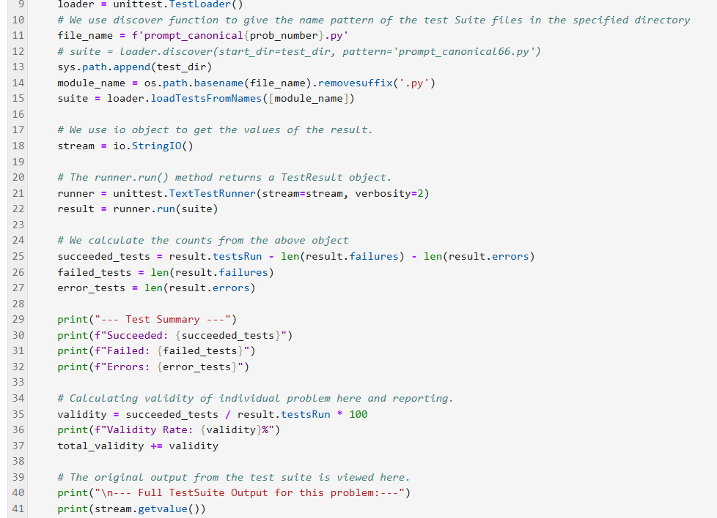
Fig. 11: Evaluation of individual test Suite and measuring the validity of the test suite
We did these steps on all the test suites over the dataset and finally calculate the average validity rate of the generated LLM-test suites as a whole.
Our average validity rate of the entire dataset is 97.01%.
Secondly, we test our test suites for coverage. For this no need of the coding was required, since coverage library have a good number of useful commands. We run two such commands. The first (coverage run) command is to run the test suites against the ground truth solutions and find the coverage percentages. This command does this operation as a whole in a single directory, so we provided our directory, prompt_canonica_testSuite\ on the command as its argument.
Additionally, we generate a report to see the coverage rates of each suite on each file. The second command (coverage report) directly notifies of this. A detailed report is generated if the argument -m is given with the command. Here the report shows all the test suites’ coverages in percentages in the third column, whereas the fourth column displays the missing lines if the test cases for that particular problem. At the bottom of the report, we observe the final average coverage percentage of the entire dataset.

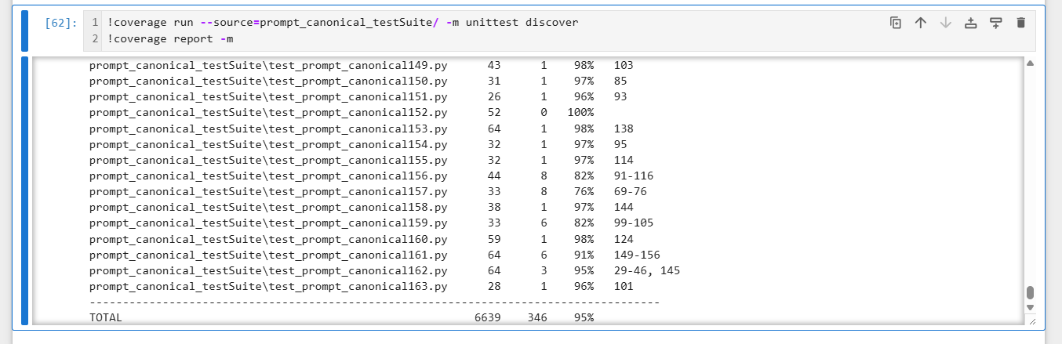
Fig. 12: The coverage percentages and the average coverage of the dataset
Our average coverage of the entire dataset is 95.0%.

Finally, we evaluate the dataset and the LLM-generated Test suites against mutation score. Similar to the coverage library, mutation library also has some command line instructions to operate mutations on the source ground truth values of the problems. The command (mutmut run –paths-to-mutate==`directory`) takes the source ground truth solution functions and mutate them. Then the command introduces mutates and then runs the existing test suite on this mutated code. Mutation score is calculated on the percentage of the ratio of killed mutants to the total number of mutants. Then we get the average score by using all the mutation scores to find the average mutation score for our generated test suites of the entire dataset.
Our average mutation score of the entire dataset is 88.23%.

- Discussion and analysis (Part 1):-
LLMs are tasked to generate test cases for a provided prompt. In this assignment, using a prompt we used gemini-2.5-flash LLM to create 10 test cases, creating a single test suite, for a given problem. This is tasked over 164 problems of the entire Human-eval dataset. The generated test suites are evaluated using some adequacy metrics. The three-adequacy metrics to measure the quality of the generated test suites are the validity rate, coverage and mutation score.
We see from the above reports of this assignment, the validity rate is the largest value while the mutation score is the lowest. So according to our assignment,
average validity score > average coverage > average mutation score
Validity score is the measurement of the ratio between passed tests to the total number of tests. From that simple relationship, the validity should be the highest as usual. This is because the 10 test cases generated by the LLM are too correct.
On the other hand, coverage measures the line coverage of the test cases provided on a given ground truth function. This means that any function containing if-else case has many branches and lines in it, all of which are being tested with those generated test cases. This is separate from the simple validity metric. As a result, many test cases fail to address all the line or branch coverages, where those tests pass simply on the run in validation measurement. That’s why coverage gives a lower result than validity score.
Similarly, mutation scores are stricter than the other two. This is because mutants are generated using the library package by operating on the mutant operators of the entire function. The test cases are then tried against these mutants of the function. Furthermore, test cases fail on this newly created mutated function than in case of coverage success. As a result, mutation score becomes the lowest metric value compared to coverage and validity rate.
To conclude, the reason behind this is that the Google gemini-2.5-flash LLM is trained on the Human-Eval dataset itself. For this reason, when we were tasked to generate test cases, LLM created test cases which have almost no way to get failed. This is proven by the three metrics mentioned above. However, because of the entire design mechanism of the metrics, mutation score is the best metric to evaluate correctly test suites. That’s why the mutation score is the lowest on the dataset.

[Please note that more comments are made in the Jupyter notebook file connected with this report, submitted in the same repository.]

- Iterative Enhancement Process (Part 2):-
In this part of the assignment, we separate the test suite for each problem from the ground truth solutions using simple string operations. Afterwards, we provide the LLM again, with this test suite and the given prompt from the Human-eval dataset. We prompt the LLM to generate a possible solution of the function that is specified in the dataset-provided prompt. We use the following prompt to task this to the LLM:
"Using the provided 10 test cases and the function specification, create a possible solution code function for the problem in a runnable python format. The entire test suite must contain the 10 test cases below your possible solution function.”

We store the new files separately. As before in part 1, we run the old test cases against this new System Under Test (SUT). The tests after being run, some of them were failing more than the Part 1. For each failed test, for each problem, we try to capture the error message of its failure. Then this error message along with the entire new SUT and the 10-test case test suite is provided to the LLM again to get the failed test to be fixed. For this step we used 3 iterations. This is because, much more iterations exhaust our API to prompt the LLM for the day, as our limit was around 270~300 requests. In these 3 iterations, we captured error message of the failed test case. Then, we send the whole SUT and test suite along with this error message to LLM and prompt to fix it. Then we capture what the LLM returned. Then we run the new suite again on the SUT. We see if the failed test fails again. If yes, then we iterate 2 more times. This entire step is done for all the problems of the dataset.

Finally, we try to measure the newly fixed test cases’ new coverage value. At the start of the previous we store the coverage percentage. We try to compare between the two coverages of that problem. Unfortunately, we were not able to complete these steps of the assignment.

--- the end ---

