/*Query1

1) Retrieve information (SSN, first name and last name) about students who take the

course ‘Database Management Systems’.

*/

SELECT Student.SSN,Student.FirstName,Student.LastName

FROM Student,Enrolls,Course

WHERE Student.SSN = Enrolls.SSN AND

Enrolls.CourseNo = Course.CourseNo AND

CourseName = 'Database Management Systems';

/*Query 2

2) Retrieve the courses (List course name and number of sections) that have more than 2

sections.

*/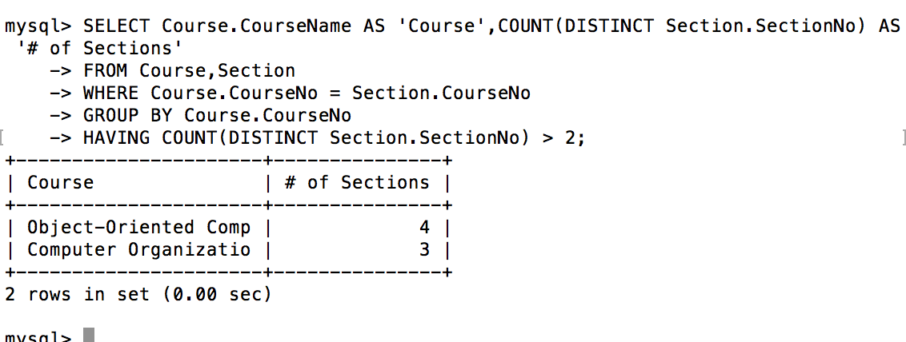

SELECT CourseName ,COUNT(DISTINCT Section.SectionNo) AS '# of Sections'

FROM Course,Section

WHERE Course.CourseNo = Section.CourseNo

GROUP BY Course.CourseNo

HAVING COUNT(DISTINCT Section.SectionNo) > 2;

/*Query3

3) List each course number, course name and section number which have 3 or more

students in the section.

*/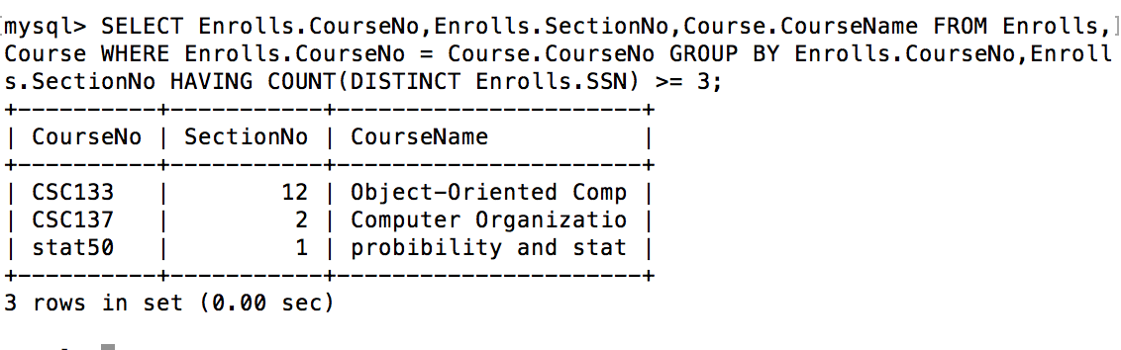

SELECT Course.CourseNo, Course.CourseName, Enrolls.SectionNo

FROM Course, Enrolls

WHERE Enrolls.CourseNo = Course.CourseNo

HAVING COUNT(DISTINCT Enrolls.SSN) >= 3;

* Query4

4) Retrieve the information (SSN, first name, and last name) of students who got Grade ‘A’

in at least 3 exams.

*/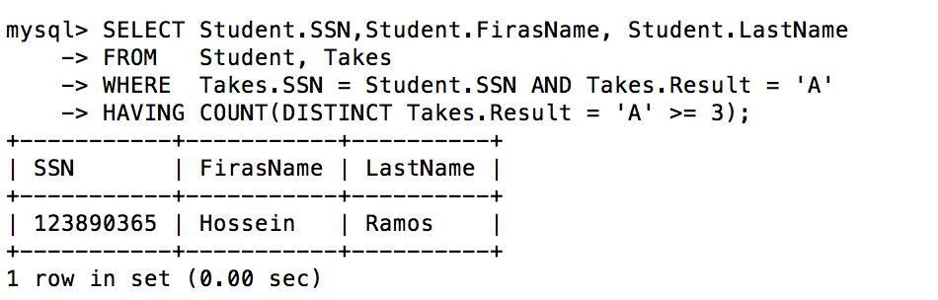

SELECT Student.SSN,Student.FirasName, Student.LastName

FROM Student, Takes

WHERE Takes.SSN = Student.SSN AND Takes.Result = 'A'

HAVING COUNT(DISTINCT Takes.Result = 'A' >= 3);

/*Query 5

5) Obtain information (exam number, exam date, course number and section number)

about exams taking place in building ‘RVR’. Along with that get the room’s capacity and

room number.

*/

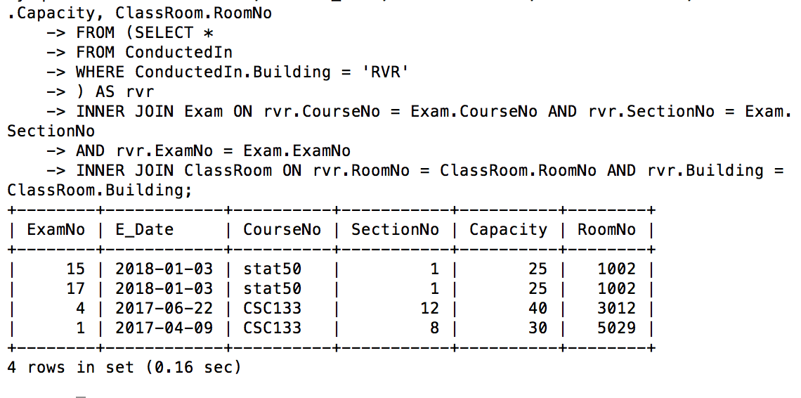

SELECT Exam.ExamNo, Exam.E_Date as ExamDate, Exam.CourseNo, Exam.SectionNo, ClassRoom.Capacity, ClassRoom.RoomNo

FROM (SELECT *

FROM ConductedIn

WHERE ConductedIn.Building = 'RVR'

) AS RVR

INNER JOIN Exam ON RVR.CourseNo = Exam.CourseNo AND RVR.SectionNo = Exam.SectionNo

AND RVR.ExamNo = Exam.ExamNo

INNER JOIN ClassRoom ON RVR.RoomNo = ClassRoom.RoomNo AND RVR.Building = ClassRoom.Building;

/*Query 6

6) Retrieve information (SSN, first name and last name) about students who are enrolled in

both the course ‘CSC133’ and ‘CSC137’. ‘CSC133’ and ‘CSC137’ are both course

numbers.

*/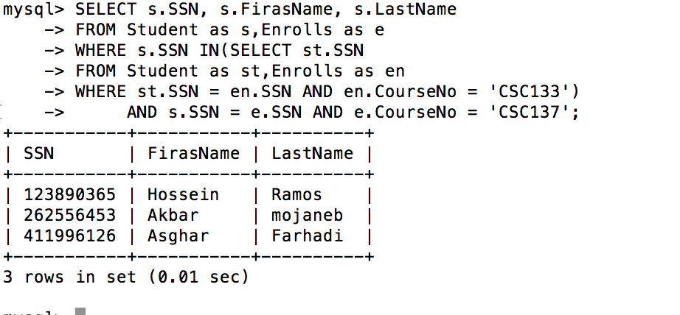

SELECT s.SSN, s.FirstName, s.LastName

FROM Student as s,Enrolls as e

WHERE s.SSN IN (SELECT st.SSN

FROM Student as st,Enrolls as en

WHERE st.SSN = en.SSN AND en.CourseNo = 'CSC133')

AND s.SSN = e.SSN AND e.CourseNo = 'CSC137';

!-- CSC137 outside () not not get error massage

/*Query 7

7) Get the information (SSN, first name and last name) about students who take the course

‘Data structure and algorithms’. Also get the section number in which they have

enrolled in the course, as well as the instructor of the section.*/

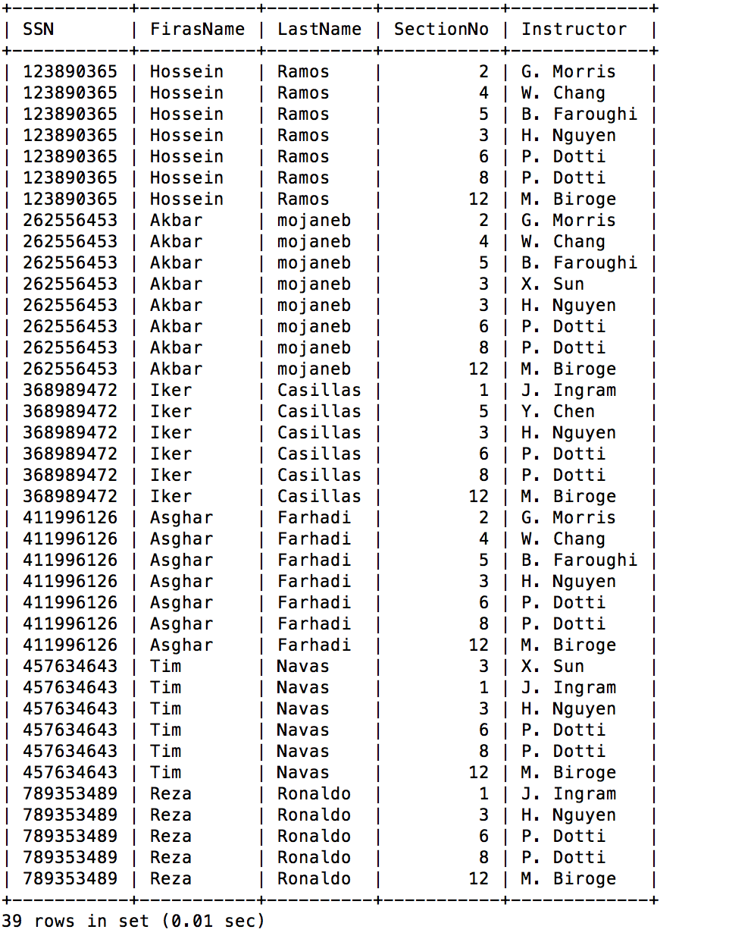

SELECT st.SSN, st.FirasName, st.LastName, se.SectionNo, se.Instructor

FROM Student as st,Enrolls as en ,Course as co, Section as se

WHERE st.SSN = en.SSN AND en.CourseNo = co.CourseNo

AND en.CourseNo = se.CourseNo AND en.SectionNo = se.SectionNo

AND co.CourseName = 'Data Structure and Algorithms';