Ehsan Hosseinzadeh Khaligh

Socket programming 1

I ran this program in my MAC and I did not use the athena server. I used Intellij IDE to run the code and test it.

TCP

1)Server code

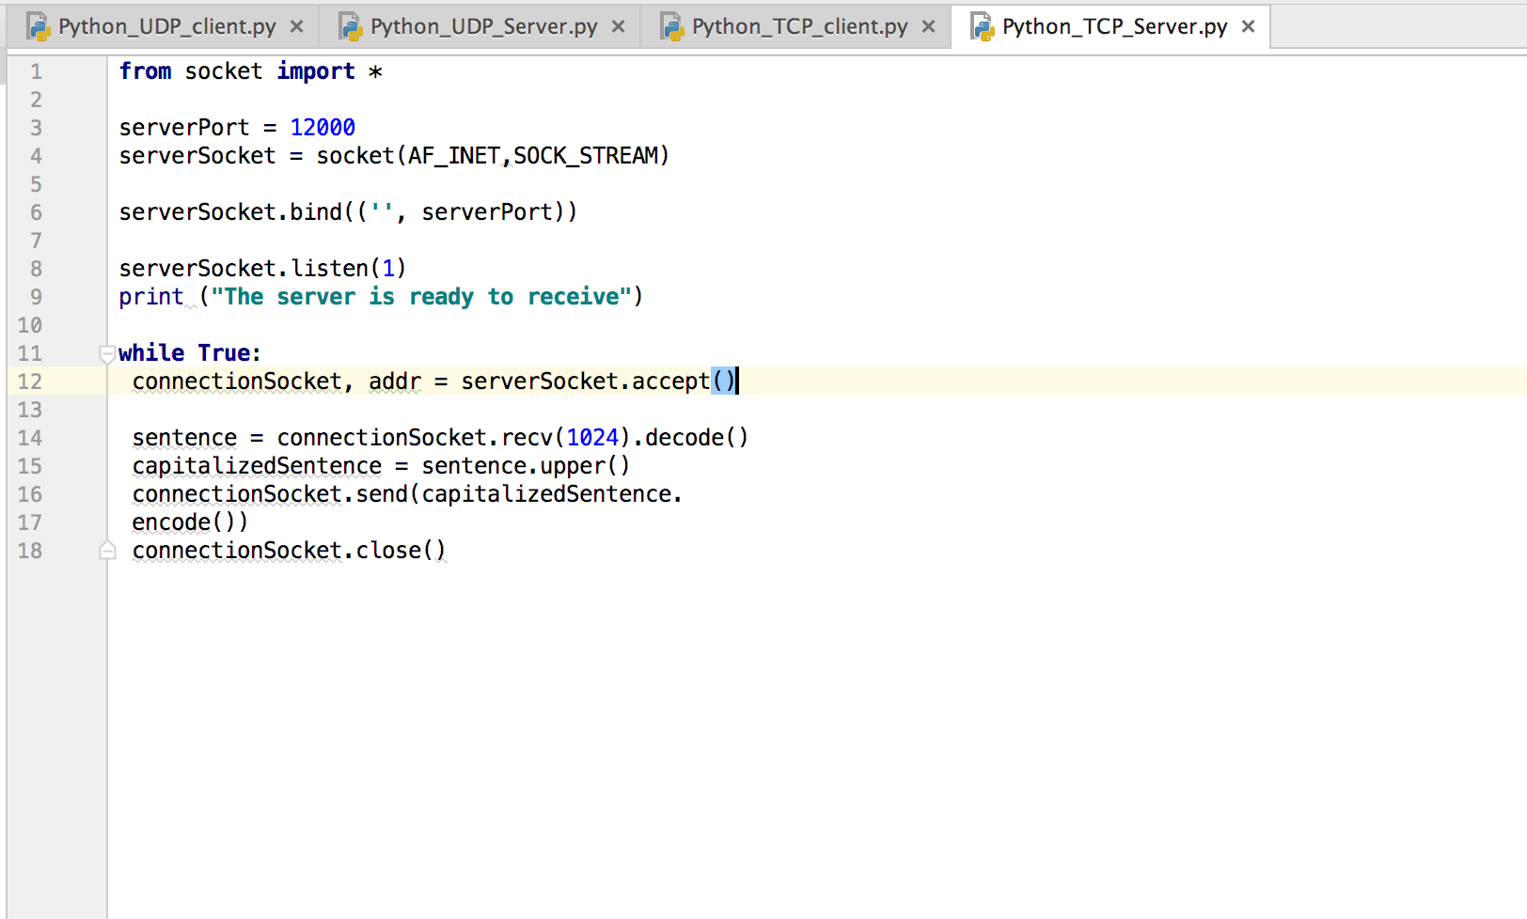

2)Client code

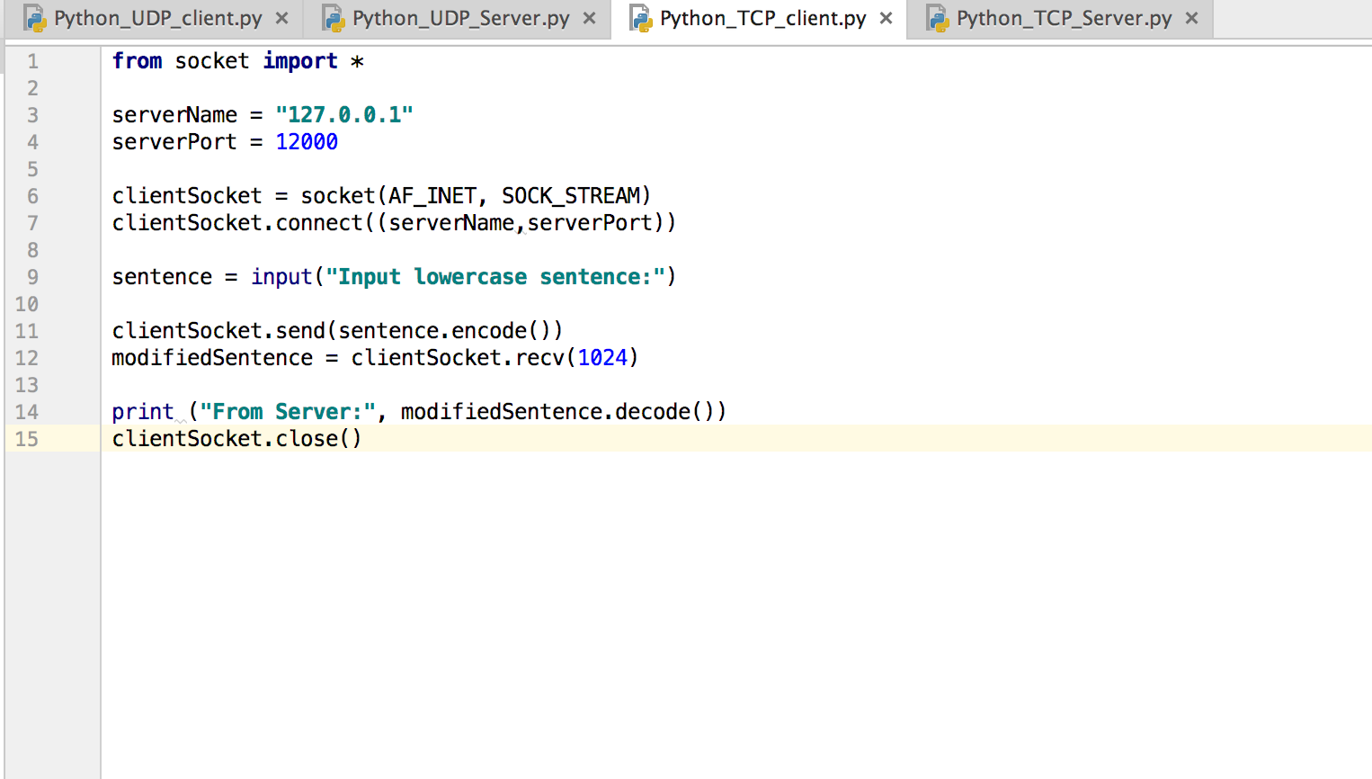

3)Server running

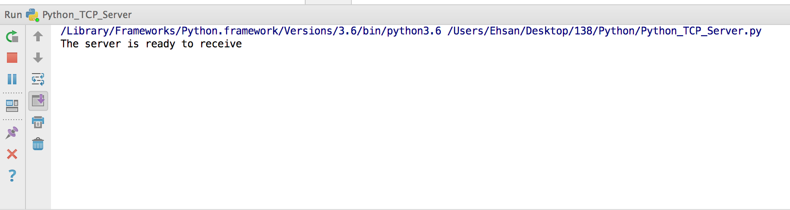

4)Client returns lower case input to uppercase.

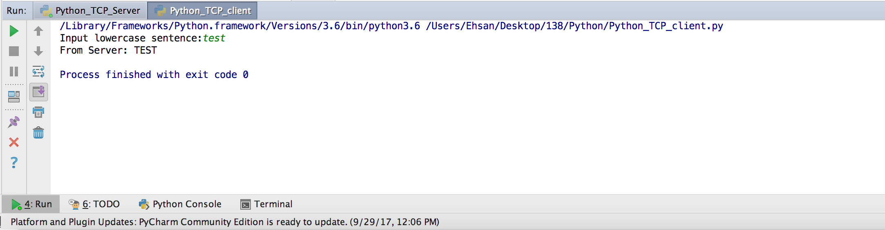

UDP

1)Server code

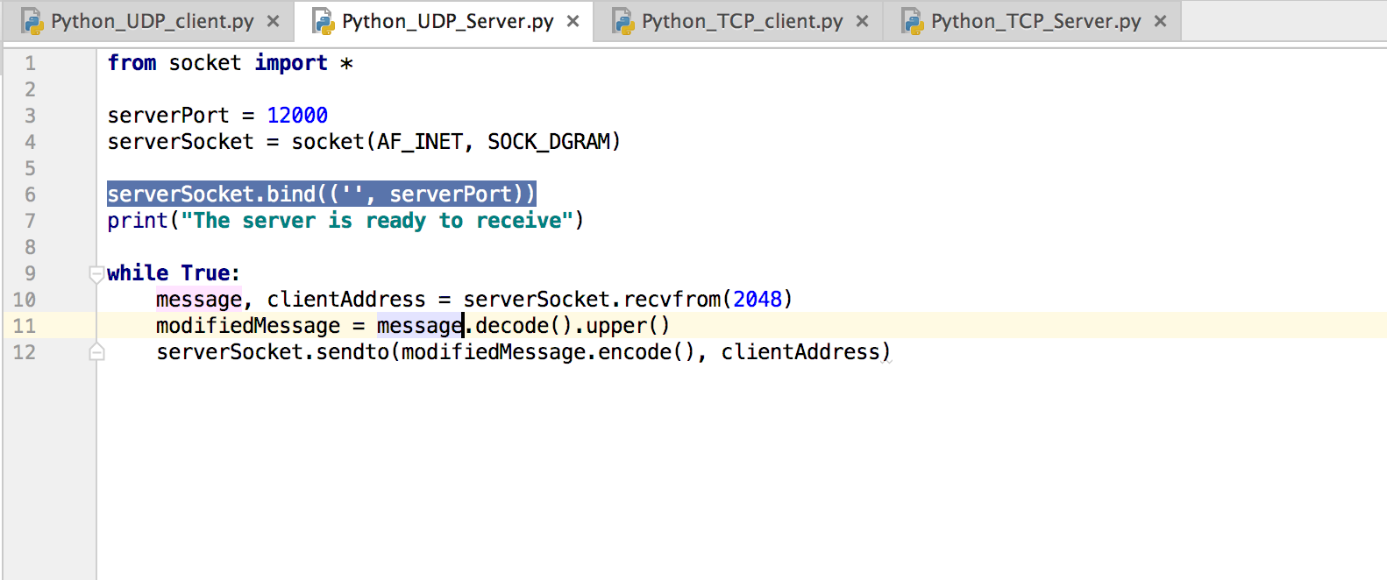

2)Client code

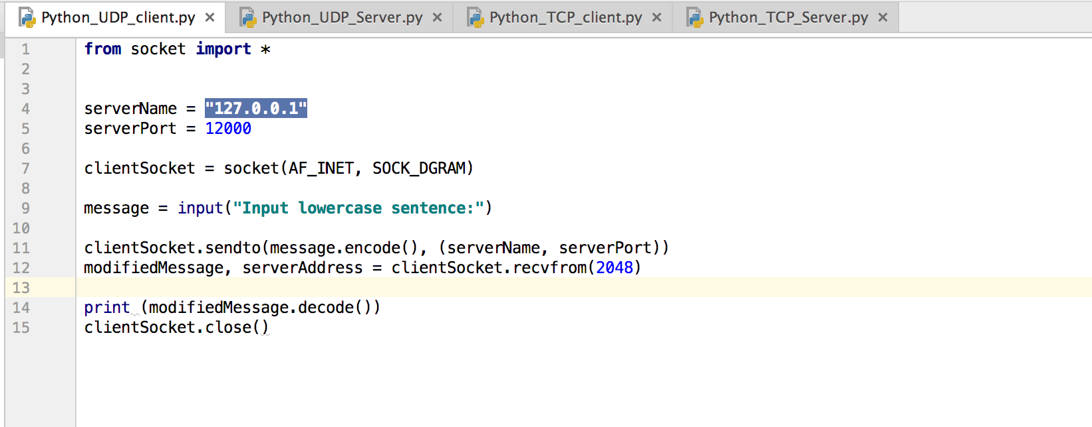

3)Server running

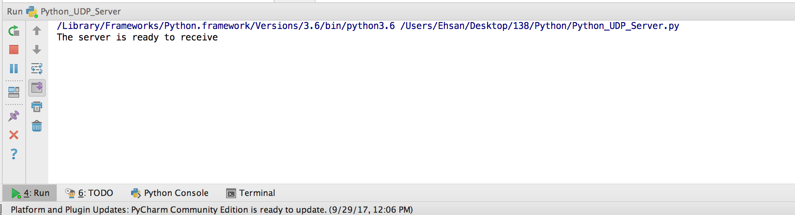

4)Client returns lower case input to uppercase.

