darkniche: An R package for climatic dark diversity, directional niche coverage and threshold-robust null-model inference
Ehsan Rahimi¹, and Chuleui Jung²
Agricultural Research Institute, Gyeongkuk National University, Andong, Republic of Korea
(ehsanrahimi666@gmail.com)
Department of Plant Medical, Gyeongkuk National University, Andong, Republic of Korea (cjung@gknu.ac.kr).
*Corresponding Author: Ehsan Rahimi, Email: ehsanrahimi666@gmail.com

Abstract
A region's climatic dark diversity is the set of species that are absent from it although its climate lies inside their tolerance. Estimating that set requires answering a containment question -- is this region's climate inside this species' niche? -- but the statistics the field uses for niche comparison in environmental space, Schoener's D and Warren's I, are symmetric measures of similarity. They penalise niche mass that lies outside the region, so a broad-niched species scores near zero against a small region it could trivially occupy, precisely for the trait that makes generalists successful colonisers. A second, less visible problem affects the inference built on top: the standard region-level test compares the observed number of climatically suitable species against a null expectation at one chosen similarity threshold, and the direction of that comparison is not stable in the threshold.
We present darkniche, an open-source R package that implements the directional alternative end to end. Niches and regional climate availabilities are estimated as densities on one shared environmental lattice; climatic admissibility is scored by directional niche coverage in a threshold form (DNC_{q}) and a threshold-free integral form (DNC_{auc}), with ancillary position and novelty indices and with D, I and the Bhattacharyya coefficient computed alongside for comparison; every species-region pair can be screened against three analytical null models controlling for niche breadth, climate availability and range geometry; the admissibility threshold is calibrated externally against documented introduced ranges using fast DeLong tests on realm- and area-matched comparisons; and dark diversity is reported with an area-adjusted ratio and a threshold-sweep diagnostic.
Two case studies ship with the package. In a controlled simulation in which admissibility is known from the generating geometry and never from any evaluated statistic, DNC_{q} recovers it with AUC = 0.997 against 0.882 for Schoener's D (paired DeLong z = 28.1); thresholded at its own optimum, D over-estimates the size of the admissible pool by 215% where DNC_{q} errs by 21%. Applied to the published results for all 619 WWF terrestrial ecoregions, which are bundled as example data, the package reproduces a forty-fold gradient in dark diversity, an area confound of r = -0.441 that moves 286 ecoregions by more than a tenth of the ranking, and a direction census in which 71 ecoregions appear enriched at the 80th percentile of the coverage distribution and 449 at the 99th, with 439 of 452 reliably testable ecoregions changing direction somewhere in between.
All 33 exported functions are documented with runnable examples and covered by 162 unit tests, of which 56 verify the numerical core against an independent reference implementation. darkniche makes climatic dark diversity a measurable, testable and reproducible quantity, and makes the two ways of getting it wrong -- an area-driven ranking and a threshold-driven direction -- visible in the output rather than hidden in a footnote.
Keywords: climatic dark diversity, directional niche coverage, species pool, null models, environmental space, niche overlap, threshold dependence, R package

1. Introduction
Every regional biota is a subset of the species that could live there. The complement -- species absent despite meeting the region's abiotic requirements -- is its dark diversity (Partel, Szava-Kovats & Zobel 2011), and the concept has become a standard way of converting the species-pool idea into a measurable quantity (Zobel 2016; Moeslund et al. 2017). Its appeal is that it turns an absence into evidence: where a large share of the suitable pool is unrealised, something other than climate -- dispersal limitation, biotic resistance, historical contingency -- is deciding community membership.
Two operational steps stand between the concept and a number. The first is deciding which absent species are suitable. Where niches are compared in a gridded environmental space (Broennimann et al. 2012; Di Cola et al. 2017), suitability is almost always scored with Schoener's D or Warren's I (Schoener 1970; Warren, Glor & Turelli 2008). Both are symmetric: they measure how similar two densities are. But climatic admissibility is not a similarity question. It asks whether the region's climate is contained in the species' tolerance, and containment is directional. A species whose niche is much broader than the region will always have most of its mass outside it, and every symmetric statistic will therefore score the pair low -- for the very trait that makes broad-niched species the ones that most often establish outside their native range (van Kleunen et al. 2015). The problem is structural, not a matter of tuning: the min-overlap functional over unit-mass densities is identically Schoener's D, so no rescaling of a symmetric statistic can express containment.
The second step is deciding whether a region holds more suitable species than chance allows. The natural test counts the species whose coverage exceeds a threshold and compares that count with its expectation under randomised niches (Gotelli & Graves 1996; Gotelli 2000). Its sensitivity to the threshold is rarely reported. When observed coverage is bimodal -- as it is whenever most species have essentially no overlap with a given region and a minority have a great deal -- while the null distribution is unimodal, the two distributions must cross, and the sign of the comparison depends on which side of the crossing the threshold falls. A single-threshold result is then a property of the analyst's choice rather than of the region.
Software has not kept pace with either problem. `ecospat` (Di Cola et al. 2017) and `ENMTools` (Warren et al. 2021) provide the symmetric statistics and their equivalency and similarity tests, and are excellent at what they were designed for; neither offers a directional metric, because the framework they implement has no place for one. `DarkDiv` (Carmona & Partel 2020) estimates dark diversity from co-occurrence, a complementary approach that requires community data and does not use environmental space. No package computes climatic admissibility directionally, screens it against nulls, calibrates it against observed establishment, or tests whether an aggregate result survives a change of threshold.
Here we introduce darkniche, an R package that closes that gap. It provides a directional metric family with the symmetric statistics retained for comparison, three analytical nulls, external calibration against documented introduced ranges, dark-diversity accounting with an area adjustment, and a threshold-sweep diagnostic -- with the published results for all 619 terrestrial ecoregions bundled so that the entire workflow can be reproduced from the package alone.

2. Why containment is not similarity
The distinction the package rests on can be stated exactly. Let Z_{s} be a species' niche density and Z_{e} a region's climate density, both normalised to unit mass on a common lattice of P cells. Schoener's D is 1 - 0.5 sum |Z_{s} - Z_{e}|, which is equal to sum min(Z_{s}, Z_{e}); Warren's I is a monotone function of the Bhattacharyya coefficient. Both are invariant to which density is called the species and which the region, and both are maximised only when the two densities coincide.
Climatic admissibility asks something else: what share of the region's climate falls where the species can live. In threshold form,
DNC_{q} = sum_{c in E_{q}(Z_{s})} Z_{e}(c),
where E_{q}(Z_{s}) is the q-envelope of the niche -- the smallest set of lattice cells holding a fraction q of its density mass. This replaces the naive positive support, which after kernel smoothing covers most of the lattice and would make coverage a function of bandwidth rather than of ecology. Because a single envelope level is still a choice, the package's default region-level statistic is the threshold-free integral
DNC_{auc} = integral from 0 to 1 of DNC_{q} dq = sum over c of [1 - Q_{s}(c)] Z_{e}(c),
where Q_{s}(c) is the cumulative density rank of cell c within the niche -- the smallest q at which the cell enters the envelope. Both statistics are inner products between a weight vector derived from the ranking of the niche density and the region density, which is what makes the environmental-shift null of Section 4.5 inexpensive: translating a niche translates its weights unchanged.
Three properties follow. DNC_{q} saturates at 1 when a broad niche engulfs a small region, which is the correct answer to a containment question and the answer D cannot give; DNC_{auc} does not saturate, so it still separates a region at the niche core from one at the margin; and the converse quantity, the share of the niche that lies inside the region (NSI_{q}), measures something different again and is reported separately rather than conflated with coverage. The package also returns the min-overlap identity DNC_{min}, whose numerical equality with D is asserted in the test suite, so that the algebraic claim above is checked rather than believed.
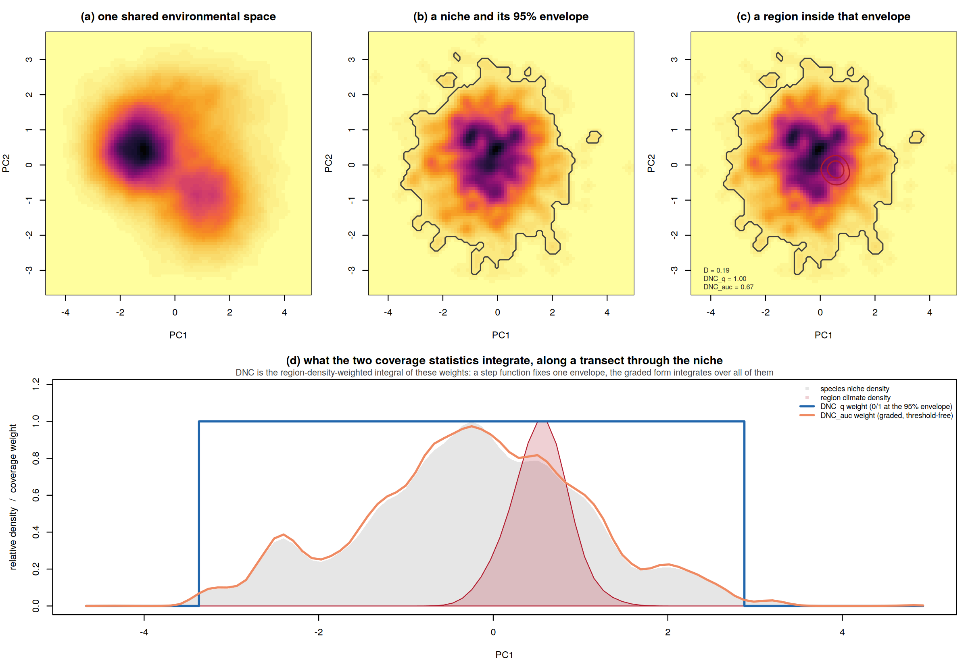
Fig. 1. The shared engine of darkniche and what the two coverage statistics integrate. (a) All species niches and all regional climate availabilities are estimated as kernel densities on one lattice defined from the global background, so every object is comparable. (b) The q-envelope is the smallest set of cells holding a fraction q of the niche mass. (c) A region nested inside that envelope: Schoener's D is low because most of the niche lies outside the region, while directional coverage records that the region is habitable throughout. (d) Along a transect through the niche, DNC_{q} weights cells 0 or 1 at one envelope level, whereas DNC_{auc} weights them by 1 minus their cumulative density rank and therefore integrates over every level; the coverage statistic is the region-density-weighted integral of the weight curve.

3. Package design and architecture
darkniche is written in base R with no hard dependencies beyond `stats`, `graphics`, `grDevices`, `utils` and `tools`, which keeps it installable anywhere and makes its numerical behaviour auditable line by line. `terra` is suggested rather than required, because projecting rasters into environmental space is the user's step and different studies do it differently. The package is organised into six modules (Table 1) and follows three design commitments.
One engine, one lattice. Every density in an analysis -- each species niche, each regional climate availability, the global background -- is estimated by `dn_density()` on the single lattice returned by `dn_space()`, with one fixed bandwidth for all objects so that estimated niche breadth reflects ecology rather than sample size. Metrics, nulls and the accounting layer all consume those densities, so nothing in the package can silently compare objects estimated on different footings.
Guardrails are API, not prose. The two failure modes that the underlying empirical studies found to be decisive are encoded in the returned objects rather than left to the user's discipline. `dn_aggregate()` suppresses the effect size, p-value and enrichment ratio whenever the expected count falls below five, because a ratio of 2,000-fold against an expectation of a thousandth of a species is arithmetic rather than evidence. `dn_cddr()` returns the area-adjusted residual beside the raw ratio and documents that the raw ratio must not be used to rank regions. `dn_sweep()` returns a classed object whose `print` method states whether the direction of the test reverses across thresholds, computed only from thresholds the test itself considers reliable, so the warning survives into any report that prints the result.
Verified against an independent implementation. The numerical core was ported from the Python pipeline used in the source studies and is checked against fixtures generated by that pipeline: kernel density estimation to within 2 x 10⁻⁷ of `scipy.ndimage.gaussian_filter`, all twelve pairwise metrics to within 5 x 10⁻⁶, envelopes, entry quantiles and the aggregate test exactly, and the environmental-shift null exactly under injected shift targets. The agreement of two independent implementations is a stronger correctness claim than either could make alone.
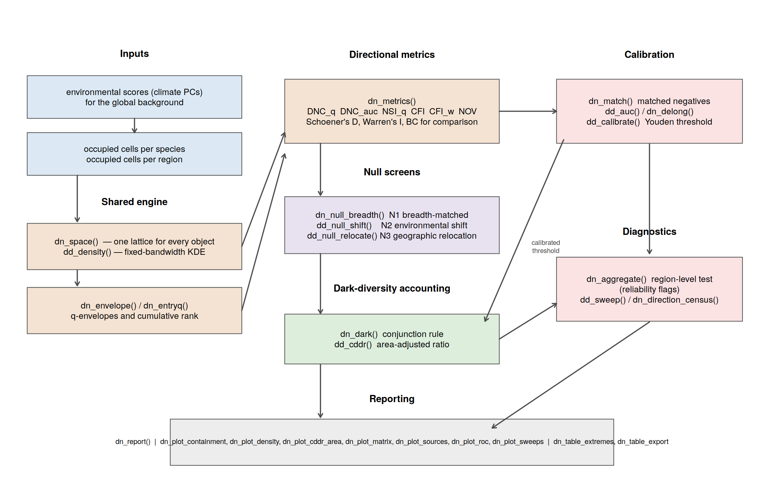
Fig. 2. Modular architecture and data flow of darkniche. Inputs (blue) are environmental scores for the global background and the occupied cells of each species and region. The shared engine (orange) builds one lattice and one density per object, from which the directional metrics are computed. Null screens (purple) test each pair against randomised niches; the calibration path (pink, right) fixes the admissibility threshold externally against documented introduced ranges and feeds it to the accounting layer (green). Diagnostics return region-level tests with reliability flags and the full threshold sweep. The reporting layer (grey) assembles figures and tables from any of these.
Table 1. Modules and exported functions of darkniche. All functions carry runnable examples and are covered by the test suite.
Module | Functions | Purpose
1 - Environmental space | dn_space, dn_density, dn_centres, dn_moments | One shared lattice; fixed-bandwidth kernel densities; first and second moments for the position indices
2 - Coverage geometry | dn_envelope, dn_entryq, dn_weights | q-envelopes, cumulative density rank, and the weight vectors whose inner product with a region density gives each coverage statistic
3 - Metrics | dn_metrics | DNC_q, DNC_auc, NSI_q, NSI_min, DNC_min, CFI, CFI_w, NOV, with Schoener's D, Warren's I and the Bhattacharyya coefficient for comparison
4 - Null models | dn_null_breadth, dn_null_shift, dn_null_relocate, dn_null_summary, dn_ses | Breadth-matched (N1), environmental-shift (N2) and geographic relocation (N3) nulls; standardised effect sizes with a floored null SD
5 - Calibration and accounting | dn_match, dn_auc, dn_delong, dn_calibrate, dn_dark, dn_cddr | Realm- and area-matched negatives, DeLong AUC and paired tests, Youden calibration, the conjunction rule, and the area-adjusted dark-diversity ratio
6 - Inference and reporting | dn_aggregate, dn_sweep, dn_direction_census, dn_report, dn_data, dn_plot_* (7), dn_table_extremes, dn_table_export | Region-level test with reliability flags, the threshold-sweep diagnostic and its census, bundled ecoregion results, publication figures and table export to CSV, Markdown or LaTeX
Table 2. The research questions darkniche is built to answer, the quantity each one reduces to, and the function that computes it. The left column is the form in which such questions are usually asked; the right column is what a user actually calls.
Question | Quantity | Function
Could this species live in this region, given its climate? | Directional coverage of the region's climate by the niche | dn_metrics(...)$DNC_auc
Is that coverage more than a species of its niche breadth would achieve anyway? | Standardised effect size against the breadth-matched null | dn_null_breadth()
Does the result require the niche to sit where it does in environmental space? | Effect size against niches translated to available climates | dn_null_shift()
Does it require the range to occupy the geography it does? | Effect size against ranges stamped elsewhere on the grid | dn_null_relocate()
What coverage value should count as 'admissible'? | Youden threshold of a model validated on documented introductions | dn_match(), dn_calibrate()
Does directional coverage predict real establishment better than niche similarity? | Paired AUC comparison on matched positives and negatives | dn_auc(), dn_delong()
Which species are absent although the region is admissible? | The conjunction rule applied to every species-region pair | dn_dark()
Which regions hold the largest unrealised pools? | Dark-diversity ratio, and its residual after removing area | dn_cddr(), dn_report()
Does this region hold more admissible species than chance allows? | Poisson-binomial count test, suppressed when unreliable | dn_aggregate()
Is that answer a property of the region or of my threshold? | The same test across a range of thresholds, with reversal detection | dn_sweep(), dn_direction_census()

4. Core functionality
Below we describe each module: what it computes, how it is implemented, and the decision it protects the user from getting wrong.

4.1 The environmental space -- dn_space(), dn_density()
`dn_space()` defines the lattice from the distribution of environmental scores over the whole study background, clipping each axis at its 0.1% and 99.9% quantiles and padding by 5% so that kernels near the edge are not truncated. `dn_density()` bins a point set on that lattice and smooths it with a Gaussian kernel whose bandwidth is a fixed fraction of the axis range (2% by default), returning a unit-mass density. A single bandwidth for every object is a deliberate choice: adaptive bandwidths make a species with few records appear to have a narrow niche, which would propagate directly into the coverage statistic. The implementation reproduces `scipy.ndimage.gaussian_filter` with constant boundary handling, which is what makes the cross-language verification in Section 6 possible.

4.2 Coverage geometry -- dn_envelope(), dn_entryq(), dn_weights()
`dn_envelope()` returns the smallest set of cells holding a fraction q of a density's mass, with ties broken by a stable ordering so that the envelope is reproducible. `dn_entryq()` returns, for every cell, the smallest q at which it enters the envelope; cells at the mode enter near 0, peripheral cells near 1, and unoccupied cells are assigned 1. `dn_weights()` exposes the resulting weight vector for either statistic. Because both weight vectors depend only on the ranking of the niche density, translating a niche in environmental space translates its weights unchanged -- the identity that lets the shift null replace B re-derivations with B array shifts.

4.3 The metric block -- dn_metrics()
`dn_metrics()` computes every metric for a block of species against a block of regions in one call, returning a named list of matrices (Table 3). The symmetric statistics are computed from the same L1 pass that yields the min-overlap term, so they cost little and are always available for comparison. The Mahalanobis core-fit index CFI and its availability-weighted form CFI_{w} describe where in the niche a region sits rather than how much of it is covered, and the novelty share NOV records the fraction of the region's climate outside the niche entirely; these enter the establishment model of Section 4.6 as ancillary predictors.
Table 3. The metric family returned by dn_metrics(). Directional metrics answer a containment question; symmetric metrics answer a similarity question; the identity row is a checked algebraic consequence rather than a separate method.
Metric | Type | Question answered | Behaviour when a broad niche engulfs a small region
DNC_q | directional | What share of the region's climate lies inside the niche's q-envelope? | saturates at 1 (correct, but cannot rank within the saturated set)
DNC_auc | directional | The same, integrated over every envelope level | high but unsaturated; still separates core from margin
NSI_q | directional (converse) | What share of the niche lies inside the region? | near 0; measures a different quantity, not a worse estimate of the same one
CFI, CFI_w | position | How close to the niche core is the region, in Mahalanobis terms? | high when the region sits centrally, independent of relative size
NOV | novelty | What share of the region's climate is outside the niche entirely? | near 0
DNC_min | identity check | sum min(Z_s, Z_e) / sum Z_e | identically Schoener's D; asserted in the test suite
D, I, BC | symmetric | How similar are the two densities? | low, because most of the niche lies outside the region

4.4 Null screens -- dn_null_breadth(), dn_null_shift(), dn_null_relocate()
A coverage value is not evidence on its own: broad-niched species cover everything, and regions with common climates are covered by everything. The package provides three nulls that remove different explanations. `dn_null_breadth()` (N1) standardises each species against reference species of similar niche breadth within its taxon, answering whether this species is exceptional for its breadth. `dn_null_shift()` (N2) translates the species' weight array to random, availability-weighted positions in environmental space, answering whether the observed coverage requires the niche to sit where it does. `dn_null_relocate()` (N3) stamps the species' geographic range footprint at random positions on the study grid and recomputes coverage from the relocated range, answering whether the result requires the range to occupy the geography it does.
The three are not interchangeable, and the documentation says so explicitly where it matters. The breadth-matched null draws its reference from the observed pool, so its marginal distribution reproduces the observed one almost exactly and the expected count at any threshold equals the observed count by construction; it therefore has no power in the region-level test of Section 4.7, however appropriate it is for ranking individual species. `dn_aggregate()` documents this and the shift and relocation nulls are the ones intended for it.
`dn_ses()` converts an observation and its null moments into a standardised effect size with the null standard deviation floored at a small fraction of the between-species spread. Reference distributions for coverage metrics are heavily zero-inflated; when an entire stratum piles up at zero the null SD collapses and any non-trivial observation divides by something near machine noise. The effect is real -- that species genuinely is exceptional against its stratum -- but the magnitude is not interpretable, and unfloored these artefacts outrank genuine signal in any effect-size-ordered table.

4.5 Calibration against documented introductions -- dn_match(), dn_auc(), dn_delong(), dn_calibrate()
Admissibility is only meaningful if the threshold means something. The package therefore supports external calibration against species that have demonstrably established outside their native range. `dn_match()` builds the comparison set: for each region a species actually reached, it samples unreached regions from the same biogeographic realm with the nearest log-areas. Matching is not cosmetic -- without it the negatives are dominated by climatically implausible regions that every metric rejects equally, and all metrics look equally good. `dn_auc()` implements the DeLong variance estimator using the fast rank-based algorithm of Sun & Xu (2014), and `dn_delong()` the paired test between two correlated AUCs on the same cases. `dn_calibrate()` returns the Youden-optimal threshold, which is then passed to `dn_dark()`.

4.6 Dark-diversity accounting -- dn_dark(), dn_cddr()
`dn_dark()` applies a conjunction rule: a pair is climatically admissible when the calibrated establishment probability exceeds the threshold and every supplied null screen is passed, and it is dark when it is additionally an absence. Applying the full rule to the observed side while thresholding raw coverage on the null side would compare a strict criterion against a lax one, and the package documents the symmetry requirement in both functions.
`dn_cddr()` computes the climatic dark-diversity ratio, n_dark / (n_dark + n_observed), and -- when areas are supplied -- the residual from its regression on log area. The adjustment is not optional in practice. A small region occupies little environmental space, so more niches enclose it, while its smaller area supports fewer natives; both effects inflate the ratio for reasons that have nothing to do with the ecology of interest. In the bundled global results the confound is r = -0.441 (Section 5.2), and the function returns the residual alongside the raw value with the warning in its documentation.

4.7 Region-level inference -- dn_aggregate()
`dn_aggregate()` tests whether a region holds more admissible species than the null expects. The observed count is the number of species whose coverage exceeds a threshold; the expected count is the number whose null coverage would exceed the same threshold. Because each species has its own null mean and standard deviation, that count is Poisson-binomial rather than binomial, and the function computes its expectation and variance exactly, sum p_i and sum p_i(1 - p_i), without simulation. A normal approximation is used for the z-score, and is sound at the counts that arise in practice -- but not when the expected count is small, which is why results with an expectation below five are returned with the effect size, p-value and enrichment ratio set to `NA` and a `reliable` flag set to `FALSE`.

4.8 The threshold-sweep diagnostic -- dn_sweep(), dn_direction_census()
`dn_sweep()` runs the aggregate test across a range of thresholds placed at quantiles of the observed coverage distribution, so that the sweep is comparable across regions of different richness. It returns a classed object whose `print` method reports the range of the observed-to-expected ratio and states, in words, whether the direction of the test reverses; the `plot` method draws the curve. Crucially, the verdict is computed only from thresholds the test itself flags as reliable -- otherwise the diagnostic would report exactly the numbers the test refuses to report.
`dn_direction_census()` summarises a sweep over many regions: how many are called enriched and how many depleted at each threshold, how many change direction somewhere in the sweep, and how many do so monotonically. We suggest this census as a reporting standard. A study whose regions are threshold-stable can report a single threshold and say so; a study whose regions are not cannot, and should report the sweep instead.

4.9 Reporting -- dn_report(), dn_plot_*(), dn_table_export()
`dn_report()` assembles the quantities a region-level study must report together -- raw ratio, area-adjusted residual, the rank on each, the shift between them, and the direction census -- into one object whose `print` method surfaces both failure modes. Seven plotting functions cover the figures such studies need: densities with envelopes, the containment demonstration, the ratio against area with the confound displayed rather than hidden, region-by-taxon matrices, source decompositions, ROC comparisons, and multi-region sweeps. `dn_table_extremes()` builds the top-and-bottom table ranked on the residual, and `dn_table_export()` writes any table to CSV, Markdown or LaTeX.

4.10 Bundled example data -- dn_data()
Seven datasets ship with the package (Table 4), all of them real output from the global analysis of Rahimi & Jung (in review): 619 WWF terrestrial ecoregions, 35,087 species and 21,718,853 evaluated species-region pairs. Every example, test and case study in this paper runs on them, so a reader can reproduce each number in Section 5.2 from a clean R session without downloading anything.
Table 4. Datasets bundled with darkniche, accessed through dn_data(). All are results of the global analysis of Rahimi & Jung (in review); the raw range polygons and climate rasters that produced them are third-party data and are not redistributed.
Dataset | Rows | Contents
ecoregion | 619 | Observed and dark species richness, dark-diversity ratio and area for every terrestrial ecoregion
sweep | 2,476 | The aggregate null test at four thresholds per ecoregion, with reliability flags
sources | 619 | Share of each ecoregion's dark diversity whose source species are native near (<1,000 km), regionally (1,000-5,000 km) or distantly (>5,000 km)
region_taxon | 3,095 | Dark-diversity ratio for every ecoregion x taxonomic group combination
taxon | 5 | Dark-diversity rate per taxonomic group with 95% confidence intervals
auc | 10 | AUC of every metric against documented introduced ranges (18,899 matched comparisons)
containment | 18 | AUC by niche-to-region size stratum, the regime in which containment and similarity diverge

4.11 Worked examples
The following sequence is the whole workflow on a user's own data. Every object is a plain matrix or data frame, and no step requires leaving R.
Building the space and the densities. One lattice is defined from the study background, and every niche and every regional climate availability is estimated on it with the same bandwidth:
# install from GitHub; add INSTALL_opts to get the test suite as well
remotes::install_github("ehsanrahimi666/darkniche")
library(darkniche)

sp <- dn_space(background_scores, R = 100) # PC1-PC2 of climate, all cells
Zg <- dn_density(background_scores, sp) # availability, for the nulls

Zs <- t(sapply(species_cells, function(p) as.numeric(dn_density(p, sp))))
Ze <- t(sapply(region_cells, function(p) as.numeric(dn_density(p, sp))))
Asking the containment question. `dn_metrics()` returns one matrix per metric, species in rows and regions in columns, so a whole study is one call:
m <- dn_metrics(Zs, Ze, q = 0.95)

m$DNC_auc[1:3, 1:3] # directional coverage
m$D[1:3, 1:3] # Schoener's D, for comparison

# the algebraic identity the package asserts in its own tests:
all.equal(as.numeric(m$DNC_min), as.numeric(m$D))
#> TRUE
Screening the values. A coverage value alone is not evidence: broad-niched species cover everything. Each null answers a different 'anyway' question, and the effect sizes are what the accounting layer consumes:
nul <- dn_null_shift(matrix(Zs[1, ], sp$R, sp$R), Ze, Zg, B = 499)
dn_null_summary(m$DNC_auc[1, ], nul)
#> null_mean null_sd ses p_emp n_valid
#> 1 0.081 0.096 3.42 0.002 499
Fixing what 'admissible' means. The threshold is calibrated outside the analysis, on species that have demonstrably established beyond their native range, with negatives matched on realm and area so that the comparison is not won by climatically implausible regions:
cmp <- dn_match(positives, regions, reached, ratio = 5)
dn_auc(score[cmp$idx], cmp$label)$auc
dn_delong(dnc_score, d_score, cmp$label)$p # is the gain significant?
thr <- dn_calibrate(model_prob, cmp$label) # Youden threshold
Accounting, and the two guardrails. `dn_dark()` applies the conjunction rule; `dn_cddr()` returns the area-adjusted residual beside the raw ratio; and `dn_sweep()` refuses to let a single-threshold verdict pass unexamined:
pairs <- dn_dark(pair_table, p_min = thr,
ses_cols = c("n1_ses", "n2_ses"))

x <- dn_cddr(n_dark, n_present, area_km2)
attr(x, "confound_r") # rank on x$cddr_residual, never on x$cddr

sw <- dn_sweep(obs_coverage, null_mean, null_sd)
sw
#> Threshold sweep of the aggregate null test
#> thresholds: q0.80 - q0.99 (20 points)
#> obs/expected ratio: 0.412 - 6.883
#> ** DIRECTION REVERSES across the sweep: a single-threshold
#> verdict for this region is an artefact of the threshold. **
Reporting. For a study with many regions, `dn_report()` assembles the ranking, the area adjustment and the direction census into one object whose printed form states both risks explicitly. Running it on the bundled global results reproduces Section 5.2 in three lines:
rep <- dn_report(dn_data("ecoregion"), dn_data("sweep"))
rep
#> Climatic dark-diversity report
#> regions: 619
#> CDDR: 0.022 - 0.924 (median 0.579)
#> area confound: r = -0.441 -- rank on the residual, never on raw CDDR
#> 286 regions move more than 10% of the ranking when area is removed
#> threshold sweep: 439 of 452 regions (97%) change direction
#> ** a single-threshold enrichment claim is not supportable here **

5. Case studies
We demonstrate the package on two datasets that test different things: a simulation in which the right answer is known by construction, and the published global analysis, in which it is not.

5.1 A controlled simulation with known admissibility
The claim that symmetric statistics cannot answer a containment question is testable if admissibility is known independently. We generated a three-component environmental background of 30,000 cells, 120 species with tolerance scales spanning an order of magnitude (0.20 to 1.60 in units of the environmental axes) and 60 regions with climate scales spanning 0.12 to 0.90, giving 7,200 pairs. A pair was labelled admissible when at least 90% of the region's climate mass fell inside the species' tolerance disc of radius twice its generating scale -- a criterion computed by Monte Carlo from the generating parameters on fresh draws, never from an estimated density and never from any statistic the analysis then evaluated. This yielded 809 admissible pairs (11.2%).
Directional coverage recovers that ground truth almost perfectly, and the symmetric statistics do not (Table 4; Figure 3). DNC_{q} reached AUC = 0.997 (95% CI 0.996-0.998) against 0.882 for Schoener's D and 0.889 for Warren's I; the paired DeLong statistic for DNC_{q} against D was z = 28.1. The failure is confined to the regime the directional family was designed for: stratifying by the niche-to-region size ratio, D falls from 0.978 in the intermediate stratum to 0.957 where the niche greatly exceeds the region, while both directional forms stay above 0.99 in both.
The practical consequence is a mis-sized pool, not merely a lower AUC. Thresholding each metric at its own Youden-optimal value, D admits 2,548 pairs where 809 are truly admissible -- an over-estimate of 215%, at 30% precision -- and I over-estimates by 205%. DNC_{auc} over-estimates by 60% and DNC_{q} by 21% at 81% precision. A dark diversity built on a symmetric screen is therefore not a noisier version of the right quantity; it is roughly three times too large, and inflated most in exactly the regions whose climates are broadly tolerable.
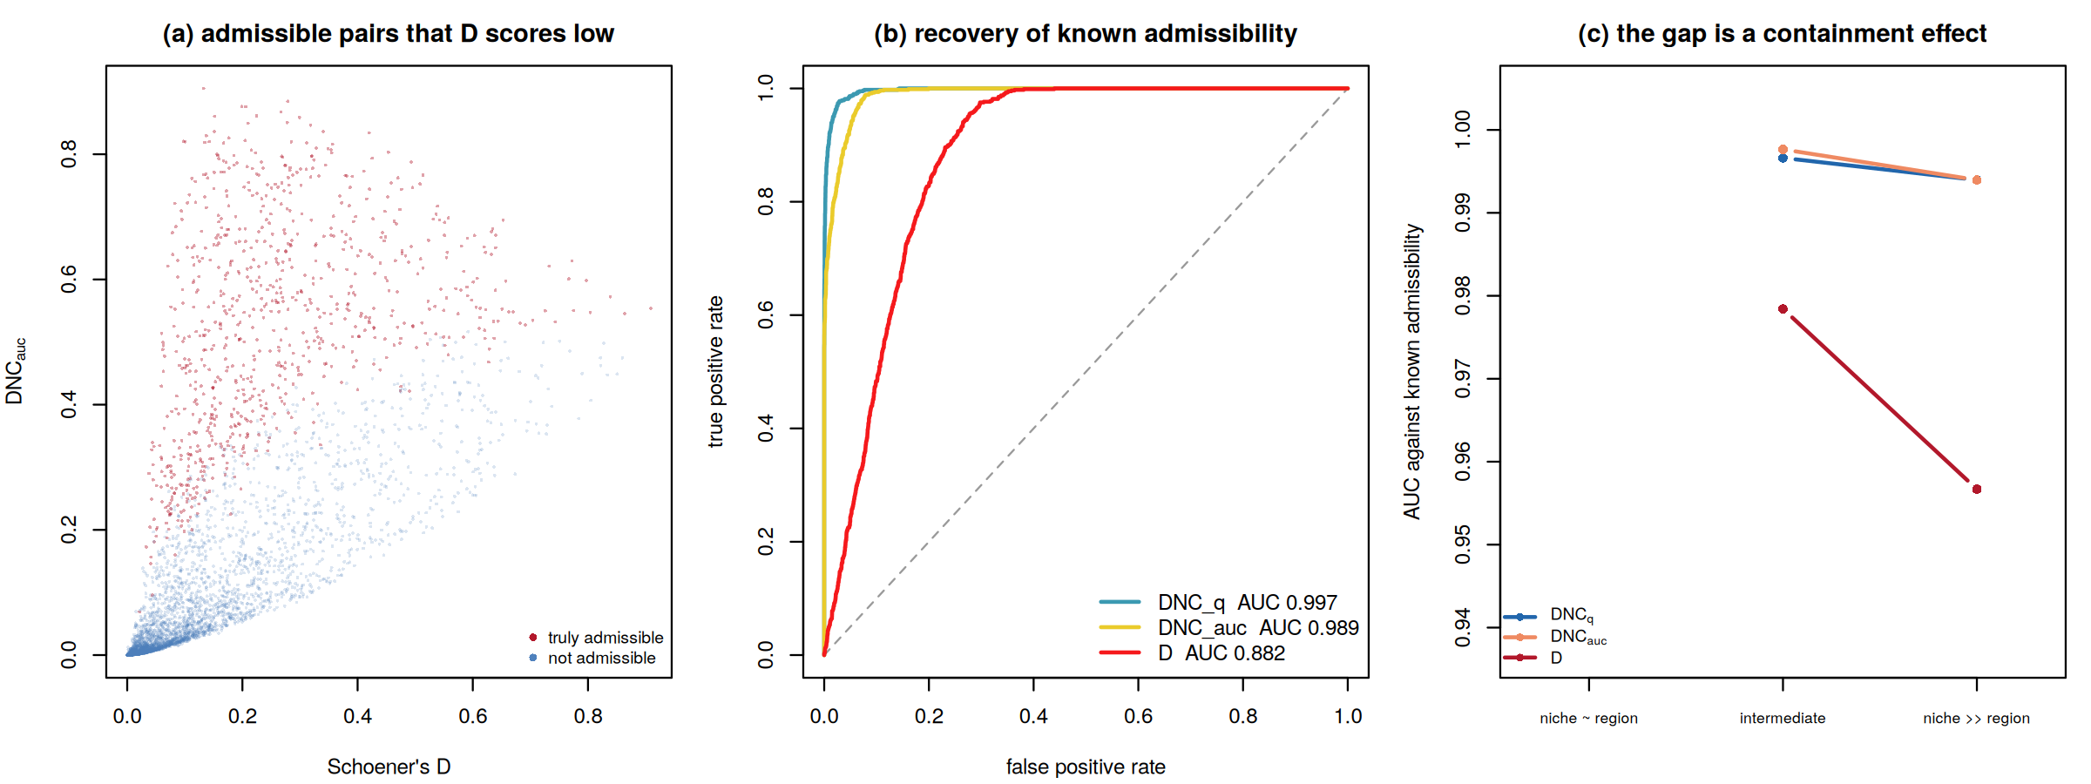
Fig. 3. Recovery of known admissibility in the controlled simulation (120 species x 60 regions; 809 of 7,200 pairs admissible by construction). (a) Every pair, plotted as Schoener's D against DNC_{auc} and coloured by the ground truth: a large population of truly admissible pairs occupies the low-D region, where a symmetric screen discards them. (b) ROC curves against the known labels. (c) AUC by niche-to-region size stratum; the lowest stratum contains no admissible pairs by construction and is therefore not estimable.
Table 5. Recovery of known admissibility in the simulation. AUC with 95% confidence intervals and the paired DeLong test against Schoener's D, followed by the size of the admissible pool each metric recovers at its own Youden-optimal threshold against the 809 pairs that are admissible by construction.
Metric | AUC | 95% CI | z vs D | Pool recovered | Pool error | Precision
DNC_q | 0.997 | 0.996-0.998 | 28.1 | 978 | +21% | 0.81
CFI_w | 0.991 | 0.990-0.993 | 29.2 | -- | -- | --
DNC_auc | 0.989 | 0.987-0.991 | 29.3 | 1,296 | +60% | 0.62
CFI | 0.983 | 0.980-0.985 | 28.6 | -- | -- | --
I | 0.889 | 0.881-0.896 | 14.6 | 2,471 | +205% | 0.32
D | 0.882 | 0.874-0.890 | -- | 2,548 | +215% | 0.30
NSI_q | 0.805 | 0.795-0.815 | -36.3 | -- | -- | --

5.2 The world's 619 terrestrial ecoregions
The bundled global results let the package be exercised on a real analysis at full scale. Loading them and calling `dn_report()` reproduces the published quantities in a few lines. The climatic dark-diversity ratio spans 0.022 to 0.924 with a median of 0.579, and in 411 of 619 ecoregions the absent admissible pool exceeds the realised one. Validation against documented introduced ranges gives DNC_{q} an AUC of 0.705 (0.696-0.714) against 0.688 for D -- a smaller margin than in the simulation, as expected when the labels reflect transport opportunity as well as climatic suitability, but in the same direction and estimated on 18,899 matched comparisons.
The area confound. The raw ratio correlates with log area at r = -0.441. Ranking on the residual instead of the raw value changes the ordering substantially: the two rankings correlate at Spearman 0.883, the median ecoregion moves 56 places, and 286 of 619 move by more than a tenth of the ranking (Figure 4a, b). The regions at the top of the adjusted gradient are arid subtropical and insular systems -- southwestern Arabian foothills savanna (residual +0.364), the Red Sea Nubo-Sindian desert (+0.353), the Sahara (+0.337) -- and those at the bottom are boreal-arctic systems and endemic-rich tropical mountains, saturated for opposite reasons.
Composition. Averaged over ecoregions, 68.8% of dark diversity is contributed by species whose native ranges lie more than 5,000 km away, 25.9% by species 1,000-5,000 km away and 5.3% by species within 1,000 km (Figure 4c): the unrealised pool is a distant pool, which is what dispersal limitation across a climatically connected world looks like. Within ecoregions the taxonomic ordering follows dispersal ability -- median ratios of 0.75 for amphibians, 0.71 for reptiles, 0.69 for vascular plants, 0.59 for mammals and 0.45 for birds (Figure 4d).
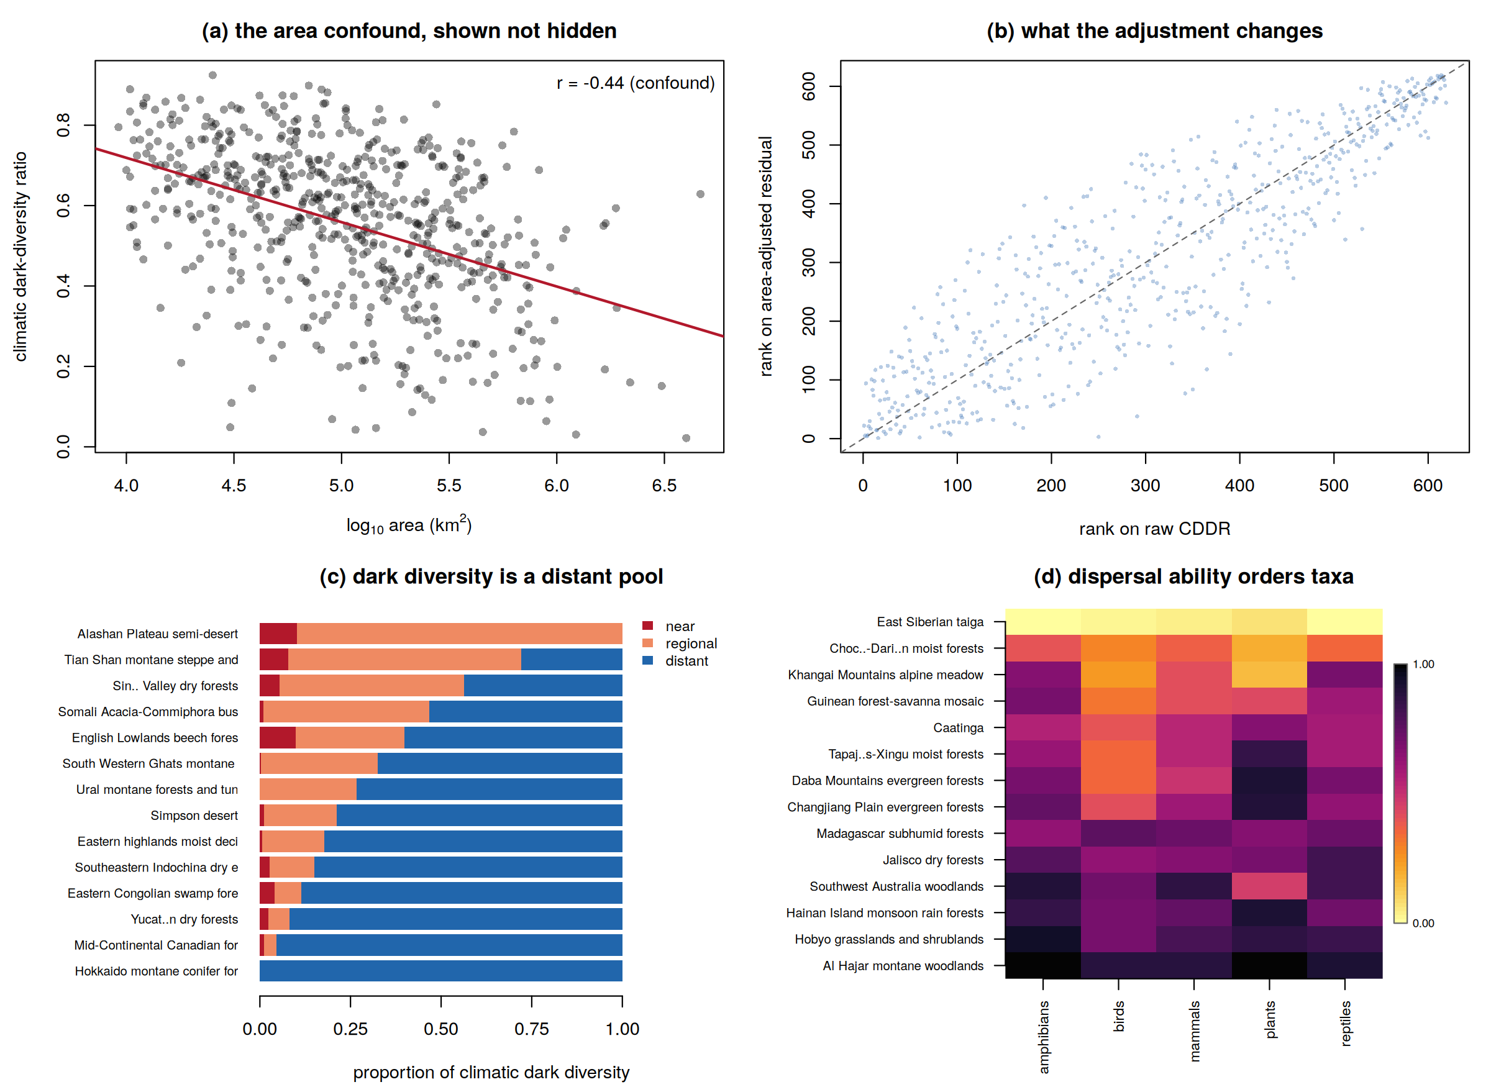
Fig. 4. The bundled global results, analysed with darkniche. (a) The raw dark-diversity ratio against log area, with the fitted confound (r = -0.441); dn_cddr() returns the residual from this line beside the raw value. (b) Rank on the raw ratio against rank on the area-adjusted residual: the adjustment moves the median ecoregion 56 places. (c) Source decomposition for a sample of ecoregions spanning the range of composition; the distant class dominates almost everywhere. (d) Dark-diversity ratio by ecoregion and taxonomic group for a sample spanning the gradient.
The threshold sweep. Running `dn_direction_census()` over the bundled sweep gives the result that motivates the diagnostic (Table 6; Figure 5). At the 80th percentile of the coverage distribution, 548 of 619 ecoregions appear significantly depleted relative to the null and 71 enriched; at the 99th percentile, 602 appear enriched and 17 depleted. Restricting attention to the 452 ecoregions whose expected counts are reliable at every threshold, 439 -- 97% -- change direction somewhere in the sweep. The change is monotone rather than noisy, which identifies the mechanism: observed coverage is bimodal while the null is unimodal, so the two distributions cross once and the sign of the comparison follows.
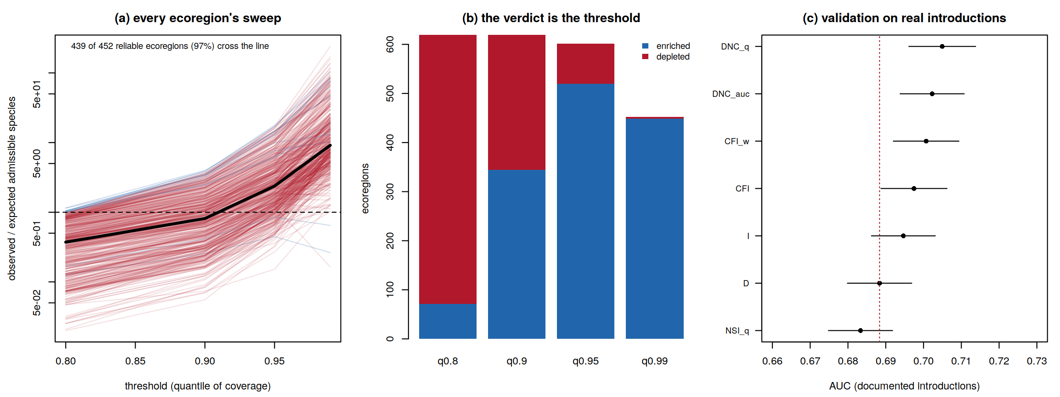
Fig. 5. The threshold-sweep diagnostic on the bundled global results. (a) Each line is one ecoregion's observed-to-expected ratio of admissible species as the threshold moves across quantiles of the coverage distribution; red lines cross the no-enrichment line somewhere in the sweep, the heavy line is the median across ecoregions. (b) The direction census: how many reliably testable ecoregions are called enriched and how many depleted at each threshold. (c) Validation against documented introduced ranges, AUC with 95% confidence intervals; the dashed line marks Schoener's D.
Table 6. Direction census of the aggregate null test over 619 ecoregions, produced by dn_direction_census(). Counts under 'reliable' exclude cells whose expected count falls below five, which dn_aggregate() does not report. The same data support opposite worldwide conclusions depending on the threshold.
Threshold (quantile of coverage) | Enriched (all) | Depleted (all) | Enriched (reliable) | Depleted (reliable)
q0.80 | 71 | 548 | 71 | 548
q0.90 | 344 | 275 | 344 | 275
q0.95 | 538 | 81 | 520 | 81
q0.99 | 602 | 17 | 449 | 3
Ecoregions changing direction | 553 of 619 |  | 439 of 452 (97%)

6. Testing, reproducibility and quality control
The package carries 162 unit tests in two layers. The first, 56 assertions, is a golden test suite comparing every numerical component against fixtures produced by the independent Python implementation used in the source studies: lattice construction, kernel density estimation, envelopes and entry quantiles, all twelve pairwise metrics, the environmental-shift null under injected shift targets, the standardised effect size with its floor, the Poisson-binomial aggregate test including its reliability flags, and the breadth-matched null. Tolerances are set by the reference's own float32 storage rather than chosen for convenience, and the generator script is shipped in `tools/` so the fixtures can be regenerated.
The second layer, 106 assertions, tests behaviour rather than arithmetic: that the bundled data reproduce the published summaries, that the area-adjusted residual is orthogonal to log area by construction, that the conjunction rule respects absence, that the aggregate test suppresses unreliable cells, that the sweep flags a reversing region and does not flag a stable one, that DeLong tests are antisymmetric in their arguments, that matched negatives respect realm membership and exclude reached regions, that degenerate inputs fail loudly rather than returning a plausible-looking number, and that every plotting and export function runs on the bundled data.
Writing that layer found two defects worth recording. `dn_sweep()` had been computing its reversal verdict from all thresholds, including those the aggregate test flags as unreliable -- so the diagnostic could have reported precisely the numbers the test refuses to report; the verdict, the printed range and the plotted curve now use reliable thresholds only. And `dn_auc()` returned `NaN` rather than an error when its labels contained only one class, which in a scripted workflow would have propagated silently into a table; it and its relatives now stop with a message naming the problem. Both are covered by regression tests, and both are recorded in the repository's design notes.
A reader can run the suite without cloning the repository: R does not install a package's tests by default, so `remotes::install_github("ehsanrahimi666/darkniche", INSTALL_opts = "--install-tests")` followed by `testthat::test_package("darkniche")` reproduces all 162 assertions from an installed copy.
The package passes `R CMD check` with no errors, warnings or notes; continuous integration runs the check on Linux, Windows and macOS and rebuilds the documentation site on every push. It is distributed from GitHub and installed with `remotes::install_github()`, deliberately not through CRAN: the existing CRAN package `DarkDiv` (Carmona & Partel 2020) estimates dark diversity from co-occurrence data, and a near-name collision would confuse users of both. Every exported function has a runnable example, and the two case studies of Section 5 are shipped as scripts in `analysis/` that regenerate every figure and table in this paper from a clean session.

7. Limitations
darkniche scores climatic admissibility, and climatic analogues are not habitat analogues. A region may be climatically admissible for a species and yet lack its host plant, its soil, its pollinator or its successional stage. The package's output is therefore an upper bound on the pool that abiotic tolerance permits, not a prediction of what will establish, and the documentation is explicit that a dark-diversity list is not a risk ranking.
Niches estimated from observed occurrences are realised rather than fundamental. Because dispersal limitation and biotic interactions have already truncated them, estimated tolerance is narrower than true tolerance and the resulting dark diversity is a lower bound on the quantity the concept names. The bias is conservative but real, and it is larger for species whose realised ranges are strongly constrained.
Three implementation limits are worth stating. The environmental space is two-dimensional by default; a three-dimensional lattice is planned but not yet exposed. The kernel density estimation and the metric block are written in base R, which is fast enough for the 10² to 10⁴ objects a typical study involves but not for the 21.7 million pairs of the bundled global analysis -- that run was performed with the reference Python pipeline, and the package's role there is to reproduce, diagnose and report rather than to recompute. And the geographic relocation null requires the user to supply a projection from grid cells to environmental scores, since the package deliberately holds no rasters.
Finally, the calibrated admissibility threshold shipped as a default (0.177) is the Youden threshold of one specific establishment model validated on one specific set of documented introductions. It is documented as such. Studies using different metrics, taxa or validation data should recalibrate with `dn_calibrate()` rather than inherit it.

8. Future directions
Three extensions are planned. Compiled backends for `dn_density()` and `dn_metrics()`, validated against the current implementations by the existing golden tests, will raise the practical ceiling on study size. A three-dimensional environmental space will be exposed behind the same interface, with the sensitivity machinery of the source studies -- which found rank correlations above 0.94 between two- and three-dimensional analyses -- reported as a diagnostic rather than assumed. And a generalised-linear establishment-model helper will close the calibration loop inside the package, so that users need not leave R to fit the model whose threshold `dn_dark()` consumes.
More broadly, the threshold-sweep diagnostic is not specific to dark diversity. Any aggregate null-model test that counts objects above a threshold on a bimodally distributed similarity statistic is exposed to the same reversal, and `dn_sweep()` accepts observed values and null moments from any source. We would welcome its use as a routine check in niche-overlap, invasion-risk and community-assembly analyses that currently report a single threshold.

9. Conclusions
darkniche makes climatic dark diversity a quantity that can be measured, tested and reproduced. It replaces symmetric niche overlap with a directional family that answers the containment question the concept actually poses -- recovering known admissibility at AUC 0.997 against 0.882 for Schoener's D in a controlled simulation, and avoiding the three-fold over-estimate of the admissible pool that a symmetric screen produces. It supplies the null models, the external calibration and the accounting that turn a coverage value into evidence. And it makes the two ways of reaching a wrong conclusion visible in the returned objects: an area-driven ranking, corrected by the residual that `dn_cddr()` returns beside the raw ratio, and a threshold-driven direction, exposed by the sweep that `dn_sweep()` reports and, on the bundled global data, found to reverse in 97% of reliably testable ecoregions. With the published results for all 619 terrestrial ecoregions bundled and 162 tests including a cross-language verification of the numerical core, the package is intended to be usable as a method and auditable as software.
Ethics declarations
Conflict of interest
The authors declare that they have no conflict of interest.
Ethics approval
Not Applicable.
Consent to participate
Not applicable.
Consent for publication
The authors confirm that they have no conflicts of interest to disclose concerning this publication.
Competing interests
The authors declare that they have no competing interests.
Funding
This work was supported by the Basic Science Research Program through the National Research Foundation of Korea (NRF) funded by the Ministry of Education.
Data availability
darkniche is open source under GPL-3, installed with `remotes::install_github("ehsanrahimi666/darkniche")`, with reference documentation at https://ehsanrahimi666.github.io/darkniche/ and source at:

https://github.com/ehsanrahimi666/darkniche
The bundled ecoregion datasets, the golden test fixtures and the scripts that regenerate every figure and table in this paper are included in the repository. The underlying range polygons and climate rasters are third-party data available from IUCN, BirdLife International, WorldClim and the WWF terrestrial ecoregions dataset.

Acknowledgements
We thank the developers of ecospat, ENMTools and DarkDiv, whose work defined the problems this package addresses, and the data providers (IUCN, BirdLife International, WorldClim and WWF), whose open data made the bundled analysis possible.

References
Broennimann, O., Fitzpatrick, M.C., Pearman, P.B., Petitpierre, B., Pellissier, L., Yoccoz, N.G. et al. (2012). Measuring ecological niche overlap from occurrence and spatial environmental data. Global Ecology and Biogeography, 21, 481-497.
Carmona, C.P. & Partel, M. (2020). Estimating probabilistic site-specific species pools and dark diversity from co-occurrence data. Global Ecology and Biogeography, 30, 316-326.
DeLong, E.R., DeLong, D.M. & Clarke-Pearson, D.L. (1988). Comparing the areas under two or more correlated receiver operating characteristic curves: a nonparametric approach. Biometrics, 44, 837-845.
Di Cola, V., Broennimann, O., Petitpierre, B., Breiner, F.T., D'Amen, M., Randin, C. et al. (2017). ecospat: an R package to support spatial analyses and modeling of species niches and distributions. Ecography, 40, 774-787.
Gotelli, N.J. (2000). Null model analysis of species co-occurrence patterns. Ecology, 81, 2606-2621.
Gotelli, N.J. & Graves, G.R. (1996). Null Models in Ecology. Smithsonian Institution Press, Washington, DC.
Hijmans, R.J. (2020). terra: spatial data analysis. R package.
Lewis, R.J., Szava-Kovats, R. & Partel, M. (2016). Estimating dark diversity and species pools: an empirical assessment of two methods. Methods in Ecology and Evolution, 7, 104-113.
Moeslund, J.E., Brunbjerg, A.K., Clausen, K.K., Dalby, L., Fløjgaard, C., Juel, A. et al. (2017). Using dark diversity and plant characteristics to guide conservation and restoration. Journal of Applied Ecology, 54, 1730-1741.
Partel, M., Szava-Kovats, R. & Zobel, M. (2011). Dark diversity: shedding light on absent species. Trends in Ecology & Evolution, 26, 124-128.
Ronk, A., Szava-Kovats, R. & Partel, M. (2015). Applying the dark diversity concept to plants at the European scale. Ecography, 38, 1015-1025.
Schoener, T.W. (1970). Nonsynchronous spatial overlap of lizards in patchy habitats. Ecology, 51, 408-418.
Soberon, J. & Peterson, A.T. (2005). Interpretation of models of fundamental ecological niches and species' distributional areas. Biodiversity Informatics, 2, 1-10.
Sun, X. & Xu, W. (2014). Fast implementation of DeLong's algorithm for comparing the areas under correlated receiver operating characteristic curves. IEEE Signal Processing Letters, 21, 1389-1393.
Svenning, J.-C. & Skov, F. (2004). Limited filling of the potential range in European tree species. Ecology Letters, 7, 565-573.
van Kleunen, M., Dawson, W., Essl, F., Pergl, J., Winter, M., Weber, E. et al. (2015). Global exchange and accumulation of non-native plants. Nature, 525, 100-103.
Warren, D.L., Glor, R.E. & Turelli, M. (2008). Environmental niche equivalency versus conservatism: quantitative approaches to niche evolution. Evolution, 62, 2868-2883.
Warren, D.L., Matzke, N.J., Cardillo, M., Baumgartner, J.B., Beaumont, L.J., Turelli, M. et al. (2021). ENMTools 1.0: an R package for comparative ecological biogeography. Ecography, 44, 504-511.
Zobel, M. (2016). The species pool concept as a framework for studying patterns of plant diversity. Journal of Vegetation Science, 27, 8-18.

