Conversion from OR to RR or RD

Ehsan Karim: ehsank.com

15 August 2020

Table of Contents

# Notations

* OR = Odds ratio
* RR = Risk ratio
* RD = Risk difference
* p0 = Background event rate (e.g., for unexposed group)
* p1 = Risk for experiencing event for exposed group
* O0 = Background odds of experiencing events
* O1 = Odds for experiencing event for exposed group

# Functions

## OR to RD

Following ref 1

OR2RD <- function(OR,p0){  
 O0 = p0/(1-p0)  
 RD = O0*(OR-1)/( (1+OR*O0)*(1+O0) )  
 return(RD)  
}

## OR to RR

Following ref 1

OR2RR <- function(OR,p0){  
 O0 = p0/(1-p0)  
 RD = O0*(OR-1)/( (1+OR*O0)*(1+O0) )  
 RR = (RD+p0)/p0  
 return(RR)  
}

Following ref 2

OR2RRx <- function(OR,p0){  
 O0 = p0/(1-p0)  
 O1 = OR*O0   
 p1 = O1/(1+O1)   
 RR = p1/p0  
 return(RR)  
}

Following ref 3

OR2RRy <- function(OR,p0){  
 RR = OR/(1 - p0 + (OR * p0))  
 return(RR)  
}

# Testing the Function

## OR to RD

### Option 1

Using derivation by a student: Liang Xu.

OR = seq(0.1,2,0.1)  
p0.list = seq(0.1,.9,0.1)  
plot(OR,seq(-0.55,0.15,length=20), type = "n", xlab = "OR", ylab = "RD")  
for (i in p0.list){  
 p0 = i   
 p1 = OR * (p0/(1 - p0))/(1 + OR * (p0/(1 - p0)))  
 RD = p1-p0  
 lines(OR,RD, col = i*10, lty = i*10)  
}  
legend("bottomright", legend=p0.list, title="p0",  
 col=p0.list*10, lty=p0.list*10, cex=0.8)

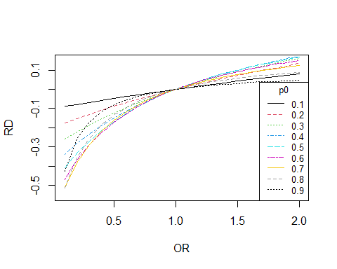

### Option 2

OR = seq(0.1,2,0.1)  
p0.list = seq(0.1,.9,0.1)  
plot(OR,seq(-0.55,0.15,length=20), type = "n", xlab = "OR", ylab = "RD")  
for (i in p0.list){  
 RD = OR2RD(OR = OR, p0 = i)  
 lines(OR,RD, col = i*10, lty = i*10)  
}  
legend("bottomright", legend=p0.list, title="p0",  
 col=p0.list*10, lty=p0.list*10, cex=0.8)



## OR to RR

### Option 1

OR = seq(0.1,2,0.1)  
p0.list = seq(0.1,.9,0.1)  
plot(OR,seq(0,2,length=20), type = "n", xlab = "OR", ylab = "RR")  
for (i in p0.list){  
 p0 = i  
 p1 = OR * (p0/(1 - p0))/(1 + OR * (p0/(1 - p0)))  
 RR = p1/p0  
 lines(OR,RR, col = i*10, lty = i*10)  
}  
legend("bottomright", legend=p0.list, title="p0",  
 col=p0.list*10, lty=p0.list*10, cex=0.8)

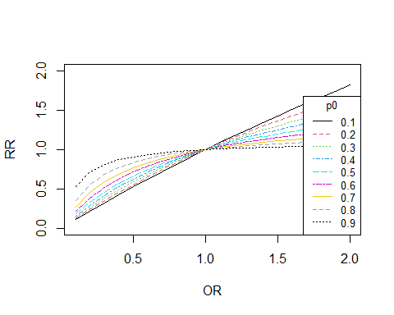

### Option 2

OR = seq(0.1,2,0.1)  
p0.list = seq(0.1,.9,0.1)  
plot(OR,seq(0,2,length=20), type = "n", xlab = "OR", ylab = "RR")  
for (i in p0.list){  
 RR = OR2RR(OR = OR, p0 = i)  
 lines(OR,RR, col = i*10, lty = i*10)  
}  
legend("bottomright", legend=p0.list, title="p0",  
 col=p0.list*10, lty=p0.list*10, cex=0.8)



### Option 3

OR = seq(0.1,2,0.1)  
p0.list = seq(0.1,.9,0.1)  
plot(OR,seq(0,2,length=20), type = "n", xlab = "OR", ylab = "RR")  
for (i in p0.list){  
 RR = OR2RRx(OR = OR, p0 = i)  
 lines(OR,RR, col = i*10, lty = i*10)  
}  
legend("bottomright", legend=p0.list, title="p0",  
 col=p0.list*10, lty=p0.list*10, cex=0.8)



# Working with a data

## Titanic data

### OR

url <- "http://biostat.mc.vanderbilt.edu/wiki/pub/Main/DataSets/titanic.txt"  
titanic <- read.csv(file = url, stringsAsFactors = FALSE)  
titanic$age[is.na(titanic$age)] <- median(titanic$age, na.rm = TRUE)   
fit.OR <- glm(survived ~ sex,  
 family = binomial("logit"), data = titanic)  
est.OR = exp(coef(fit.OR))  
est.OR

## (Intercept) sexmale   
## 1.9679487 0.1019158

require(epiDisplay)  
logistic.display(fit.OR)

##   
## Logistic regression predicting survived   
##   
## OR(95%CI) P(Wald's test) P(LR-test)  
## sex (cont. var.) 0.1 (0.08,0.13) < 0.001 < 0.001   
##   
## Log-likelihood = -679.3609  
## No. of observations = 1313  
## AIC value = 1362.7217

### RD

* The outcome variable is survived
* sex variable is considered as the exposure variable: Female categoty is the reference category, and hence considered here as the background population to calculate $p0$.
* Stating values were identified by grid search (e.g., using for loop within plausible values)

tablex <- table(titanic$sex,titanic$survived)  
tablex

##   
## 0 1  
## female 156 307  
## male 708 142

survival.rate = tablex[,"1"]/sum(tablex[,"1"])  
survival.rate

## female male   
## 0.6837416 0.3162584

p0 <- survival.rate[1]  
p0

## female   
## 0.6837416

OR2RD(OR=est.OR[2],p0=p0)

## female   
## -0.5031861

fit.RD <- glm(survived ~ sex, start = c(.1,-.01),  
 family = binomial("identity"), data = titanic)  
fit.RD

##   
## Call: glm(formula = survived ~ sex, family = binomial("identity"),   
## data = titanic, start = c(0.1, -0.01))  
##   
## Coefficients:  
## (Intercept) sexmale   
## 0.6631 -0.4960   
##   
## Degrees of Freedom: 1312 Total (i.e. Null); 1311 Residual  
## Null Deviance: 1687   
## Residual Deviance: 1359 AIC: 1363

### RR

OR2RR(OR=est.OR[2],p0=p0)

## female   
## 0.2640699

OR2RRx(OR=est.OR[2],p0=p0)

## sexmale   
## 0.2640699

OR2RRy(OR=est.OR[2],p0=p0)

## sexmale   
## 0.2640699

require(sjstats)  
or_to_rr(or=est.OR, p0=p0)

## (Intercept) sexmale   
## 1.1842080 0.2640699

* Stating values were identified by grid search (e.g., using for loop within plausible values)

fit.RR <- glm(survived ~ sex, start=c(-1,.5),  
 family = binomial("log"), data = titanic)  
fit.RR

##   
## Call: glm(formula = survived ~ sex, family = binomial("log"), data = titanic,   
## start = c(-1, 0.5))  
##   
## Coefficients:  
## (Intercept) sexmale   
## -0.4109 -1.3785   
##   
## Degrees of Freedom: 1312 Total (i.e. Null); 1311 Residual  
## Null Deviance: 1687   
## Residual Deviance: 1359 AIC: 1363

exp(coef(fit.RR))

## (Intercept) sexmale   
## 0.6630670 0.2519486

# References

1. [Popham, F. (2016). Converting between marginal effect measures from binomial models. International journal of epidemiology, 45(2), 590-591.](https://academic.oup.com/ije/article/45/2/590/2572549)
2. [StatsToDo : Odd and Risk Interconversion Explained](https://www.statstodo.com/OddRiskConversion_Exp.php)
3. [Get relative risks estimates from logistic regressions or odds ratio values](https://strengejacke.github.io/sjstats/reference/odds_to_rr.html)