Task 1

In first Search the Landing Page was displayed first and all results were loaded including the left panel. But in second and all subsequent searches only the results are loaded. And in the left panel only some vales got updated.

Example

Searching directly from Landing Page whole “<main….” section/tag is loaded which includes both “<aside..” tag and “<div class=”main” > ...</div>” among others. Once this DOM structure is loaded a second search does not reload all these elements again. Only values in “<aside...” are updated for example the text 104 was replaced with 60 in “<span class="js_slider_label_min">60</span>”. Similarly List items in “<ol …... id="js_itemlist" …...” are updated with list of hotels in Hilden.

Task 3

A Random search for Hotels in a small town in Pakistan named “Rahim Yar Khan” the Auto Complete in the search input showed there are 2 hotels in Raahim Yar Khan

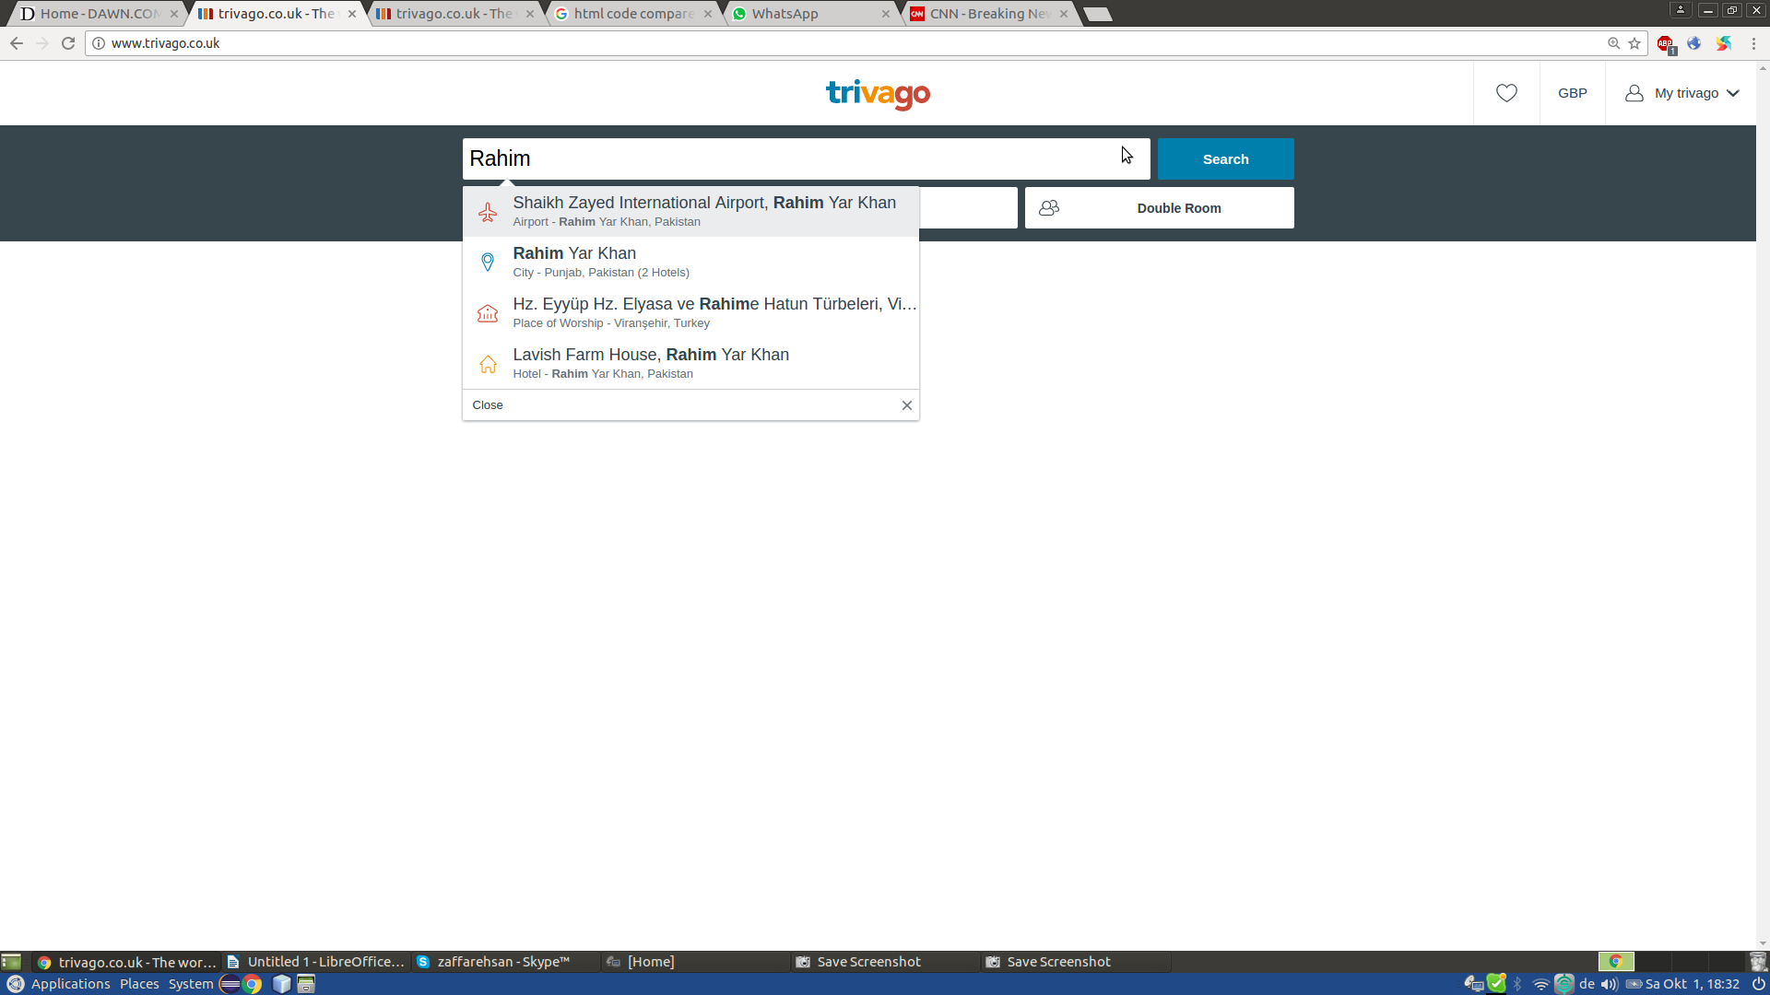

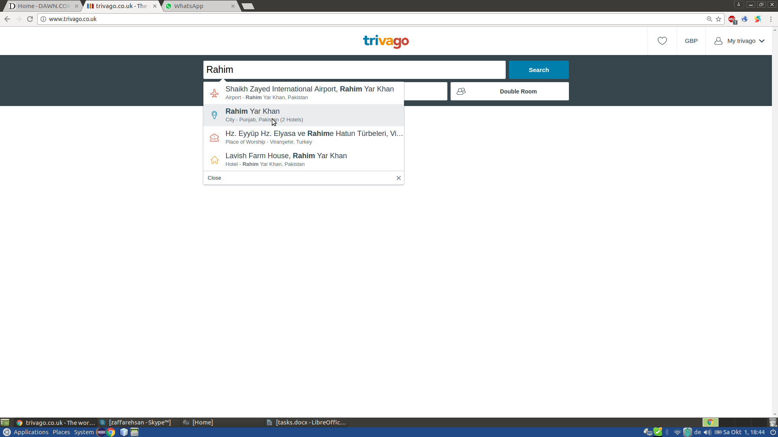

But the search results showed none

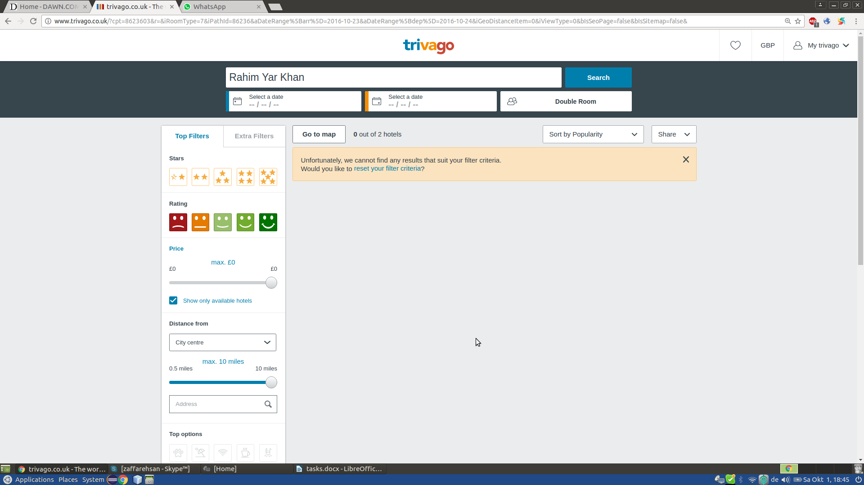

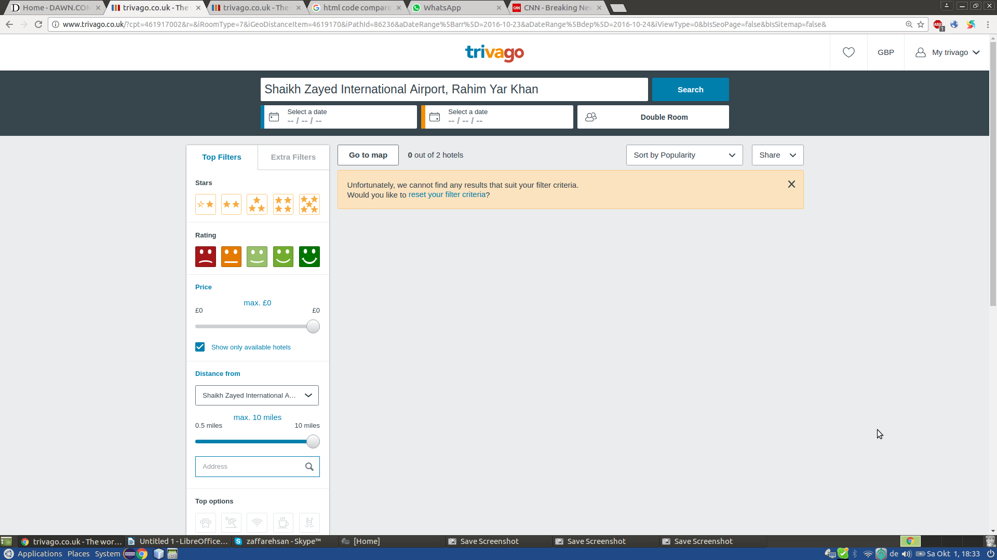

This bug can be noticed with few other cities as well.. e..g. “Mandera” in Kenya.