HOSPITAL INFORMATION SYSTEM

MyInventory Module
Comprehensive A-Z User Manual & Reference Guide
Version: 4.0 (Real Data Edition)
Generated on: 20/08/2026

1. Introduction & Full Module Scope
The MyInventory module covers all aspects of drug and non-drug inventory. It contains 12 dedicated pages for specific functions:
1. Inventory Overview Dashboard
2. Drug Inventory (Pharmacy Catalog)
3. Non-Drug Inventory (Consumables)
4. Facility Drug Inventory (Hospital Level)
5. Facility Non-Drug Inventory (Hospital Level)
6. APPL Inventory (Govt Approved Products)
7. Store Location Management
8. Stock Movement Scanner (FEFO Scanning)
9. Kew.PS-4 Digital Ledger
10. Inventory Reports & Exports
11. Near Expiry Tracker
12. Slow Moving Items

2. Inventory Overview Page
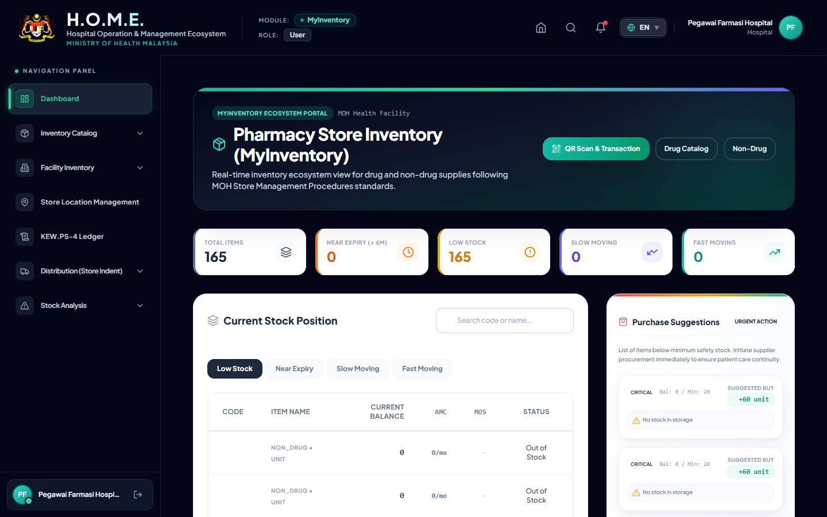
Functions: Top-level management dashboard tracking AMC (Average Monthly Consumption) and MOS (Months of Stock).
Buttons & Action: Filter tabs for Low Stock, Near Expiry, Slow Moving, and Fast Moving. Search bar filters by Code.

3. Drug & Non-Drug Inventory Pages
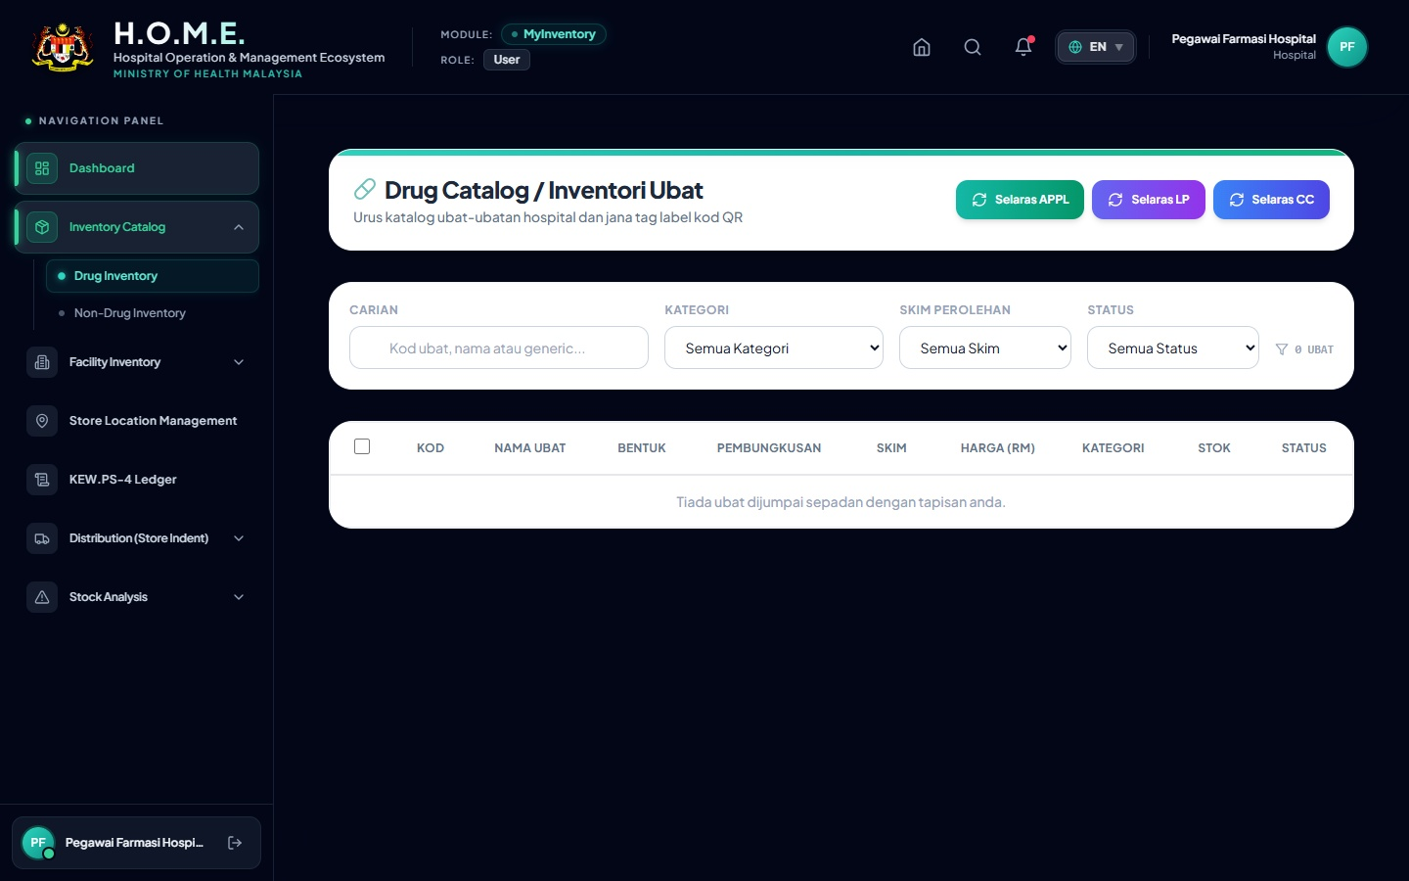
Functions: Maintain the master list of all drugs and non-drugs. View exact active batch records.
Buttons & Action: '+ Add New Item', 'Edit (Pencil)'. Toggle Status between Active/Discontinued.

4. Store Location Management
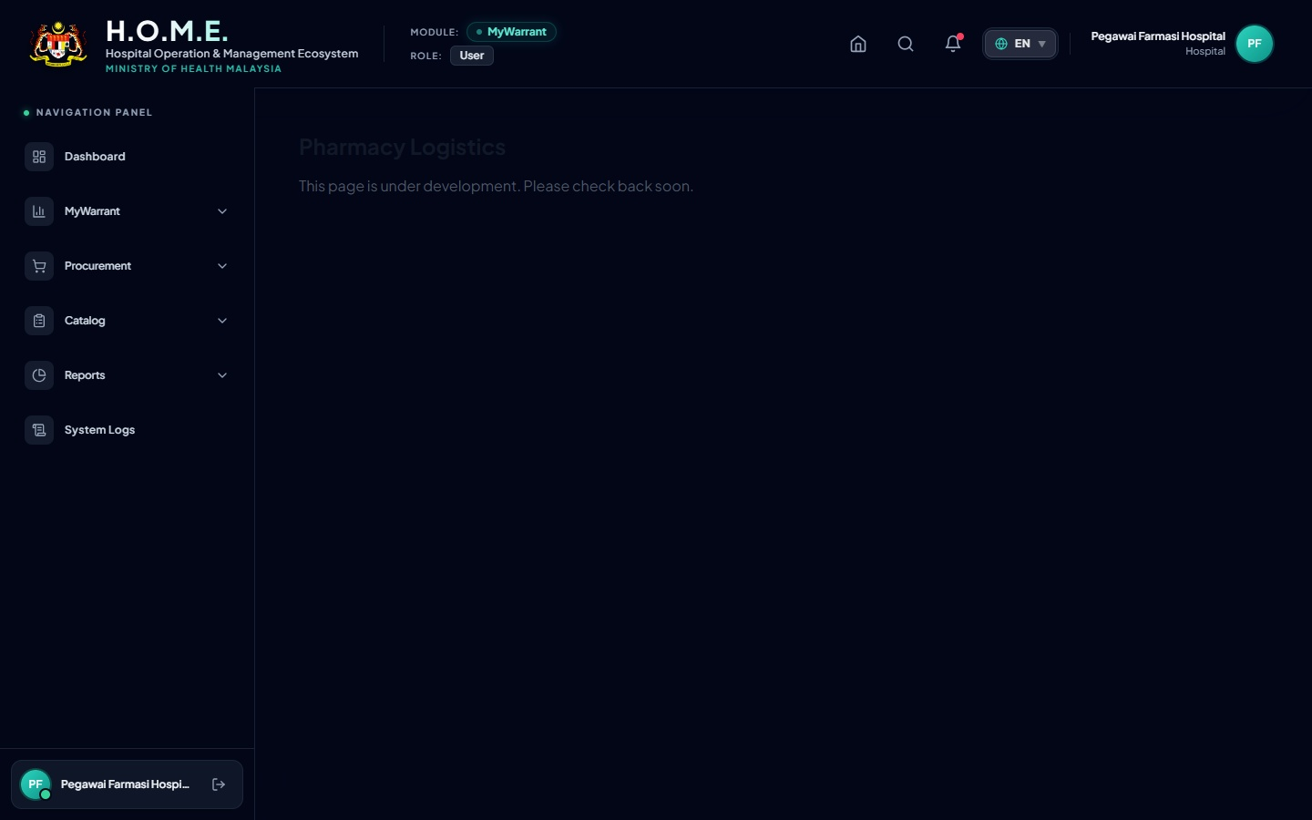
Functions: Map out the physical store (Cabinet > Rack > Bin). Used to assign specific items to specific physical areas.
Buttons & Action: '+ Add Location', 'Print Labels' to generate physical rack barcodes.

5. Real Data Example: Amlodipine 5mg Tracking
To ensure absolute clarity, below is the real data flow for Amlodipine 5mg exactly as recorded in the system database.
 | Amlodipine 5 mg Tablet  System ID: 2d59513c-5e9f-4dd1-97de-90ca70f78f35  Item Code: D02.0011.01 | Vote: APPL  Batch: 5038170 | Expiry: 2028-09-30  Location: Decanting (DC)

6. Kew.PS-4 Digital Ledger & Printed Report
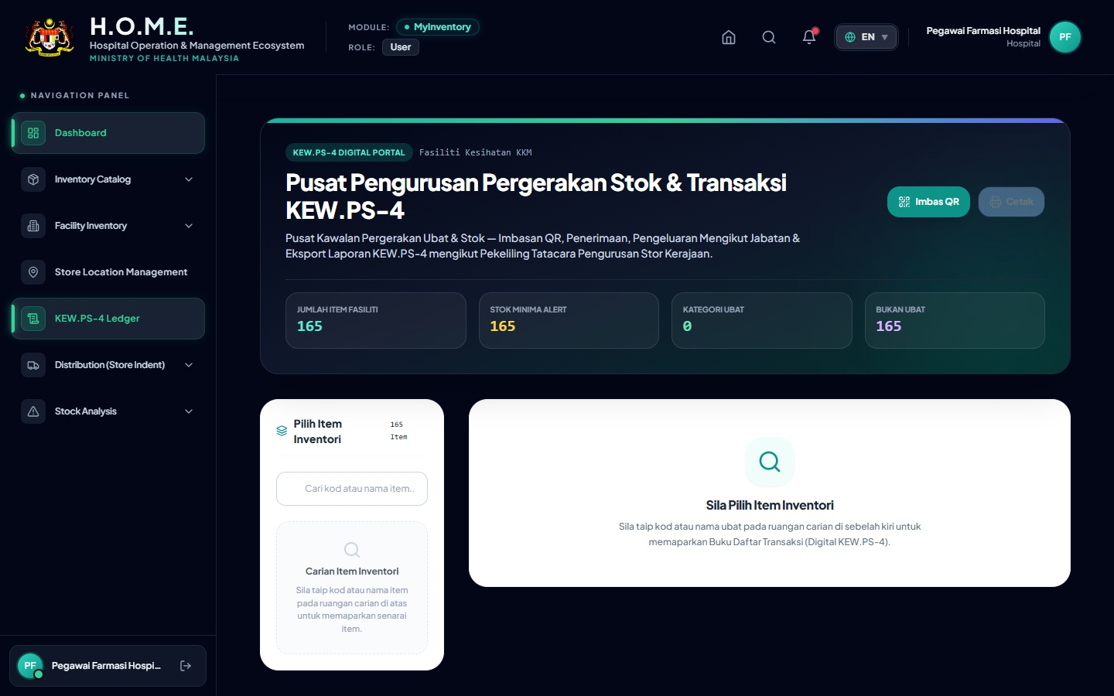
Functions: Replaces the physical government Kad Petak (Bin Card). It automatically tracks all movements.
Buttons & Action: 'Print KEW.PS-4' button generates the official A4 PDF for auditing. Below is the exact printed output using the real database transactions for Amlodipine 5mg (Batch 5038170):
KEW.PS-4 : KAD PETAK (BIN CARD)
Item: Amlodipine 5 mg Tablet |  |  | Code: D02.0011.01
Date | Ref No / Notes | Receipt (+) | Issue (-) | Balance | Officer
2026-01-29 | TXN-1785824211724-8791  (Daripada: PHARMANIAGA) | 10 | - | 10 | System Admin
2026-03-31 | ISS-DEPT-606261-412  (Agihan ke: Pharmacy Sub Store) | - | 10 | 0 | System Admin

7. Stock Movement Scanner (Receiving & Issuing)
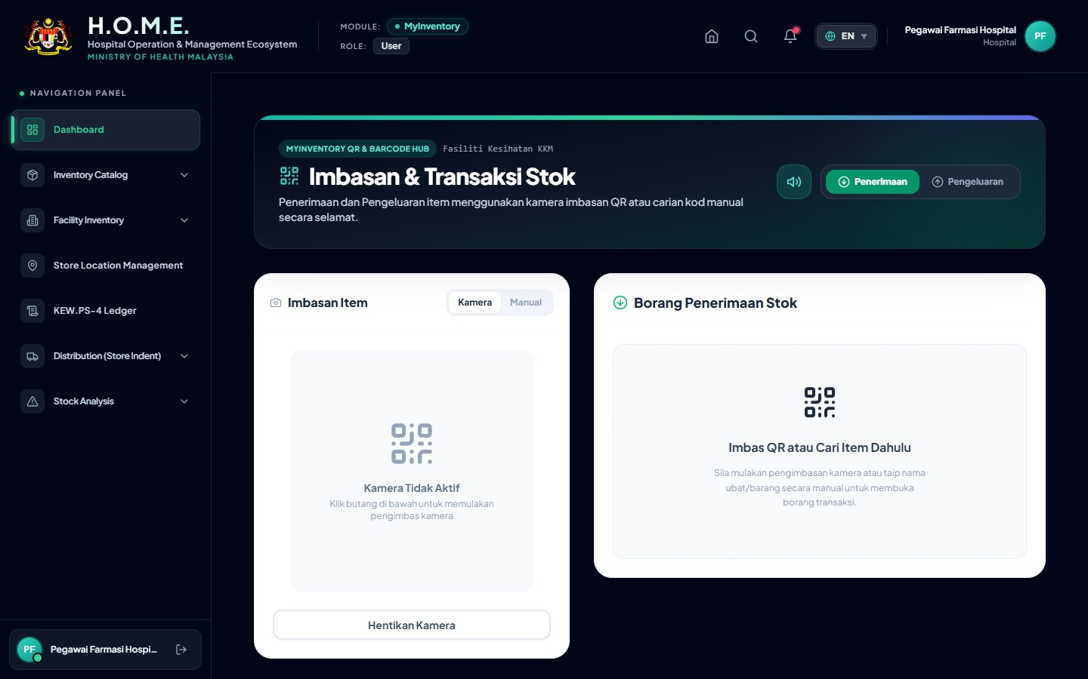
Functions: Web-based QR/Barcode scanner. Automatically enforces FEFO (First Expiry First Out) when issuing.
Buttons & Action: 'Penerimaan' (Receipt), 'Pengeluaran' (Issue). 'Camera Icon' to toggle Webcam. 'Speaker Icon' to toggle beep sounds.

8. Near Expiry & Slow Moving Items
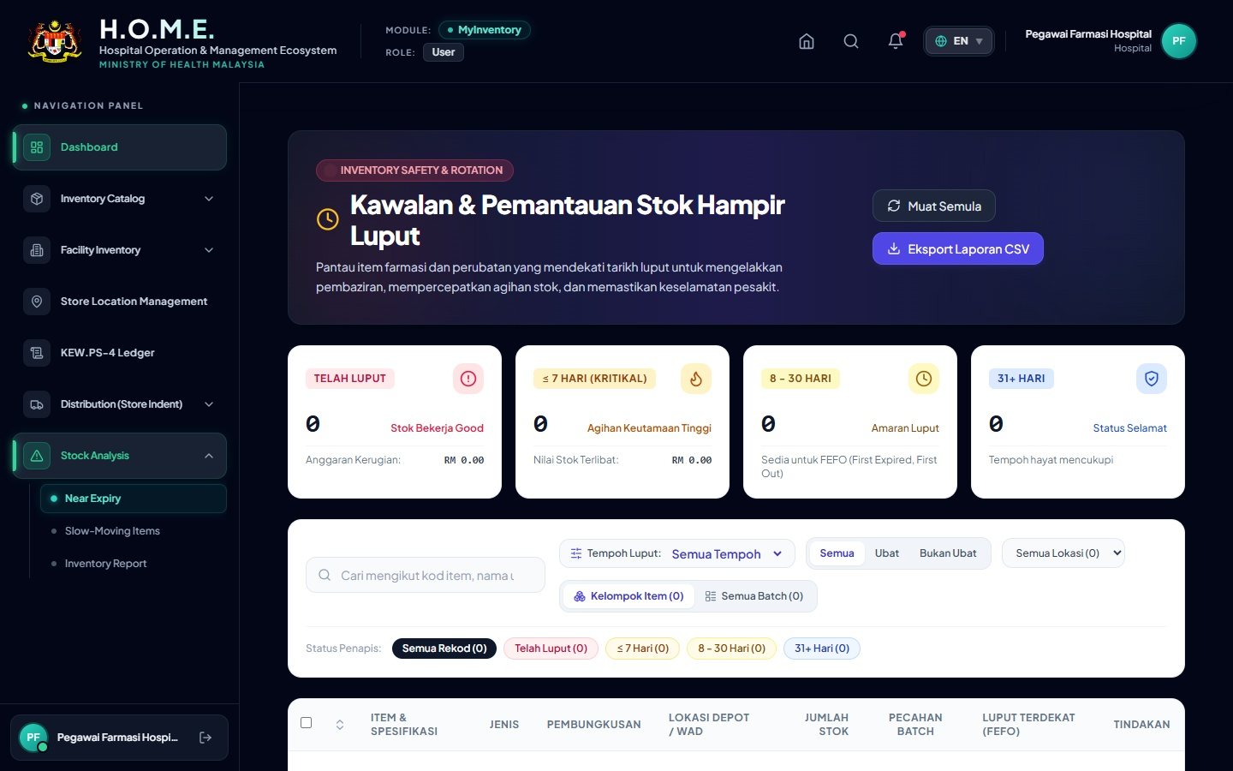
Functions: Near Expiry page filters batches expiring in < 30, 90, or 180 days. Slow Moving page identifies dead stock.
Buttons & Action: 'Threshold Dropdown' to select days. 'Quarantine Button' to lock expired stock.

9. Inventory Report Page & APPL Inventory
Functions: Full stock valuation reports and dedicated APPL (Approved Product Purchase List) item tracking.
Buttons & Action: 'Export to Excel' to download CSV for analysis. 'Export to PDF' for signed management summaries.

