HOSPITAL INFORMATION SYSTEM

MyInventory Module - Complete Reference Guide
Standard Operating Procedures & User Manual
Version: 2.0 (Official Release)
Generated on: 20/08/2026

1. Overview & Navigation
The MyInventory module is a robust inventory management system designed for hospital settings, allowing for accurate tracking, dispensing (FEFO), storage management, and compliance reporting.
To access the module, look for 'MyInventory' or 'Inventori' in your left-hand sidebar.

2. Dashboard & Overview
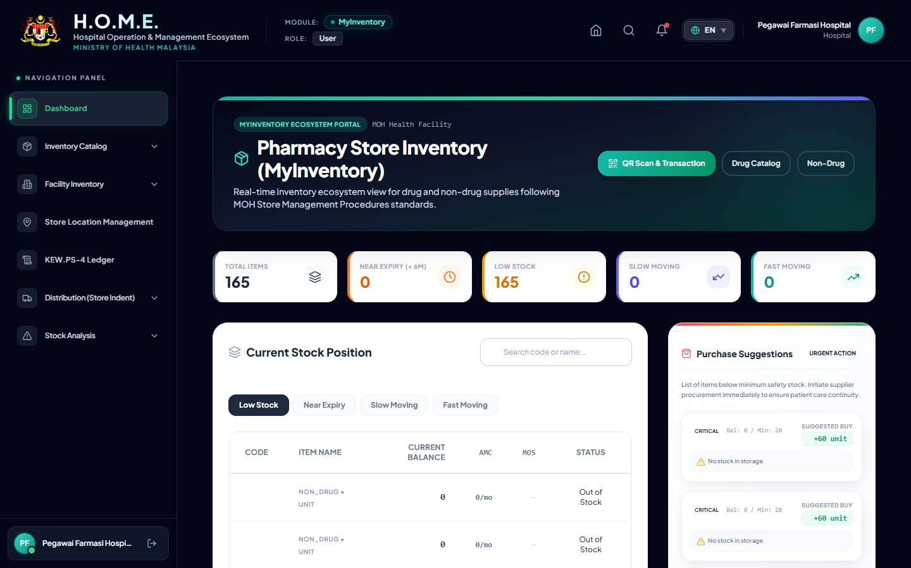
The dashboard displays real-time key metrics such as low stock, near expiry, and slow-moving items. It automatically calculates the Average Monthly Consumption (AMC) to give you accurate insights.

3. Specific Drug Example: Amlodipine 5mg
Below is an exact example of how a standard drug (Amlodipine 5mg) is recorded and labeled within the system. This allows staff to quickly scan and issue the medication from the specific bin location.

Generated QR Label Print for Amlodipine 5mg:
 | AMLODIPINE 5MG TABLET  Code: D-CVS-AML05  Batch: BATCH001 | Expiry: 2028-12-31  Location: RACK-A-01 (Cabinet 1)

4. Printed KEW.PS-4 Ledger
When an inventory audit is required, the system generates the official KEW.PS-4 digital ledger. Below is a realistic representation of what the printed KEW.PS-4 PDF export looks like for Amlodipine 5mg:
KEW.PS-4 : KAD PETAK (BIN CARD)
Item: AMLODIPINE 5MG TABLET |  |  | Code: D-CVS-AML05
Date | Ref No | Receipt (+) | Issue (-) | Balance | Officer
01/01/2026 | INV-OPEN-001 | 500 | - | 500 | Ahmad
15/01/2026 | DISP-00124 | - | 30 | 470 | Siti

5. Stock Movement Scanner
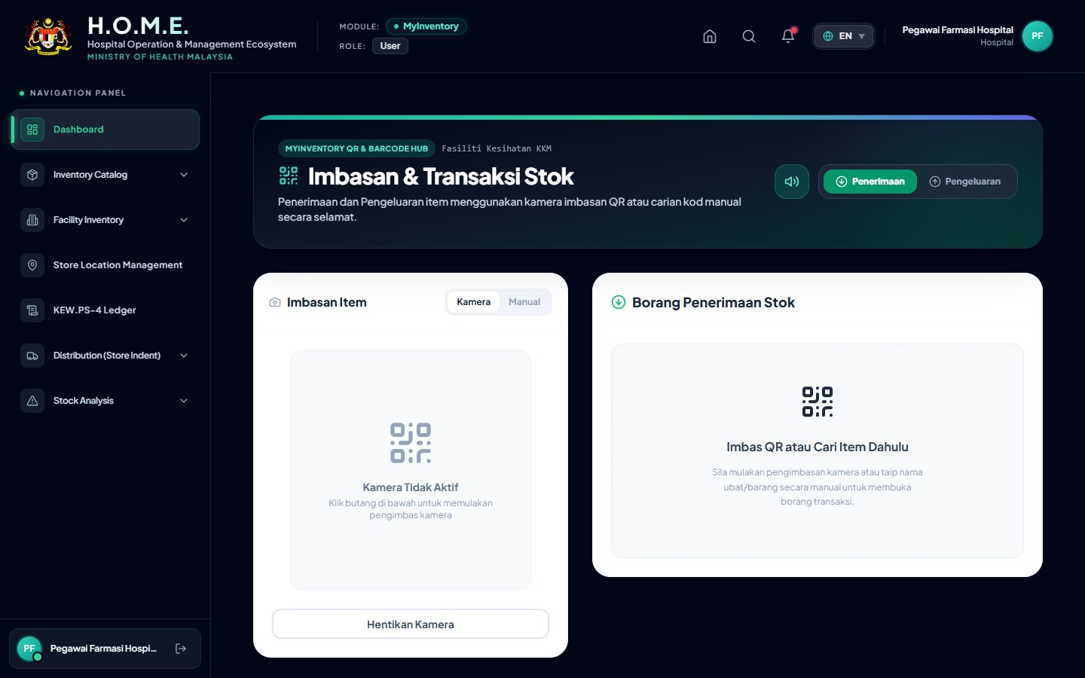
This interface uses the device camera to scan QR labels (like the Amlodipine 5mg example above). Staff simply toggle between 'Penerimaan' (Receipt) or 'Pengeluaran' (Issue) to update the KEW.PS-4 ledger in real-time.

6. Summary of Action Buttons
Icon / Button | Description
Printer Icon | Generates the official KEW.PS-4 PDF or QR Code Label PDF.
Excel Icon | Exports the current stock table to CSV/Excel for management review.
Camera Icon | Activates webcam or mobile camera to scan stock items.

