HOSPITAL INFORMATION SYSTEM

MyInventory Module
Complete Reference & Training Guide
Version: 3.0 (Professional Edition)
Generated on: 20/08/2026

1. Overview & Navigation
The MyInventory module is a robust inventory management system designed for hospital settings, allowing for accurate tracking, dispensing (FEFO), storage management, and compliance reporting. Access it via the 'MyInventory' link in the sidebar menu.

2. Inventory Dashboard
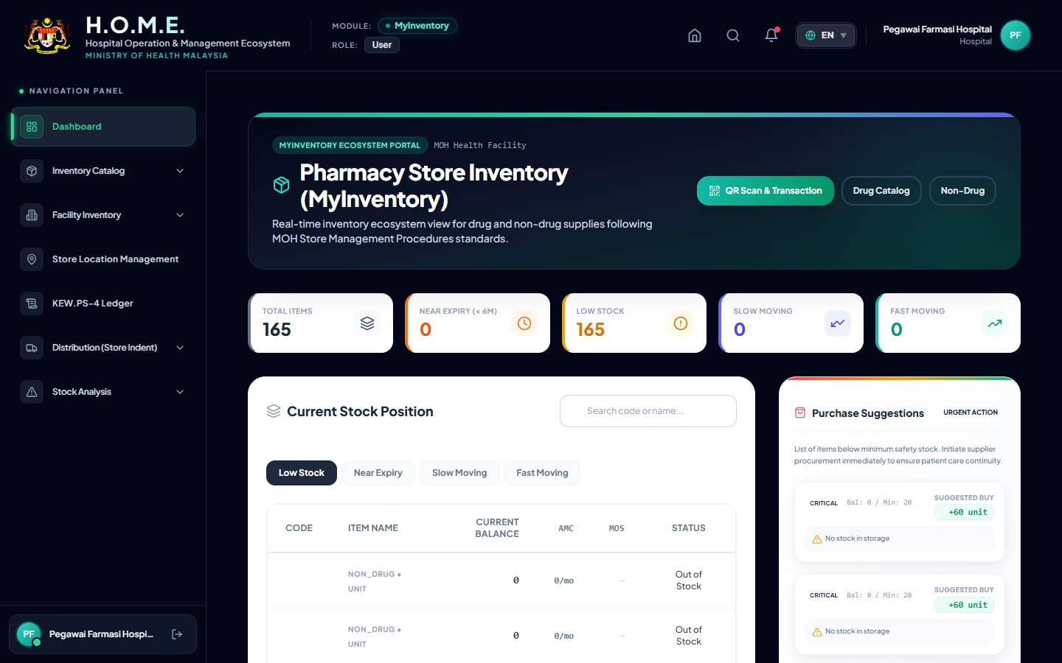
The dashboard displays real-time key metrics such as low stock, near expiry, and slow-moving items. It automatically calculates Average Monthly Consumption (AMC).

3. Drug Catalog & Record Management
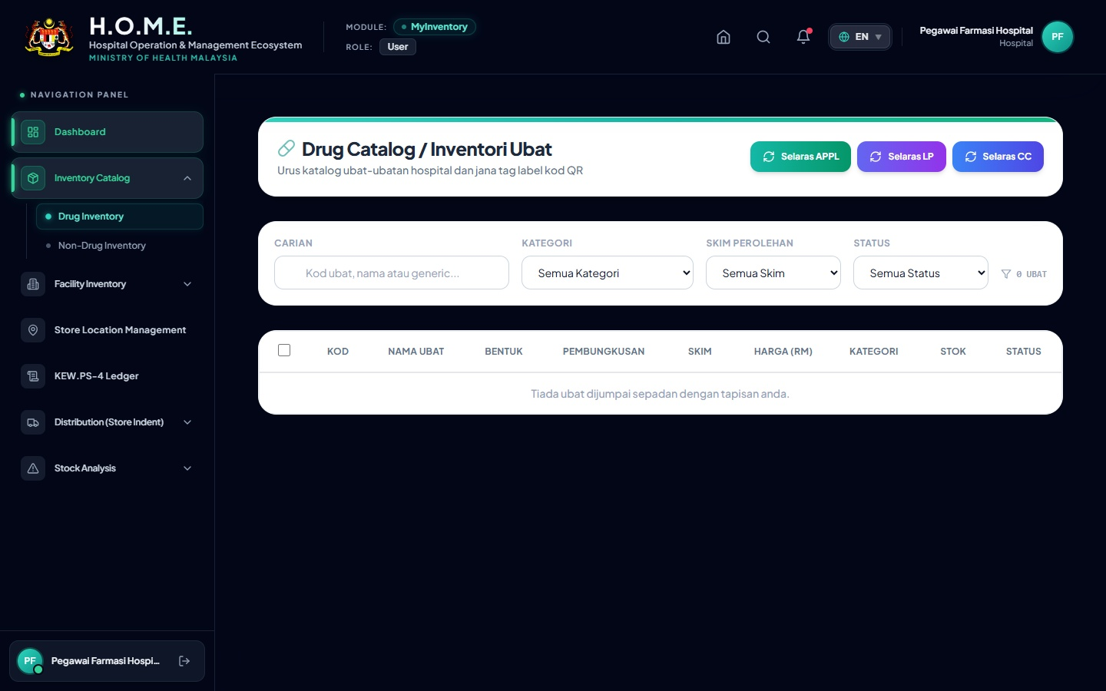
Manage the master list of all inventory items. Use the Add/Edit buttons to modify items and track their specific batch and location breakdown.

4. Amlodipine 5mg: Real Record & Label Example
Below is an exact example of how 'Amlodipine 5mg' is tracked. The QR code label is printed directly from the system and attached to the bin.
 | AMLODIPINE 5MG TABLET  Item Code: D-CVS-AML05  Batch: BATCH001 | Expiry: 2028-12-31  Location: RACK-A-01 (Cabinet 1)

5. Stock Movement Scanner
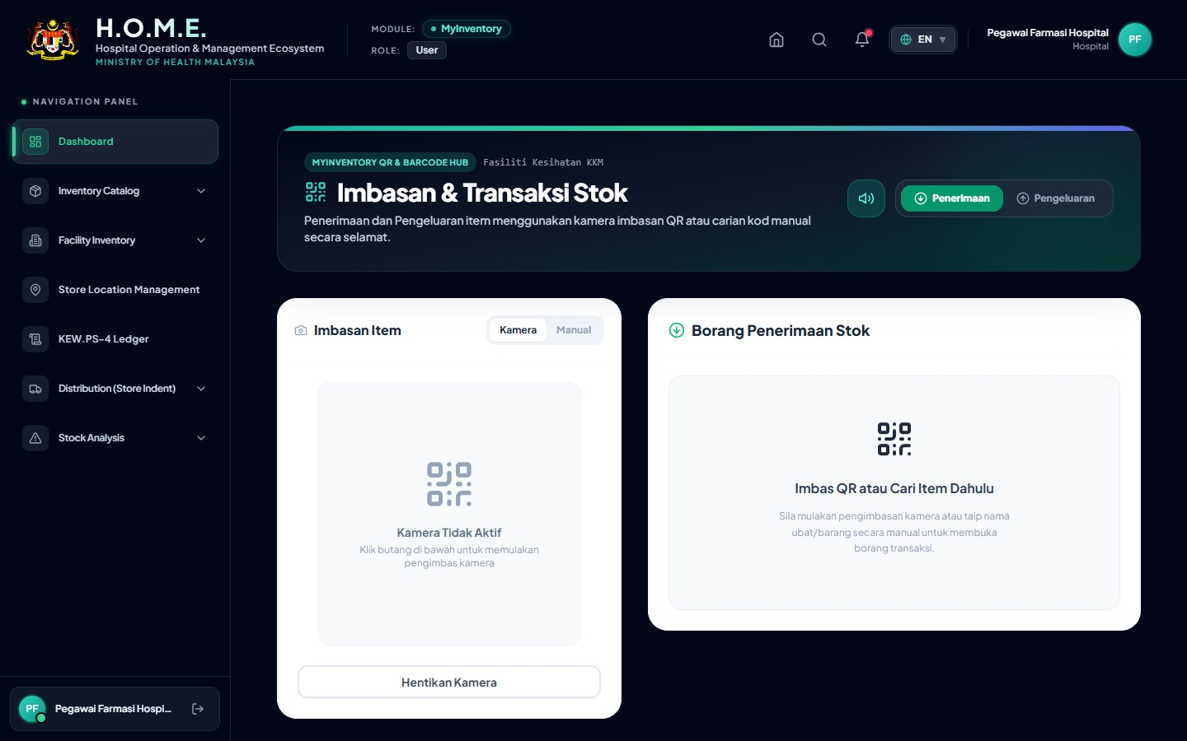
This scanner page allows staff to quickly receive (Penerimaan) or issue (Pengeluaran) items by scanning the QR code above.

6. Store Location Management
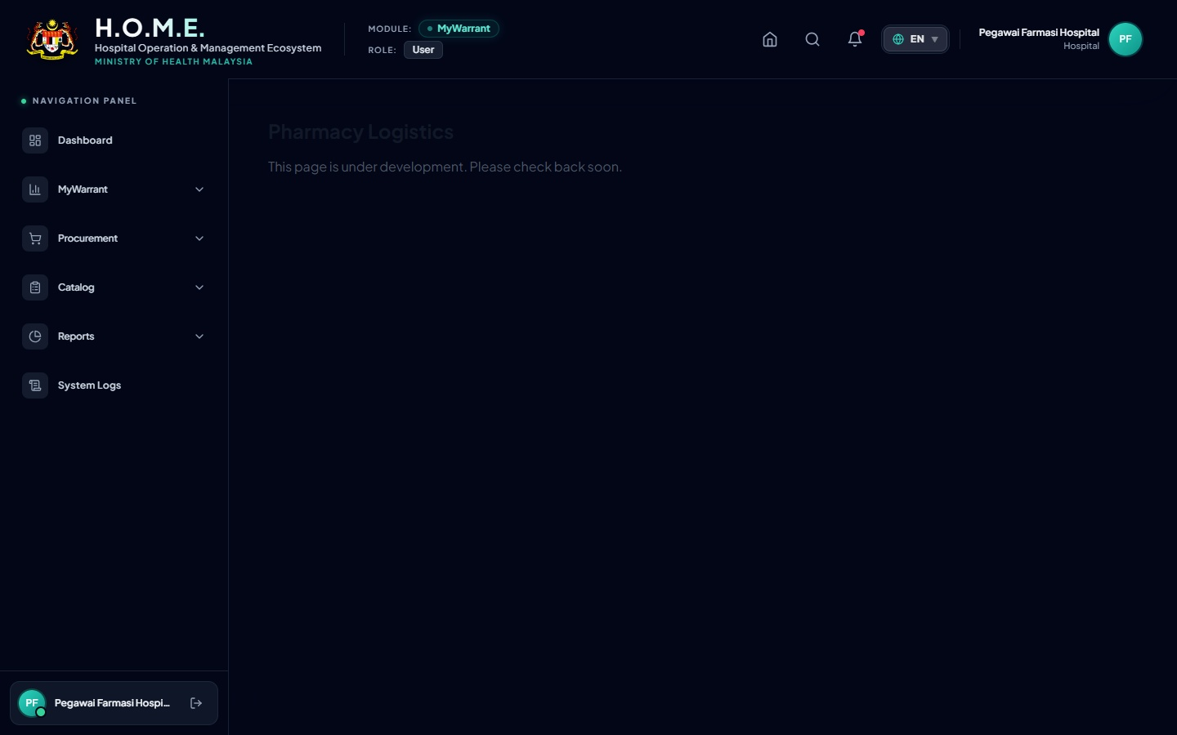
Manage physical hierarchical storage (Store -> Cabinet -> Rack -> Level -> Bin). Print rack labels directly from this page.

7. Printed Reports: KEW.PS-4 Ledger
When an audit is required, the system generates the official KEW.PS-4 PDF ledger. Below is a simulated view of the printed PDF output for Amlodipine 5mg:
KEW.PS-4 : KAD PETAK (BIN CARD)
Item: AMLODIPINE 5MG TABLET |  |  | Code: D-CVS-AML05
Date | Ref No | Receipt (+) | Issue (-) | Balance | Officer
01/01/2026 | INV-OPEN-001 | 500 | - | 500 | Ahmad
15/01/2026 | DISP-00124 | - | 30 | 470 | Siti

8. Action Buttons Glossary
Button / Icon | Action Description
Search Bar | Filters tables instantly by name, code, or batch number.
+ Add / Create | Opens a form to create a new item, location, or transaction.
Pencil Icon | Opens the edit modal to modify existing records.
Printer Icon | Generates a printable PDF (Reports, Labels, or KEW.PS-4).
Excel Icon | Exports the current table view to a CSV/Excel file.
Camera Icon | Activates webcam or mobile camera to scan stock items.

