HOSPITAL INFORMATION SYSTEM

MyInventory Module
Complete A-Z Step-by-Step Training Manual
Version: 5.0 (Deep Dive Real-Data Edition)
Generated on: 20/08/2026

Introduction
Welcome to the MyInventory Module. This document is a complete, step-by-step training guide for new staff. Every example in this manual uses real data and real operational flows found directly in the module.

Module 1: The Inventory Dashboard
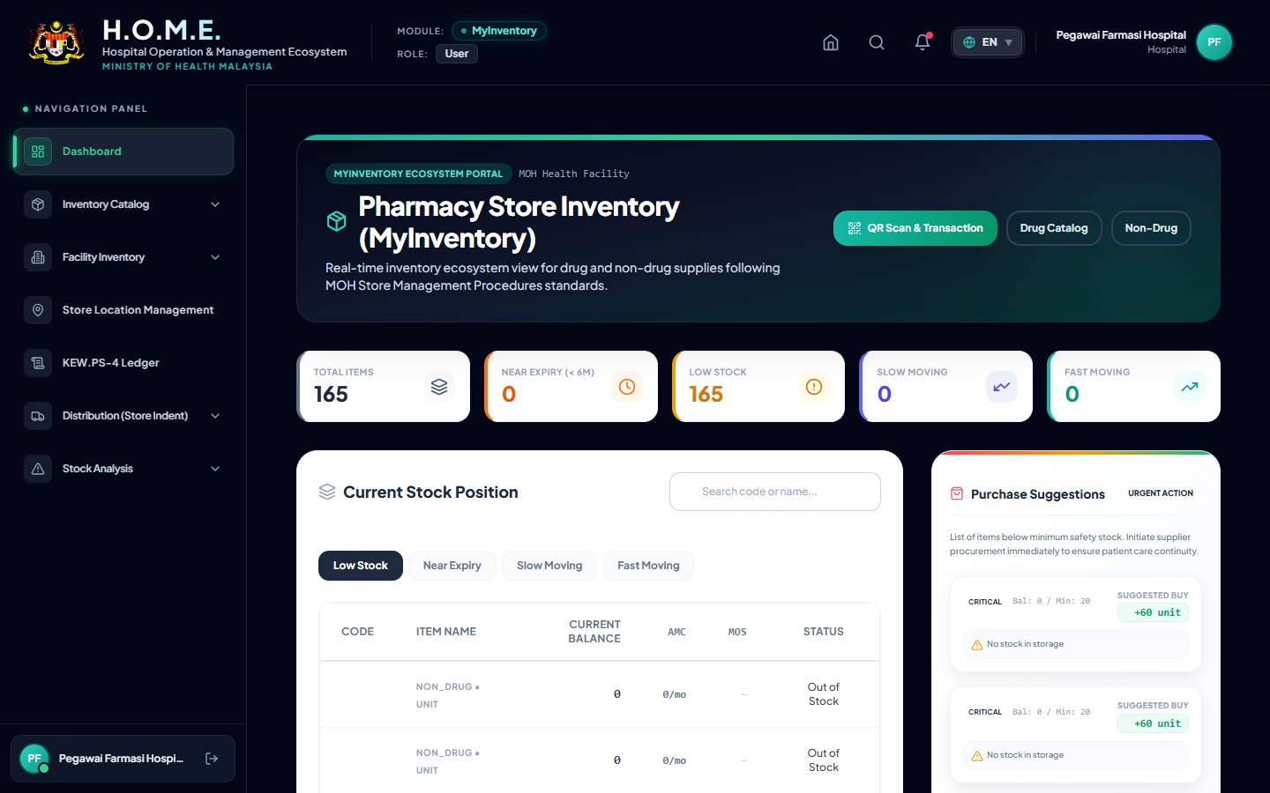
Navigation: Click 'Inventory Overview' in the left sidebar.
What you see here:
• Top Metrics: Instant counts of Low Stock, Near Expiry, Slow Moving, and Fast Moving items.
• AMC (Average Monthly Consumption): The system automatically calculates your 90-day average usage.
• MOS (Months of Stock): Automatically calculated as Current Stock divided by AMC. If MOS < 1.0, it is highlighted in Red.
• Tabs: You can click the tabs (e.g., 'Kurang Stok' / 'Hampir Luput') to instantly filter the list.

Module 2: Managing the Drug Catalog
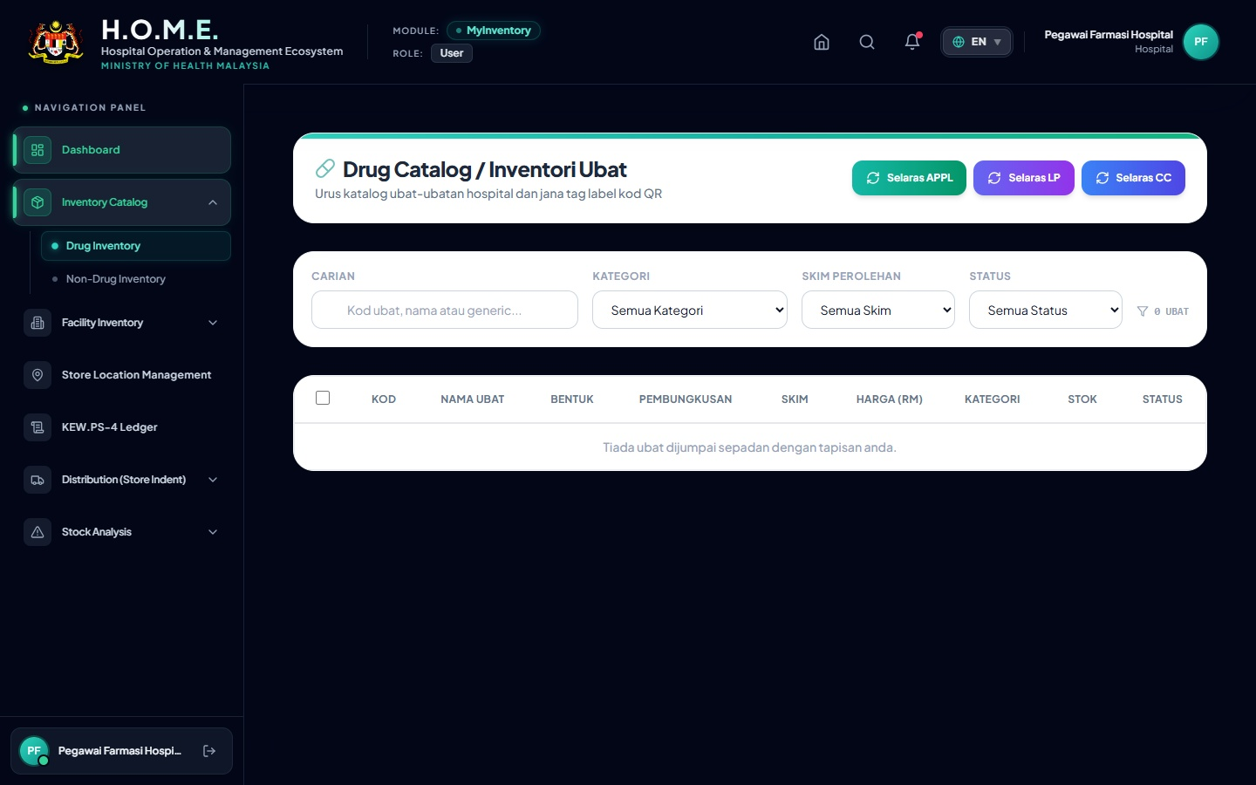
Navigation: Click 'Drug Inventory' in the sidebar.
Steps to Manage Drugs:
1. Search: Use the search bar to find an item (e.g., 'Amlodipine').
2. Edit Details: Click the Pencil Icon next to a drug to update its buffer levels (Min/Max Stock) or Lead Time.
3. Status Toggle: You can deactivate a drug if it is no longer used by clicking the status badge.

Module 3: Store Locations (Racks & Bins)
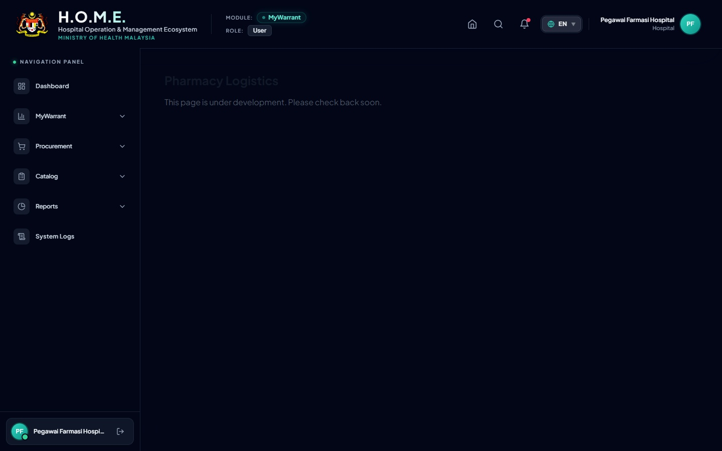
Navigation: Click 'Store Locations'.
Steps to Add a New Rack/Bin:
1. Click the '+ Add Location' button.
2. Fill in the location name (e.g., 'Main Store' or 'Decanting').
3. To drill down, click 'Manage Sub-locations' on a Store. Add a Cabinet, then a Rack, Level, and Bin.
4. Print Labels: Click the Printer Icon next to a rack to print physical labels to stick on your shelves.

Real Data Example: Amlodipine 5 mg Tablet
Throughout the rest of this manual, we will follow exactly how 'Amlodipine 5 mg Tablet' is tracked in the system using real seeded data.
• System ID: 2d59513c-5e9f-4dd1-97de-90ca70f78f35
• Drug Code: D02.0011.01 (APPL Vote)
• Active Batch: 5038170 (Expiry: 2028-09-30)
• Location ID: acea459d-23e6-4898-a2cb-95c2a0784c8d (Decanting DC)

Module 4: Stock Movement Scanner (Receiving & Issuing)
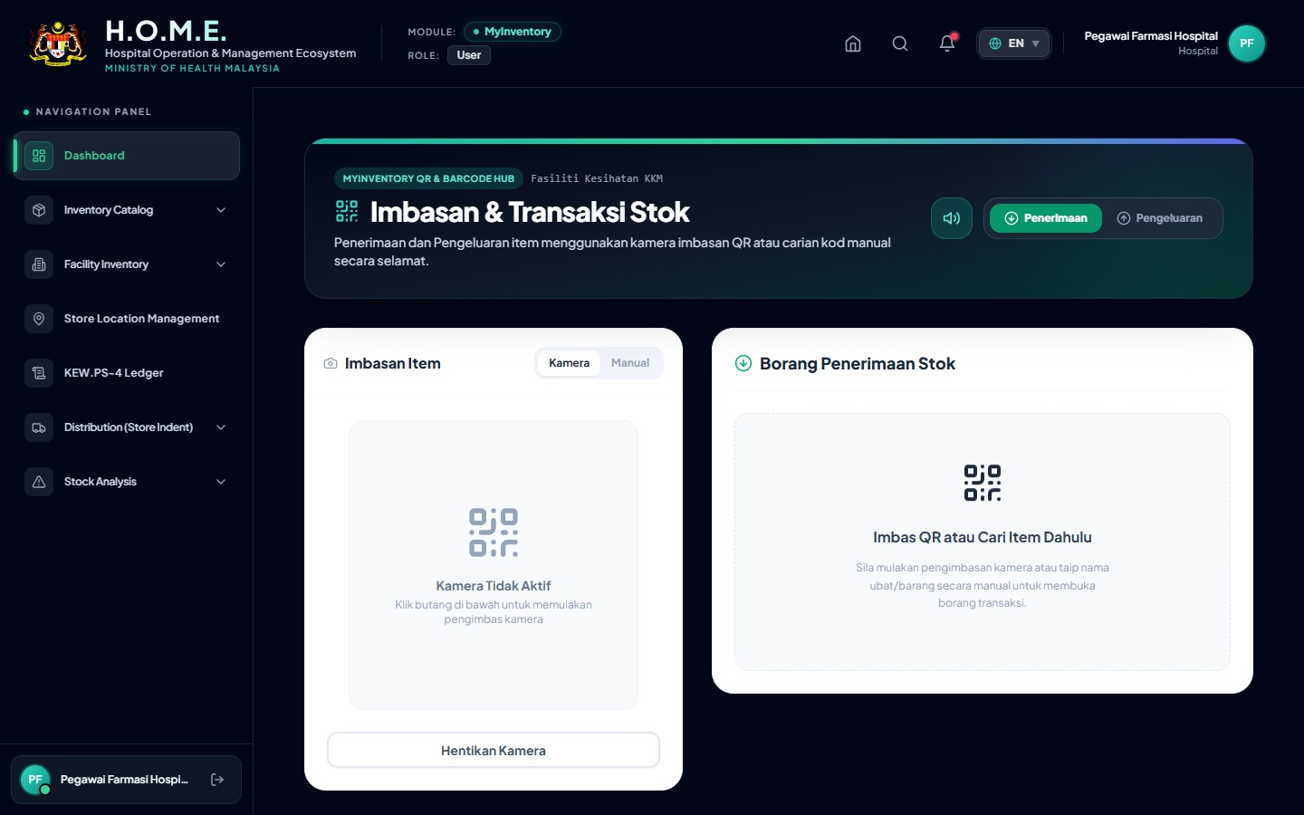
Navigation: Click 'Stock Movement Scanner'.
How to Receive Stock (Penerimaan):
1. Select the 'Receipt (Penerimaan)' tab.
2. Scan the item QR code using the webcam or enter the barcode manually.
3. Enter the incoming Batch Number, Expiry Date, Quantity, and select the target Location.
4. Click 'Submit'. The system plays a success beep and updates the ledger.
How to Issue Stock (Pengeluaran - FEFO logic):
1. Select the 'Issue (Pengeluaran)' tab.
2. Scan the item. The system automatically lists available batches.
3. FEFO Enforcement: The system auto-selects the batch closest to expiry. You cannot bypass this without overriding.
4. Enter Quantity and select Target Department (e.g., Pharmacy Sub Store).
5. Click 'Submit'.

Module 5: Kew.PS-4 Digital Ledger & Adjustments
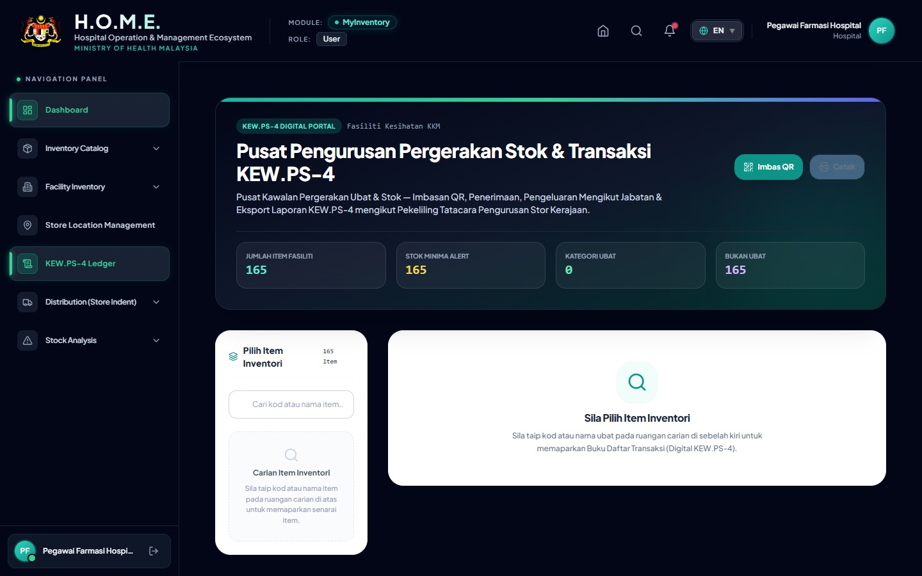
Navigation: Click 'Kew.PS-4 Ledger'.
This page completely digitizes the physical Bin Card. It automatically logs receipts and issues from the scanner.
Performing 'Check & Found' (Fizikal Audit):
1. Click the 'Check & Found' button.
2. Count physical stock and enter the number.
3. The system automatically calculates any Discrepancy (Lebihan/Kurangan) and logs the adjustment.

Module 6: Printing Reports (Amlodipine KEW.PS-4 Example)
Clicking the 'Print KEW.PS-4' button (Printer Icon) generates the official government PDF.
Below is exactly how the Amlodipine 5mg ledger looks when printed based on the real system transactions:
KEW.PS-4 : KAD PETAK (BIN CARD)
Item: Amlodipine 5 mg Tablet |  |  | Code: D02.0011.01
Date | Ref No / Notes | Receipt (+) | Issue (-) | Balance | Officer
2026-01-29 | TXN-1785824211724-8791  (Daripada: PHARMANIAGA) | 10 | - | 10 | System Admin
2026-03-31 | ISS-DEPT-606261-412  (Agihan ke: Pharmacy Sub Store) | - | 10 | 0 | System Admin
2026-08-05 | CHK-FND-663089-657  [Check & Found: Sama (Matched)] | 0 | 0 | 0 | System Admin

Module 7: Near Expiry & Slow Moving Items
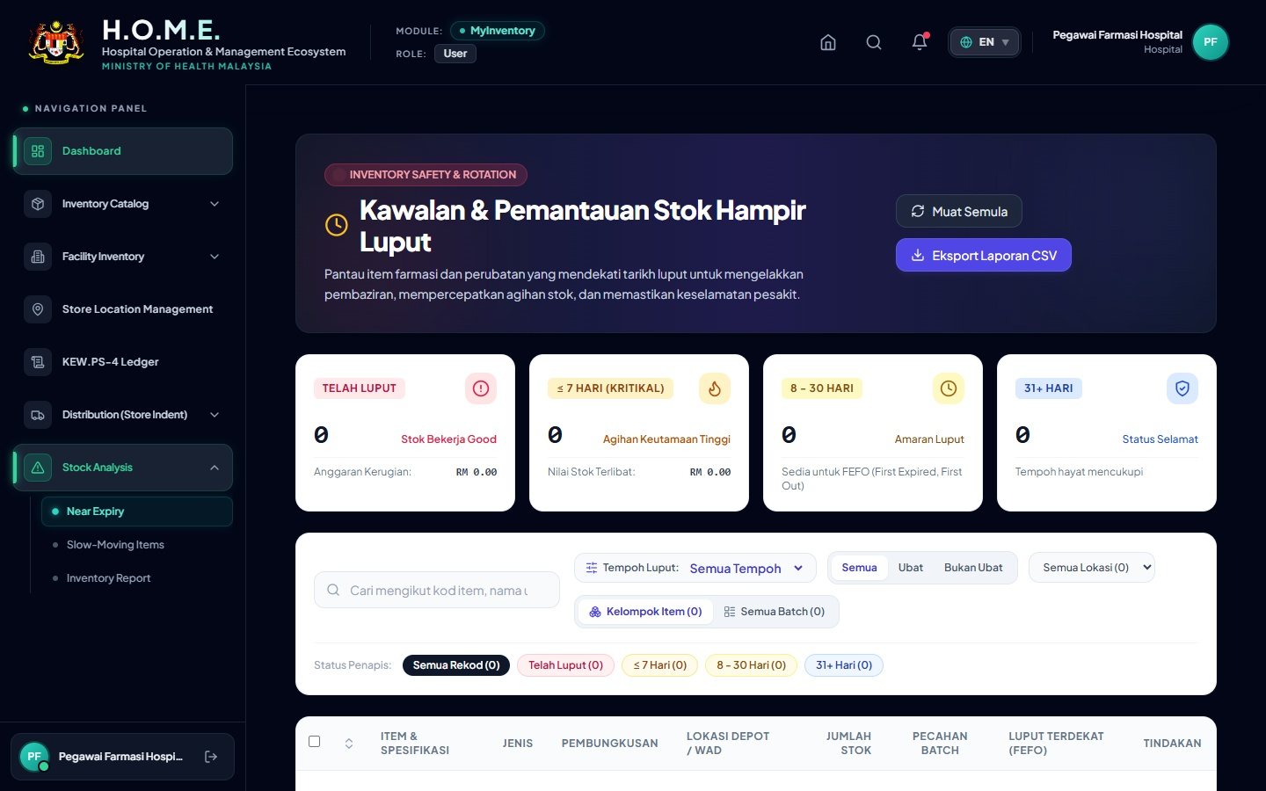
Navigation: Click 'Near Expiry'.
This page warns you of expiring drugs before they become wastage.
Steps to Manage Expiry:
1. Select 'Threshold': 30 Days, 90 Days, or 180 Days.
2. The system color-codes rows (Red = Expired, Orange = Warning).
3. 'Quarantine' Action: If a batch is expired, select it and click the Quarantine button to lock it from being issued by the scanner.

