### WebScrape Wizard

Submitted Towards the Partial Fulfilment of the Requirements for the Award of the Degree of

### Bachelors in Technology by

Nikhil Singh (21124071)

Harsh Chaturvedi (21124039)

Umesh Kumar (21124114)

### Under the Mentorship of

Dr. Mohit Kumar

Assistant Professor, Department of IT



### Department of Information Technology

**Dr B.R Ambedkar National Institute of Technology Jalandhar-144008, Punjab (INDIA)**

18.09.2024

### Undertaking

We declare that the project work presented in this report entitled WebScrape Wizard , submitted to the Department of Information Technology, Dr. B R Ambedkar National Institute of Technology Jalandhar, for the award of the Bachelor of Technology degree in Information Technology, is our original work. We have not plagiarized or submitted the same work for the award of any other degree. In case this undertaking is found incorrect, we accept that our degree may be unconditionally withdrawn.

Nikhil Singh (21124071)

Harsh Chaturvedi (21124039)

Umesh Kumar (21124114)

Department of Information Technology

Dr B R Ambedkar National Institute of Technology Jalandhar Jalandhar, Punjab, India

September, 2024

### Certificate

This is to certify that the project report entitled WebScrape Wizard submitted by Nikhil Singh (21124071), Harsh Chaturvedi (21124039) and Umesh Kumar (21124114), to Dr B R Ambedkar National Institute of Technology Jalandhar, in partial fulfillment for the award of the degree of B. Tech in Information Technology has been carried out under our supervision and that this work has not been submitted elsewhere for a degree.

Dr. Mohit Kumar Assistant Professor

Department of Information Technology,

Dr B R Ambedkar National Institute of Technology Jalandhar Jalandhar, Punjab, India

September, 2024

|  |  |  |
| --- | --- | --- |
|  | **INDEX** |  |
| **Abstract** |  | **i** |
| **1. Introduction** |  | **1** |
| 1.1 Project Definition. |  | 1 |
| 1.2 Objective of the project. |  | 2 |
| **2. Literature Review** |  | **3** |
| 2.1 Approach |  | 3 |
| 2.2 Limitation |  | 5 |
| **3. About Model** |  | **6** |
| 3.1 Assumptions |  | 7 |
| 3.2 Module Divison |  | 7 |
| 3.2.1 User Authentication Module |  | 7 |
| 3.2.2 Data Management Module |  | 8 |
| 3.2.3 Scraping Engine Module |  | 8 |
| 3.2.4 Subscription Manage Module |  | 8 |
| 3.2.5 Community Support Module |  | 9 |
| 3.3 Data Flow Diagram |  | 10 |
| 3.4 Entity Relation Diagram |  | 15 |
| 3.5 Class Diagram |  | 16 |
| 3.6 Use Case Diagram |  | 17 |
| **4. Conclusion** |  | **18** |
| 4.1 Future Scope |  | 18 |
| **5. Reference** |  | **19** |

### List of Figures

|  |  |
| --- | --- |
| Data Flow Diagram Level-0 | 10 |
| Data Flow Diagram Level-1 | 11 |
| Data Flow Diagram Level-2(Data Scrapping Process) | 12 |
| Entity Diagram | 15 |
| Class Diagram | 16 |
| Use Case Diagram | 17 |
|  |  |

**Abstract**

**Project Overview**

Our project, "WebScrape Wizard," represents a pivotal innovation in online data extraction tools designed specifically for users who require swift and accurate data collection from various websites. This tool is not merely a software extension; it is envisioned as a cornerstone for robust, digital data management, revolutionizing how users interact with data on the web.

**Vision and Purpose**

"WebScrape Wizard" is more than just a Chrome extension—it's a comprehensive tool that fosters a vibrant community of users ranging from data scientists to market researchers, all passionate about deriving value from data. Our platform's meticulous design focuses on facilitating a seamless, intuitive, and productive experience, enabling users to extract data efficiently and accurately.

**Features and Functionality**

The extension boasts user-friendly features and a robust configuration system that promotes an effortless initiation into the world of data extraction. It’s designed to be intuitive and accessible, ensuring that every user, regardless of their technical proficiency, can effectively harness its capabilities.

**Innovative Elements**

A distinctive feature of "WebScrape Wizard" is its ability to not only scrape data but also format this data into user-friendly CSV or Excel files, enhancing the data's utility and readiness for analysis. This functionality adds a gamified element to data extraction, engaging users in a fun and productive way. Instructors and analysts can also benefit from this feature as it allows them to organize and analyze data more effectively, thus adding a valuable layer to their data analysis tasks.

**Community and Collaboration**

We are committed to building a vibrant, inclusive community of users who are dedicated to leveraging our tool for a wide array of applications—from academic research to commercial data analysis. Our approach utilizes sophisticated data extraction and processing techniques to harness the power of collective data in an online environment. This promotes not only individual learning and problem-solving but also collective intelligence and collaborative data-driven projects.

**Call to Action**

Join us in embracing "WebScrape Wizard," and be a part of a community where data is not only extracted but transformed into meaningful insights. Every data point extracted is a step forward in the quest for knowledge, and every dataset formatted is a valuable contribution to the wealth of global data intelligence.

i

* 1. **Project Definition**

# Introduction:

"WebScrape Wizard" is an innovative Chrome extension designed to simplify and enhance the process of extracting data from web pages into CSV or Excel formats, catering especially to data analysts and researchers. It boasts a user-friendly interface for efficient data collection, robust export options, secure user authentication via Google OAuth, and dynamic data handling capabilities that allow for custom queries and flexible data management. With rigorous security protocols including encrypted data storage, "WebScrape Wizard" aims to empower users by providing a powerful tool for digital data extraction while ensuring data integrity and security.

* + 1. **Problem Statement:** In today's educational ecosystem, conventional learning methodologies often do not meet the evolving needs for interactive and collaborative educational experiences. Addressing this gap, there's a pressing requirement for a sophisticated online tool tailored for the vibrant academic community of NIT Jalandhar. Existing platforms fail to fully integrate critical functionalities such as interactive Q&A sessions, well-organized content navigation, and access to subject-specific resources, including opportunities to enhance practical skills via coding contests. Security issues, particularly concerning user authentication and access permissions, also pose significant challenges. In response, the development of "WebScrape Wizard" is proposed. This Chrome extension aims to revolutionize data extraction for educational purposes by offering a secure, intuitive, and versatile tool that not only simplifies data collection into manageable formats but also enhances the collaborative and educational endeavors of students and educators alike.

### Motivation

• **Enhance Data Management:** Elevate the efficiency of data extraction and management by providing a robust Chrome extension that streamlines the process of pulling and organizing data from web pages directly into CSV or Excel formats.

• **Foster User Collaboration:** Enable users to share their data extraction templates and results, fostering a community-driven approach to information gathering and knowledge sharing.

• **Embrace Technological Innovation:** Utilize the latest advancements in web scraping technology to offer features that accommodate a wide range of data extraction needs, from simple page data to complex hierarchical structures.

• **Encourage Analytical Skills:** Provide tools and features that enhance users' abilities to analyze and interpret web data, promoting skill development in data analysis and coding.

• **Ensure Data Security:** Implement state-of-the-art security measures to protect user data and ensure the integrity of the data extraction process, maintaining a safe and reliable platform.

• **Promote Active Engagement:** Design the extension to be intuitive and engaging, encouraging users to take an active role in their data collection tasks and thereby enrich their overall experience with digital tools.

• **Empower User Growth:** Deliver a versatile, user-friendly platform that supports continuous learning and improvement, helping users to expand their technical capabilities and adapt to various data-related challenges.

### Objectives of the project

• **Create a Collaborative Data Collection Environment:** Develop an online platform that allows users to share data scraping templates and results, enhancing collaborative data extraction and analysis.

• **Promote Knowledge Sharing:** Enable users to share best practices, tips, and techniques related to data scraping, fostering a community of learning and continuous improvement.

• **Ensure User-Friendly Interface:** Design an intuitive and accessible interface that simplifies the process of web scraping for users of all skill levels.

• **Facilitate Admin Control:** Provide extension administrators with tools to manage user access, monitor data scraping activities, and customize settings to ensure optimal performance and security.

• **Auto-Saving of Data Extraction Sessions:** Implement a feature that automatically saves the progress of data extraction tasks when users switch tabs or navigate away, enhancing the user experience and data integrity.

• **Support Specific User Groups:** Restrict extension use to authenticated users, ensuring a focused and relevant user base, possibly integrating with corporate or academic institutions.

• **Subject-Specific Data Extraction:** Allow users to set up data extraction tasks based on specific subjects or categories, facilitating targeted and efficient data gathering.

• **Enhance Research and Analysis:** Provide tools that support deep analysis and visualization of extracted data, enabling users to gain insights and make informed decisions based on accurate information.

• **Promote Active User Engagement:** Encourage users to actively engage with the extension by contributing to a shared library of scraping scripts and participating in community challenges or competitions.

• **Ensure Robust Security and Authentication:** Implement stringent security measures including encrypted data storage, secure authentication methods, and detailed access logs to protect user data and prevent unauthorized access.

• **Streamline User Onboarding and Training:** Develop comprehensive tutorials and guides to help new users quickly become proficient with the extension, reducing learning curves and fostering self-sufficiency.

• **Encourage Interactive Learning:** Leverage interactive tutorials and real-time feedback mechanisms to help users learn and improve their data scraping skills continuously.

• **Facilitate Professional Development:** Offer advanced features and integrations that allow professional users to enhance their technical skills, automate repetitive tasks, and produce high-quality data outputs.

# Literature Review

For the "WebScrape Wizard" Chrome extension, an extensive review of existing literature was conducted to ensure the development was informed by the latest advancements in data extraction technologies and methodologies. This included scholarly articles, industry whitepapers, and active forums such as Stack Overflow, with a focus on web scraping tools, data management systems, user experience in software tools, and security protocols in web applications. This comprehensive review helped shape a robust framework for designing an extension that meets the nuanced needs of users requiring efficient and secure data extraction.

**Data Extraction and Management Tools**

* **Traditional Data Management Systems:** Traditionally, data management systems have been integral to storing and processing information but often do not cater to dynamic or real-time data extraction needs. The literature suggests a growing demand for tools that can not only manage but also dynamically extract and process data from various online sources.
* **Advanced Web Scraping Tools:** The effectiveness of sophisticated web scraping tools has been widely documented, showing significant improvements in data collection efficiency and accuracy. These tools enable users to extract structured data from unstructured or semi-structured web pages, enhancing the usability of extracted data.

**User Experience in Software Tools**

* **Intuitive User Interfaces:** Studies emphasize the importance of intuitive software designs that facilitate ease of use and minimize the learning curve for new users. This is particularly critical for tools like "WebScrape Wizard," which aim to serve a broad user base with varying technical skills.
* **Efficient Workflow Integration:** Research highlights the need for software tools to integrate seamlessly into existing workflows, suggesting that extensions like "WebScrape Wizard" should offer features like direct export to CSV or Excel and customizable data scraping settings.

**Security Measures in Web Applications**

* **Robust Authentication Systems:** Ensuring user authentication and data security is paramount, as noted in the literature focusing on security protocols for web applications. "WebScrape Wizard" incorporates advanced security measures such as OAuth authentication to safeguard user data.
* **Data Protection Protocols:** The implementation of stringent data protection measures, such as encrypted data storage and secure data transmission, is essential for maintaining the integrity and confidentiality of the data extracted using the extension.

### Approach:

**Technology Stack Selection:** For the development of "WebScrape Wizard," it is crucial to utilize technologies such as React for the popup UI, Node.js for backend processing (if needed), along with HTML, CSS, and JavaScript for the core extension development. Selecting the right frameworks, libraries, and tools, such as Puppeteer for backend scraping tasks, will be essential for building a robust and efficient product.

**User-Centric Design:** The design of "WebScrape Wizard" should focus on providing a clear, engaging user interface and easy navigation to ensure a seamless user experience. Emphasizing simplicity in the UI will help users efficiently manage their data extraction tasks without a steep learning curve.

**Development and Testing:** Development should be organized into sprints to effectively plan, prioritize, and execute each phase of the project. It's important to develop and test individual components of the extension, such as the data extraction engine and the export functionalities, ensuring they meet the intended specifications. Continuous testing throughout the development cycle will help identify and rectify issues early, facilitating a successful project completion.

**Discussion Features:** While "WebScrape Wizard" primarily focuses on data extraction, incorporating a feature for users to share scraping templates, discuss challenges, and exchange solutions could enrich user engagement. This could include a simple forum or feedback mechanism within the extension or an online community linked from the extension.

**Community Building:** Promoting a sense of community among users of "WebScrape Wizard" can enhance the value of the extension. Encouraging users to share their custom scraping setups and success stories can foster collaboration and peer support, enhancing user satisfaction and engagement.

**Continuous Improvement:** Establish a roadmap for ongoing updates and feature enhancements based on user feedback and evolving market needs. Regular updates could include new data formats, improved scraping algorithms, and enhanced security measures, ensuring that "WebScrape Wizard" remains at the cutting edge of technology.

### Limitations:

* + 1. **Compatibility Issues:** The current version of the platform may face compatibility issues with certain devices. This limitation may arise from differences in screen sizes, operating systems, or browsers. It is essential to acknowledge this constraint as it may impact the accessibility and user experience for individuals using devices that are not currently supported. Future updates will prioritize addressing compatibility concerns to ensure a seamless experience across a broader range of devices.
    2. **Lack of Decorum Monitoring Mechanism:** As of now, the platform lacks a mechanism to actively monitor and ensure that users maintain decorum in their interactions. The absence of such a feature may lead to inappropriate content, discussions, or behavior, which can compromise the overall user experience and community atmosphere. Implementing a robust monitoring system or content moderation tools is crucial to fostering a positive and respectful environment within the platform.

# About Model:

## Technology Models:

## Agile Methodology:

## Description: Agile is an iterative approach to software development that emphasizes flexibility, rapid iteration, and continuous user feedback. It involves dividing the project into manageable tasks or user stories, completed in short cycles or sprints.

## Applicability: For a development team focused on creating a robust Chrome extension like "WebScrape Wizard," adopting Agile practices like Scrum can enhance collaboration, adaptability, and the ability to respond swiftly to changing requirements or user feedback.

## Benefits: Agile facilitates the rapid deployment of functional increments of "WebScrape Wizard," allowing the team to integrate user feedback early and often, ensuring that the development aligns closely with user needs and market demands.

## MVC (Model-View-Controller) Architecture:

## Description: MVC is a design pattern that separates an application into three interconnected components: Model (data), View (user interface), and Controller (business logic and data manipulation).

## Applicability: Implementing MVC architecture in "WebScrape Wizard" can streamline the development process, allowing team members to specialize and work more efficiently on separate aspects of the project.

## Benefits: MVC supports scalability and maintainability, crucial for adapting and expanding "WebScrape Wizard" as it grows. This architectural approach also enhances code reusability and simplifies troubleshooting and updates.

## Educational Model:

## Active Learning:

## Description: Promotes the importance of interactive and hands-on learning experiences that engage users directly in the process of data collection and manipulation.

## Implementation: "WebScrape Wizard" can facilitate active learning by providing users with interactive tutorials, real-time feedback on their scraping tasks, and opportunities to customize and test different data extraction strategies.

## Social Learning Theory:

## Description: Highlights the role of observation, imitation, and modeling in learning new behaviors or skills.

## Implementation: By incorporating community features where users can share, discuss, and collaboratively refine data scraping templates and results, "WebScrape Wizard" leverages social learning to enhance user competence and confidence.

## Security Models:

## Role-Based Access Control (RBAC):

## Description: Assigns permissions based on predefined roles within the system to control access to resources.

## Implementation: "WebScrape Wizard" can implement RBAC to differentiate access levels between regular users, power users, and administrators, ensuring secure and appropriate interactions with the platform's features.

## User Experience (UX) Models:

## User-Centered Design (UCD) Process:

## Description: Focuses on involving users throughout the design and development process to tailor the product to their needs and expectations.

## Implementation: "WebScrape Wizard" adopts the UCD process by engaging with its user base through surveys, usability testing, and beta releases to gather feedback and iteratively refine the user interface and functionalities.

## Five Dimensions of Usability:

## Description: A framework that evaluates interactive systems across learnability, efficiency, memorability, error management, and satisfaction.

## Implementation: The development team of "WebScrape Wizard" will focus on these usability dimensions to optimize the extension, ensuring it is easy to learn, efficient in use, minimizes errors, and leaves users satisfied with their data scraping experience.

## Assumptions:

### User Compliance with Relevance and Decorum

It is assumed that users engage responsibly, asking pertinent questions and adhering to community decorum. This assumption ensures a positive and constructive environment within the online community.

### Compatibility with Desktop and Tab Browsers Only

The website is currently optimized for desktop and tablet browsers. It may not display optimally on smaller devices. This assumption underscores the importance of future development to enhance compatibility with various device sizes, providing a seamless experience for a broader user base.

* 1. **Module Division:** The model is divided into the following modules:

**3.2.1 User Authentication Module:**

The User Authentication Module of WebScrape Wizard manages user registration, login, and authentication processes, ensuring secure access to the tool.

* User Registration:
  + Enables new users to create accounts by providing essential details such as username, email, and password.
  + Incorporates robust input validation to maintain data integrity and security.
* User Login:
  + Allows registered users to access their accounts using their credentials.
  + Implements secure authentication protocols like HTTPS and OAuth for safe data transmission.
* Session Management:
  + Maintains user sessions for continuous interaction with the extension without repeated logins.
  + Uses secure session tokens and timeout mechanisms to enhance security and user experience.
* Email Verification:
  + Verifies new accounts via email to confirm the user's identity, using OTPs for added security.

This module is critical in safeguarding user data and providing a seamless authentication experience within WebScrape Wizard.

**3.2.2 Data Management Module:**

This module enables users to manage their data extraction templates and results effectively.

* Template Management:
  + Users can create, save, and modify data scraping templates.
  + Supports validation of template settings to ensure optimal scraping performance.
* Data Storage:
  + Manages the storage of extracted data in a secure, structured manner.
  + Allows users to retrieve, view, and organize their historical data extractions.
* Export Functionality:
  + Facilitates the export of scraped data into various formats like CSV or Excel for further analysis.
  + Implements efficient data handling to maintain data fidelity during export.

This module is essential for ensuring that data is handled efficiently, securely, and is easily accessible to the user.

**3.2.3 Scraping Engine Module:**

The core component responsible for the execution of data scraping activities based on user-defined templates.

* Scrape Initiation:
  + Users can start a scraping session using selected templates with customized settings.
  + Incorporates error handling to manage and mitigate potential scraping issues.
* Data Processing:
  + Processes raw data extracted from web pages, transforming it into structured formats.
  + Utilizes advanced algorithms to clean and validate data before it is stored or displayed.
* Performance Monitoring:
  + Monitors the performance of scraping sessions, providing analytics and insights on execution times and success rates.
  + Allows users to optimize their scraping strategies based on real-time feedback.

This module ensures that WebScrape Wizard performs data extraction efficiently, reliably, and with high user configurability.

**3.2.4 Subscription Management Module:**

Manages different user subscriptions, providing access to various features based on the subscription level.

* Plan Selection:
  + Users can choose from various subscription plans tailored to different user needs and budgets.
  + Facilitates plan upgrades and downgrades depending on user preference.
* Payment Processing:
  + Handles payment transactions securely using encrypted channels.
  + Integrates with external payment gateways for broad payment method support.
* Subscription Benefits:
  + Manages the allocation of features and resources according to the subscribed plan.
  + Ensures that users receive timely updates and support as part of their subscription benefits.

This module is crucial for managing user subscriptions effectively, ensuring scalability and support based on user engagement levels with WebScrape Wizard.

**3.2.5 Community and Support Module:**

Fosters a community around WebScrape Wizard, providing support and facilitating user interaction.

* Forum and Discussions:
  + Offers a platform for users to share tips, discuss issues, and provide feedback on the tool.
  + Moderation tools to maintain a constructive and respectful community environment.
* Tutorial and Documentation:
  + Provides comprehensive guides and tutorials to help users maximize the use of WebScrape Wizard.
  + Updates documentation regularly to reflect new features and best practices.
* Support Ticketing:
  + Enables users to raise support tickets directly within the tool for any issues or inquiries.
  + Tracks and manages these tickets to provide timely and effective support.

This module enhances user experience by providing robust community support and comprehensive educational resources, essential for new and existing users of WebScrape Wizard.

### DFD Diagram:

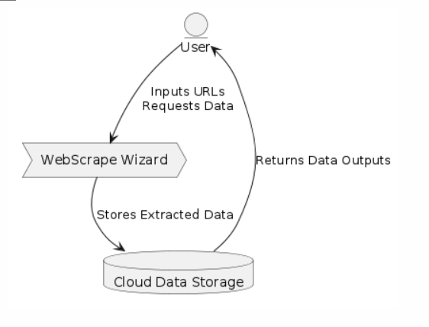

Fig 3.3.1: level-0 DFD Diagram

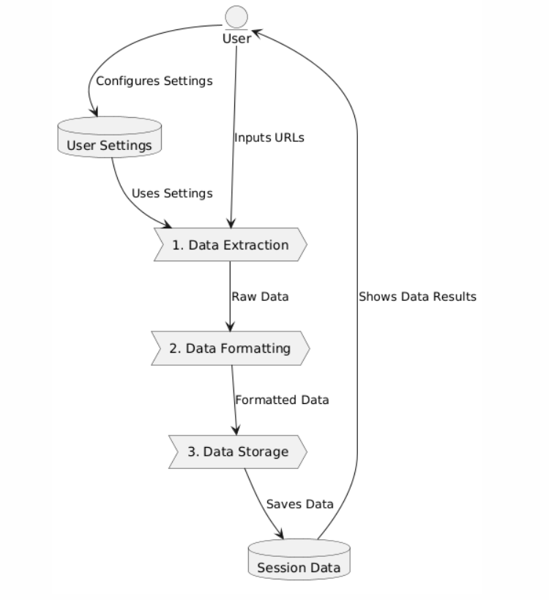

Fig 3.3.2: Level-1 DFD Diagram

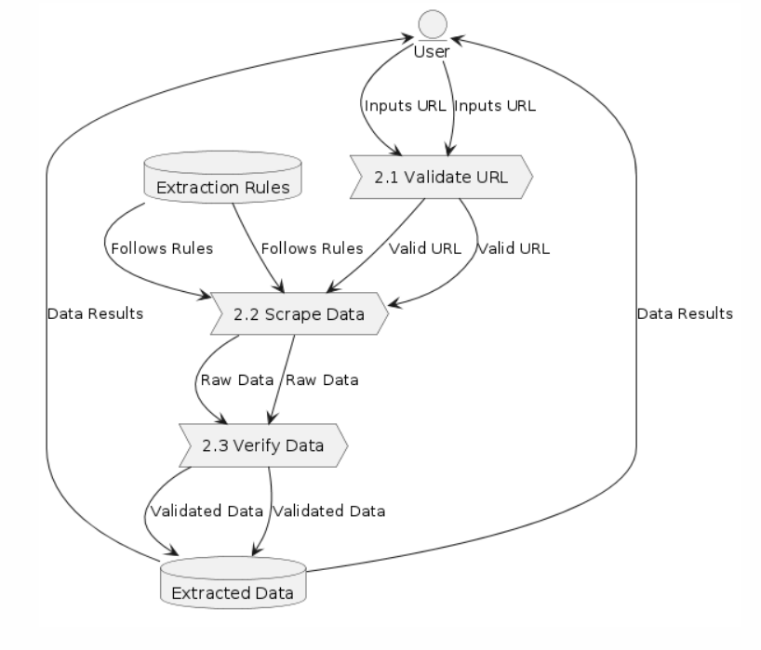

Fig 3.3.3: Level-2 DFD Diagram for Data Extraction Process

### Entity Diagram:

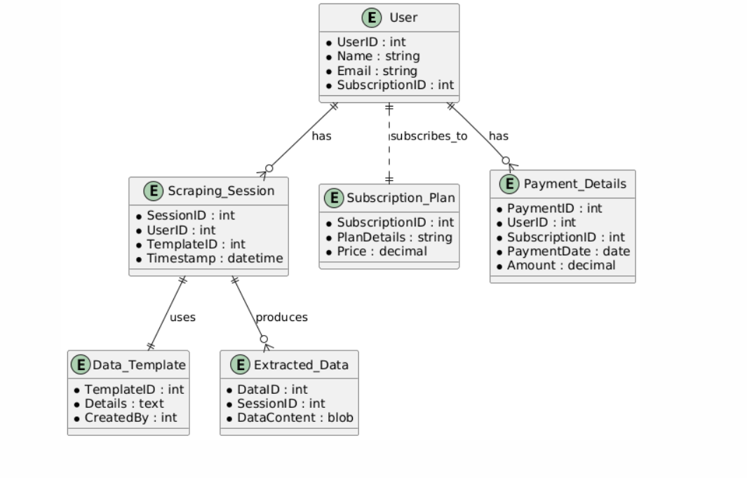

Fig 3.4.1: Entity Diagram

### Class Diagrams:

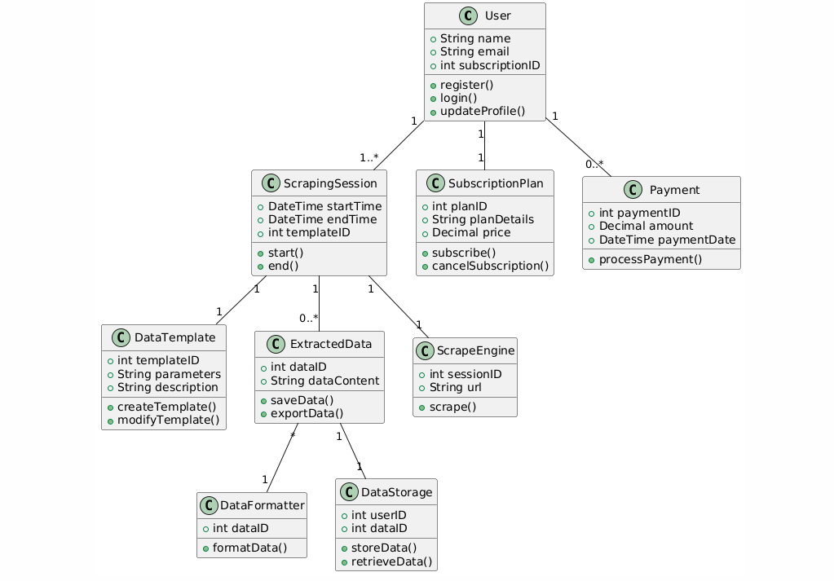

Fig 3.5.1: Class Diagram

### Use case Diagram:

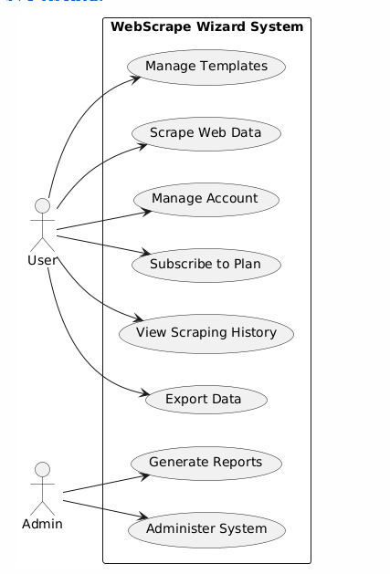

Fig 3.6.1 Use case Diagram

### Conclusion

WebScrape Wizard has quickly established itself as an essential tool in the field of web data extraction, offering a sophisticated yet user-friendly platform that significantly simplifies the process of gathering and managing data from various online sources. Designed with the end-user in mind, it provides an intuitive interface, customizable scraping capabilities, and seamless data export options, making it ideal for professionals across various industries—from academic researchers to market analysts. Our ongoing commitment to innovation ensures the incorporation of advanced features and improvements based on user feedback, which enhances functionality and user engagement. By fostering a community of data enthusiasts and maintaining rigorous security protocols, WebScrape Wizard not only facilitates efficient data collection but also ensures data integrity and security. As we continue to evolve, our focus will remain on expanding our technological capabilities and enhancing user experience, reaffirming our position as a leader in data extraction technology.

### Future Scope:

As we continue to evolve the "WebScrape Wizard" platform, our roadmap is focused on enhancing the capabilities and reach of our data extraction tool to maximize user engagement and utility. Our future scope includes:

* **Advanced Data Handling Features**: We plan to introduce more sophisticated data parsing and handling capabilities, allowing users to extract and manipulate complex data sets with greater precision and efficiency.
* **Enhanced User Collaboration Tools**: Developing features that enable users to share their custom scraping templates and results within the platform, fostering a community-driven approach to data extraction and knowledge sharing.
* **Expanded Export Options**: We aim to support a wider range of data formats and integration capabilities, enabling users to seamlessly transfer extracted data into various analytics tools and platforms.
* **Real-Time Data Extraction**: Implementing real-time scraping capabilities to provide users with the most current data available, enhancing the application's utility for live event monitoring and instant data retrieval.
* **Comprehensive User Education Program**: Launching educational resources and tutorials to help users maximize their use of the platform, from basic data extraction techniques to advanced customization and automation.
* **Robust API Integrations**: Building out robust API integrations that allow users to embed "WebScrape Wizard" functionalities into their own applications and workflows, broadening the tool’s applicability across different industries.
* **Enhanced Security Measures**: Strengthening platform security to ensure user data privacy and protection, especially as the tool scales and handles more sensitive information.
* **Industry-Specific Customization**: Tailoring scraping capabilities to meet the specific needs of various industries such as market research, finance, and academic research, making "WebScrape Wizard" a versatile tool across multiple sectors.
* **Community Building Initiatives**: Enhancing community engagement features to allow users to connect, share insights, and collaborate on projects directly through the platform.
* **Partnership and Integration with Data Analysis Tools**: Establishing partnerships with popular data analysis and visualization software providers to offer seamless integration, enabling users to analyze and visualize their scraped data efficiently.

### Reference:

1. React documentation. Available: https://legacy.reactjs.org/docs/getting-started.html
2. Npm Documentation. Available: https://docs.npmjs.com/
3. MongoDB Documentation. Available: https://[www.mongodb.com/docs/drivers/node/current/](http://www.mongodb.com/docs/drivers/node/current/)
4. Node.js documentation. Available: <https://nodejs.org/en/docs>
5. MDN Documentation. Available: <https://developer.mozilla.org/en-US/docs/Web>