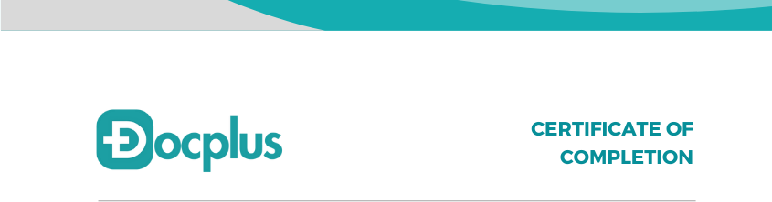

# Date : June 20, 2024

This is to certify that **Ms Palavi Kumari** has completed an internship at **Docplus** as **Full- Stack Developer Intern** from 01/06/2024 to 20/07/2024 for a duration of 2 Months.

During this period, **Ms Palavi Kumari** consistently demonstrated an innate ability to blend aesthetic finesse with functional design, creating seamless user experiences. Their work consistently met the high standards set by our organization.

We wish her success in all her future endeavours!

# Best regards,

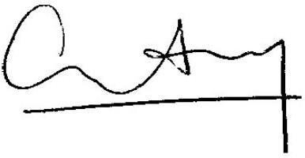

Manish Kothary Director, Docplus