Freight Rate Prediction: Approach

1. Problem
A load is one truck shipment from a pickup city to a delivery city. Its rate (posted_rate) is the price in dollars paid to move it. In trucking, rates are often expressed as rate per mile (RPM) = rate ÷ distance. A typical value here is about $2.15 per mile, so a 300-mile load costs around $650.
We are given 48,000 past loads where the price is known (Jan–Oct 2025) and 12,000 future loads where it is hidden (Nov–Dec 2025). The goal is to predict the price of each future load. A model that predicts a fair price before a load is booked lets a business quote customers quickly, spot over- or under-priced loads, and plan ahead.

2. Data
Column | Meaning
pickup, delivery (+ lat/lon) | Start and end city with map coordinates
distance | Miles driven
equipment | Trailer type: Dry Van (standard), Reefer (refrigerated), Flatbed (open)
weight | Cargo weight in lb
date | Shipping day
market_index | Daily measure of how strong the trucking market is
quote_signal | A noisy hint about this load's price, roughly on a $/mile scale. Useful, but unreliable on its own
posted_rate | Target: the price in dollars (training data only)

Data-quality issues and fixes
Issue | Size | Fix
Corrupted prices | 677 loads (1.4%) | Prices about 3.5× or about 0.3× the expected value (figure 1). Each price was compared with an out-of-fold model prediction, and loads more than 1.6× off were removed from training.
Negative weights | 292 loads (0.6%) | Sign errors, because their sizes match normal weights. Converted to positive.
Missing weight | 300 loads (0.6%) | Left blank with a flag. LightGBM handles missing values natively.
Missing market_index | 374 loads (0.8%) | Filled with that day's median, because market_index is almost the same for all loads on a day.
Cities seen only in validation | 8 cities, 12% of validation loads | Cities like Chicago and San Diego never appear in training. The model uses map coordinates instead of city names, so it works for any city.

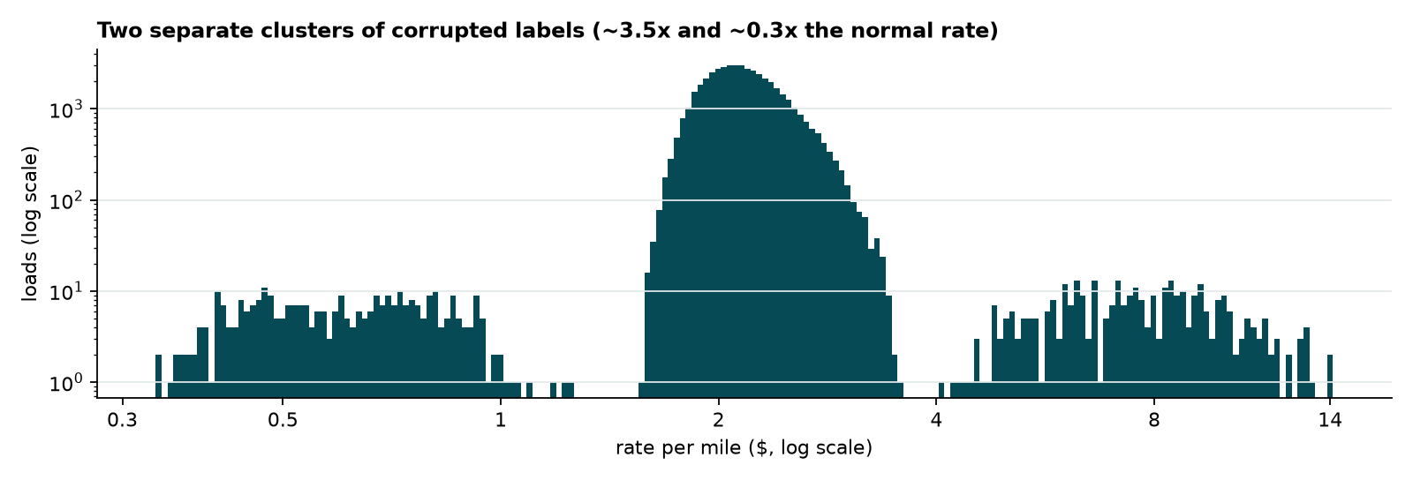
Figure 1: rate per mile. The large central peak is normal. The two small clusters are the corrupted prices.

3. Key findings
- Distance is the biggest driver of price.
- Reefer costs about 13% more than Dry Van, and Flatbed about 8% more.
- After removing lane effects, the daily price level is explained almost perfectly by three things (figure 2):
- Market index: when market_index goes up 10%, prices go up about 1.5%.
- Upward trend: prices rise about 7% per year, like slow inflation.
- Quarter-end ramp: in the last month of every quarter (Mar, Jun, Sep), prices climb steadily by about 4% from the 1st to the 31st, then drop back on the 1st of the next month. Companies rush to ship before quarter-end, which pushes prices up. December is also a quarter-end month.
- After these three effects, only about 0.5% day-to-day variation is left.
- market_index rises and falls every week, peaking on Thursdays, and prices follow it.
- A plain LightGBM model was off by 3.7% on Sep–Oct, and almost all its errors were in the same direction: it guessed about 3.6% too low. Tree models can't extend a time trend into dates they have never seen. When the September market index was low (like in January), the model predicted January-level prices.
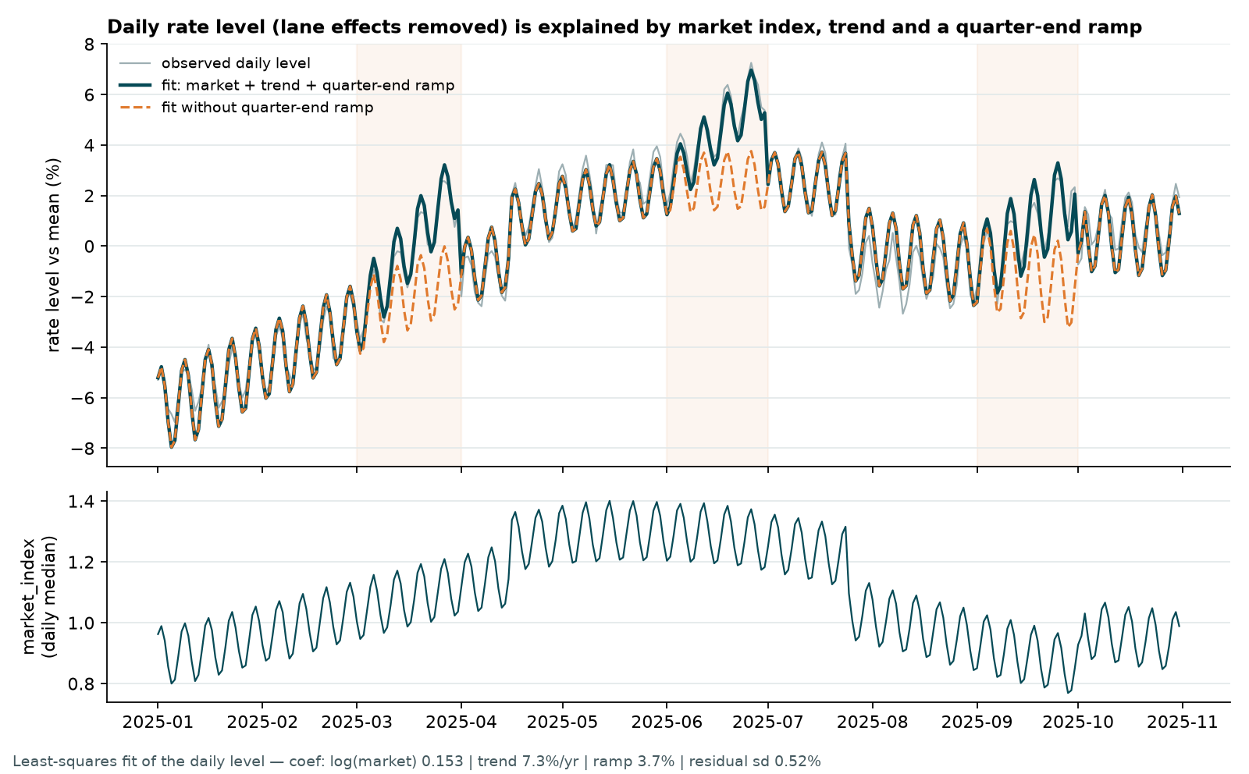
Figure 2: daily price level (grey) vs. the market + trend + quarter-end explanation (dark). Without the quarter-end ramp (orange dashed), the shaded months are missed.

4. Model
A two-stage model. The final price is Stage 1's estimate adjusted by Stage 2's correction.
- Stage 1, linear formula: handles the big, smooth effects: market index, the yearly trend, the quarter-end ramp, distance and trailer type. A formula can extend a trend into the future, which is what Nov–Dec needs.
- Stage 2, LightGBM: learns everything the formula misses: which routes are more or less expensive (from coordinates), the effect of weight, quote_signal and the day of the week. Stage 1's output is passed to LightGBM as its starting point (init_score).
Details:
- Log price: we predict the logarithm of the price, not the price itself. This turns percentage effects (+4%, ×1.5) into simple additions, which both stages handle better. At the end we convert back to dollars.
- Trees: LightGBM builds many small decision trees ("if distance > 800 and trailer is Reefer, add a bit"). Each new tree fixes the mistakes of the previous ones. The number of trees, 300, was chosen by testing several values in the backtest.
- Huber loss: a training setting that stops a few strange prices from pulling the model too far. It is a second safety net after removing the corrupted prices.
- No month feature: November and December never appear in the training data, so a tree model would not know what to do with them. The formula's trend and quarter-end terms cover time instead.

5. Validation and data split
The loads to predict (Nov–Dec) are all later than the training data (Jan–Oct). A random split would let the model see future market conditions and would overstate accuracy. So every test trains on earlier months and tests on the next two months (a rolling backtest, figure 3).
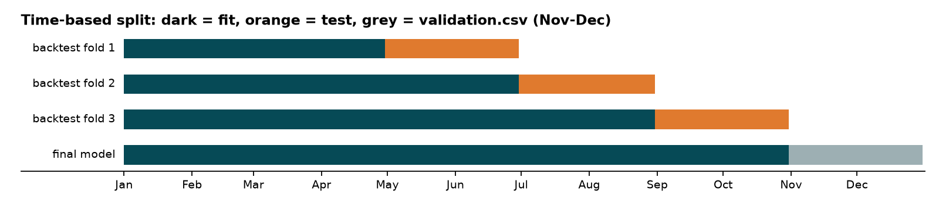
Figure 3: dark = training months, orange = test months, grey = the real Nov–Dec predictions.
Metrics: MAPE (average error as a % of the true price), MAE (average error in dollars) and bias (whether we guess too high or too low on average). MAPE, lower is better:
Method | May–Jun | Jul–Aug | Sep–Oct | Average
Baseline: trailer-type average $/mile | 8.93% | 7.96% | 8.09% | 8.33%
Baseline: lane average $/mile | 6.53% | 4.28% | 3.74% | 4.85%
LightGBM only | 2.19% | 2.90% | 3.81% | 2.97%
+ market formula | 1.91% | 2.57% | 4.58% | 3.02%
+ market + trend | 1.52% | 4.41% | 1.94% | 2.62%
Final: + market + trend + quarter-end | 1.40% | 2.23% | 1.61% | 1.75%

On the most important period (train Jan–Aug, test Sep–Oct), the final model has:
- MAPE 1.61%: on average the guess is 1.6% away from the real price.
- MAE $37.5: on average the guess is $37.50 away.
- Bias −0.4%: almost no tendency to guess too high or too low.
- Including the 1.4% corrupted prices in scoring, MAPE rises to 4.1%. Those prices are wrong, so no honest model should match them. Both numbers are reported for transparency.

Tried, but did not help
- Lane averages as extra inputs (target encoding): no improvement. Map coordinates already capture which routes are pricey.
- Choosing the number of trees by early stopping on the last training month: unstable across periods, so we used the value that worked best on average across all three backtests.
- Trend without the quarter-end ramp: good on Sep–Oct but bad on Jul–Aug, because it mistook June's quarter-end rise for trend. Adding the ramp fixed it in every period.

6. Final model and predictions
- Retrained the final model on all clean data from Jan–Oct (the most recent data matters most).
- Predicted the 12,000 validation loads → outputs/validation_predictions.csv.
- Filled the December file → outputs/december_chart_inputs.csv.
- score.py validated both files and created outputs/candidate_december.png.

December chart
The chart tracks one fixed load (Lexington → Fort Wayne, 360 miles, Dry Van, 32,000 lb) where only the date changes. The December file has no market_index or quote_signal, which the model needs. So for each December day we used the median market_index and quote_signal of all validation loads on that same day. quote_signal comes from 200–500 mile loads only, because its spread depends on distance.
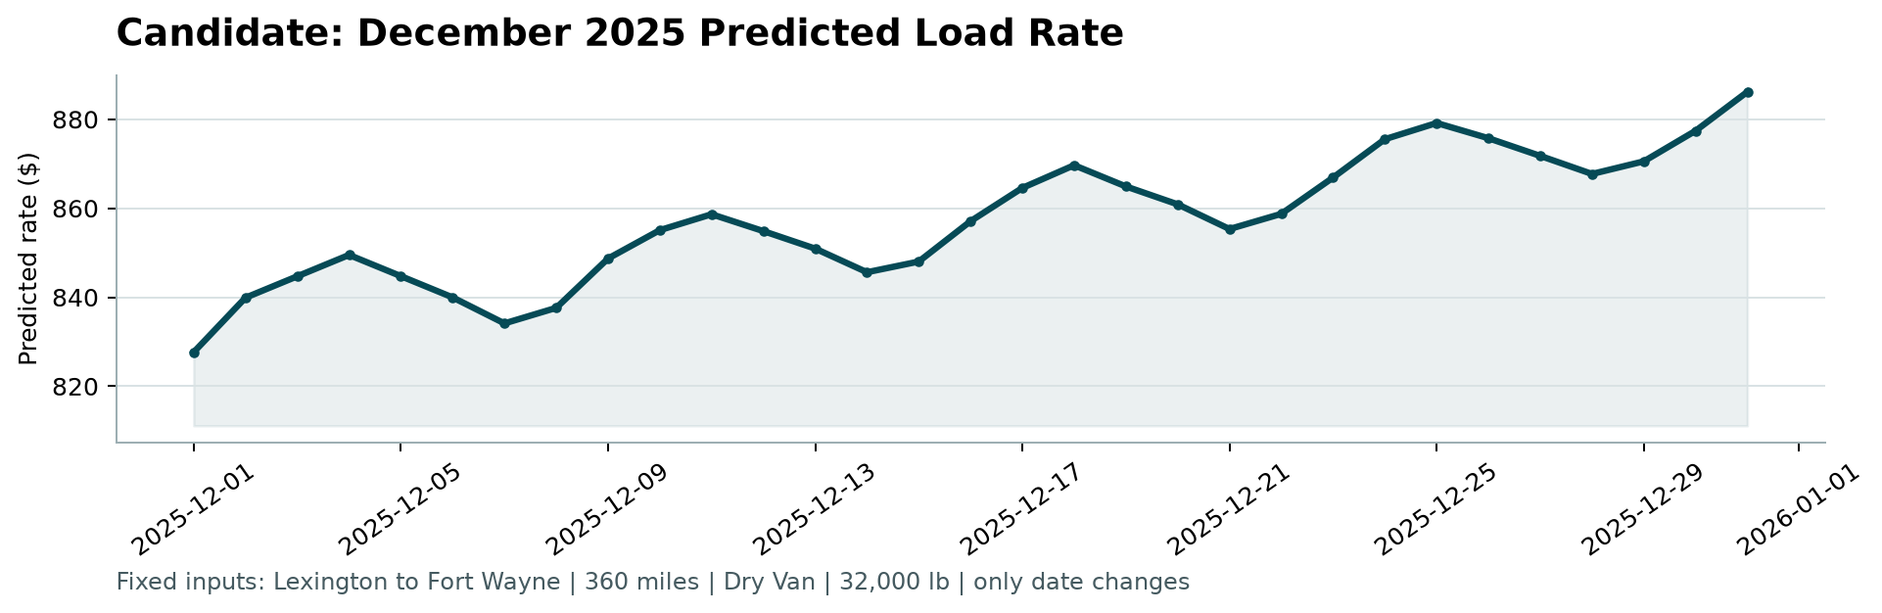
Figure 4: December predictions, created by score.py.
- Prices rise from about $828 on Dec 1 to about $886 on Dec 31. This is the quarter-end ramp (December is the last month of Q4) plus the slow upward trend.
- The weekly up-and-down wave comes from market_index, which peaks every Thursday.

7. Next steps
- Prediction ranges (a low–high band, not just a single number).
- More months of data to confirm the quarter-end effect and to learn holiday effects.
- Re-estimate the trend regularly, and monitor for data drift.

