COS80022 – Software Quality and Testing

Test Report for Lab 8

Student Name: Chaudhary M E Zamurad
Student ID: 102438166
Student email: 1024381666@student.swin.edu.au
Submission date: 16/05/2021

- Equivalence Partitioning

Test cases

# | Input Partition | Input Data | Expected Result
TC0 | Checking characters | ABC | Invalid input! You should provide an integer!
2 | Checking alpha num | A2 | Invalid input! You should provide an integer!
3 | Checking zero value | 0 | Invalid input! You should provide an integer!
4 | Checking decimal | 349.55 | Invalid input! You should provide an integer!
5 | Checking special | &% | Invalid input! You should provide an integer!
6 | Checking negative values | -350 | Invalid input! You should provide a non-negative integer!
7 | Testing no rewards | 300 | No rewards
8 | Test coffee | 351 | The reward is: coffee
9 | Test reward 2 | 1000 | The reward is: Coffee and cake
10 | Reward3 | 3512 | The reward is: coffee, cake and sandwich
11 | REWARD4 | 5512 | The reward is: unable to earn > 5000

Screenshot of test results
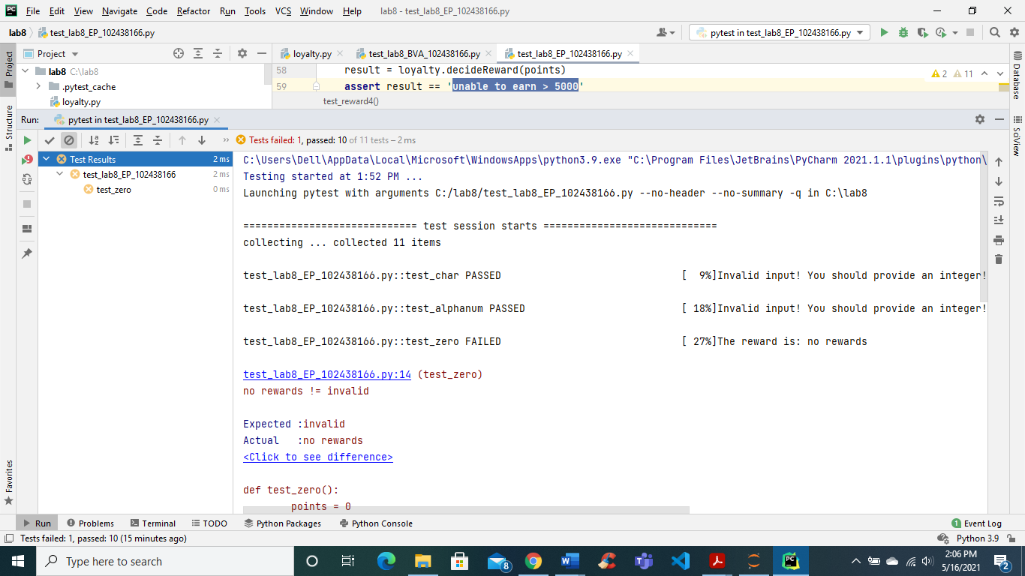

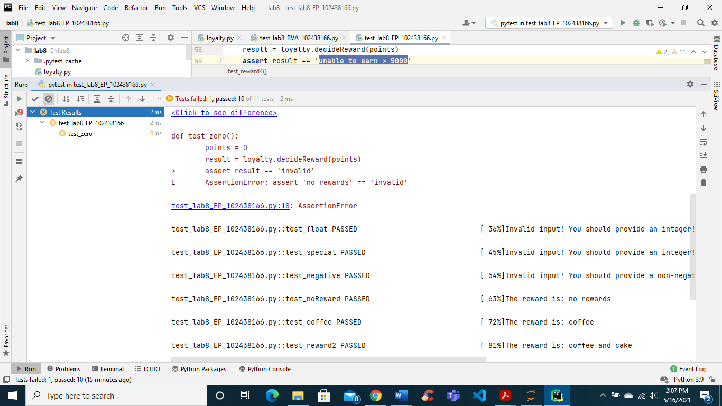

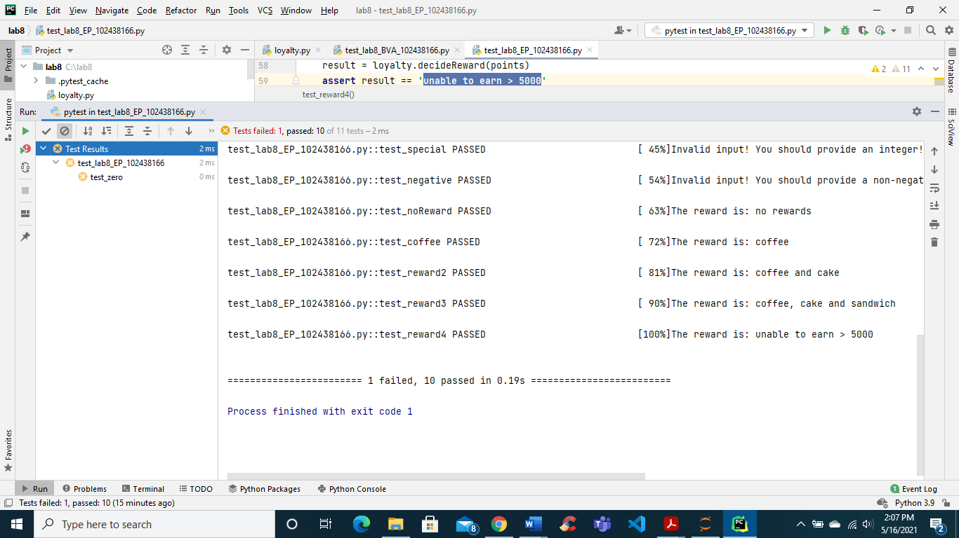

- Boundary Value Analysis

Test cases

# | Boundary/Partition Tested | Input Data | Expected Result
TC0 | Invalid | -1 | Invalid input! You should provide a non-negative integer!
2 | No rewards min | 0 | No rewards
3 | No rewards max | 349 | No rewards
4 | Coffee min | 350 | Coffee
5 | Coffee max | 949 | Coffee
6 | Cake min | 950 | Coffee and cake
7 | Cake max | 2999 | Coffee and cake
8 | Sandwich min | 3000 | Coffee, cake and sandwich
99 | Sandwich max | 5000 | Coffee, cake and sandwich
10 | Exceeds | 5001 | Unable to earn

Screenshot of test results
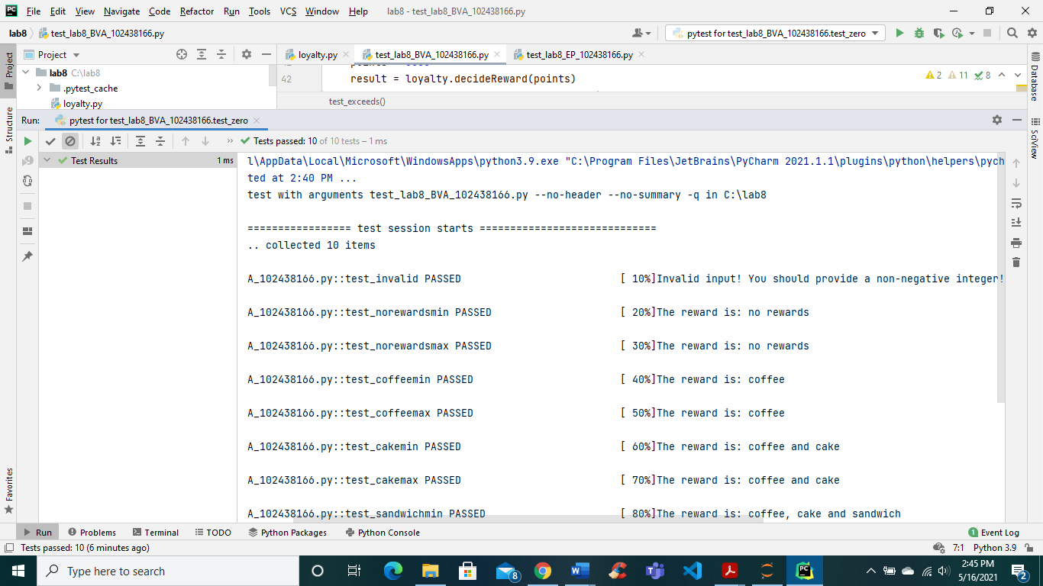
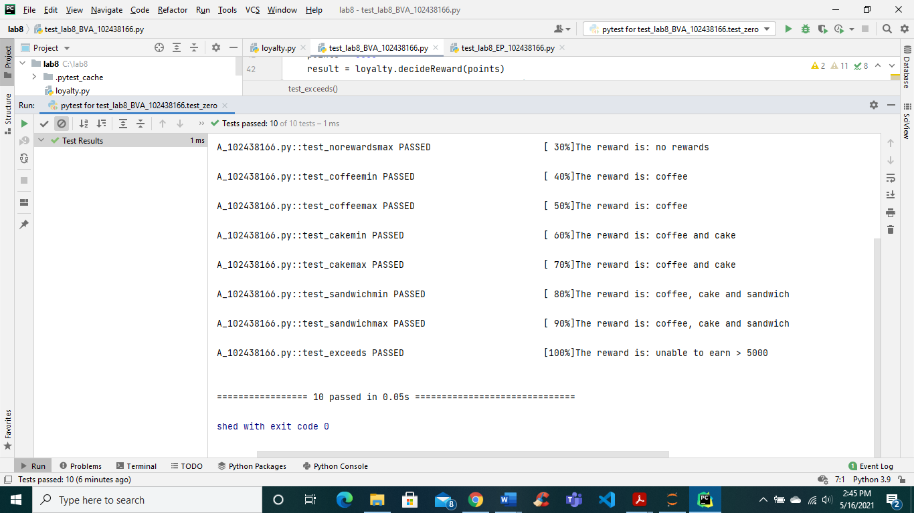
Analysis of test results
Yes, one test failed, and I have attached the screenshot above in the EP section.
Test name: test_zero
Expected: Invalid
Actual: No rewards
So, by changing the expected value to no rewards we removed the failure.
