COS80022 – Software Quality and Testing

Test Report for Lab 9

Student Name:
Student ID:
Student email: 102438166@student.swin.edu.au
Submission date: 19/05/2021

- For ‘getMax1’

Test cases
[Fill all your designed test cases into the following tables. The first test case is given as an example. Please remove the example when filling the table. Add new rows if you have more test cases]
Table 1. Test cases for 100% statement coverage on ‘getMax1’
# | Input Data | Expected Result
 | 1,5,10 | 10
Table 2. Test cases for 100% branch coverage on ‘getMax1’
# | Input Data | Expected Result
 | 10,4,6 | 10
 | 5,3,6 | 6
 | 1,1,1 | 1
Table 3. Test cases for 100% path coverage on ‘getMax1’
# | Input Data | Expected Result
 | 0,1,2 | 2
 | 2,1,0 | 2
 | 1,0,2 | 2
 | 0,2,1 | 2

Screenshot of test results
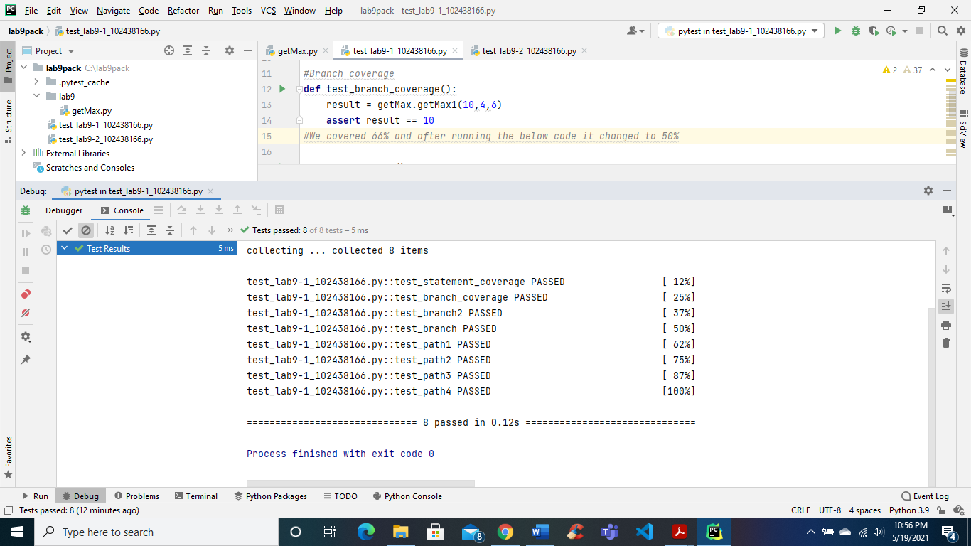

- For ‘getMax2’

Test cases
Table 4. Test cases for 100% statement coverage on ‘getMax2’
# | Input Data | Expected Result
 | 1,2,3 | 3
Table 5. Test cases for 100% branch coverage on ‘getMax2’
# | Input Data | Expected Result
 | 2,1,3 | 3
 | 3,4,2 | 4
 | 2,1,0 | 2
 | 3,5,5 | 5
Table 6. Test cases for 100% path coverage on ‘getMax2’
# | Input Data | Expected Result
 | 0,1,2 | 2
 | 0,2,1 | 2
 | 2,1,0 | 2
 | 1,0,2 | 2

Screenshot of test results
- 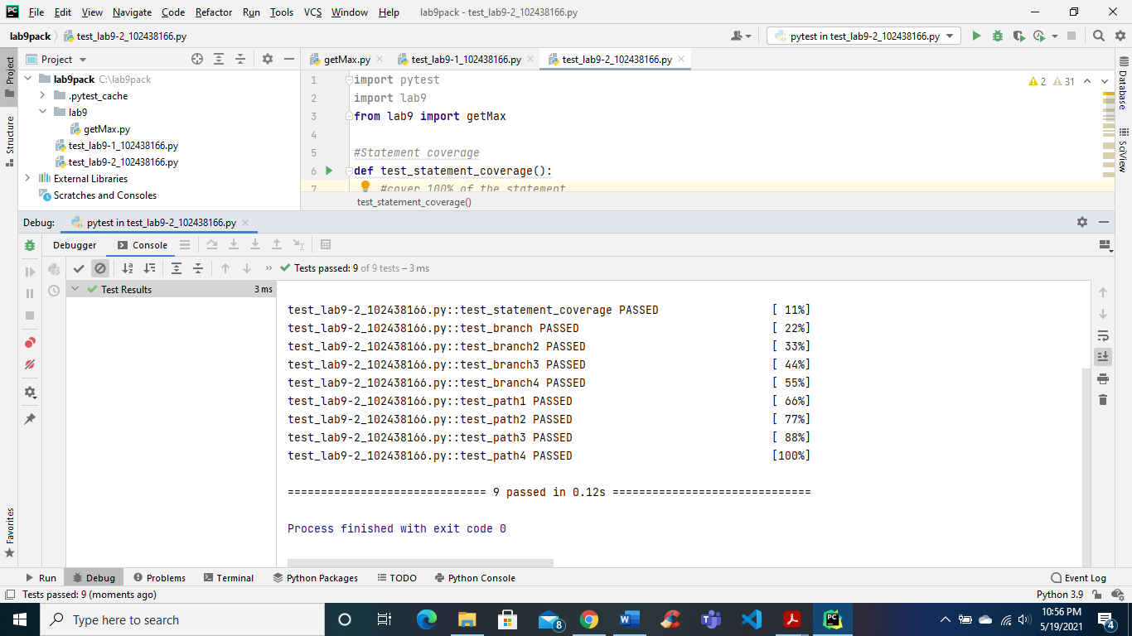
Analysis of test cases

Is there any difference among the three sets of test cases (Table 1-3) for ‘getMax1’? Why?
Yes, because the logic behind getMax1() only allow us to run 8 test which covers every branch and path. Secondly, there is only two decision branches which is another reason that we have lower number f test cases in this section.

Is there any difference among the three sets of test cases (Table 4-6) for ‘getMax2’? Why?
Yes, because this function have three decision branches which allowed us to run nine different test cases which would cover every branch and path of getMax2().

