**CHATBOT**

Introduction:-

Chat ro**bot**, a computer program that simulates human conversations, or chat, through artificial intelligent. Typically, a chat bot will communicate with a real person.

At the most basic level, a chatbot is a computer program

That simulates and processes human conversation, allowing humans to interact with digital devices as if they were communicating with a real person.

Chatbots can be simple as rudimentary programs that answer a simple and common query with a simple line response, or as sophisticated as digital assistant that learn and evolve to deliver increasing levels of personalization as they gather and process information.

Organizations use chatbots to engage with customers alongside the classic customer service channels like phone, email, and social media.

Chatbots provide service teams the information they need quickly, serving up relevant resources even as the customer conversation changes. The simplest form of a chatbot system parses customer input, then scans its database for articles related to certain words and phrases. In short, it operates like a document-retrieval system based on keywords.

Our chatbot is the basic of chatbot, in which our chatbot answered of simple common questions, That we code of some common question and there are answer.

Our chatbot in based on college common question, That some student ask to our chatbot about a specified college and our chatbot give him answer, we named our chatbot assistant name ‘EKARI’. If client or student ask her names she reply’s EKARI, And our chatbot reply answer of some common question that student mostly ask about college Like- Fee details, Course details, Placement details, location, admission cell contact number etc…

The chatbot we created she did not speak or listen she only understand text, and she give answers in only form of text.

What is Chatbot?

Chatbots offer a conversational experience using artificial intelligence and natural language processing to mimic conversation with real people.

> A Chatbot is a conversational agent that interacts with user using natural language.

> Started as an attempt to humans.

> Numerous applications of Chatbots such as Customer Services, call centers etc..

Need for Chatbots?

ChatBots can improve lead generation, qualification and nurturing. Chatbots can ask questions throughout the Buyers journey provide information that may persuade the user and create a lead. Chatbots can then provide potential customers information to the sales team, who can engage with the lead.

>chatbots can be used in business, all types of business like- Hotel, Colleges etc…

Chatbots are conversational robots programmed and designed to instantly answer users questions.

Chatbots have many more use cases in human resources management, in schools administration and in many other contexts.

>Better human Computer interactions

>To express their interest queries directly and pointing.

**Benefits of Chatbot:-**

The first **Benefit of chatbots** is that they can **work 24 hours a day**, **7 days a weak**.

Also, if ever a chatbot struggles to understand some user’s input and gets stuck trying to answer their queries or solving problems, it can escalate tough requests to your human support team.

In a globalized world where customers expect to receive fast, or even instantaneous answers, from companies located on their side of the globe, chatbots tend to come in very handly.

Chatbots can handle **multiple customers** at the **same time,** Usually a human employee can manage between 4 to 5 simple Customers queries at a time.

Chatbots can however **handle** **as many requests** as you like at the same time.

Chatbots significantly free up employees **time,** allowing them to focus on higher value-added tasks.

**Chatbots** can be **deployed** anywhere, with ideta’s software you can easily create a chatbot and then deploy it on as many channels as you like: FaceBook, Messenger, Instagram, etc.. The more channels your chatbot will be deployed on, the more customers you will be able to reach.

Chatbot **Easy** **to use**, The simple interface makes it more familiar to the users. This can increase sales and engage customers to follow the same for your brand.

Purpose:-

Chatbots boost operational efficiency and bring cost saving to Businesses while offering convenience and added services to internal customers.

They allow companies to easily resolve many types of customer queries and issues while they need for human interface, chatbot can solve client questions then companies does not need people for solving customers question on phone or massages they just type there question on chatbot and chatbot give him answer.

By contract, chatbot allows business to engage with an unlimited number of customers in a personal way and can be scaled up or down according to demand and business needs. By using chatbot, a business can provide humanlike, personalized, proactive services to peoples.

Basic purpose of chatbot is saving peoples time, direct customer service, giving answers etc…

Chatbot allows businesses to connect with customer in a personal way without expense of human representatives.

For example:- many of the questions or issues have are common and easily answered.

That’s why companies create FAQs and trouble shooting guides.

Chatbot provides a personal alternative to a written FAQ or guide and can even triage questions,

**Conclusion :-**

Chatbots are effective tools when it comes to education, IR, e-commerce,etc..

Downside includes malicious users as in yahoo messenger.

The aim of chatbot designers should be: to build tools that help people, facilities their work, and their interaction with computer using natural language; but not to replace the human role totally; but not to replace the human role totally, or imitate human conversation perfectly.

**Chatbot Architecture:-**

Programming languages can be used to build a web API. The back end-end gets massages, thinks about a reply, and returns it back to the client. The front-end may be one of the best to messenger apps or a chat interface and your web server will connect the back-end and front-end.

There are two types of chatbots: bots for amusement and bots for business. Discussion frameworks can generally be separated into two classification: retrieval based models and generative based models.

**User input**

Context Response



Archive



 Retrieval Based Model



 Response

User massages Massage Archives

Generative Model

Response

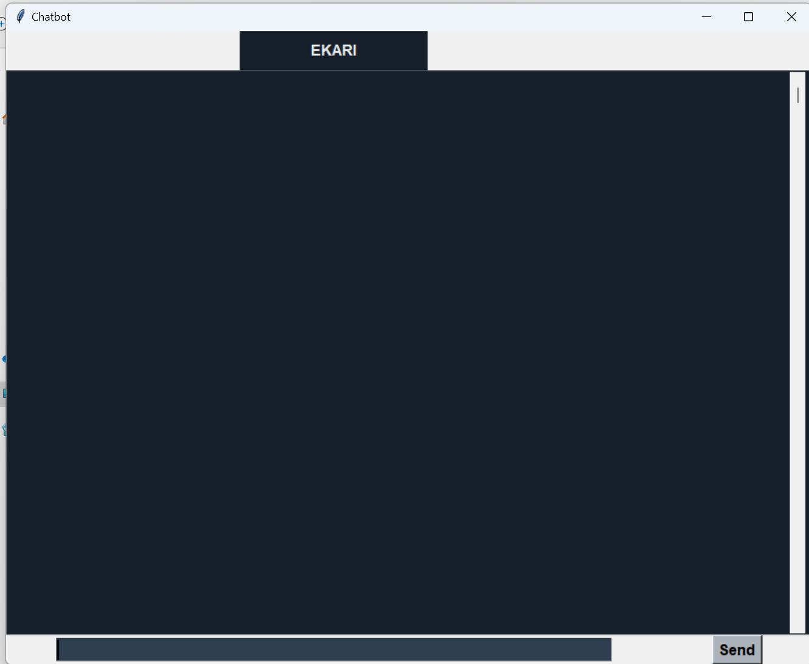

This is the interference of our CHATBOT.

On top there is EKARI written, because we named our Chatbot as EKARI.

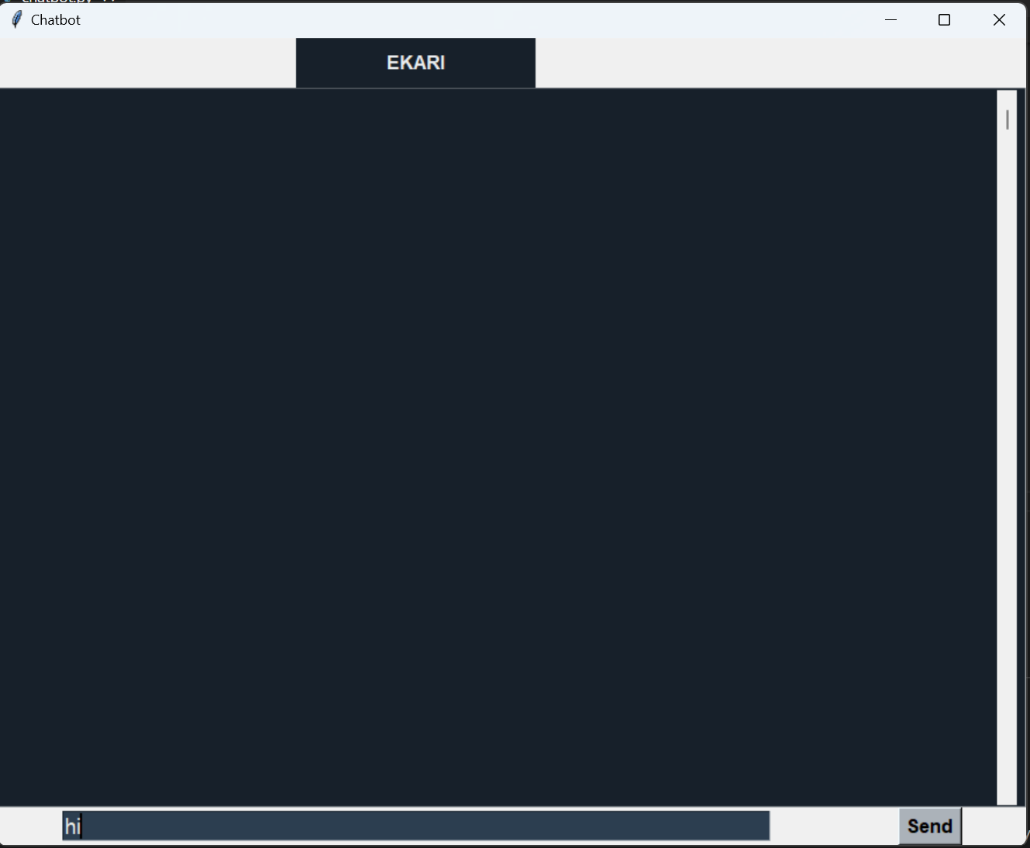

There on Bottom our client/customer ask questions to Chatbot business related.

And after writing question they have to press ‘Send’.

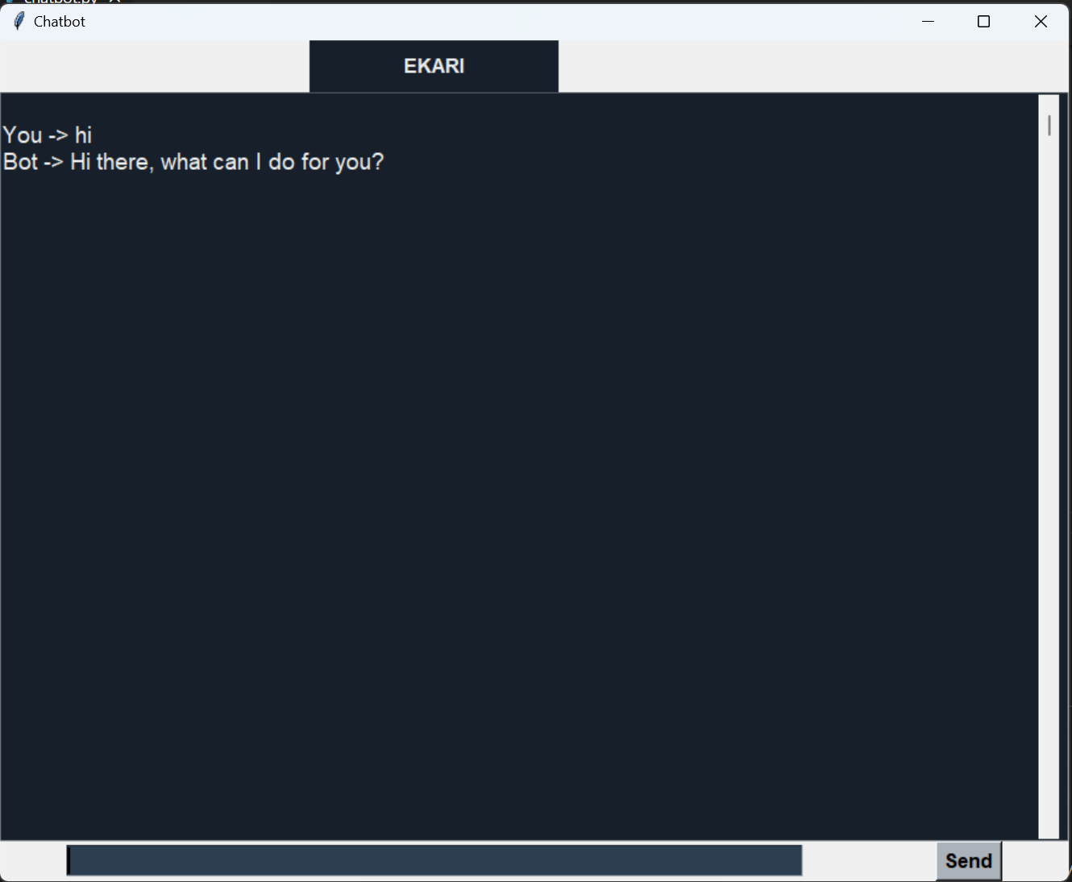

As you can see in above picture user send question and chatbot replied him.

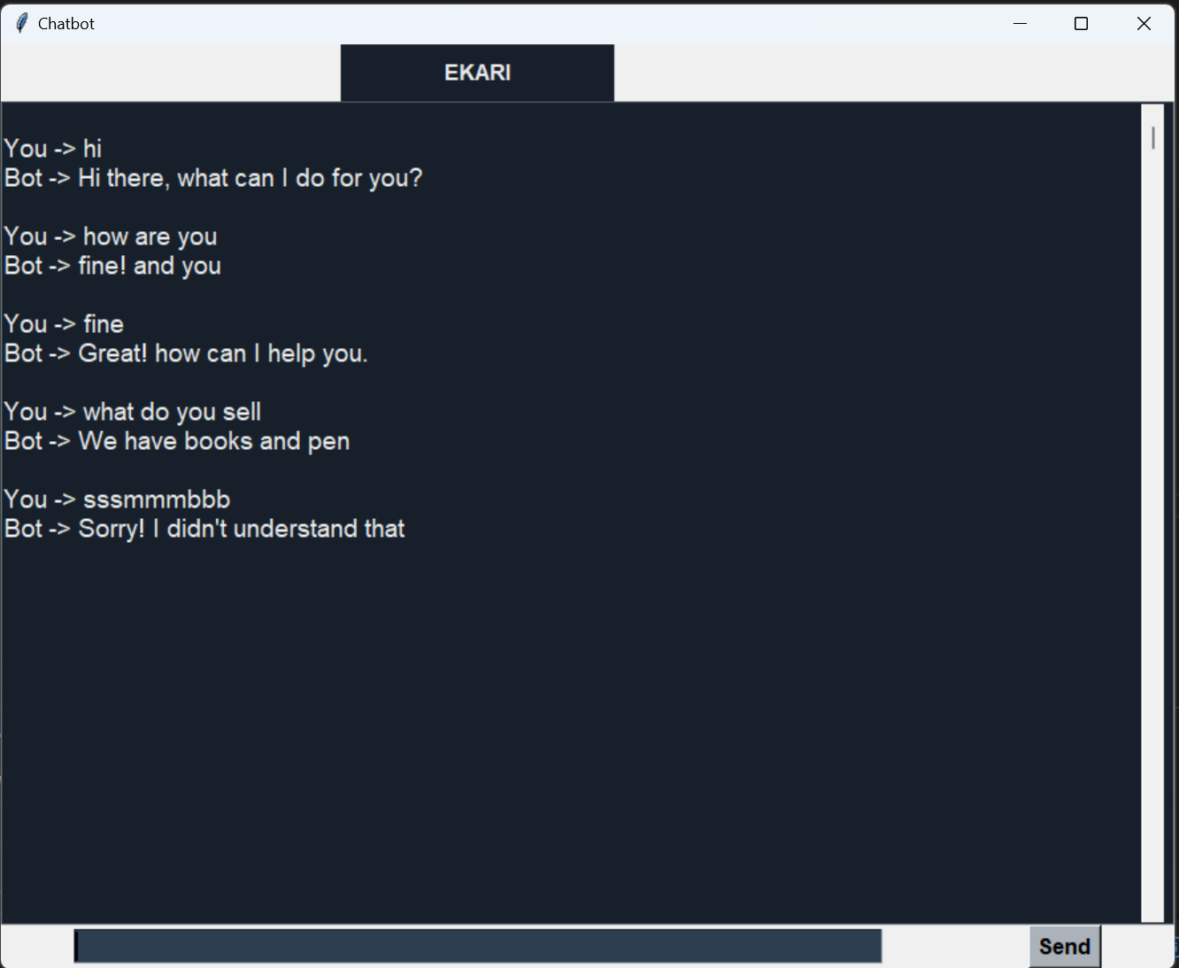

As well as you can see in above picture, chatbot response on his/her questions.

If client ask her something, that’s not in business purpose then she replies ‘Sorry I did not Understand that’.

Signature:-

(i)EHETSHAN ALAM … … … … … … … … … … …

(ii)KANISH KUMAR … … … … … … … … … … …

(iii)RAVI RAJA … … … … … … … … … … ….

(iv)SAWYAM RAUT … … … … … … … … … … ….