PENETRATION TESTING REPORT
Footprinting, OSINT & Network Scanning
PM1 + PM3 + PM4 + PM5 | WEEK 2

Field | Details
Pentester | Ihtisham Khan
Program / Batch | Cybersecurity & Ethical Hacking Internship - Networkwalks, Batch B083
Week | Week 2
Modules Completed | W2-PM1, W2-PM3, W2-PM4, W2-PM5, W2-PM-FINAL
Authorized Targets | networkwalks.com (as assigned/authorized by Networkwalks); microsoft.com passive OSINT task as specified in the lab; own local LAN for Zenmap scanning
Systems Used | Kali Linux virtual machine and Windows 10 host
Report Date | 20 September 2026

Scope note: This report documents educational reconnaissance and scanning tasks. No exploitation was performed. Publicly visible information and local-network observations are discussed as findings, not as proof of exploitable vulnerabilities.

1. Executive Summary
Week 2 of the internship focused on the first two stages that normally come before exploitation: reconnaissance/footprinting and network discovery. I completed four practical modules instead of only the minimum requirement. The work covered command-line reconnaissance with six Kali Linux tools, graphical OSINT with Maltego, passive information gathering with theHarvester, and local network discovery with Zenmap.
The exercises produced a consistent technical picture of the assigned Networkwalks target. WHOIS and DNS-based tools identified registration, hosting and mail infrastructure; WhatWeb and HTTP headers exposed the web stack and WordPress-related information; Wafw00f detected ModSecurity; and DNSRecon returned name-server, mail, SPF/TXT and service records. Maltego then demonstrated how an investigator can visually connect a domain to related entities such as an email address.
The theHarvester task showed a different side of OSINT. A focused Baidu query against microsoft.com returned a small set of email addresses and hosts, while the all-sources run produced far more data but also demonstrated a practical limitation: many data sources require their own API keys. The task was therefore useful not only for collecting results but also for understanding why OSINT outputs depend heavily on source availability, authentication and data quality.
Finally, Zenmap was used against my own 192.168.100.0/24 LAN. Three live IP addresses were identified: 192.168.100.1, 192.168.100.18 and 192.168.100.53. The scan also exposed services on the gateway and Windows host and produced a topology map. The purpose of this activity was host and service discovery on an authorized local network, not exploitation.

2. Scope, Authorization and Method
The work in this report was completed within the scope of the Networkwalks Week 2 practical assignments. The target and data sources were those specified by the internship material, and the internal network scan was performed only on my own local LAN. I did not attempt to bypass authentication, exploit a vulnerability, disrupt a service, or access data that was not publicly available or under my control.
Module | Activity | Target / Scope
W2-PM1 | Footprinting with multiple Kali tools | networkwalks.com - assigned/authorized target
W2-PM3 | Maltego domain-to-email transform | networkwalks.com - assigned/authorized target
W2-PM4 | Passive OSINT with theHarvester | microsoft.com - exactly as specified in the lab exercise
W2-PM5 | Host/service discovery with Zenmap | Own local LAN: 192.168.100.0/24

3. Tools and Environment
Tool | Purpose in this project
Kali Linux | Primary platform for reconnaissance and OSINT commands
WHOIS | Domain registration, registrar, dates and name-server information
WhatWeb | Web technology fingerprinting
nslookup | DNS resolution of the target domain
curl -I | HTTP response-header inspection
Wafw00f | Web Application Firewall fingerprinting
DNSRecon | DNS record and service enumeration
Maltego | Graph-based OSINT and relationship mapping
theHarvester 4.10.1 | Passive collection of emails, hosts, IPs and related public data
Zenmap / Nmap 7.91 | Local subnet discovery, service visibility and topology mapping
Windows ipconfig | Local IPv4 address, subnet mask and gateway identification

4. W2-PM1 - Footprinting with Multiple Kali Tools
This module was the broadest reconnaissance exercise of the week. I ran six separate tools against networkwalks.com. Each tool answered a different question, and the combined output gave a much clearer profile than any single command could provide.

4.1 WHOIS - Domain Registration and Hosting Clues
$ whois networkwalks.com
The WHOIS lookup showed that the domain is registered through GoDaddy.com, LLC. The registry record showed a creation date of 6 November 2019 and an expiry date in November 2027. Registrant information was privacy-protected through Domains By Proxy, LLC. The visible name servers included NS6135.HOSTGATOR.COM and NS6136.HOSTGATOR.COM, which linked the domain to HostGator infrastructure. DNSSEC was shown as unsigned in the returned record.
Interpretation: This result demonstrates how much infrastructure context is available from public registration data even when the actual registrant identity is protected. It is useful for asset mapping, but it does not by itself indicate a security weakness.
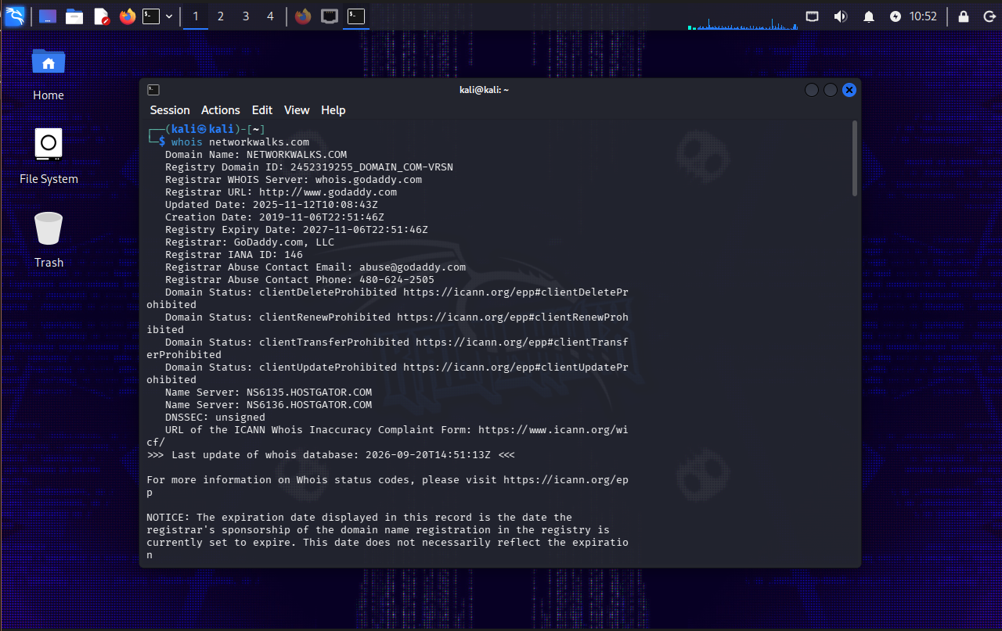
Figure 1 - WHOIS output for networkwalks.com.

4.2 WhatWeb - Technology Fingerprinting
$ whatweb networkwalks.com
WhatWeb first observed an HTTP 301 redirect to HTTPS and then fingerprinted the live HTTPS site. The output identified Apache, WordPress 7.1.1, WordPress Download Manager 3.3.58, Bootstrap 7.1.1, jQuery 3.7.1, HTML5, Google Tag Manager, an email address (info@networkwalks.com), and the IP address 192.232.216.135. The page title was reported as Networkwalks Academy.
Interpretation: The important lesson here is not that the software is automatically vulnerable, but that detailed version and platform information can be collected remotely and can later be compared with vendor advisories during an authorized assessment.
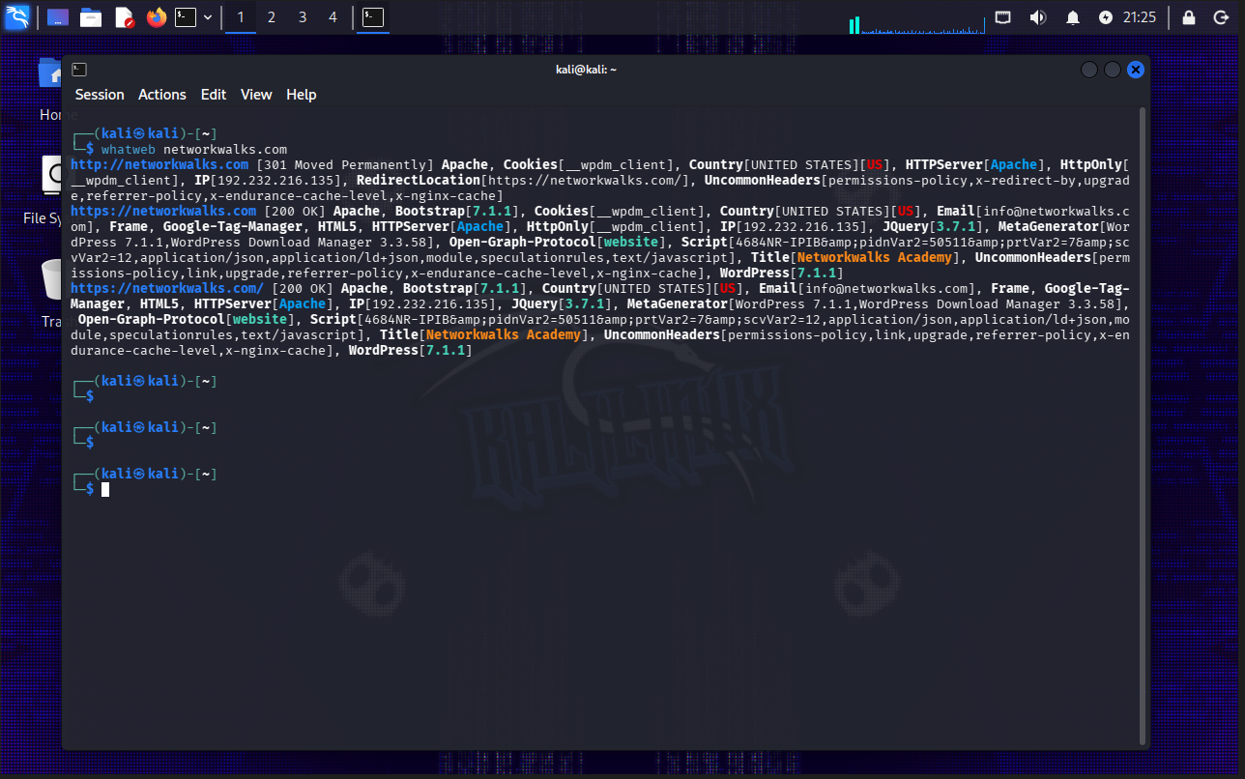
Figure 2 - WhatWeb fingerprint showing the web stack and exposed metadata.

4.3 nslookup - Domain Resolution
$ nslookup networkwalks.com
The DNS lookup used 8.8.8.8 as the resolver and returned 192.232.216.135 for networkwalks.com. This confirmed the address already visible in the WhatWeb output.
Interpretation: Resolving a domain to an IP address is a basic infrastructure-mapping step. Consistency between independent tools also increases confidence that the observation is correct at the time of testing.
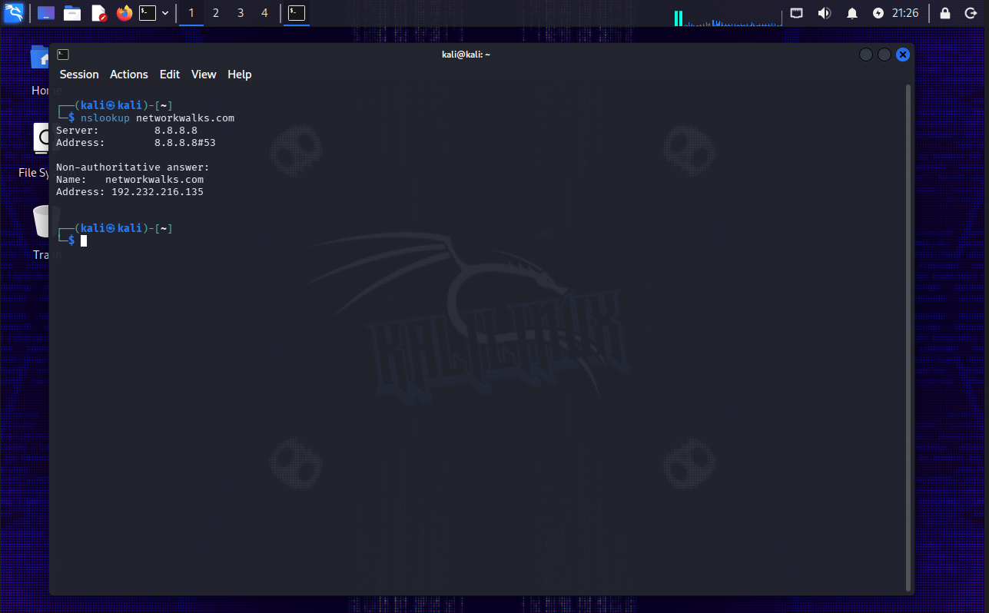
Figure 3 - nslookup result resolving networkwalks.com to 192.232.216.135.

4.4 curl -I - HTTP Response Headers
$ curl -I https://networkwalks.com
The server returned HTTP/2 200. The headers showed Apache as the server, a secure HttpOnly __wpdm_client cookie, the WordPress REST API endpoint /wp-json/, a JSON alternate link to /wp-json/wp/v2/pages/53, a referrer policy, and WordPress-related cache headers.
Interpretation: Response headers are useful because they expose application behaviour and framework clues without downloading the full page. In this case the REST API link and server information supported the WordPress fingerprint already produced by WhatWeb.
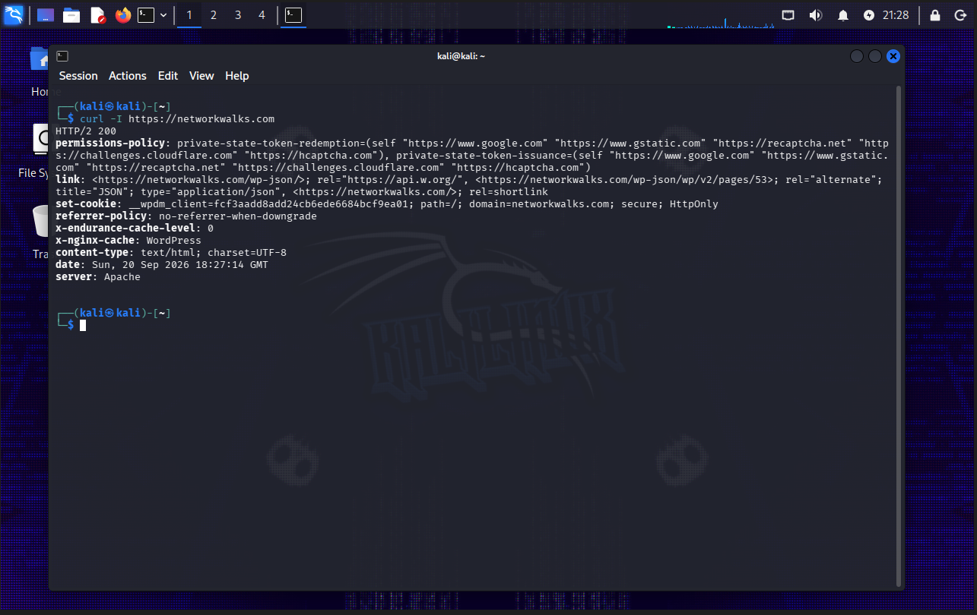
Figure 4 - HTTP response headers returned by curl -I.

4.5 Wafw00f - WAF Detection
$ wafw00f networkwalks.com
Wafw00f v2.4.2 reported that the site is behind a ModSecurity (SpiderLabs) Web Application Firewall. The tool completed the check using two requests.
Interpretation: The presence of a WAF is an important part of understanding the defensive architecture of a web application. The result confirms a protective control is visible, but it does not prove how the WAF is configured or how effective it is against specific attacks.
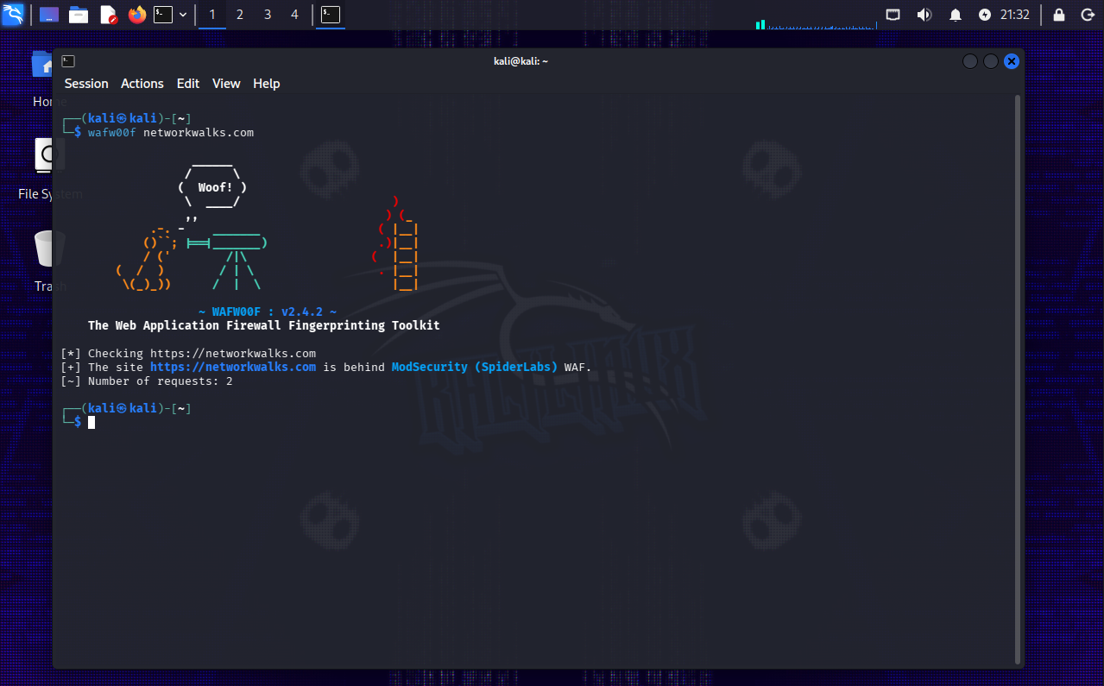
Figure 5 - Wafw00f identifying ModSecurity (SpiderLabs).

4.6 DNSRecon - DNS Infrastructure Enumeration
$ dnsrecon -d networkwalks.com
DNSRecon returned the SOA and NS infrastructure, including ns6135.hostgator.com (50.87.144.87) and ns6136.hostgator.com (192.232.216.131). It identified mail.networkwalks.com and the main A record at 192.232.216.135. TXT output included an SPF record and a Google site-verification token. The scan also enumerated eight _autodiscover._tcp SRV records pointing to cpanelemaildiscovery.cpanel.net endpoints on TCP 443. DNSRecon reported no answer to its DNSSEC query during this run.
Interpretation: Compared with a simple DNS lookup, DNSRecon exposed a broader view of the domain's supporting infrastructure. These records are valuable for documentation and attack-surface review, while still being public DNS data rather than confirmed vulnerabilities.
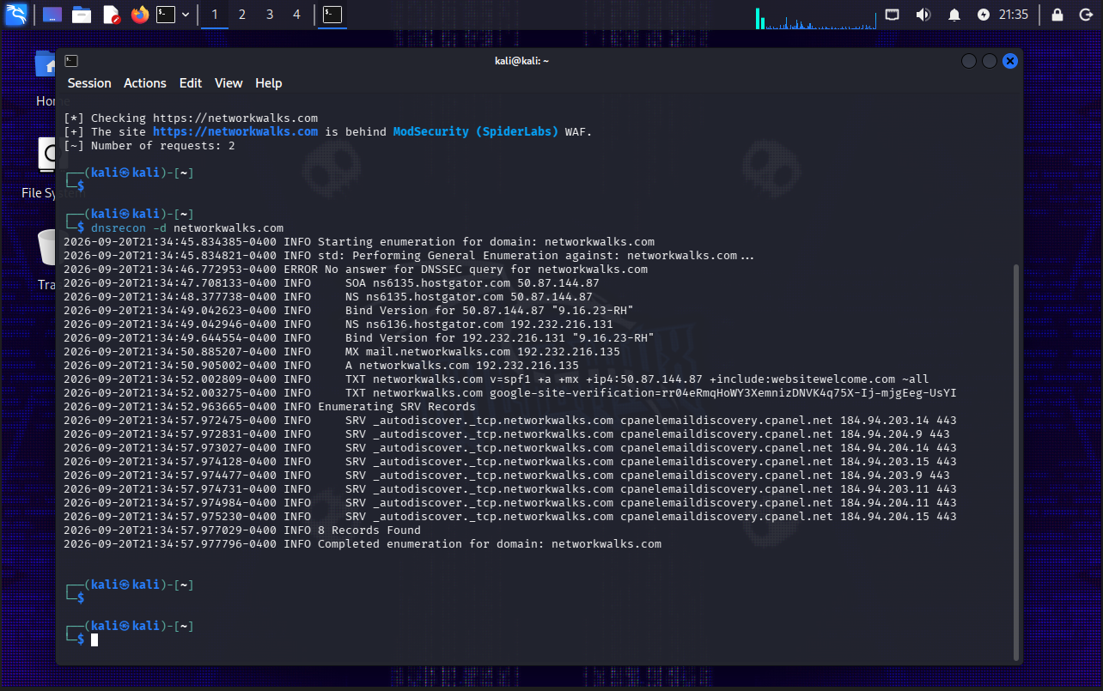
Figure 6 - DNSRecon output showing NS, MX, A, TXT and SRV information.

5. W2-PM3 - Footprinting with Maltego
The Maltego exercise moved from text-based reconnaissance to relationship mapping. The objective was to create a domain entity for networkwalks.com and run email-related transforms so that related information could be represented as a graph.

5.1 Configuration Issue and Troubleshooting
During the first attempt, Maltego displayed the warning: 'Please input a valid engine ID to use the Google API' for the networkwalks.com entity. Instead of treating the failed transform as the final result, I checked the available transform configuration and adjusted the setup so that a working email-related transform could run. After the configuration issue was resolved, the graph returned info@networkwalks.com as an email entity linked to the domain.
This troubleshooting step is worth recording because OSINT platforms often depend on external transform providers, API credentials and quotas. A failed transform can therefore be a configuration or provider issue rather than an indication that no data exists.
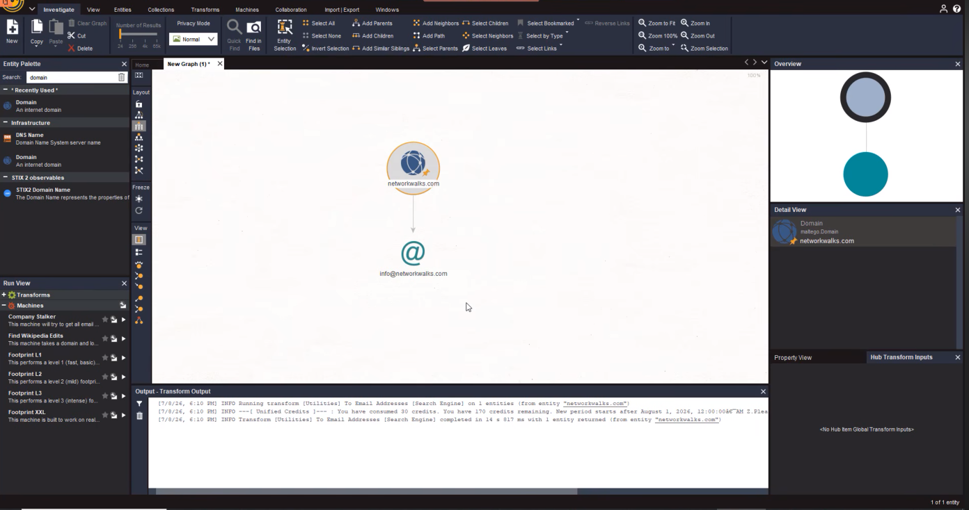
Figure 7 - Completed Maltego graph linking networkwalks.com to info@networkwalks.com.

6. W2-PM4 - Footprinting with theHarvester
The theHarvester practical used microsoft.com as specified in the module instructions. The goal was to compare a focused search using one public source with a broader all-sources search. The exercise was passive OSINT: results were collected from supported public data sources rather than by exploiting Microsoft systems.

6.1 Task 1 - Baidu Source, Limit 1000
$ theHarvester -d microsoft.com -l 1000 -b baidu
The run completed with no IP addresses found from this source, four email-style results and seven hosts. The hosts included account.microsoft.com, developer.microsoft.com, jobs.careers.microsoft.com, learn.microsoft.com, prod.support.services.microsoft.com, spocdev.microsoft.com and support.microsoft.com.
The email results included entries such as abc@microsoft.com and contactspocaccess@microsoft.com. OSINT output should not be assumed to be current, validated or security-sensitive simply because a tool returns it. Public-source data can contain stale, test or low-quality entries, so results require verification before being treated as authoritative assets.
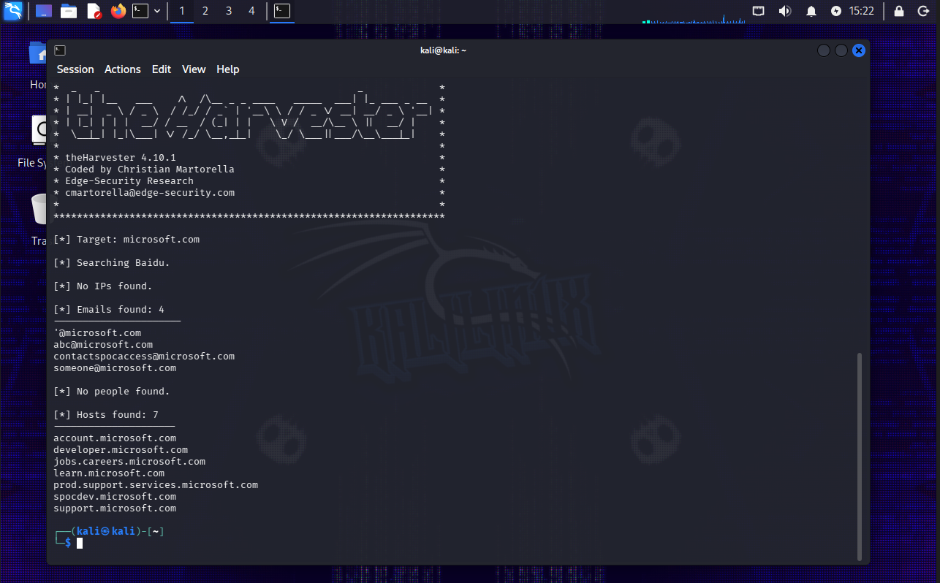
Figure 8 - theHarvester Baidu run showing four email results and seven hosts.

6.2 Task 2 - All Sources, Limit 50
$ theHarvester -d microsoft.com -l 50 -b all
The all-sources run demonstrated a real limitation of reconnaissance tooling: many providers require API keys. The output reported missing or invalid credentials for services including BeVigil, Bitbucket, BuiltWith, Brave Search, Censys, CriminalIP, Dehashed, DNSDumpster, GitHub, HaveIBeenPwned, Hunter, Netlas, Onyphe, PentestTools, ProjectDiscovery, RocketReach, SecurityScorecard, Shodan, Tomba, VirusTotal, WhoisXML and ZoomEye, among others. Some unauthenticated or available sources still continued to return results.
Despite the provider limitations, the combined output became very large. The recorded summary included six ASNs, two interesting URLs, 138 IP addresses, three email addresses and 9,966 host entries. Hudson Rock processing also reported 43 hosts from employee URLs, while Windvane used limited unauthenticated access and a DNS fallback. The large host count is best treated as raw OSINT collection rather than a verified asset inventory; aggregation can include historical records, wildcard-style entries, third-party infrastructure and duplicates.
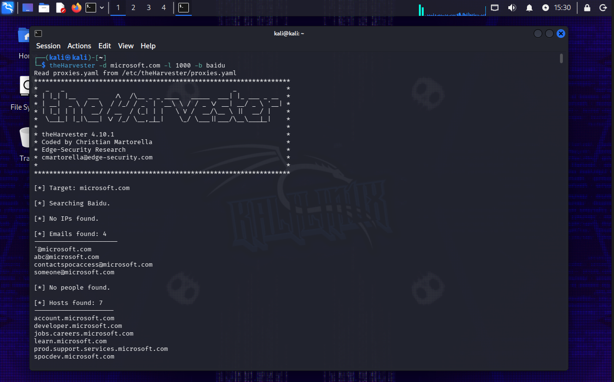
Figure 9 - theHarvester all-sources run. The console output also contained multiple API-key warnings and a very large result set.

7. W2-PM5 - Network Scanning with Zenmap
For the network-scanning module I used the Windows host and my own local network. I first identified the actual LAN addressing with ipconfig, then scanned the /24 subnet in Zenmap and reviewed the host list, services and topology. This was different from the instructor example because my network uses the 192.168.100.0/24 range.

7.1 Local Network Information
Item | Observed value
Windows IPv4 address | 192.168.100.18
Subnet mask | 255.255.255.0 (/24)
Default gateway | 192.168.100.1
Scan range | 192.168.100.0/24
Live IP addresses observed | 192.168.100.1, 192.168.100.18, 192.168.100.53
Live hosts | 3

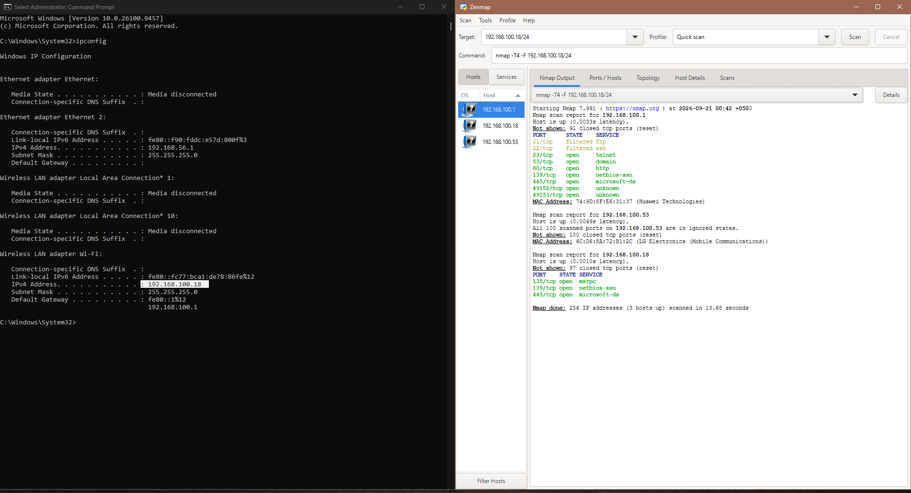
Figure 10 - Windows ipconfig information beside the Zenmap scan output.

7.2 Host and Service Observations
The scan found three live IP addresses. The service view in the captured output showed the following observations:
Host | Observed services / notes
192.168.100.1 | Gateway/router. TCP 23 (telnet), 53 (domain/DNS), 80 (HTTP), 139 (netbios-ssn), 445 (microsoft-ds) and high ports 49152/49153 were shown open; TCP 21 and 22 were shown filtered. Zenmap identified the MAC vendor as Huawei Technologies.
192.168.100.18 | Local Windows host. TCP 135 (msrpc), 139 (netbios-ssn) and 445 (microsoft-ds) were shown open in the scan output.
192.168.100.53 | Live local device. Zenmap identified the MAC vendor as LG Electronics (Mobile Communications).

These are discovery results, not vulnerability findings. An open port only shows that a service was reachable during the scan. Determining whether a service is necessary, securely configured or vulnerable would require a separate authorized assessment.
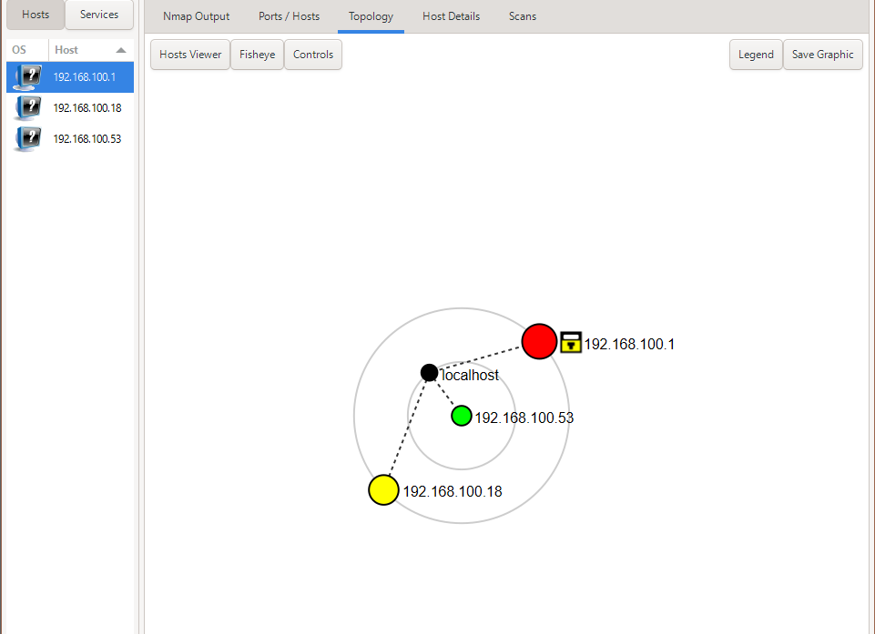
Figure 11 - Zenmap topology showing the three discovered IP addresses and the localhost node.
The topology was also exported to PDF as required by the practical. The saved topology lists 192.168.100.18, 192.168.100.1 and 192.168.100.53 alongside the localhost representation.

Figure 12 - Practice-lab completion screen showing 10/10 questions answered.

8. Findings and Security Relevance
The following table summarizes the main observations. The risk labels are intentionally conservative because these exercises did not include exploitation or vulnerability validation.
Observation | Evidence | Security relevance | Level
Technology/version information publicly visible | WhatWeb: WordPress 7.1.1, WP Download Manager 3.3.58, Apache, jQuery, Bootstrap | Can support asset profiling and later comparison with security advisories. Exposure alone is not a vulnerability. | Low
Origin/server IP resolvable | nslookup/WhatWeb: 192.232.216.135 | Provides infrastructure context and a direct address for the public service. | Low
WordPress REST endpoint and server headers exposed | curl -I: /wp-json/, Apache and cache/cookie headers | Adds application fingerprinting information and visible endpoints. | Low
WAF technology identifiable | Wafw00f: ModSecurity (SpiderLabs) | Reveals part of the defensive stack; also confirms a WAF is present. | Informational
DNS and mail infrastructure publicly enumerable | DNSRecon: NS, MX, A, TXT/SPF and SRV records | Helps map supporting infrastructure and public services. | Low
Public email relationship discoverable | WhatWeb/Maltego: info@networkwalks.com | Public contact data can contribute to OSINT profiles and social-engineering exposure. | Low
Large passive OSINT footprint | theHarvester all-sources run | Demonstrates how many public/historical records can be aggregated. Results require validation. | Informational
Multiple reachable services on local gateway | Zenmap: telnet, DNS, HTTP, NetBIOS/SMB and high ports visible | Services should be reviewed on an internal network and disabled/restricted if unnecessary. | Medium
Windows file-sharing/RPC services visible on LAN | Zenmap: TCP 135, 139 and 445 on 192.168.100.18 | Normal on many Windows networks, but exposure should be limited to trusted local networks and protected by firewall policy. | Medium

9. Problems Encountered and What I Learned
Two parts of Week 2 were especially useful because they did not work perfectly on the first attempt.
Maltego transform configuration: The initial Google-related transform produced an engine-ID warning. I had to work through the transform/provider configuration before I could complete the email relationship task. This reinforced that OSINT platforms are integrations of multiple external data sources, not a single self-contained scanner.
theHarvester API dependencies: The -b all option attempted many providers, but a large number could not run without API keys. Instead of treating the warnings as a failed project, I separated source limitations from successful results and documented both. That is closer to real security work, where tools frequently depend on credentials, quotas, provider changes and incomplete data.
Interpreting results carefully: The week also highlighted the difference between enumeration and vulnerability confirmation. A version string, a DNS record, an email address or an open port is an observation. It becomes a vulnerability only after further testing shows a security weakness.

10. Recommendations
1. Maintain an accurate external asset inventory. Regularly review which domains, subdomains, mail services and public-facing technologies are intentionally exposed.
2. Keep web software and plugins updated. Public version information should be compared against current vendor advisories, and WordPress/plugins should be patched through normal change management.
3. Review unnecessary information disclosure. Where practical, reduce nonessential server/version details and review HTTP headers and public metadata.
4. Review DNS records periodically. Remove obsolete DNS, mail or service records and confirm that public records match intended infrastructure.
5. Keep WAF rules maintained. ModSecurity is visible as a defensive control; its rules, logging and tuning should be maintained rather than assuming the presence of a WAF alone is sufficient.
6. Treat public email exposure as part of the social-engineering surface. Use anti-phishing controls, user awareness, MFA and appropriate mail filtering for public-facing addresses.
7. Restrict internal services to where they are needed. On local networks, services such as Telnet, SMB/NetBIOS and administrative web interfaces should be reviewed. Unnecessary services should be disabled, and required services should be limited by firewall and trusted-network policy.
8. Repeat network discovery periodically. A baseline of known devices makes it easier to identify unexpected hosts appearing on the LAN.
9. Validate OSINT before acting on it. Large aggregated datasets from theHarvester or similar tools may contain stale or unrelated records. Results should be verified with authoritative sources before being treated as confirmed assets.

11. Conclusion
Week 2 gave me practical experience in moving from broad public reconnaissance to more structured OSINT and then to local network discovery. PM1 showed how several small tools can be combined to build a reliable picture of a target. PM3 showed how the same information can be represented visually and how transform configuration affects results. PM4 demonstrated both the value and the limitations of large-scale passive OSINT. PM5 then connected reconnaissance concepts to network-layer host and service discovery on my own LAN.
The most important outcome was learning to separate observations from conclusions. Public software information, DNS records and open ports are useful evidence, but they are not automatically vulnerabilities. Good security reporting should state exactly what was observed, explain why it matters, document limitations and avoid claiming more than the evidence supports.

Appendix A - Commands Used
whois networkwalks.com
whatweb networkwalks.com
nslookup networkwalks.com
curl -I https://networkwalks.com
wafw00f networkwalks.com
dnsrecon -d networkwalks.com
theHarvester -d microsoft.com -l 1000 -b baidu
theHarvester -d microsoft.com -l 50 -b all
ipconfig
Zenmap / Nmap scan of the local 192.168.100.0/24 network

Appendix B - Evidence Inventory
Evidence | Module | Purpose
WHOIS screenshot | PM1 | Domain registration and name-server evidence
WhatWeb screenshot | PM1 | Technology fingerprinting evidence
nslookup screenshot | PM1 | Domain-to-IP resolution evidence
curl -I screenshot | PM1 | HTTP header evidence
Wafw00f screenshot | PM1 | WAF detection evidence
DNSRecon screenshot | PM1 | DNS record enumeration evidence
Maltego graph screenshot | PM3 | Domain-to-email relationship evidence
theHarvester Baidu screenshot | PM4 | Focused OSINT result evidence
theHarvester all-sources screenshot/output | PM4 | Broad-source OSINT and API limitation evidence
ipconfig + Zenmap scan screenshot | PM5 | Local addressing, hosts and services evidence
Zenmap topology screenshot/PDF | PM5 | Network topology evidence
Practice-lab completion screenshot | PM5 | Module completion evidence

