# End User Help Documentation

RvtLock3r has two different end users:

* The vendor, providing a set of elements equipped with protected properties
* The consumer, working with these elements to create the BIM

## Vendor

The owner of the BIM.

Sets the ground truth of the BIM element properties he /she wants to protect.

Under the Ribbon tab `**Lock3r**`, on the validation panel, the push button **Ground Truth** provides the functionality to generate the ground truth data and saving it on the Extensible storage.

The vendor may manually validate a given model to check if any prohibited property was modified using the push button **validate** on the validate panel under `Lock3r` ribbon tab.

The application will run successfully without any error if the model is original or is not modified.

In case any of the protected properties were modified, the application throws an error with a message and a list of element ids of the modified elements.

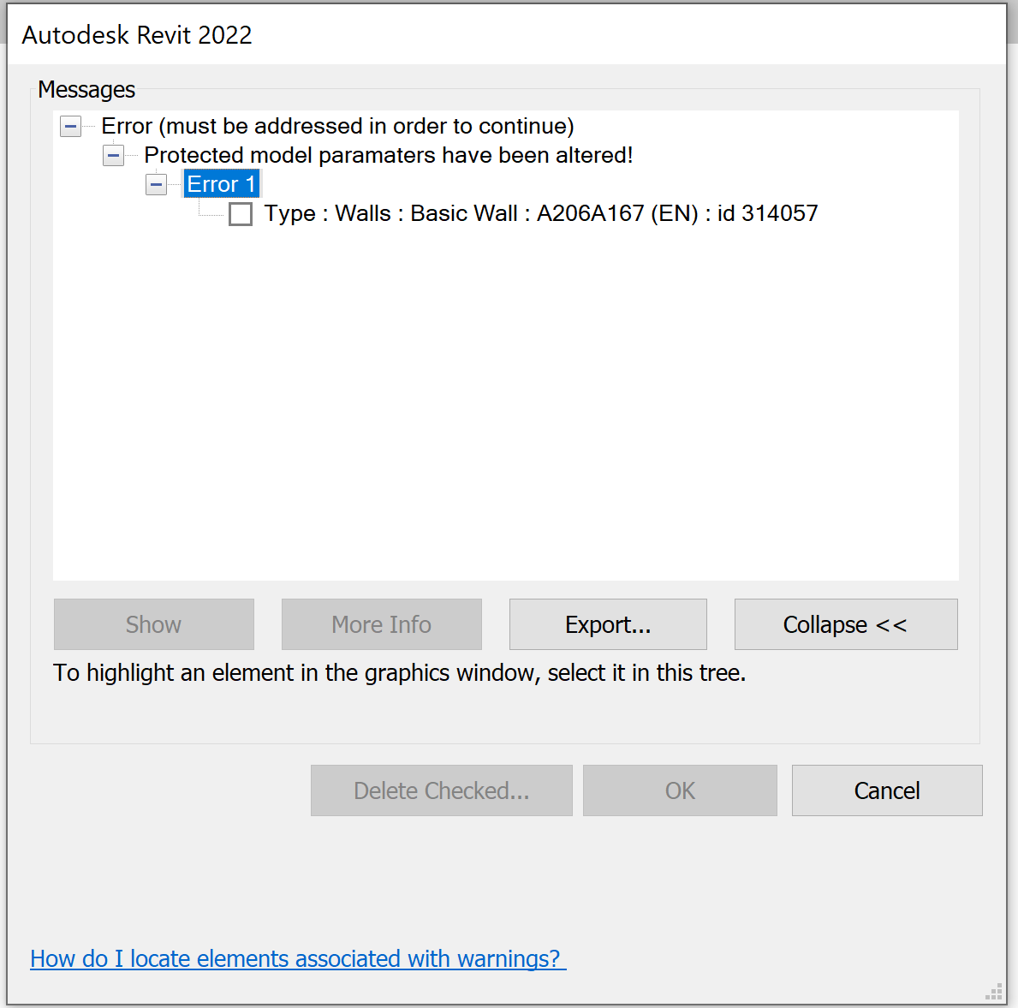

## Consumer

Makes use of the with the vendor elements and their read-only properties.

Prohibited to modify certain properties.

The consumer can interact with model however they wish. The interaction is based on trust that they will not interfere with prohibited properties.

In case the consumer opens a model containing modified properties from whichever source, an informational dialog box is provided to inform the user that the protected properties have been tampered with. They may choose to proceed with the tampered model or contact the vendor for the original data.

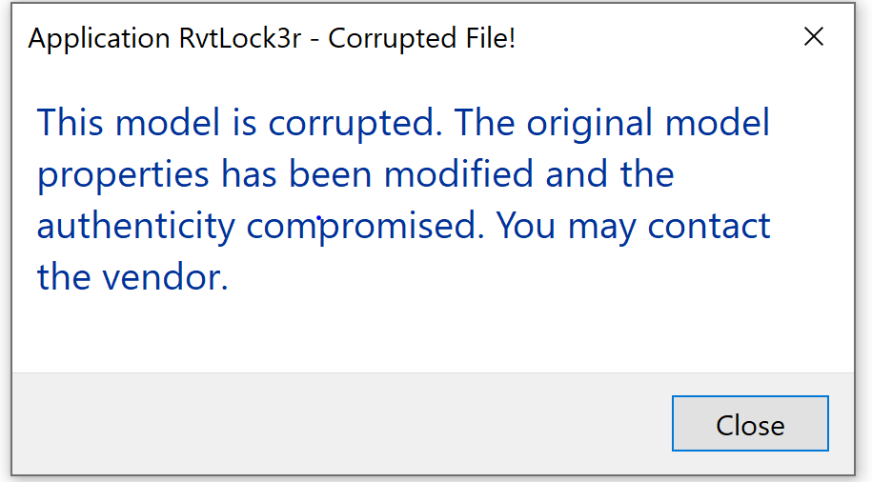

During interaction with the model, the consumer may intentionally or unintentionally modify a protected property. When they try to save, an informational dialog box is provided informing the user that the property is read-only and they are not allowed to modify it.

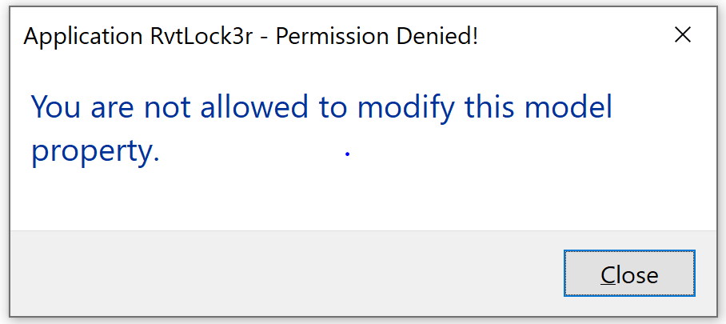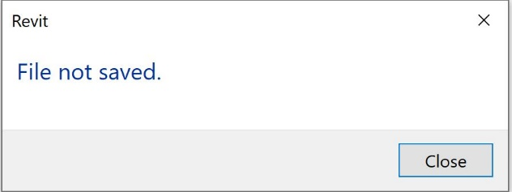

In case the consumer decides to close Revit with open unsaved modifications, an optional dialog box is provided for the consumer’s decision to save or not save the model.

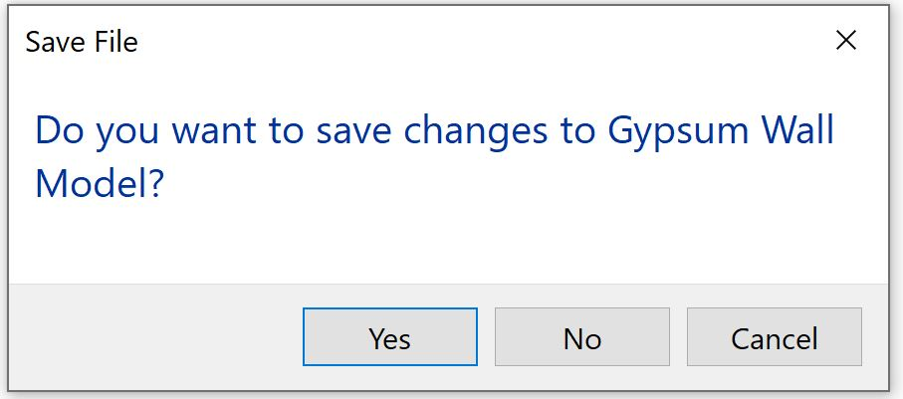

If the consumer chooses `**Yes`**, the model is saved; if `**No`,** it remains unchanged.