Project Report
Wildlife Information System (WIS)

Document Number: WIS-SRS-001

Prepared by:
Muhammad Ehtisham
Fahad Naeem Khan
Muhammad Abbas

4. DESIGN

4.1 Class Diagram
The class diagram explains the master and core classes in the system with their attributes and methods:
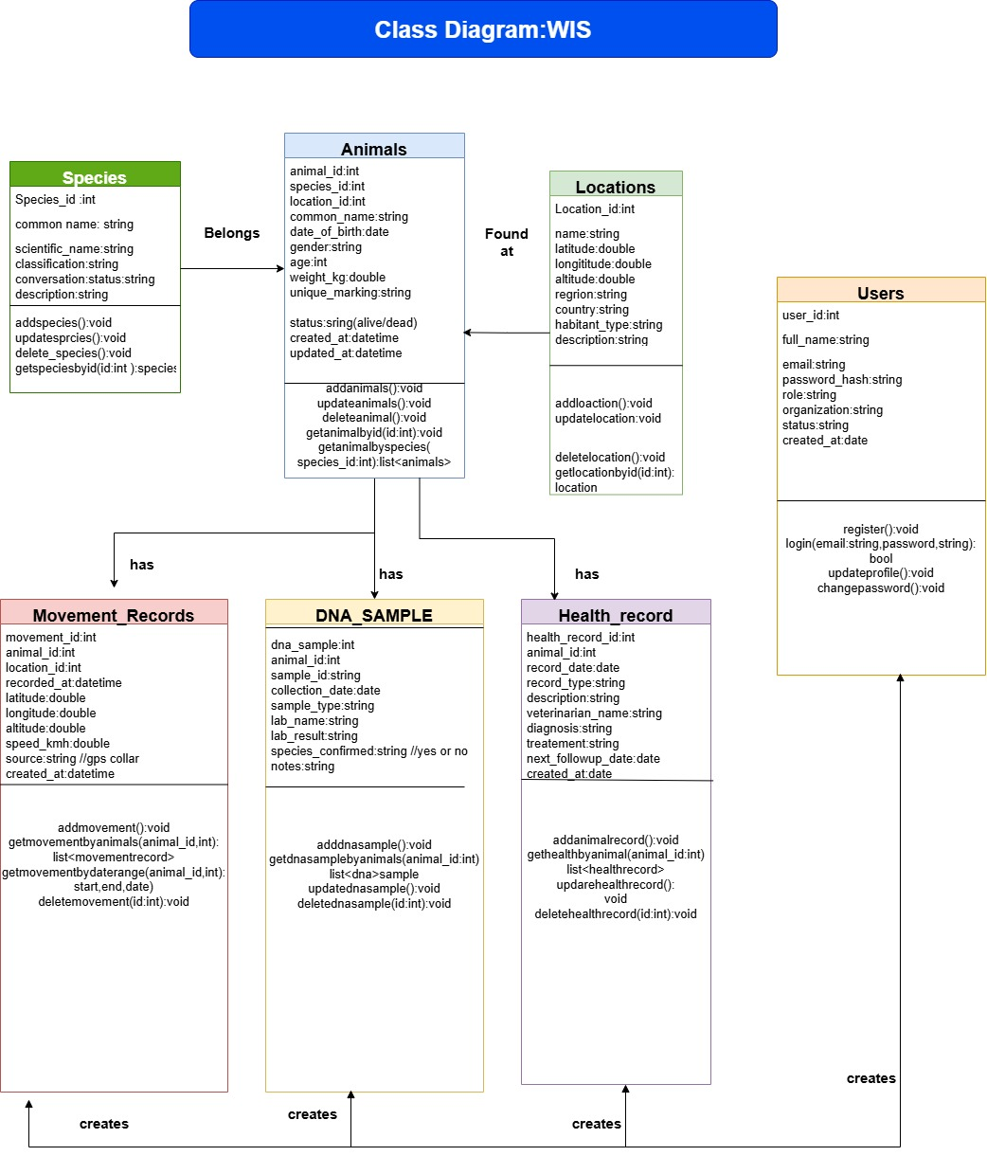
Figure 9: Class Diagram

Class: Animals
Attributes: animalId, speciesId, name, gender, ageYears, weightKg, locationId, addedBy, addedAt
Methods: save(), update(), delete(), getMovementHistory(), getHealthRecords(), getDNASamples()

Class: Movement_Record
Attributes: recordId, animalId, latitude, longitude, recordedAt, source
Methods: save(), getByAnimal(), bulkInsert()

Class: DNA_Sample
Attributes: sampleId, animalId, collectedAt, labName, result, speciesConfirmed
Methods: save(), getByAnimal()

Class: Health_Record
Attributes: healthId, animalId, date, condition, treatment, vetName, vaccineGiven
Methods: save(), update(), getByAnimal()

Class: User
Attributes: userId, name, email, passwordHash, role, createdAt
Methods: login(), logout(), updateProfile(), changePassword()

Class: Species
Attributes: speciesId, commonName, scientificName, conservationStatus, habitat
Methods: save(), getAll(), getByName()

4.2 Sequence Diagram
The detailed sequence for "Query Animal Data via API" is explained :
1. External App sends: GET /api/animals?species=Snow+Leopard/ with Authorization: Bearer <token>
2. The API Gateway verify the JWT token.
3. The Authentication Service verify the token and provides the user role.
4. The Query Controller manages the incoming request and forwards the parameters to the Animal Service.
5. The Animal Service makes an SQL query that manages both the animals table and the species table.
6. The database identify the relevant rows.
7. The Animal Service returns back the result as JSON.
8. The API Gateway responds with an HTTP 200 and the JSON payload.

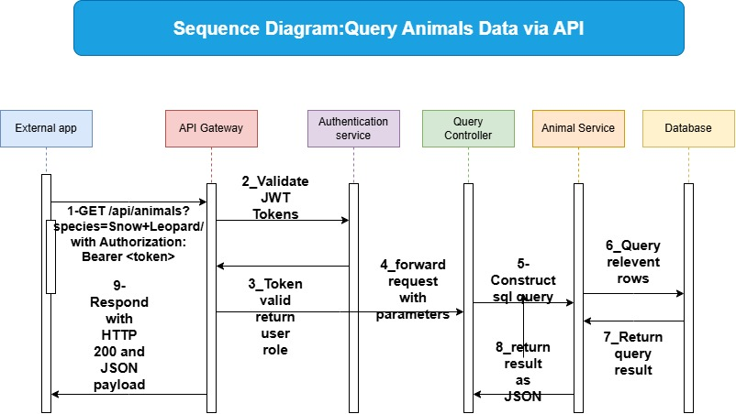

4.3 Architecture
The Wildlife Information System follows a 3-Tier Architecture:
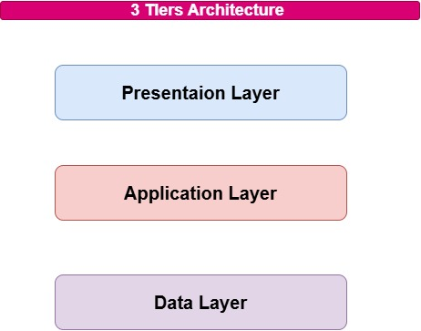
Figure 10: 3-Tier Architecture Diagram
Layer | Component | Responsibility
Presentation Layer | HTML/CSS/JS Web Interface | Basic UI for data entry, search, and export
Application Layer | Node.js + Express.js API Server | Business logic, authentication, query processing
Data Layer | PostgreSQL Database | Stores all wildlife records, users, and audit logs

External users and applications communicate with the Application Layer through the RESTful API. The Application Layer handles authentication, business logic, and data formatting. The Data Layer stores everything persistently

Key API Endpoints
Method | Endpoint | Description
GET | /api/animals | Get list of all animals (with filters)
GET | /api/animals/:id | Get a single animal by ID
POST | /api/animals | Add a new animal record
PUT | /api/animals/:id | Update animal record
DELETE | /api/animals/:id | Delete animal record
GET | /api/animals/:id/movements | Get movement history for an animal
POST | /api/movements/upload | Bulk upload CSV movement data
GET | /api/animals/:id/health | Get health records for an animal
GET | /api/animals/:id/dna | Get DNA records for an animal
POST | /api/auth/login | User login and get JWT token
GET | /api/species | Get list of all species

4.4 Interface Design
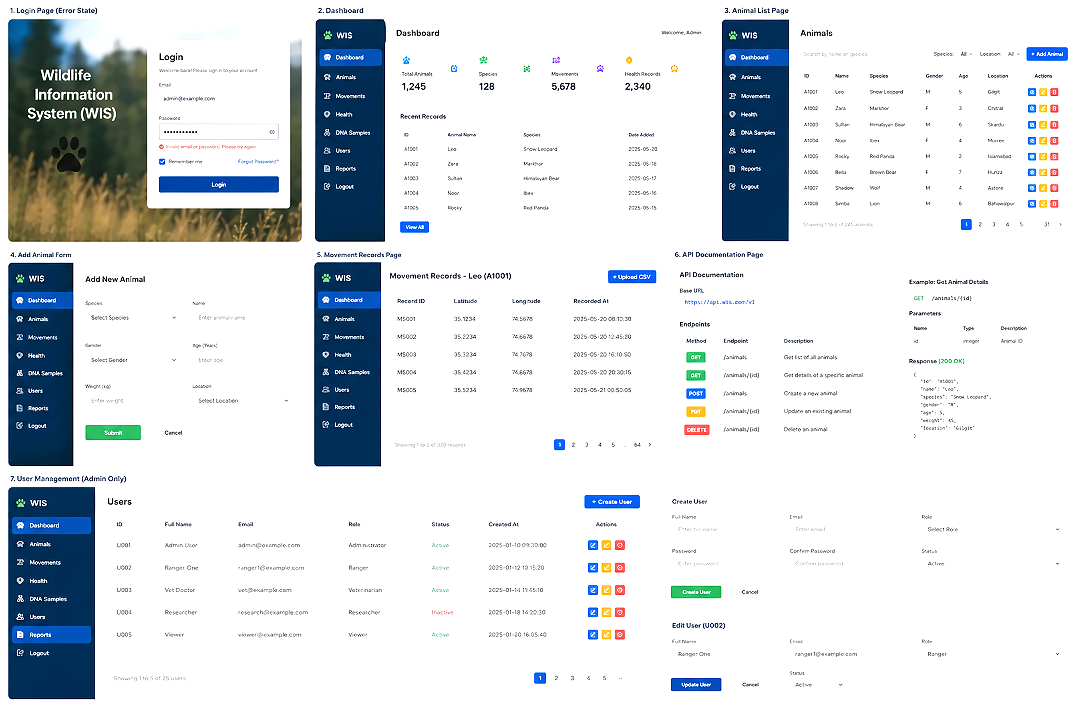
This application would have an easy-to-use web-based interface. The key pages contains:
Login Page : Contains the email address field, password field, and login button. Displays an error message if incorrect.
Dashboard : Has a welcome message, statistics about animals (including total number, number of species, and some recent records), and navigation menu.
Animal List Page : Displays a sortable table containing all animals with View, Edit, and Delete buttons.
Add Animal Form : Contains fields for entering information on the species, name, gender, age, weight, and location of an animal. Includes a submission button for recording the data.
Movement Records Page: Displays a sortable table containing GPS coordinates and the time stamps for a particular animal with an option to add a CSV file.
API Documentation Page: A straightforward page listing APIs, required parameters, and example responses.
User Management (Admin Only): Displays a sortable table containing information on all the users registered with options to create or remove an account.
Design principles: Minimal use of color; the only colors being used are blue and white. All buttons have descriptive names. Errors are displayed in red. Success messages are displayed in green.

