Project Report
Wildlife Information System (WIS)

Document Number: WIS-SRS-001

Prepared by:
Muhammad Ehtisham
Fahad Naeem Khan
Muhammad Abbas

3. ANALYSIS

3.1 Domain Model
The domain model identifies the main real world concepts per entities in the Wildlife Information System and how they relate to each other.
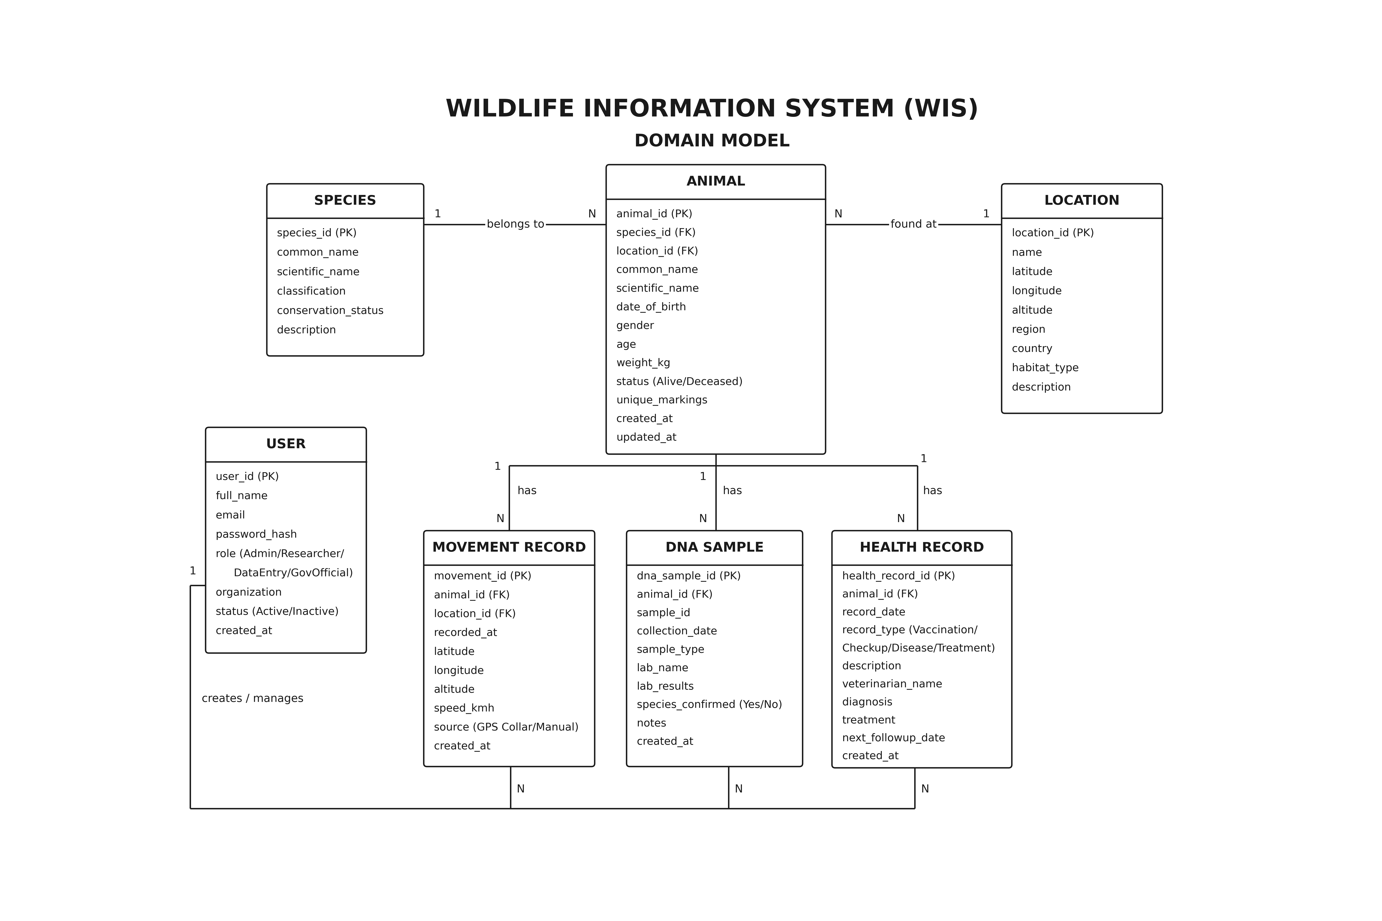
Figure 2: Domain Model — Key Entities and Relationships
Key entities: Animal (central), Species, Movement Record, DNA Sample, Health Record, User, and Location. One Animal has many Movement Records, Health Records, and DNA Samples. Each Animal belongs to one Species.

3.2 Data Flow Diagram (DFD)

Level 0 DFD (Context Diagram)
The Context Diagram shows the system as a single process and identifies all external entities that interact with it.
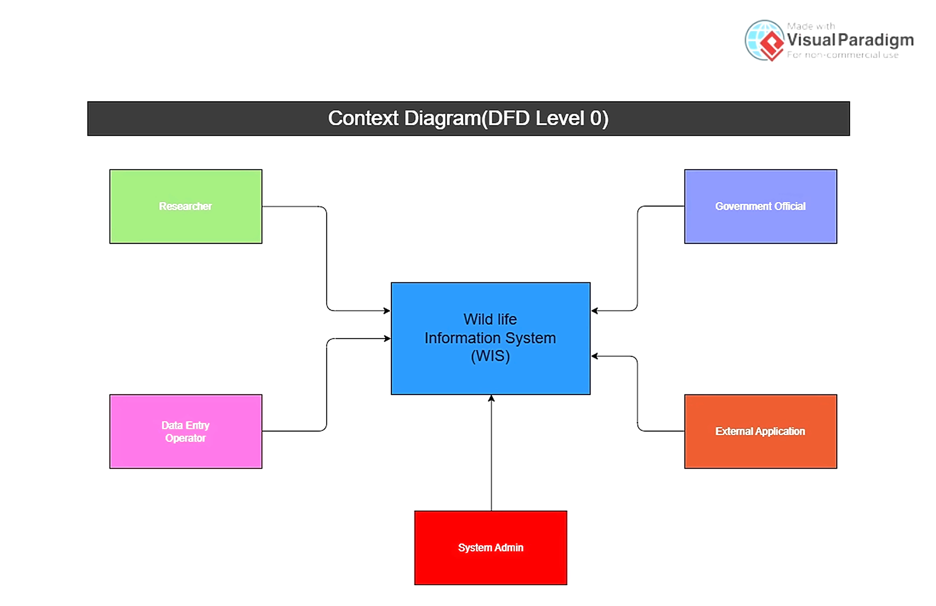
Figure 3: Context Diagram (DFD Level 0)
External Entities: Researcher, Data Entry Operator, System Administrator, Government Official, External Application (through API). The system obtains data about animals, movement details, DNA samples, and animal health information from the Data Entry Operator. Information is requested by the Researcher and Government Officials.

Level 1 DFD
The Level 1 DFD breaks the system into main processes:
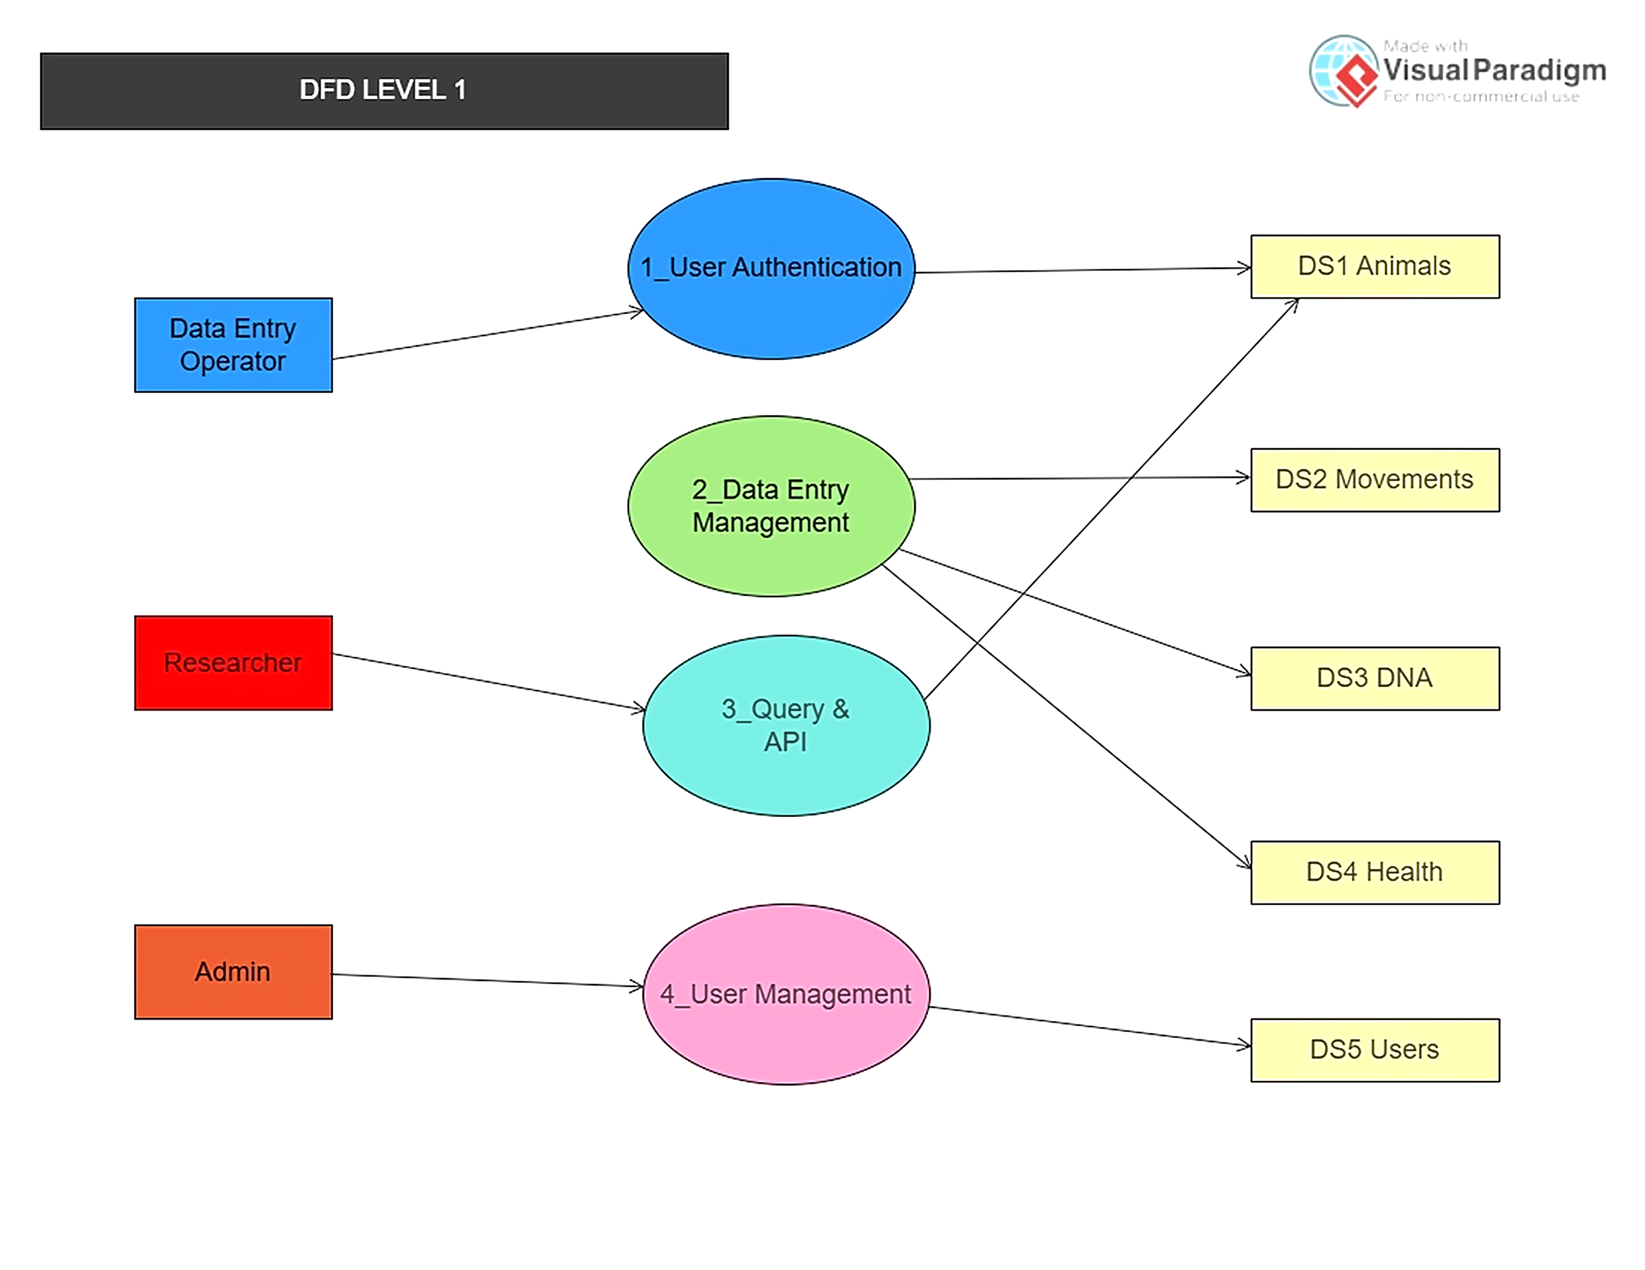
Figure 4: DFD Level 1 — System Processes
Process 1 - User Authentication: Responsible for log-in, token creation, and user-role authorization.
Process 2 - Data Entry Processing: Accepts and processes inputted data on wildlife, including animal details, movement, DNA, and health data.
Process 3 - Data Search & API Request Processing: Accepts requests from researchers or other applications and delivers requested data from the database.
Process 4 - User Processing: An admin user can create, update, or delete user account information.
Data Storage: DS1 - Animals' table, DS2 - Movement's table, DS3 - DNA's table, DS4 - Health's table, DS5 - Users' table.

3.3 System Sequence Diagrams
The following describe the interaction between actors and the system for key use cases:

Sequence 1: Add Animal Record
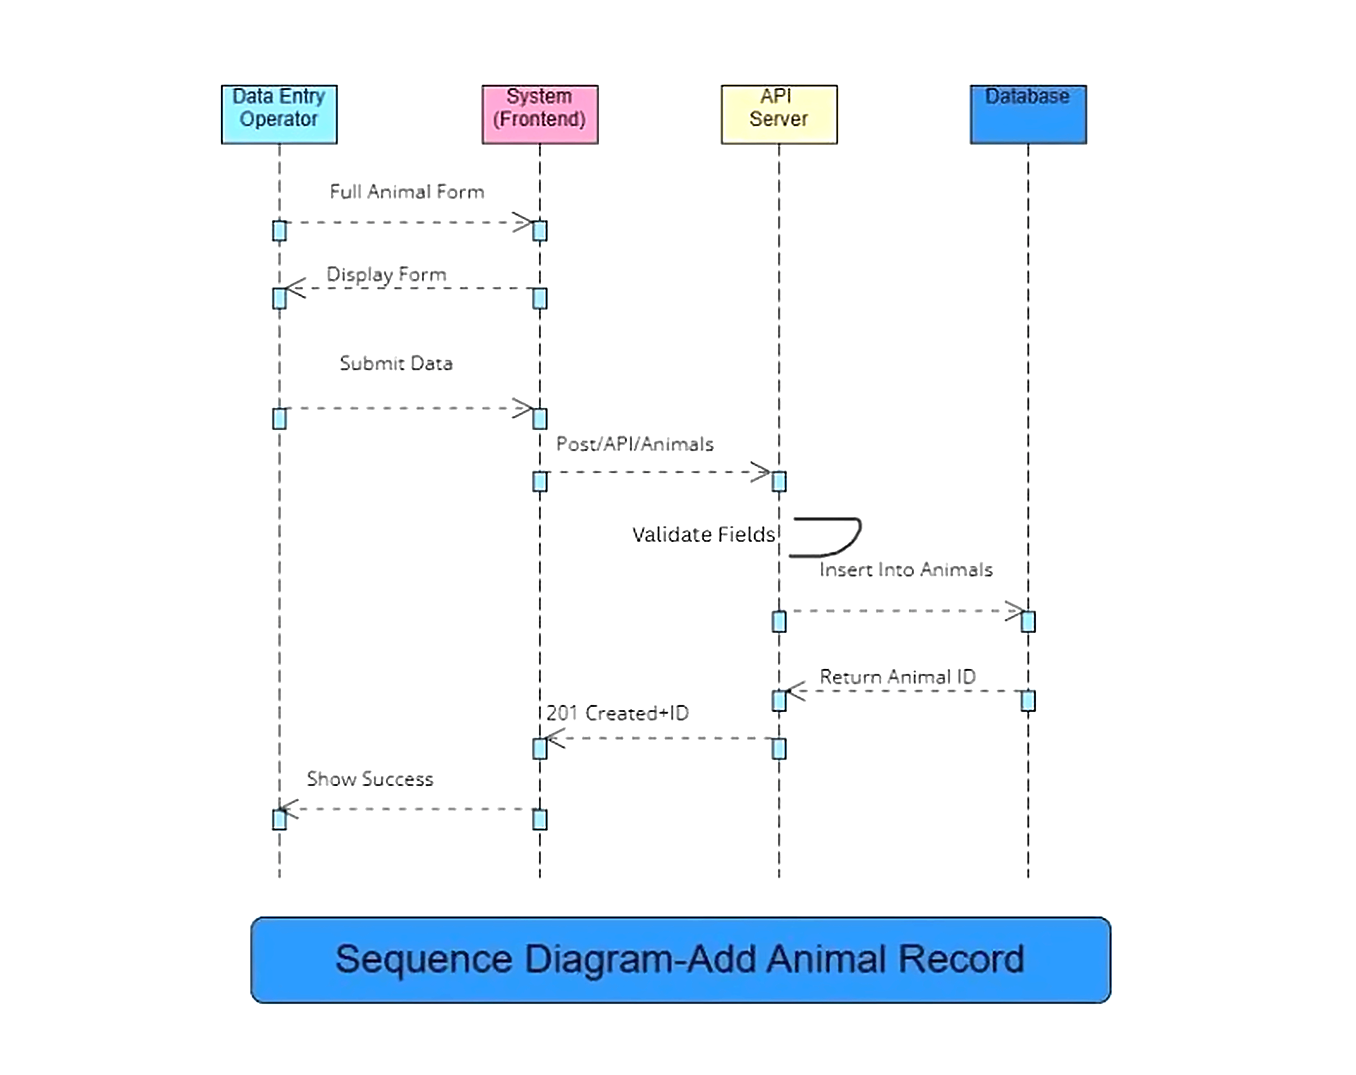
Figure 5: Sequence Diagram — Add Animal Record
- Add Animal Form is launched by Data Entry Operator.
- System displays the form with mandatory fields.
- Details are entered by Operator and Submit button is pressed.
- System validates all mandatory fields.
- System saves the record in Animals database table.
- System responds with success message containing the unique animal ID.

Sequence 2: API Query by Researcher
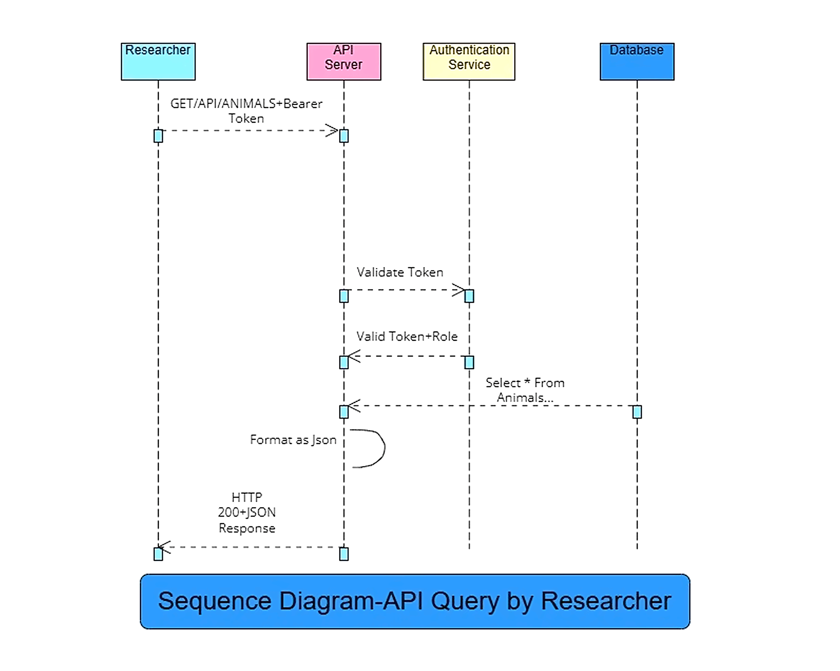
Figure 6: Sequence Diagram — API Query by Researcher
HTTP GET request containing query parameters along with the Bearer Token is sent by the researcher.
Auth Service authenticates the token.
Query is processed by the system on the basis of database.
Response from the system is in the form of JSON data and HTTP status code 200.

3.4 Activity Diagram
The following activity describes the flow when a researcher queries data through the API:
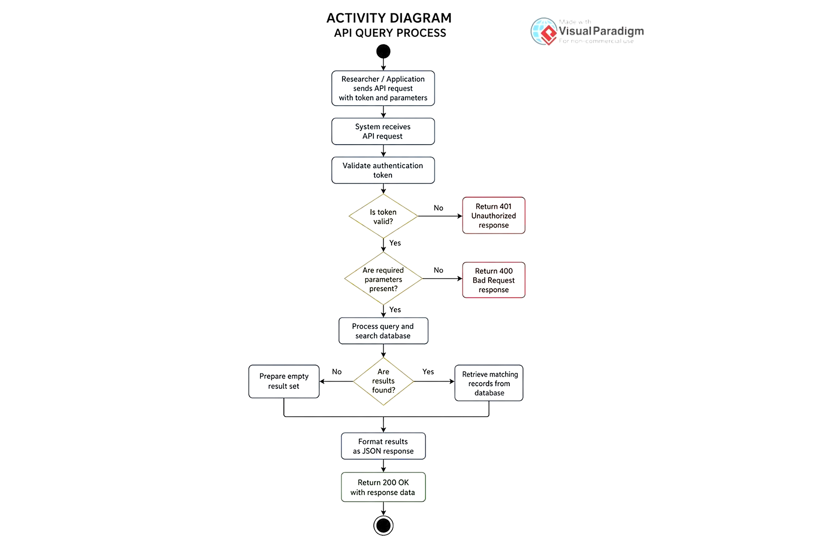
Figure 7: Activity Diagram — API Query Flow
Begin: Researcher sends API request along with token.
Decision: Is the token valid? If No → Send 401 response. If Yes → Proceed further.
Decision: Are all necessary parameters included in the query? If No → Send 400 response. If Yes → Continue.
The system searches the database for the data. If not found → Return an empty array. If found → Format the response in JSON.
System sends 200 response. End.

3.5 Database ER Diagram
The Entity-Relationship diagram shows the complete database schema for the Wildlife Information System, including all tables, primary keys (PK), foreign keys (FK), and their relationships.
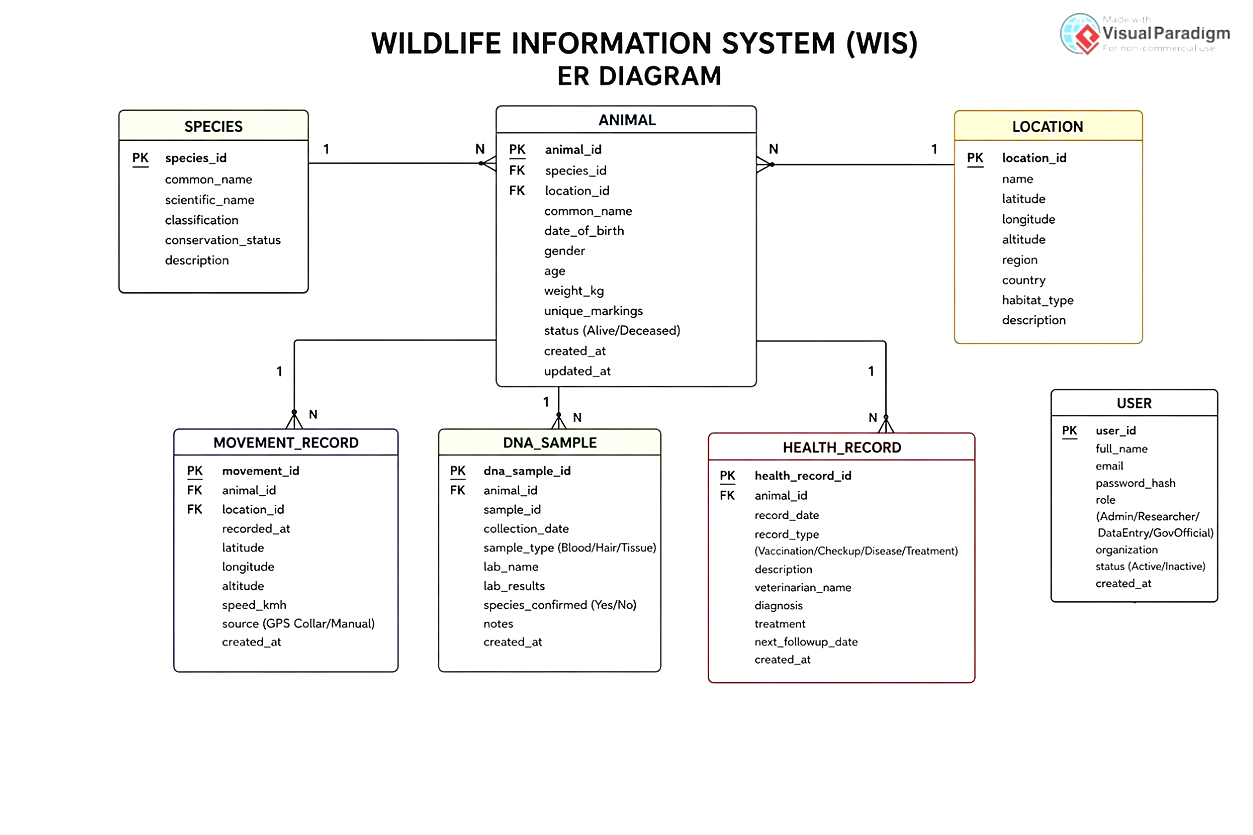
Figure 8: ER Diagram — Database Schema
Key relationships: Animal references Species (FK). Movement_Record, DNA_Sample, and Health_Record all reference Animal (FK). Each User manages multiple operations tracked in audit logs.

