Wildlife Information System (WIS): Analysis and Design
Document No. WIS-SRS-001 · Version 3.0 · October 2026
Prepared by: Muhammad Ehtisham, Muhammad Abbas, Fahad Khan

3. Analysis
This chapter analyses the problem described in Chapter 1: wildlife data is scattered across universities, forest departments and NGOs in paper records, spreadsheets and private databases. WIS stores this data in one central PostgreSQL database and exposes it through a secure RESTful API (JSON) and a basic web interface. The four user roles are Data Entry Operator, Researcher, Government Official and System Administrator. Data arrives from field researchers, IoT tracking devices and lab results. The items Chapter 1 puts out of scope (live tracking maps, automatic alerts, AI/ML, mobile apps, multiple languages) are not analysed here.

3.1 Domain Model
The domain model shows the real-world concepts WIS must record and how they relate, independent of any technology. The Animal is the central concept: it belongs to one Species, is found at a Location, and accumulates Movement Records, DNA Samples and Health Records over time. Users create these records.
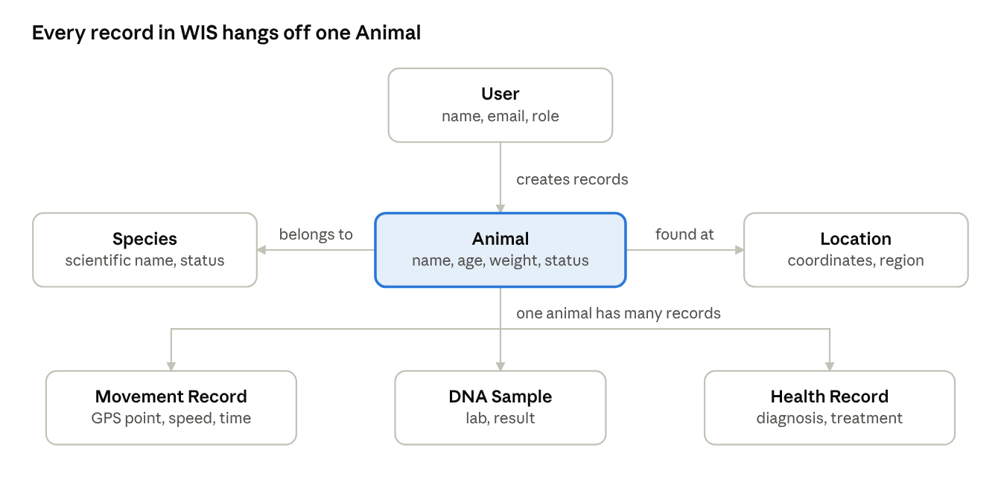
domain model · 7 concepts
Users create records; each animal links to one species and one location and owns many movement, DNA and health records.
Domain concepts
Concept | Description | Key attributes
Species | A kind of animal, for example Snow Leopard | common name, scientific name, classification, conservation status, description
Animal | An individual animal tracked by the system | name, gender, date of birth / age, weight (kg), unique marking, status (alive/dead)
Location | A place where animals are found or recorded | name, latitude, longitude, altitude, region, country, habitat type
Movement Record | One GPS reading for an animal | latitude, longitude, altitude, speed (km/h), recorded time, source (for example GPS collar)
DNA Sample | A genetic sample analysed by a lab | sample ID, collection date, sample type, lab name, lab result, species confirmed
Health Record | A veterinary event for an animal | record date, record type, diagnosis, treatment, veterinarian, next follow-up date
User | A person who logs in to WIS | full name, email, role, organization, status
Relationships
From | Relationship | To | Multiplicity
Animal | belongs to | Species | many animals to one species
Animal | is found at | Location | many animals to one location
Animal | has | Movement Record | one animal to zero or more records
Animal | has | DNA Sample | one animal to zero or more samples
Animal | has | Health Record | one animal to zero or more records
User | creates | Movement, DNA and Health records, and animals | one user to many records
Proposed access by role (to be confirmed with stakeholders)
Role | Access
Data Entry Operator | Create and update animal, movement, health and DNA records
Researcher | Search, view and export data through the web interface and API
Government Official | Search, view and export data; view dashboard statistics
System Administrator | Full access, plus user management

3.2 Data Flow Diagram (DFD)
Level 0 (context). WIS is a single process that exchanges data with six external entities.
External entity | Sends to WIS | Receives from WIS
Data Entry Operator | Animal, species, location, health and DNA data; CSV files | Confirmation or validation errors
Researcher | Search filters, API requests, export requests | Result lists, JSON and CSV data
Government Official | Search filters, report requests | Result lists, dashboard statistics, exports
System Administrator | User account details | User list, confirmations
IoT tracking device / field system | GPS readings (source: GPS collar) | Acknowledgement
Laboratory | DNA sample results | Acknowledgement
Level 1. The system is decomposed into seven processes and five data stores.
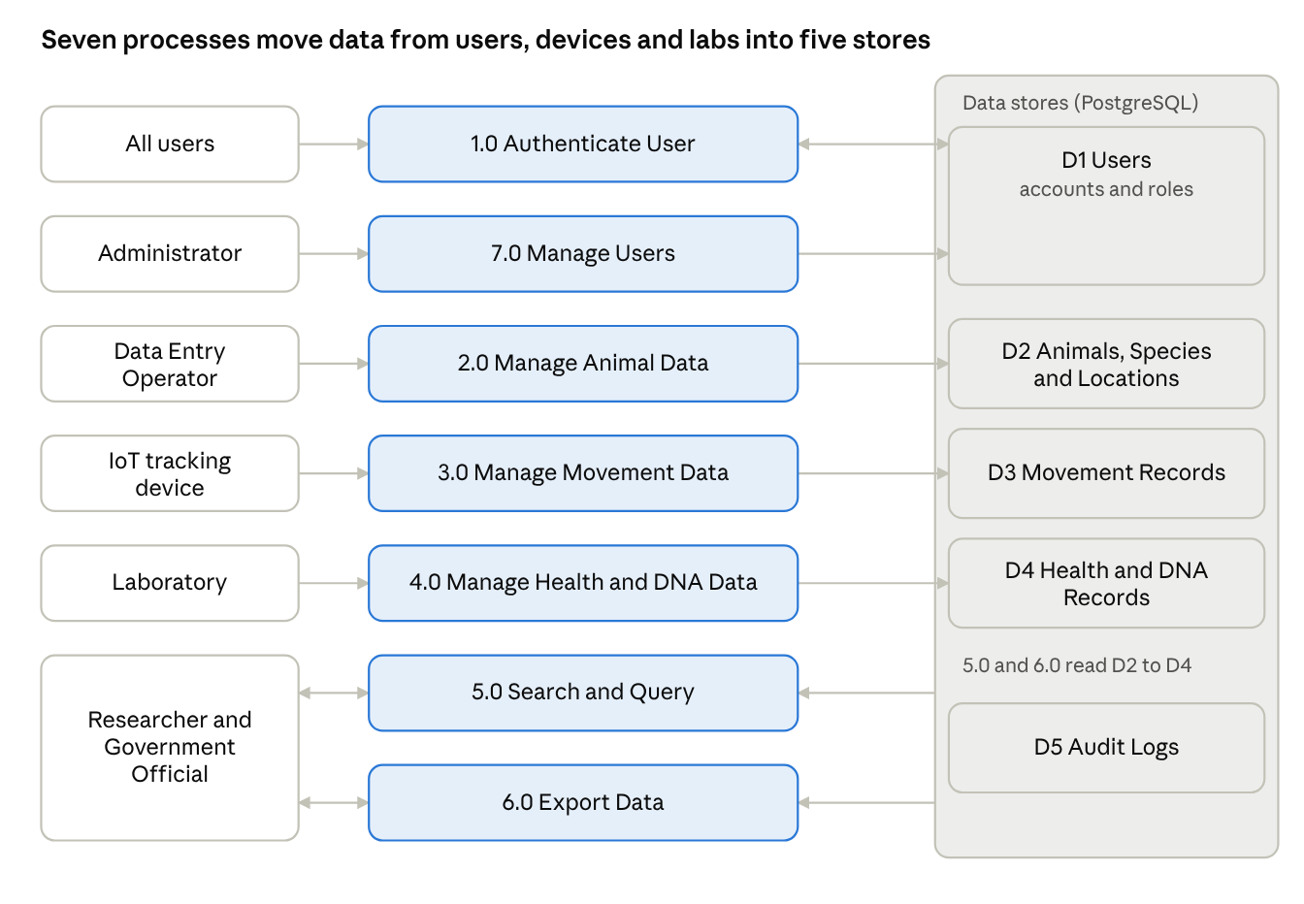
Level 1 DFD · 7 processes, 6 entities, 5 stores
Process | Purpose
1.0 Authenticate User | Checks email and password, issues a JWT, verifies the token and role on every request
2.0 Manage Animal Data | Adds, updates, deletes and views animals, species and locations
3.0 Manage Movement Data | Accepts GPS data from devices and bulk CSV uploads, validates and stores it
4.0 Manage Health and DNA Data | Stores veterinary records and lab DNA results
5.0 Search and Query | Handles filtered searches from the web interface and the REST API
6.0 Export Data | Produces JSON and CSV exports of query results
7.0 Manage Users | Creates, edits and removes user accounts (administrator only)

Data store | Contents
D1 Users | Accounts, password hashes, roles
D2 Animals and Species | Animal profiles, species, locations
D3 Movement Records | GPS readings
D4 Health and DNA Records | Veterinary records and lab DNA results
D5 Audit Logs | Record of who changed what and when

3.3 System Sequence Diagrams
A system sequence diagram treats WIS as a black box and shows only the messages between an actor and the system. The diagram below covers Add Animal Record; the tables cover the other key use cases.
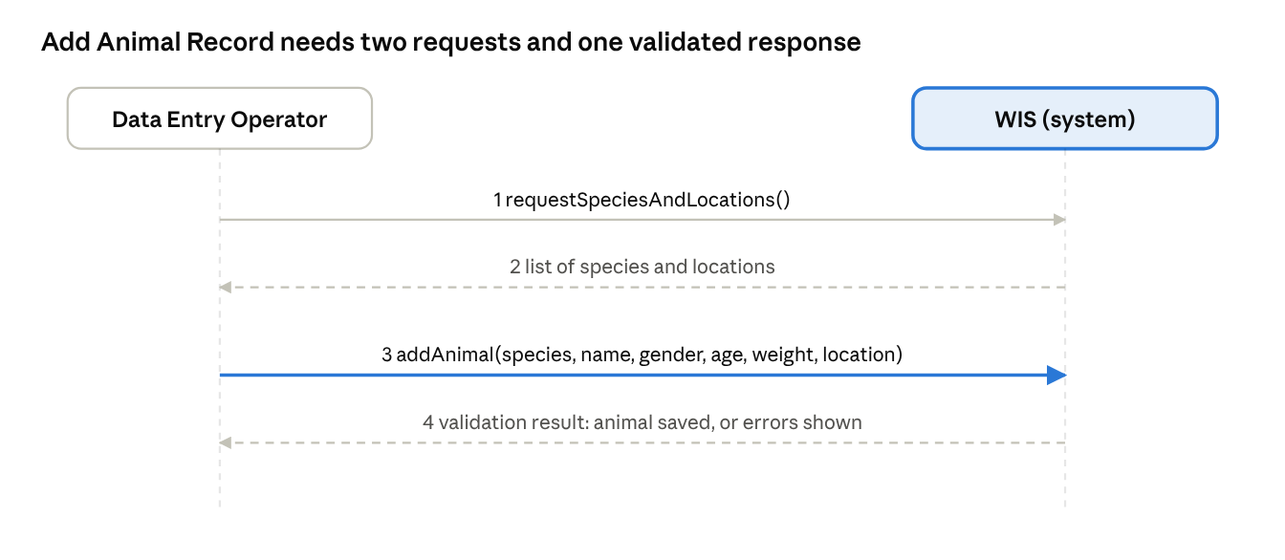
SSD · Add Animal Record · 4 messages
SSD 1: Login
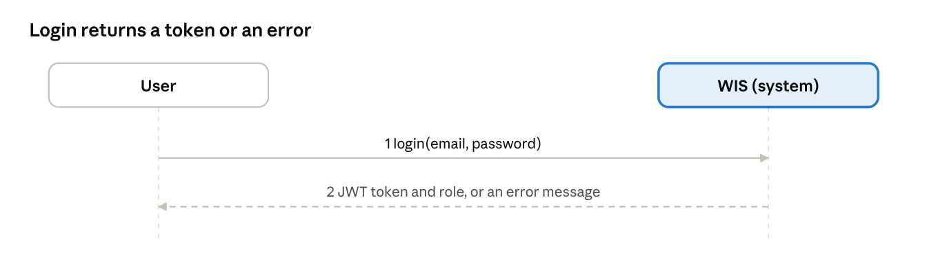
SSD 1 · Login
# | Actor to System | System response
1 | login(email, password) | Valid: JWT token and role returned. Invalid: error message
SSD 2: Add Animal Record (diagram above)
# | Actor to System | System response
1 | requestSpeciesAndLocations() | List of species and locations
2 | addAnimal(species, name, gender, age, weight, location) | Validation result
3 | (if valid) | Animal saved, success message with animal ID
SSD 3: Upload Movement CSV
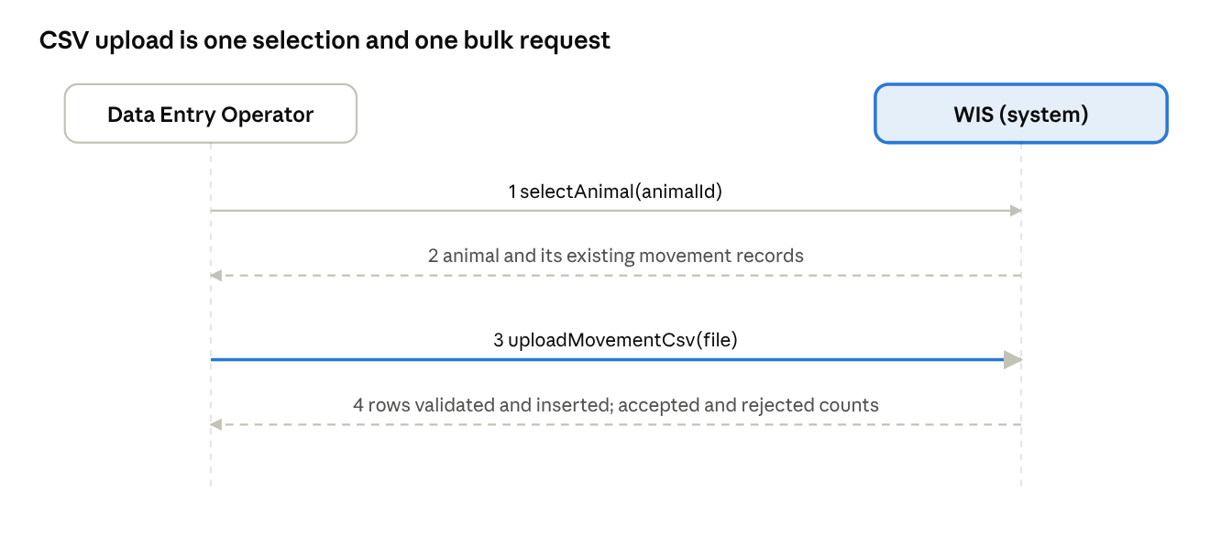
SSD 3 · Upload Movement CSV
# | Actor to System | System response
1 | selectAnimal(animalId) | Animal and existing movement records
2 | uploadMovementCsv(file) | Rows validated and inserted; count of accepted and rejected rows
SSD 4: Query Animal Data via API
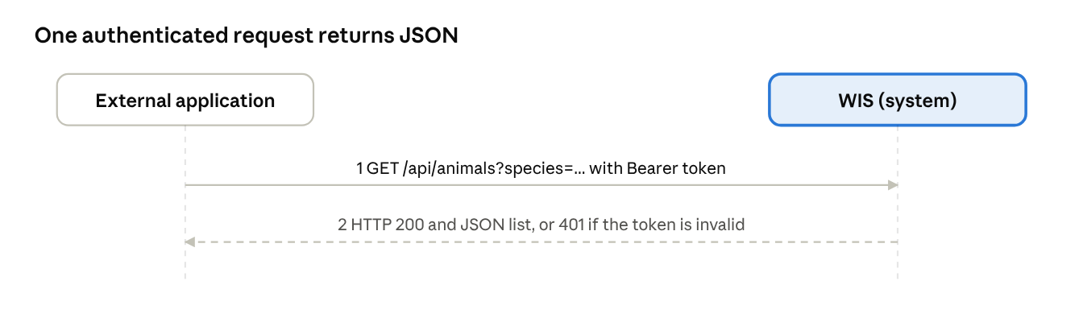
SSD 4 · Query Animal Data via API
# | Actor to System | System response
1 | GET /api/animals?species=... with Bearer token | HTTP 200 and JSON list, or 401 if the token is invalid
SSD 5: Create User (administrator)
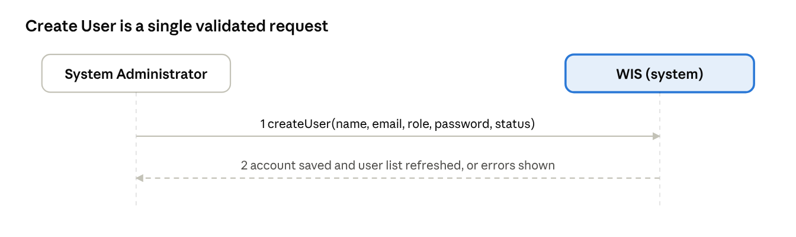
SSD 5 · Create User
# | Actor to System | System response
1 | createUser(name, email, role, password, status) | Validation result
2 | (if valid) | Account saved, user list refreshed

3.4 Activity Diagram
The activity diagram models the main data-entry workflow: a user logs in, chooses to enter a record manually or upload a CSV file, the system validates the data, and valid data is stored.
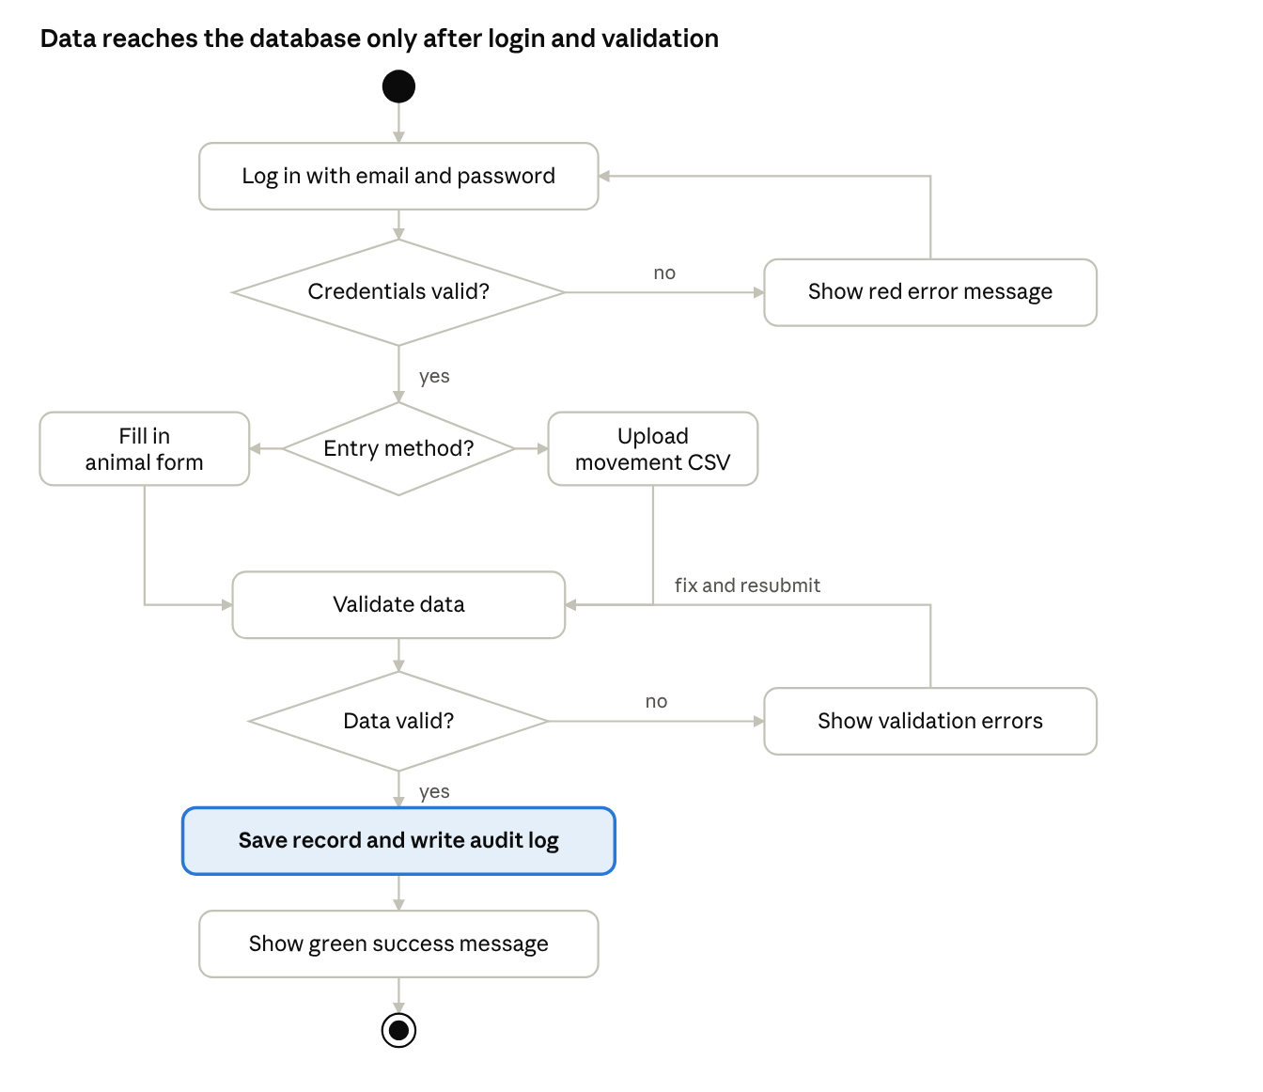
activity diagram · 2 decisions, 1 loop each

3.5 Database ER Diagram
The ER diagram maps the domain model to PostgreSQL tables. Primary keys are shown as PK and foreign keys as FK. Each data table also carries a created_by foreign key to users, which supports the audit trail.
↗ ER diagram · 8 tables
Table | Columns
species | species_id (PK), common_name, scientific_name, classification, conservation_status, description
locations | location_id (PK), name, latitude, longitude, altitude, region, country, habitat_type, description
animals | animal_id (PK), species_id (FK), location_id (FK), name, date_of_birth, gender, weight_kg, unique_marking, status, created_by (FK), created_at, updated_at
movement_records | movement_id (PK), animal_id (FK), location_id (FK), recorded_at, latitude, longitude, altitude, speed_kmh, source, created_at
dna_samples | dna_sample_id (PK), animal_id (FK), sample_id, collection_date, sample_type, lab_name, lab_result, species_confirmed, notes
health_records | health_record_id (PK), animal_id (FK), record_date, record_type, description, veterinarian_name, diagnosis, treatment, next_followup_date, created_at
users | user_id (PK), full_name, email (unique), password_hash, role, organization, status, created_at
audit_logs | log_id (PK), user_id (FK), action, entity, entity_id, logged_at
and success messages in green.

