- Create Engine is used to create connection between data base and your fast api app
- ORMs are used to convert your code python class code into SQL queries in order to perform operations on data bases
- Declarative base when you want to convert a python class into SQL table then you use declarative_base class
- By default, Pydantic expects data in the form of python dictionaries but you use ORM mode to true so that
- Every Time when you open your data base in Fast Api also close your database after doing your work otherwise program will crash
- In Fast while coding your back-end dev project you create a data model file in you create data model using SQL alchemy consider it like SQL tables
- Then in Schemas file you apply data validation on your data models and then you use the schemas file to create data by applying HTTP request on it
- There are two libraries in Fast API which we used for applying security using JWT one is passlib and the other one is python-jose library
- Passlib library is used for hashing of your password and python jose library is used for creating tokens and make sure the all the routes are protected by using token
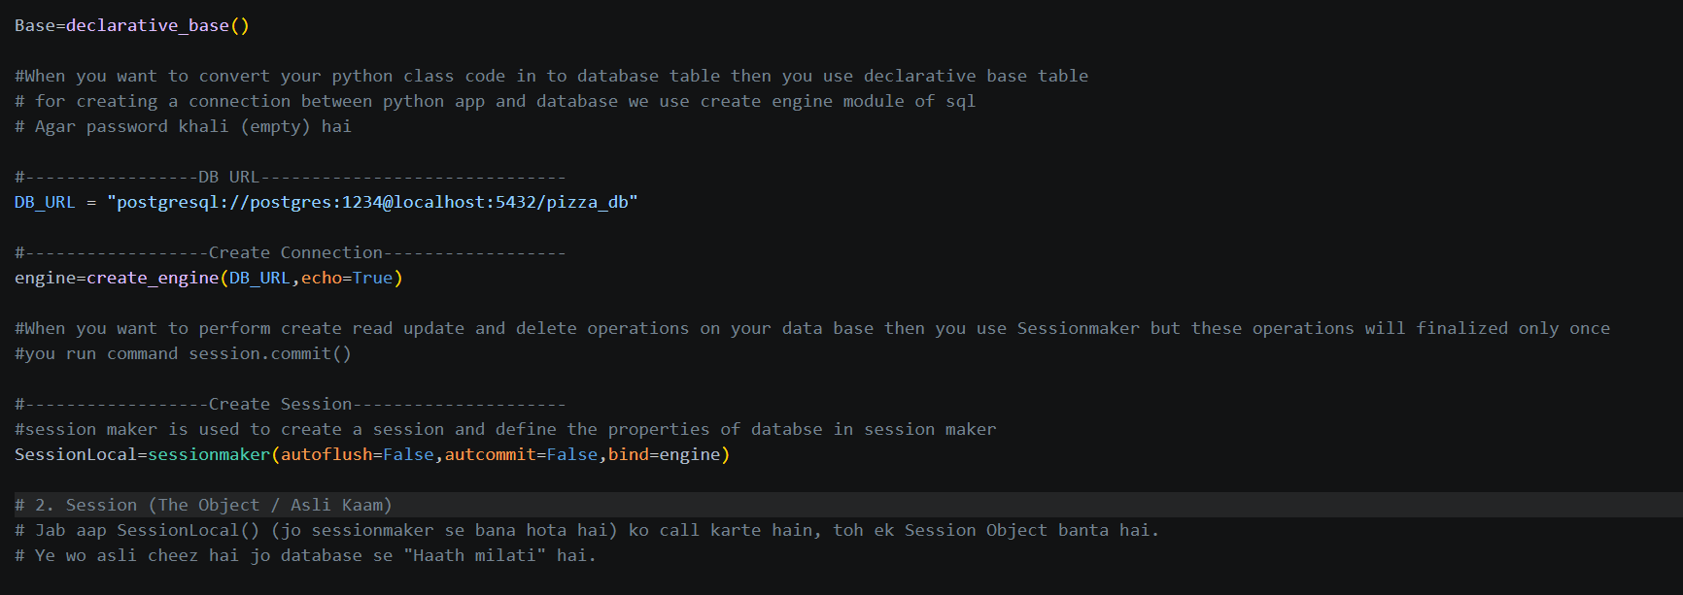

API is used for communication between frontend and backend. GET is used to fetch data. Password is used for login authentication. After login, a Bearer token (JWT) is used in requests instead of sending the password again.
Pydantic always expects input data from your side in the form of dictionary
Understanding Pydantic vs. ORM (SQLAlchemy)
In FastAPI development, we use Pydantic Models for data validation and SQLAlchemy Models for database interaction. By default, these two don't talk to each other easily because they handle data differently.
1. Default Behavior (Without from_attributes = True)
By default, Pydantic is designed to work with Python Dictionaries. It expects data in a key: value format, like data["username"].
- The Problem: When you fetch data from a database using SQLAlchemy, it returns a Class Instance (Object), not a dictionary.
- The Error: If you try to pass this database object directly to a Pydantic model, Pydantic will fail. It will throw a ValidationError because it cannot find the data in the "Object" format (e.g., user. username).
2. The Solution: from_attributes = True (formerly orm_mode)
When we set from_attributes = True inside the Pydantic model_config, we give Pydantic the "power" to read data from Objects just as easily as from Dictionaries.
- How it works: Pydantic will now look for data in two ways:
  - Dictionary Style: data["username"]
  - Attribute Style: data. username (This is how SQLAlchemy provides data).

