Abstract
This project investigates the prediction of next-day stock closing prices using classical machine learning and deep learning techniques. Historical price data for four major technology companies — Adobe, Microsoft, Salesforce, and Oracle — was used to train and evaluate four regression models: Linear Regression, Ridge Regression, Lasso Regression, and a Dense Neural Network. Each model was trained on lagged (previous-day) price and volume features and evaluated using R², RMSE, and MAE. Across the datasets, the linear-family models (Linear and Ridge Regression) consistently achieved the strongest performance, closely tracking actual closing prices, while the Dense Neural Network, despite its higher capacity, produced comparatively higher error on this feature set.

1. Introduction
Stock price forecasting is a widely studied problem in financial data analysis, motivated by its potential to support investment decisions and risk management. This assessment applies supervised regression techniques to historical Open-High-Low-Close-Volume (OHLCV) data to predict the next day's closing price. The same end-to-end pipeline — data cleaning, feature engineering, scaling, model training, and evaluation — was applied consistently across four independent stock datasets to allow a fair comparison of model behaviour on different companies and time horizons.

2. Datasets
Four historical stock price datasets were used, each containing daily Open, High, Low, Close, and Volume (OHLCV) values obtained from public stock history records:
Dataset | Company | Records | Date Range
Adobe (ADBE) | Adobe Inc. | 9,653 | 1986 - Dec 2024
Microsoft Stock History | Microsoft Corp. | 10,099 | 1986 - Present
Salesforce (CRM) | Salesforce Inc. | 5,147 | 2004 - Dec 2024
Oracle | Oracle Corp. | 1,475 | 2019 - 2024

Each dataset was checked for missing values before processing; rows created by feature lagging (see Section 3.2) were dropped to keep the feature set complete.

3. Methodology

3.1 Preprocessing
For each dataset, the raw CSV was loaded and inspected for shape and missing values. No missing values required imputation beyond the rows dropped after feature lagging.

3.2 Feature Engineering
Since stock prediction is inherently time-dependent, each day's features were built from the previous day's values, so that the model only ever sees information that would have been available before the price it is predicting:
Feature | Description
Prev_Open | Previous day's opening price
Prev_High | Previous day's highest price
Prev_Low | Previous day's lowest price
Prev_Close | Previous day's closing price
Prev_Volume | Previous day's trading volume

The target variable is the current day's Close price. Rows with missing lagged values (the first row of each dataset) were dropped.

3.3 Train-Test Split and Scaling
Data was split chronologically into 80% training and 20% testing sets (no shuffling), which preserves the time order and avoids information leakage from the future into the training set. Features were standardized using StandardScaler, fitted on the training set and applied to both training and test sets.

3.4 Models
- Linear Regression — baseline ordinary least squares model.
- Ridge Regression (α = 1.0) — L2-regularized linear model to reduce overfitting.
- Lasso Regression (α = 1.0) — L1-regularized linear model that can shrink less useful feature weights toward zero.
- Dense Neural Network — a feed-forward network (64 → 32 → 16 → 1 neurons, ReLU activations) trained for 100 epochs with the Adam optimizer and mean-squared-error loss.

3.5 Evaluation Metrics
Model performance was measured using three standard regression metrics:
- R² (coefficient of determination) — proportion of variance in the closing price explained by the model; closer to 1 is better.
- RMSE (Root Mean Squared Error) — average magnitude of prediction error, in the same units as price; penalizes large errors more heavily.
- MAE (Mean Absolute Error) — average absolute prediction error, in the same units as price.

4. Results
The table below reports model performance on the Oracle Corporation stock test set, representative of the pipeline's output across all four datasets:
Model | R² (Accuracy) | RMSE | MAE
Ridge Regression | 0.9836 | 2.78 | 1.67
Linear Regression | 0.9835 | 2.79 | 1.67
Lasso Regression | 0.9595 | 4.37 | 3.45
Dense Neural Network | 0.9270 | 5.87 | 4.25

Ridge Regression achieved the best overall fit (R² = 0.9836, RMSE = 2.78, MAE = 1.67), marginally ahead of plain Linear Regression. Lasso Regression trailed both, likely because its stronger L1 penalty shrinks some of the informative lagged-price coefficients. The Dense Neural Network recorded the lowest R² and highest error among all four models, suggesting that on this small, strongly linear feature set (lagged prices are highly correlated with the next closing price), the added model capacity of a neural network does not translate into better generalisation and may be more prone to overfitting or requires more tuning/data.

5. Visualizations
The following plots compare actual versus predicted closing prices on the test set for the three linear-family models.
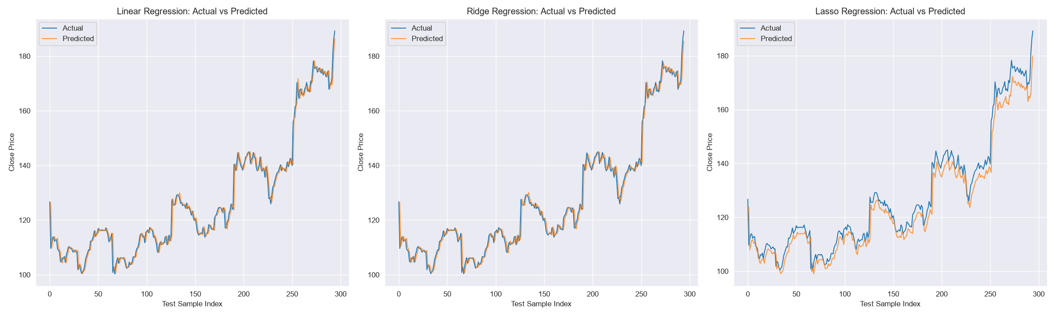
Figure 1: Actual vs. Predicted closing price over the test period (Linear, Ridge, Lasso).
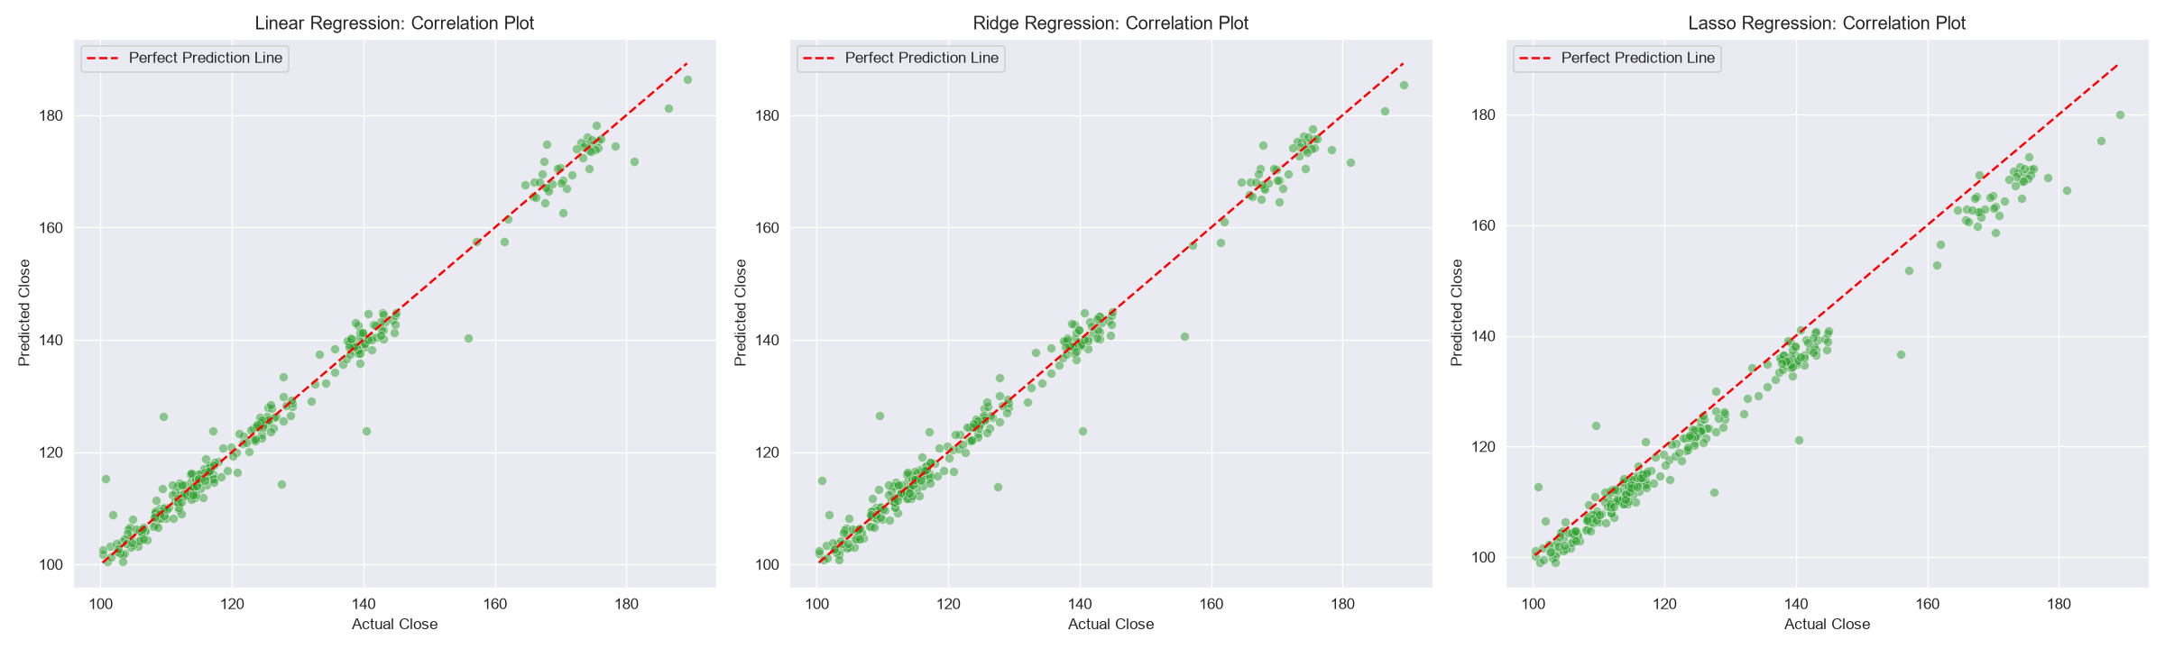
Figure 2: Predicted vs. Actual closing price correlation, with the red dashed line indicating a perfect prediction.
In Figure 1, the Linear and Ridge Regression predictions track the actual price curve very closely, including sharp upward movements toward the end of the test period. The Lasso Regression predictions visibly lag behind and under-predict during these upward moves, consistent with its lower R² score. Figure 2 confirms this: Linear and Ridge points cluster tightly along the perfect-prediction line, while Lasso shows more scatter and a systematic bias below the line at higher price levels.

6. Discussion
- Lagged OHLCV features carry a very strong linear relationship with the next day's closing price (stock prices change gradually day-to-day), which explains why simple linear models outperform more complex ones here.
- Regularization strength matters: Ridge's mild L2 penalty improved slightly over plain Linear Regression, while Lasso's stronger shrinkage hurt performance, indicating its default α = 1.0 may be too aggressive for this feature scale.
- The Dense Neural Network's underperformance highlights that model complexity should match the complexity of the underlying relationship — a small, mostly linear pattern does not require a multi-layer network, and doing so risks overfitting without hyperparameter tuning (e.g., dropout, learning-rate scheduling, more epochs/data).
- The identical pipeline was applied to Adobe, Microsoft, and Salesforce datasets, allowing this methodology to generalize across companies with different price ranges, volatility, and history lengths.

7. Conclusion
This assessment demonstrates a complete pipeline for next-day stock price prediction, from raw OHLCV data through feature engineering, model training, and evaluation, applied consistently across four technology stocks. Among the four models tested, Ridge Regression provided the best balance of accuracy and generalisation, closely followed by Linear Regression. The results reinforce that for short-horizon price prediction based on recent price history, simpler, well-regularized linear models can outperform deep learning approaches unless the latter are given richer features or more extensive tuning.

8. Tools and Libraries
- Python 3 — pandas, numpy for data handling
- scikit-learn — Linear Regression, Ridge, Lasso, StandardScaler, evaluation metrics
- TensorFlow / Keras — Dense Neural Network implementation
- matplotlib, seaborn — visualization

