Hun Lee

604958834

1.

a.

Min_Support = 2

|  |  |
| --- | --- |
| TID | ITEMS |
| 1 | b, c, j |
| 2 | a, b, d |
| 3 | a, c |
| 4 | b, d |
| 5 | a, b, c, e |
| 6 | b, c, k |
| 7 | a, c |
| 8 | a, b, e, i |
| 9 | b, d |
| 10 | a, b, c, d |

Delete items that does not meet the Minimum support threshold of 2.

|  |
| --- |
| L1 Items |
| a |
| b |
| c |
| d |
| e |

|  |
| --- |
| C2 Items |
| a, b |
| a, c |
| a, d |
| a, e |
| b, c |
| b, d |
| b, e |
| c, d |
| c, e |
| d, e |

Scan

|  |
| --- |
| c2 Items |
| a, b |
| a, c |
| a, d |
| a, e |
| b, c |
| b, d |
| b, e |

|  |
| --- |
| L3 Items |
| a, b, c |
| a, b, d |
| a, b, e |
| a, c, d |
| a, c, e |
| a, d, e |
| b, c, d |
| b, c, e |
| b, d, e |

|  |
| --- |
| c3 Items |
| a, b, c |
| a, b, d |
| a, b, e |

b.

|  |
| --- |
| item frequency head |
| a 6 |
| b 8 |
| c 6 |
| d 4 |
| e 2 |

|  |  |
| --- | --- |
| TID | ITEMS |
| 1 | b, c |
| 2 | b, a, d |
| 3 | a, c |
| 4 | b, d |
| 5 | b, a, c, e |
| 6 | b, c, |
| 7 | a, c |
| 8 | b, a, e |
| 9 | b, d |
| 10 | b, a, c, d |

F-list – b-a-c-d-e

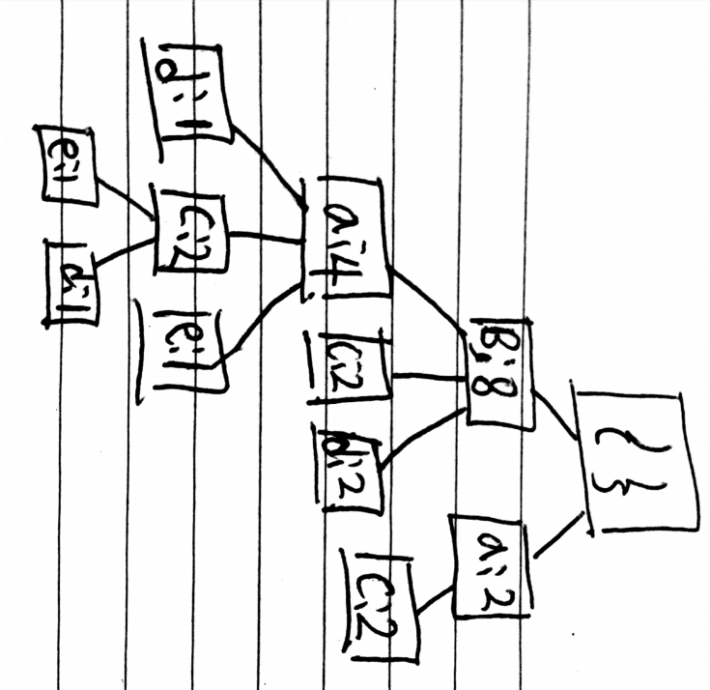

c.

conditional pattern base for d: {ba:1; bac:1; b:2}

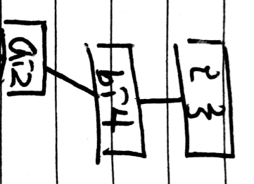

d.

{ad:2; bad:2; bd:4; d:4}

2.

('min_support:', 50, 'min_conf:', 0.25)

item: "Wicked Spoon","Holsteins Shakes & Buns" , 51.000

item: "Wicked Spoon","Secret Pizza" , 52.000

item: "Wicked Spoon","Earl of Sandwich" , 52.000

item: "The Cosmopolitan of Las Vegas","Wicked Spoon" , 54.000

item: "Mon Ami Gabi","Wicked Spoon" , 57.000

item: "Bacchanal Buffet","Wicked Spoon" , 63.000

------------------------ RULES:

Rule: "Secret Pizza" ==> "Wicked Spoon" , 0.256

Rule: "The Cosmopolitan of Las Vegas" ==> "Wicked Spoon" , 0.277

Rule: "Holsteins Shakes & Buns" ==> "Wicked Spoon" , 0.315

(115.05299997329712, 'sec')

The businesses are located in Las Vegas. The result for support tells that many users who visited wicked spoon also visited one of the restaurants that are found up there. The rule tells us that about around 30 percent of people visited one of the three restaurants in the rule section also visited wicked spoon

3.

a.

$$Confidence= P\left(A | B\right), P\left(B | A\right)= \frac{150}{500},\frac{150}{850}=0.3, 0.176$$

$$Lift=\frac{P(A⋃B)}{P(A)P(B)}= \frac{\frac{150}{10000}}{\frac{500}{10000}\frac{850}{10000}} =0.353$$

$${Confidence}_{All}=\min\left\{P\left(A | B\right), P\left(B | A\right)\right\}=0.176$$

b.

the confidence says about 30 percent of people buying bear buys nuts and 17.6 percent of people buying nuts buy bear. It looks like many people buying either of the items also buy the other item. You can see the value of lift is larger than one. That means sales of these items are positively related. In other words, buying one of the items leads to increase in sales of the other.

4.

a. s=<ab(cd)(ef)>

number of elements =4, length = 6

number of non-empty subsequences = $\left({6 \atop 1}\right)+\left({6 \atop 2}\right)+\left({6 \atop 3}\right)+\left({6 \atop 4}\right)+\left({6 \atop 5}\right)+\left({6 \atop 6}\right)=63$

b. $L_{3}=\{<(ac)e>,<b(cd)>,<bce>,<a(cd)>,<(ab)d>,<(ab)c>\}$

deleting the first letter of s1 and the last letter of s2 is same.

<(ab)c>,<bce> = <(ab)(ce)> - <(ab)e> is not in L3 , thus not frequent.

<(ab)d>, <(ab)c> = <(ab)(cd)> - <(ab)c>, <(ab)d>, <a(cd)>, <b(cd)> are in L3, thus it is frequent.

This L4 only includes <(ab)(cd)>.