Capstone Development Reflection Journal
Module B: AI for Leaders
Ka Tsun Hui
Weeks 2–6 · artifacts included
Week 2
Assignment/Capstone work: I picked finance, environment, and entertainment. I value derivatives at a hedge fund in Hong Kong, so finance was automatic. Environment is the EV transition, the industrial change I have watched most closely. Entertainment is music and film. I listen and I watch. I do not work in those industries.
Artifact (required): three industries, two public datasets each.
Industry | Dataset A | Dataset B
Finance | Historic options (Dubach): SPY/IWM/QQQ chains, 2008–2025 | FINRA equity short interest (biweekly files)
Environment | CPCA China passenger-vehicle sales, Jan 2018–Apr 2024 (Kaggle / felixzhao) | National CO2 panel (later dropped; too far from a decision I would own)
Entertainment | Ultimate Spotify Tracks DB (Hamidani, Kaggle) | The Movies Dataset (Banik, 2017, Kaggle / TMDB)

Reflection: I almost started with the biggest files I could find. Picking industries first forced a different test: would I still care about this after the class ends? Markets, EVs, and the stuff I stream.
Week 3
Assignment/Capstone work: I pulled the SPY chain for 31 December 2024 (9,646 contracts, 23 columns) and the CPCA China auto file (38,806 model-month rows). Right away: 625 option contracts with a zero bid, duplicate model-month rows, and the string NA in body type.
Artifact (required): sample rows from each of the five datasets that ended up in Milestone One, with a one-line description. Full column lists are in the paper.
Dataset 1 : SPY options, 31 Dec 2024. One listed contract. Near-the-money sample (the file’s first rows are deep in-the-money expiries).
contract_id | strike | type | last | IV
SPY250207C00594000 | 594 | call | 7.80 | 0.132
SPY250207P00594000 | 594 | put | 12.94 | 0.142
SPY250207C00595000 | 595 | call | 7.39 | 0.132

Dataset 2 : CPCA China passenger-vehicle sales. One model in one month.
year_month | brand | model | units | is_ev
2022-11 | Tesla | Model Y | 69,098 | EV
2022-11 | Wuling | Hongguang MINIEV | 68,567 | EV
2022-11 | BYD | Song PLUS | 64,145 | EV

Dataset 3 : Spotify tracks. One track, audio features plus genre.
artists | track | popularity | danceability | genre
Gen Hoshino | Comedy | 73 | 0.676 | acoustic
Ben Woodward | Ghost - Acoustic | 55 | 0.42 | acoustic
Ingrid Michaelson;ZAYN | To Begin Again | 57 | 0.438 | acoustic

Dataset 4 : TMDB movies. One film. Grumpier Old Men shows a zero budget that is missing data, not a free film.
title | release | budget | revenue | vote
Toy Story | 1995-10-30 | 30,000,000 | 373,554,033 | 7.7
Jumanji | 1995-12-15 | 65,000,000 | 262,797,249 | 6.9
Grumpier Old Men | 1995-12-22 | 0 | 0 | 6.5

Dataset 5 : FINRA short interest, 30 Sep 2026. One stock on one settlement date. File: shrt20260930.csv.
settlementDate | symbolCode | short shares | changePercent | daysToCover
2026-09-30 | A | 5,240,309 | 3.18 | 1.78
2026-09-30 | AA | 11,725,447 | -2.16 | 2.85
2026-09-30 | AAA | 7,957 | 456.82 | 1.00

Reflection: The zero-bid rows looked like ordinary quotes until I asked what a zero bid is. Nobody is buying that contract at any price. Dropping 6.5% of the file felt aggressive. Using fake prices in a model is worse.
Week 4
Assignment/Capstone work: I wrote the work problems that sit on these files, then added a fifth dataset next to the options work instead of another copy of it.
The professional problems. I value derivatives at a hedge fund in Hong Kong. I kept files that map onto questions I already have to explain, or that I care about as a consumer. In finance, a quoted smile and a set of Greeks have to be internally consistent, and a short-interest file has to tell crowded positioning from names that barely trade. A bad IV surface mis-marks a book. A short-interest spike that is really a split sets off a fake squeeze alarm for risk and for stock loan. In the auto market the question is which segments went electric, and whether a subsidy cliff changed that. Wrong mix is expensive inventory and battery supply. In music and film, streamers and studios spend against noisy popularity and revenue. A popularity score that is just genre balancing, or a budget coded as zero, sends a model the wrong way. Milestone Two should stay on those questions. An accuracy number by itself is not the point.
Artifact (required): a new related dataset, with a sample and a public link. I added FINRA's 30 September 2026 short-interest file (shrt20260930.csv): one date, 22,581 names. Same day-of-market idea as the SPY chain, but positioning and days-to-cover instead of quotes. No price join.
Link: https://cdn.finra.org/equity/otcmarket/biweekly/shrt20260930.csv
settlementDate | symbolCode | issueName | currentShortPositionQuantity | daysToCoverQuantity
2026-09-30 | A | Agilent Technologies Inc. | 5,240,309 | 1.78
2026-09-30 | AA | Alcoa Corporation | 11,725,447 | 2.85
2026-09-30 | AAA | Alternative Access First Prior | 7,957 | 1.00

Reflection: The module treats prediction as supervised segmentation. That is how I started to look at an option chain: boundaries across moneyness and expiry, the way a tree splits customers. After that I cared more about the shape of the problem than about which industry label it wore.
Week 5
Assignment/Capstone work: I locked five files: SPY options, China EV sales, Spotify, TMDB, and the 30 September 2026 FINRA short-interest file. Kaggle would not load on my machine, so Spotify and TMDB are local copies of the public Kaggle files. I made a slideshow: each dataset, a sample, why I kept it, what it can answer, and a tree vs linear-discriminant demo on Dataset 5. I tried SpaceX launches for environment. Too few rows. Out.
Artifact (required): slideshow of the five datasets. The slides are printed below. File: milestone1/dx699-week5-datasets.pptx.

Slide 1 of 9
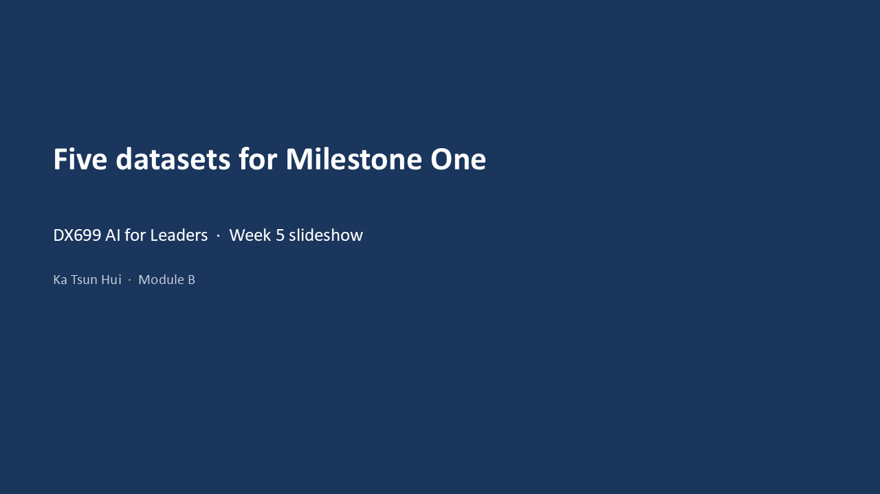
Slide 2 of 9
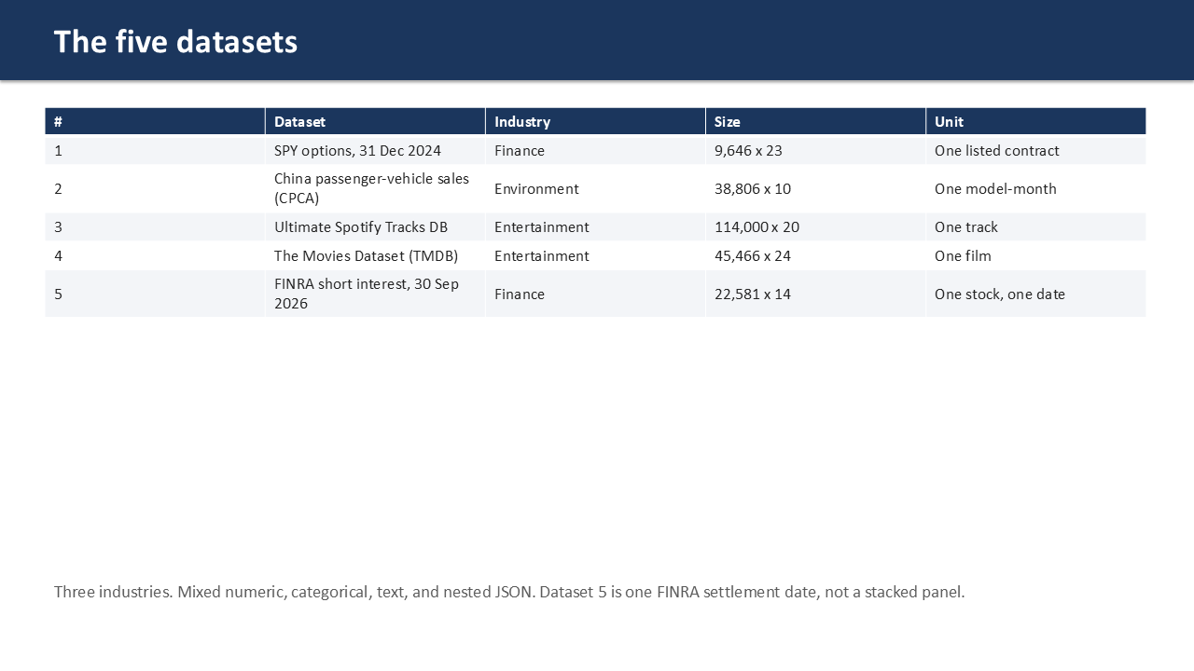
Slide 3 of 9
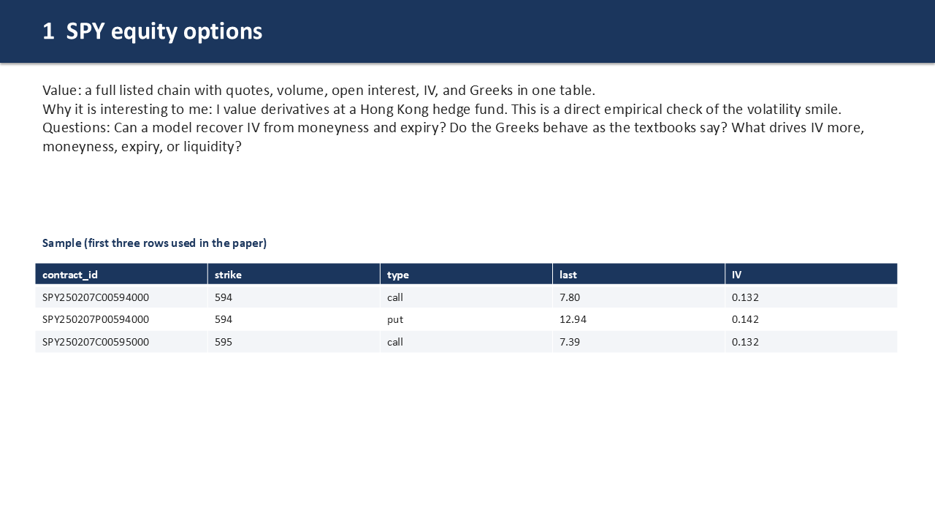
Slide 4 of 9
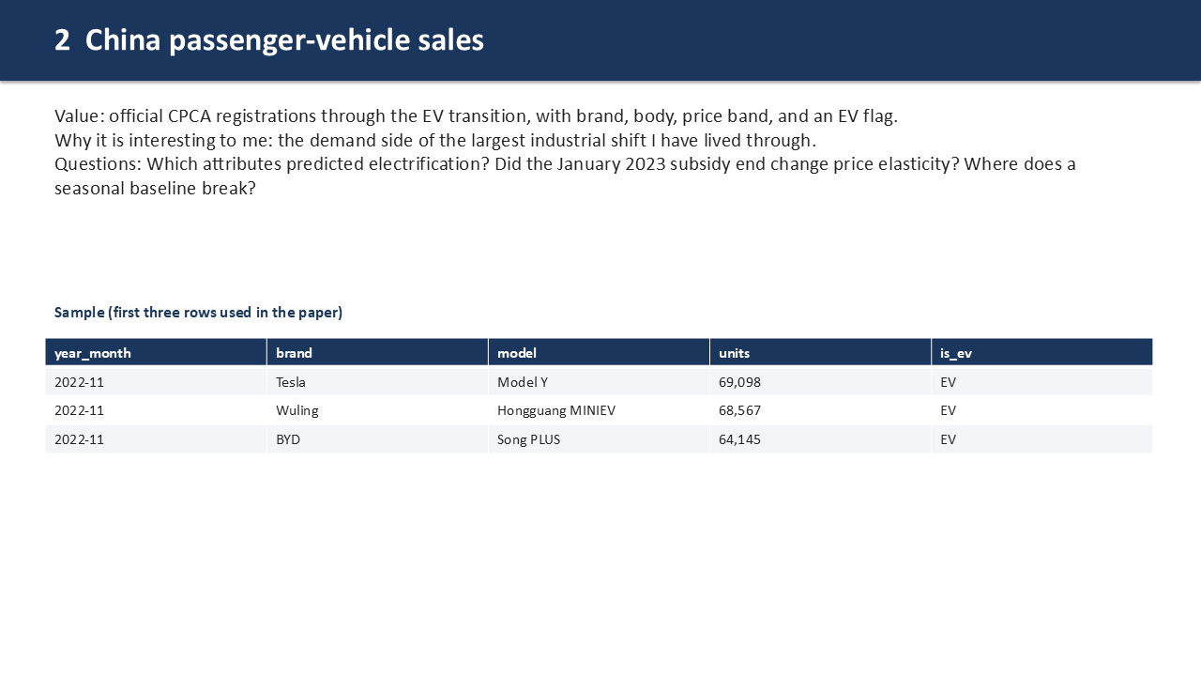
Slide 5 of 9
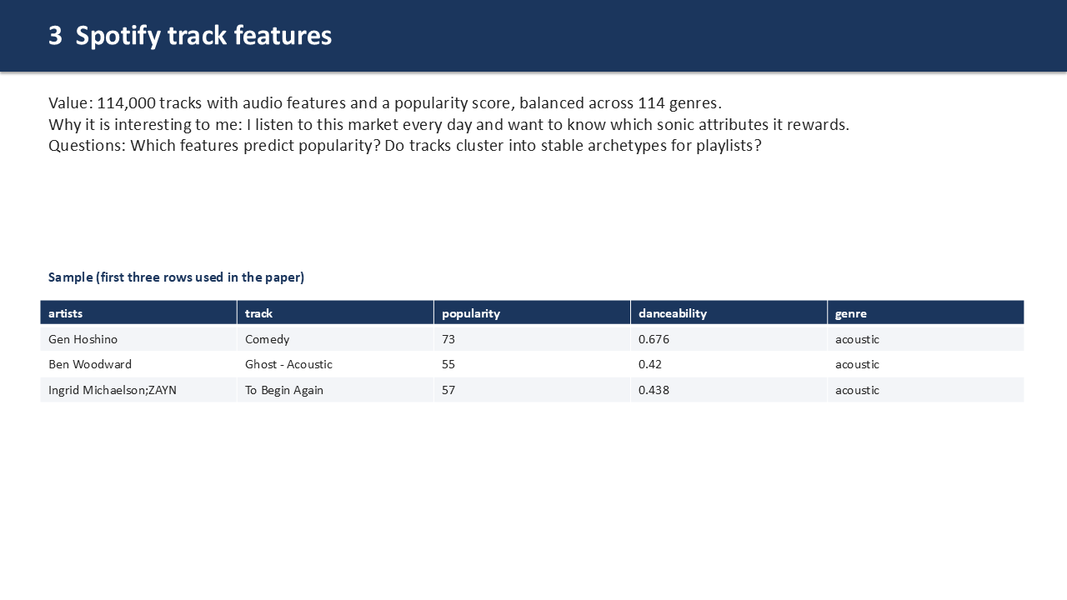
Slide 6 of 9
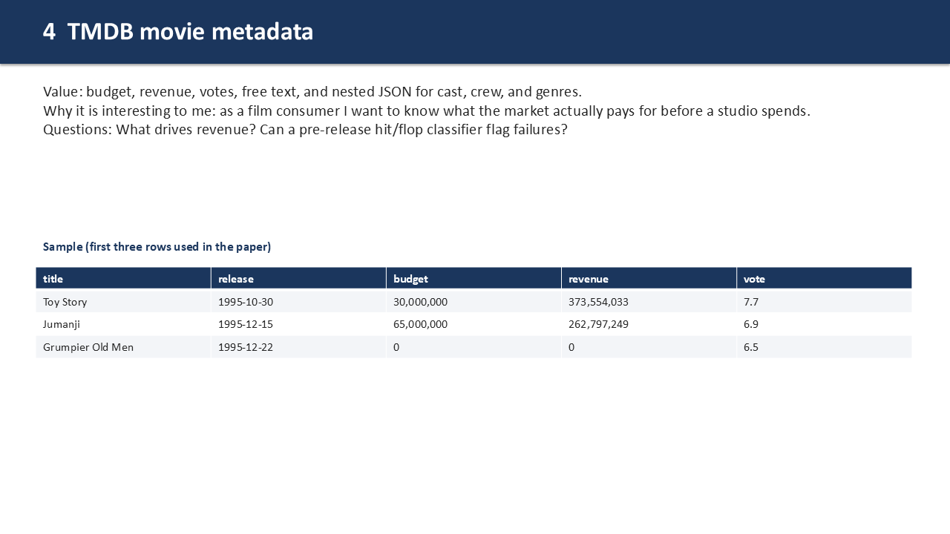
Slide 7 of 9
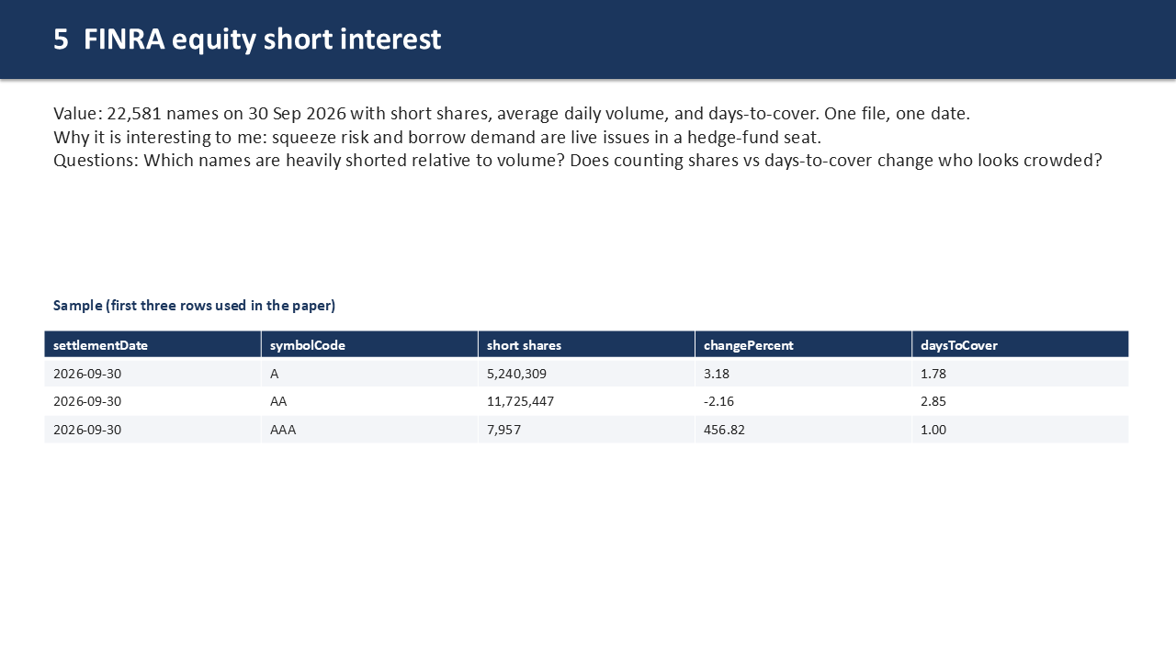
Slide 8 of 9
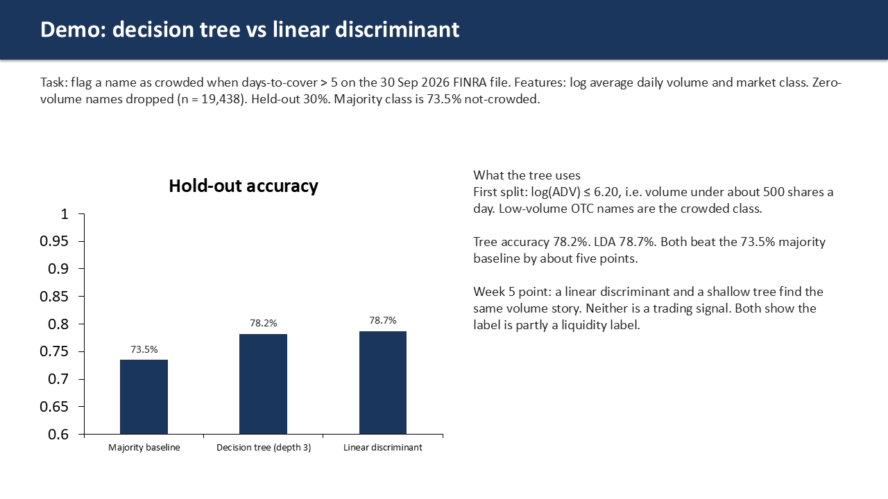
Slide 9 of 9
Demo in the deck: crowded means days-to-cover above 5, predicted from log volume and market class (n = 19,438 after dropping zero volume). Majority baseline 73.5%. Depth-3 tree 78.2%. Linear discriminant 78.7%. First split is log(ADV) <= 6.20, about 500 shares a day. The crowded class is low-volume OTC names. Liquidity, not a trading signal.
Reflection: I dropped more datasets than I added. The CO2 panel was the hard one. Pretty data, but I could not attach it to a decision I would own. Five files I can defend beat eight I cannot. The FINRA demo was useful for the linear-discriminant week: a shallow tree and LDA both find the same volume split, and both only beat the majority class by about five points.
Week 6
Assignment/Capstone work: I checked quality on the later files and whether regression and classification even make sense on each one. Spotify: 450 duplicate rows and 24,259 duplicate track ids. TMDB: 17 duplicates and budgets coded as zero. FINRA (one date): blank ticker on Nano Labs, days-to-cover stuck at 1.00 on 8,295 rows and at 999.99 on 4,034, and 3,143 names with zero volume. I also rebuilt the paper under the rubric labels, 12-point Times New Roman, double spacing, one page of examples.
Artifact (required): per-dataset regression / classification feasibility.
Dataset | Regression feasible? | Classification feasible? | Note
1 SPY options | Yes: quoted IV from moneyness and expiry | Yes: liquid vs illiquid from spread, volume, OI | 625 zero-bid quotes must be dropped first
2 China EV sales | Weak: monthly EV units from lags is a time series; rubric discourages it | Yes: EV vs gasoline from brand, body, price | Prefer the classifier
3 Spotify | No natural numeric target I would stand behind | Yes: popularity tier or genre after de-dupe | 24,259 repeated track ids are label noise
4 TMDB | Yes: log revenue from budget, genre, timing | Yes: hit vs flop from pre-release features | Zero budgets are missing, not zero
5 FINRA 30 Sep 2026 | Yes: log short shares from log volume and market class (R² 0.42) | Yes: days-to-cover > 5 from volume tier and class | Do not put short shares or days-to-cover in the classifier features

Reflection: Spotify's label noise was the puzzle I spent the most time on. Same audio features, two genre labels. You cannot classify that without first deciding what a row even is. The other headache was formatting. Double spacing cuts the word count on a page in half.

