**BLG 335E ALGORITHMS I**

**FINAL EXAM – JANUARY 13, 2023**

| **1**  **(10 pt)** | **2**  **(25 pt)** | **3**  **(15 pt)** | **4**  **(10 pt)** | **5**  **(10 pt)** | **6**  **(20 pt)** | **7**  **(10 pt)** | **Total**  **(100 pt)** |
| --- | --- | --- | --- | --- | --- | --- | --- |
| randomized select | rbt | heap | randomized select(prove) | B-trees | hash | amortized analysis |  |

Bu sınav 2022-23 sınavı değildir. Bir grup öğrenci tarafından, hatırlanan soruların yazılması sonucu tekrar yazılmış halidir.

**Q1) [10 pts]**

1. What are the worst case and average case running time of Order Statistics? **[4 pts]**
2. Run (simulate) the below RANDOMIZED-SELECT pseudocode (for the given array) and show your steps. Assume first element is the pivot for array & subarray.

**Q2) [25 pts]**

**a)** Prove that a red-black tree with n internal nodes has height h at most 2 lg(n+1). **[6 pts]**

**b)** Build a red-black tree from the given list L = [ “hatırlayamadık” ].

**c)** Insert “4” to the tree that you built.

**Q3)**

**a)** Sort the given array A = [5, 6, 3, 2] in ascending (increasing) order by using Heapsort. Show the heap as a tree structure.

**b)** What happens to the heap after applying the following operations. Show each step. Insert “50”. Insert “20”. Insert “40”. Insert “30”. Insert “10”. Remove min element. Insert “15”. Remove min element.

*Note: Assume this heap is initially empty. So, it is different from heap on a). Also heap is a max heap! (saçma ama evet, max heap)*

**Q4)** Let the T(n) = Running time of RANDOMIZED-SELECT on an input Array A[p…r] of n elements and Tk be a indicator random variable defined as follows:

Tk is 1 if kth element splits the array k : n - k - 1

Otherwise Tk is 0

What is the expected value of Tk? Show your work.

**Q5)** What is the minimum degree t of the below B-tree? The configuration after inserting “L” is given.

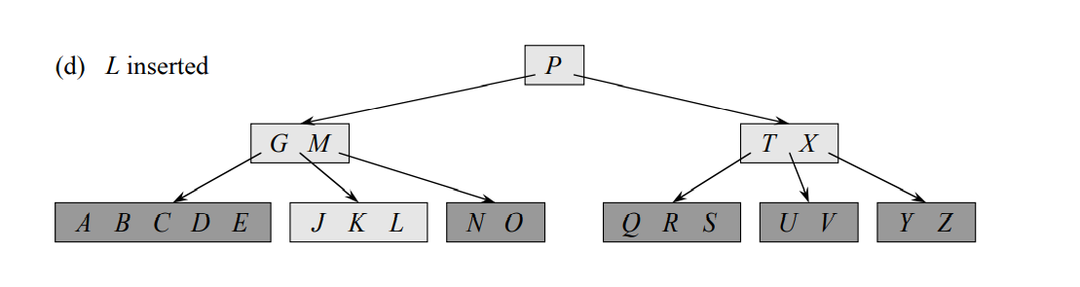

(Introduction to Algorithms, Third Edition by Thomas H. Cormen, Charles E. Leiserson, Ronald L. Rivest, and Clifford Stein, page 498.)

**Q6)** Place the keys in the given key list L = [ “hatırlayamadık” ] to m different slots where m = 13. Show your process after each step.

**a)** Linear Probing with h’(k) = k mod m and h(k,i) = (h’(k) + i) mod m.

**b)** Double Hashing with h1(k) = k mod m, h2(k) = (1 + (k mod m-1)) mod m and h(k,i) = (h1(k) + i*h2(k)) mod m

**Q7)**

**T F**

**T F** In potential method delta(fi) > 0 means amortized cost is greater than

the actual cost.

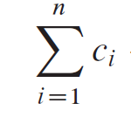

**T F**  Sum equals to amortized cost.

**T F**

**CEVAPLAR HAKKINDA:**

**2. sorunun a şıkkının cevabı kitapta (CLRS) var.**

**2. sorunun b şıkkında yaklaşık 6-7 tane elemanı vardı array’in. Her ekleme ya ağacın özelliğine herhangi bir sorun çıkarmadı ya da tek adımda rbt özelliği tekrar geri kazanılabilindi(yani eklenen düğümün amcası kırmızı renkliydi).**

**2. sorunun c şıkkında zincirleme sorunlar çıktı. Amca siyah olmasından dolayı rbt-insert-fixup fonksiyonunun diğer durumlardaki tavrını da bilmek gerekiyor.**

**5. soru: t = 3**