Elizabeth Hutton

BME 413

11/30/18

**Programming Assignment #2**

Question 1

%%%%%%%%%%%%%%%%%%%%%%%% Q1 %%%%%%%%%%%%%%%%%%%%%%%%

%load dicom image

info = dicominfo('image18.dcm');

Y = dicomread(info);

%convert to double

X = im2double(Y);

%scale pixel values

I = (X/max(X(:)))*255;

Question 2

%%%%%%%%%%%%%%%%%%%%%%%% Q2 %%%%%%%%%%%%%%%%%%%%%%%%

%crop 128x128 selection

crop_size = 128;

rect = [150 150 127 127];

cropped = imcrop(I,rect);

%plot cropped image

figure;imshow(cropped,[]);

title('Original Cropped Image');

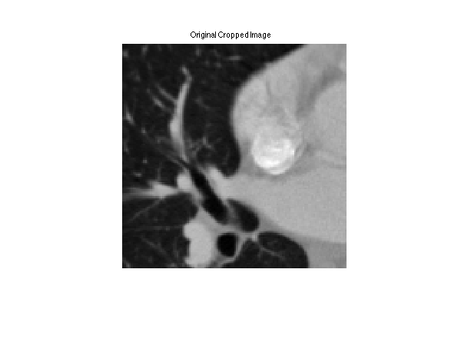

Question 3

%%%%%%%%%%%%%%%%%%%%%%%% Q3 %%%%%%%%%%%%%%%%%%%%%%%%

%pad for rotation

padder = ceil(length(cropped)*0.2);

I_padded = padarray(cropped,[padder padder],'both');

%rotate 0-179 degrees in 1 degree increments

n_projections = 180;

delta_theta = 1;

%%get projections at each degree rotation

for i=1:n_projections

pic = imrotate(I_padded,(i-1)*delta_theta,'crop');

sinogram(:,i) = sum(pic);

end

%plot sinogram

figure;

imshow(sinogram, []);

title('Sinogram');

xlabel('\theta (degrees)');

ylabel('X\prime');

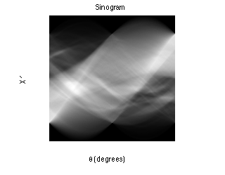

Question 4

%%%%%%%%%%%%%%%%%%%%%%%% Q4 %%%%%%%%%%%%%%%%%%%%%%%%

% 1D Fourier Transform of projections

shifted = fftshift(sinogram);

FT1 = fftshift(fft(shifted));

figure;

imshow(log(abs(FT1)),[]);

title('1D FFT of Sinogram');

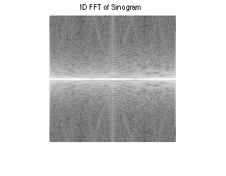

Question 5/6

%%%%%%%%%%%%%%%%%%%%%%%% Q5 %%%%%%%%%%%%%%%%%%%%%%%%

%assemble 2-d transform from 1-d projections

angles = repmat((0:180-1)*pi/180,length(FT1),1);

matrix_bound = (length(FT1)-1)/2;

rhos = repmat((-ceil(matrix_bound):floor(matrix_bound))',1,n_projections);

[x,y] = pol2cart(angles,rhos);

[XI,YI] = meshgrid((-ceil(matrix_bound):floor(matrix_bound)));

%%%%%%%%%%%%%%%%%%%%%%%% Q6 %%%%%%%%%%%%%%%%%%%%%%%%

FT2_assembled = griddata(x,y,FT1,XI,YI,'linear');

FT2_assembled(isnan(FT2_assembled)) = 0;

%plot constructed 2D fft

figure;

imshow(log(abs(FT2_assembled)),[]);

title('Constructed 2D FFT from 1D FFT');

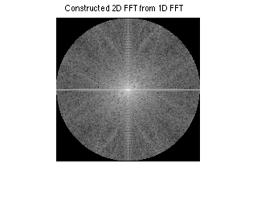

Question 7

%%%%%%%%%%%%%%%%%%%%%%%% Q7 %%%%%%%%%%%%%%%%%%%%%%%%

%direct 2-d fourier transform of image

FT2 = fftshift(fft2(fftshift(I_padded)));

%plot magnitude of 2D FFT

figure;

imshow(log(abs(FT2)),[]);

title('Direct 2D FFT');

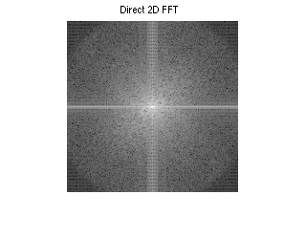

Question 8

Comparing the above plots, of the actual 2D Fourier Transform (FT) and the 2D FT constructed from the 1D projections, there are a few noticeable differences. The most obvious difference is the circular shape of the constructed 2D FT, which is a result of the interpolation across the projections. Otherwise, the key features of the transform are captured in both versions, with only slight differences in the sharpness of certain contrasts. There are more visible radial lines in the constructed 2D FT than in the direct 2D FT, which is slightly blurred.

Question 9

%%%%%%%%%%%%%%%%%%%%%%%% Q9 %%%%%%%%%%%%%%%%%%%%%%%%

%take inverse 2D FFT to plot reconstructed image

inverse_fft2 = abs(fftshift(ifft2(fftshift(FT2))));

inverse_cropped = imcrop(inverse_fft2,[padder+1 padder+1

crop_size-1 crop_size-1]);

figure, imshow(inverse_cropped,[]);

title('Reconstructed Image from Inverse 2D FFT');

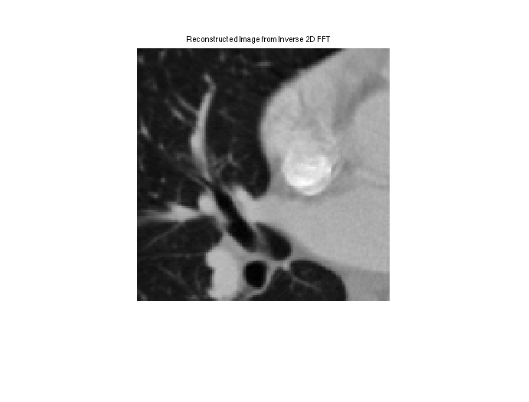

The above is a side-by-side comparison of the original 128x128 pixel image with the image reconstructed by taking the inverse 2D FT. At this level of resolution, the differences are very subtle and overall, the reconstruction is very good. The key difference is that the high frequency spots (bright white) in the original image are slightly blurred in the reconstruction.