Root Cause Analysis: VOIP Service Disruption Caused by Damaged Ethernet Cabling
  - Summary, Findings, and Recommended Actions
Prepared for Automotive Parts Retail Store

Executive Summary
A Cisco VOIP phone at the front counter lost network connectivity while continuing to receive power via Power over Ethernet (PoE). Troubleshooting isolated the fault to a damaged Ethernet cable between the phone and Cisco network switch. Visual inspection identified physical cable damage consistent with the timing of the failure. Repair of the Ethernet cable restored service.

1. Purpose
This document describes the front-counter phone outage, the investigation performed, the identified root cause, and the corrective actions taken to restore service.

2. Equipment Involved
- Phones: Cisco CP-7861
- Network Switch: Cisco Catalyst 1000
These VOIP phones use the store’s network (Ethernet cables) and receive power through the same cable (Power over Ethernet, or PoE). Each VOIP phone on this counter is directly connected to the Cisco switch via its own Ethernet cable.
There is a second counter with a different VOIP phone connection (two registers daisy-chained through the phone), which did not experience any issues.

3. Problem Description
The front counter has two VOIP phones, but only one VOIP phone is working. Business operations require both VOIP phones.
The second phone behavior follows.
- When connected to the Ethernet cable the VOIP phone powers on.
- The phone displays “Network Unavailable.” The message indicates that the phone successfully powered on but was unable to establish network connectivity.
- The phone does not have a dial-tone, indicating that the phone is unusable.
- Inspection of the phone's network settings showed that it had not received an IP address from the network.
The Cisco VOIP phones are configured to acquire their IP address from the Cisco switch using Dynamic Host Configuration Protocol (DHCP). This protocol allows automatic configuration of the phones after power-up without requiring manual configuration.

4. Business Impact
Workers on the front counter must answer incoming calls to manage retail customer queries, requests, from other stores, and commercial customer overflow. During busy periods, both phones are required to cover calls. Because many requests require putting a caller on hold, more than one phone is required to cover calls. Operating with only one functional phone reduced the store's ability to answer incoming calls and increased the likelihood of missed customer contacts. The number of missed calls increased.

5. Findings
- At the inoperable VOIP phone, there are two Ethernet cables.
- One Ethernet cable is completely non-functional (no power, no data)
- VOIP phone received power but no network connectivity.
- VOIP phone did not receive an IP address.
- Cisco switch reported a fault associated with the Ethernet cable.
- Fault followed the Ethernet cable when moved to a different Cisco switch port.
- Known-good VOIP phone failed on the same Ethernet cable.
- Visible Ethernet cable damage was identified.
- Failure began immediately after Ethernet cable handling and re-taping.
- The Ethernet cables under the counter are difficult to reach and to repair.
- Investigation of the visible Ethernet biscuit confirmed that it served a different phone and was not associated with the failed connection.
- The connection for the non-working VOIP phone is hidden out of sight under the counter,
These findings confirmed that the cable was the issue. Figure 1 shows the blue Ethernet cables terminating at the Cisco switch.

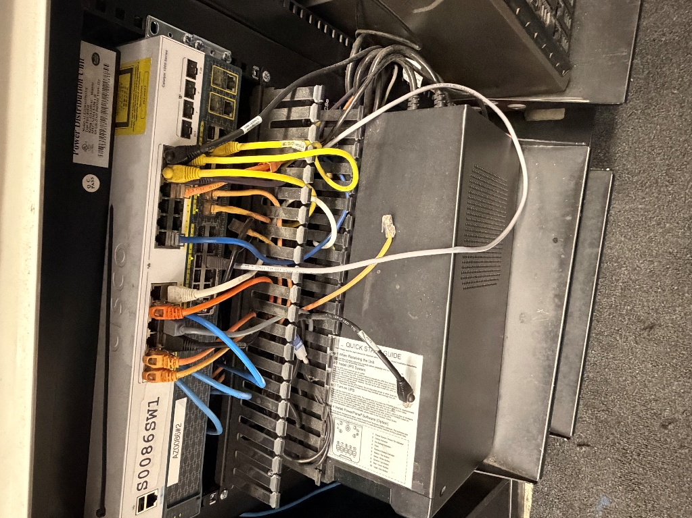
Image 1: Blue Ethernet cables carrying VOIP at the Cisco switch.
Note that Image 1 shows four blue Ethernet cables. Only three Ethernet cables reach the retail counters. The fourth Ethernet cable terminates somewhere between the Cisco switch and the counter.
Network Connectivity
Figure 1 shows the simplified network connectivity. Network connectivity passes through at least one Ethernet “biscuit” (connector).

+------------+
|Cisco Switch|
+------------+
|
|
+----------------------+
|Damaged Ethernet Cable| (running across floor under tape)
+----------------------+
|
|
+----------------------------+
|Cisco 7861 Phone |
| * PoE Power = Present |
| * Network Data = Failed|
+----------------------------+
Figure 1: Simplified Network Connectivity Diagram

6. Visible Physical Damage
Two of the Ethernet cables from the counter route under the mat and through the wall to the Cisco switch. One of these Ethernet cables is visibly damaged. These two Ethernet cables are blue. The other Ethernet cables originating from the counter (serving printers and registers) are other colors. It was confirmed that the blue Ethernet cables connected to the Cisco switch served the VOIP phone system. Image 2 shows the damaged Ethernet cable.
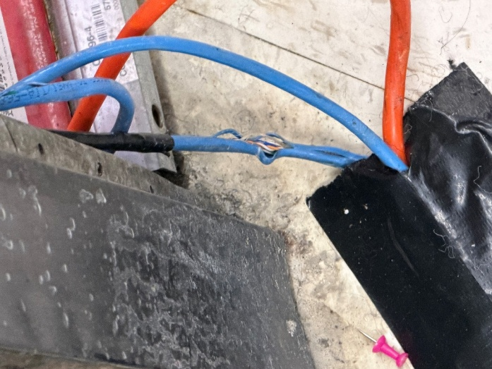
Image 2: Visible damaged Ethernet cable exiting floor tape.

7. Timing of Failure
This issue began after the two blue Ethernet cables were retaped down to the floor before a professional cleaning of the store prior to a regional meeting.
Timing of the incident suggests that taping the Ethernet cables pulled or compressed the cable. Ethernet cables consist of several wire pairs, some carrying power and some carrying data. The observed behavior is consistent with damage to conductors used for data transmission while leaving sufficient continuity for PoE power delivery.

8. Root Cause
Physical damage to the Ethernet cable serving the front counter phone interrupted network communications while allowing sufficient continuity for PoE operation.

9. Conclusion
Testing confirmed that the Cisco VOIP phones were operating correctly and that the failure was isolated to a damaged Ethernet cable serving one front-counter phone. The Ethernet cable continued to provide PoE power but could not reliably transmit network traffic. Repair of the Ethernet cable restored full phone functionality.
The combination of Cisco switch diagnostics, phone substitution testing, physical inspection, and timing analysis provides strong evidence that physical damage to the Ethernet cable was the root cause of the outage.

10. Recommendation
Replace or repair the Ethernet cable.

11. Action Performed
The Ethernet cable was repaired. Following repair, the phone successfully obtained an IP address, registered with the VOIP system, and returned to normal operation. Incoming and outgoing call functionality was verified.

12. Follow-up
All other Ethernet cables connecting registers and printers go through the counter and through a metal floor conduit before passing through the wall to the Cisco switch.

Image 3: Metal floor conduit, counter to wall
The two blue Ethernet cables carrying VOIP are the only two Ethernet cables that do not go through conduit. It is recommended that in the future the network cabling for the store be re-worked so that all Ethernet cables go through conduit and not across the floor.
The two Ethernet cables run under the mat behind the counter. Employees stand on that mat and walk over the Ethernet cables during normal store operation. Pressure on the Ethernet cables could lead to more damage in the future.
The area under the counter is filled with dust and trash, making troubleshooting difficult. It is recommended that this area be cleaned and organized. Cable management guides are recommended.

Appendix A: Technologies Referenced
Cisco CP-7861
Business-class Voice over IP (VOIP) telephone.
Cisco Catalyst 1000
Managed Ethernet switch providing network connectivity and Power over Ethernet (PoE) services.

Ethernet
Local area network cabling standard used for voice and data communications.
Power over Ethernet (PoE)
Technology allowing electrical power and network data to be transmitted over a single Ethernet cable.
Dynamic Host Configuration Protocol (DHCP)
Protocol used to automatically assign IP addresses and network configuration information to devices.
Voice over IP (VOIP)
Technology that carries telephone communications over data networks.

Appendix B: Skills Demonstrated
- Root Cause Analysis
- Fault Isolation
- Ethernet Troubleshooting
- VOIP Support
- Technical Documentation
- Business Impact Analysis
- Evidence-Based Investigation

