1. **Purpose**

This document defines the policies and procedures for controlling and implementing changes within the Quality Management System. These policies and procedures include engineering changes, labeling and packaging changes, and documentation changes.

1. **Scope**

This procedure applies to all engineering changes associated with the Quality Management System. Design and Development changes are documented in the Design Control process until the Design Transfer ECO has been completed.

1. **General** 
   1. **Definitions** – N/A
   2. **Responsibilities**

**Quality Management** – Quality Management is responsible for the implementation and continued compliance with the procedures specified in this document and by the regulatory authorities.

* 1. **Equipment and Materials** – N/A
  2. **Safety Precautions** – N/A
  3. **Training Requirement** – Operations, Engineering, and Quality are required to be trained to this procedure and the training documented.
  4. **Record Management** – All Engineering Change Orders are managed and maintained by the Quality Department.
  5. **Reference Documents and Materials**

**21 CFR 820** FDA Quality System Regulations

**ISO 13485** – Medical Device Quality Management Systems

**SOR/98-282** – Canadian Medical Device Regulations

**MDR 2017/745** – EU Medical Device Regulation

**MDD 93/42/EEC** – EU Medical Device Directive

**QP-0002** –Design Control Process

**QP-0003** – Document Control Process

**QP-0006** – Labeling and Packaging Control Process

**QF-0009-1** – Engineering Change Order (ECO) Form

**Attachment 1 –** Engineering Change Order Approval Matrix

1. **Change Control Procedure**

The change control process utilizes three separate change control processes to effectively manage changes within the Quality Management System (QMS) and Design & Development: Engineering Changes, Labeling and Packaging Changes, and Documentation Changes. These processes interact as depicted below and ensure all aspects of the planned change is reviewed, approved, and implemented.

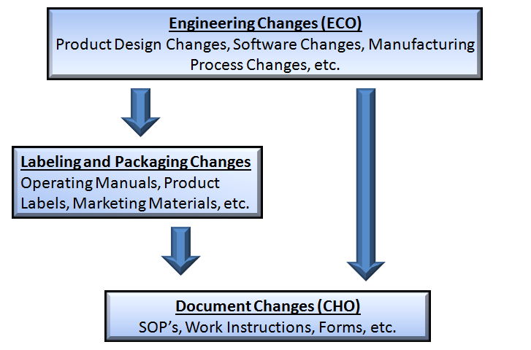

* 1. **Engineering Changes**

Engineering changes are any changes to the product design and development outputs as defined in Doc QP-0002 – Design Control Process. Examples include changes to product design specifications, software specifications, and manufacturing processes. Depending of the scope of the change, engineering changes will spinoff labeling changes and/or document changes. An ECO is documented on the Engineering Change Order (ECO) Form and includes the following information.

**Engineering Change Description**

This section provides the general information and identification of the engineering change order including: Change Initiator, Date of Proposal, ECO Number (ECO-####), and a detailed description of the proposed change. The information provided shall be detailed enough to accurately describe the scope of the changes and the rationale for making the change. Additional documentation should be attached to the ECO as necessary.

**Impacts of Change**

This section provides an assessment of the impacts of making the proposed changes. Items that are commonly impacted by ECO’s include: Validations, Verifications, FMEA’s (Risk Management), Documents, Training Requirements, Product Quality, Regulatory Requirements, and Product Disposition. Design changes shall be assessed for impact to function, performance, usability, safety, risk management, product in process, and applicable regulatory requirements regarding the medical device and its intended use. These shall be clearly identified on ECO Form. Additional documentation should be attached to the ECO as necessary. A regulatory assessment shall be included in the impact of change.

**Review and Approval Process**

The review and approval process is documented on the Engineering Change Order (ECO) Form. Each representative shall review and approve the ECO based on their area of expertise. Upon approval, ECO’s remain open until all associated changes have been documented and the Quality Department signs off on the closure. Any changes or revisions to an approved ECO shall be rerouted to the original approvers.

* 1. **Labeling Changes**

The Labeling and Packaging Control Process is defined in document QP-0006. Labeling includes product labels, operating manuals, package inserts, packaging graphics, marketing material, etc. Labeling changes may occur with or without engineering changes and implementation of the changes is designated by the effective date of the resultant document changes. The labeling and packaging review and approval process is documented on the Labeling Review and Approval Form.

* 1. **Document Changes**

The Document Control Process is defined in document QP-0003 and incorporates all changes made to documents associated with the Quality Management System. Document changes may occur independently or as a result of engineering and/or labeling changes. Engineering and labeling changes are considered complete once all associated document changes have been approved.

1. **Revision History**

| **Rev #** | **Doc #** | **Effective Date** | **CHO** | **Description of Change** |
| --- | --- | --- | --- | --- |
| 01 | QP-0009 |  |  | Initial implementation of the Change Control Process |

**Attachment 1 – Engineering Change Order Approval Matrix.**

| **Department** | **Design and Development Changes** | **Manufacturing Changes** | **Quality Changes** | **Labeling, Marketing, and Sales Changes** |
| --- | --- | --- | --- | --- |
| **Quality and Regulatory** | **Required** | **Required** | **Required** | **Required** |
| **Engineering** | **Required** | **Required** | **Required** | **Required** |
| **Operations** | **Required** | **Required** | **Required** | **Required** |
| **Sales and Marketing** | **Not Required** | **Not Required** | **Not Required** | **Required** |