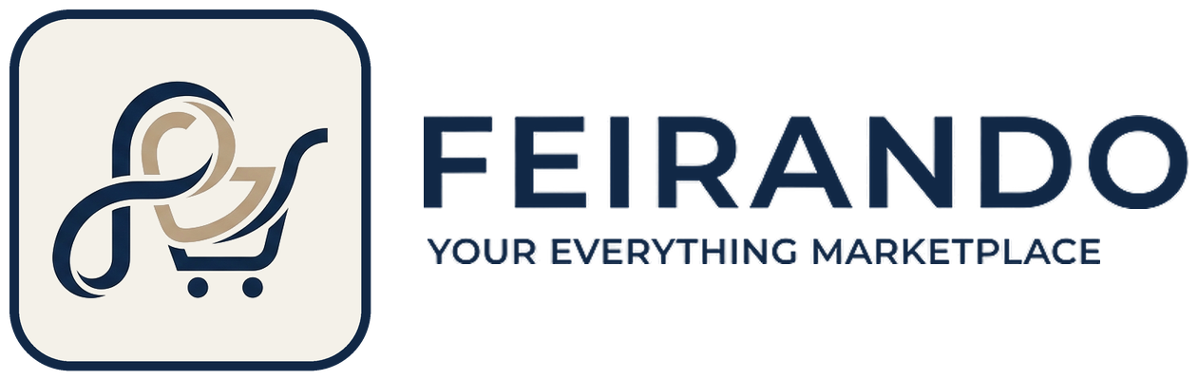
Business Model
Data source note: Feirando is a fictional company created for this case study. All order, customer, seller, product and review data comes from the public Olist Brazilian E-Commerce dataset (2016-2018), used under its published license with credit to Olist.

1. Overview
Feirando is an online marketplace in Brazil where independent sellers list products across many categories and shoppers buy them in one place. The company's promise is a reliable, satisfying shopping experience, from order to delivery.

2. Customers and value
- Sellers: get an established storefront, a customer base, and tools to run their business (order management, ERP integration, analytics).
- Shoppers: get wide choice, trusted sellers, and dependable delivery.

3. Revenue model
- Commission: a percentage of each completed sale (core revenue).
- Seller subscriptions: monthly fees for seller accounts.
- Fulfillment services (optional): packing, delivery and returns handling, charged to sellers who want them.

4. Money flow
The shopper pays the product price plus shipping. Feirando keeps its commission and passes the rest to the seller. When a seller uses its own logistics partner, only the commission applies. When Feirando handles fulfillment, a fulfillment fee is added.

5. Key risks
- Experience risk: late deliveries, poor quality or fake products damage shopper trust and the marketplace's reputation.
- Seller risk: sellers can list on competing marketplaces, so Feirando must keep offering them value.
- Retention risk: shoppers who buy once and do not return make growth expensive.

6. Role of the analytics team
Help leadership understand where the shopper experience breaks down and which sellers, regions and categories drive satisfaction and repeat business, and recommend actions with a measurable impact.

7. Data bridge
Any financial figure that depends on the items in the right-hand column will be a clearly labelled assumption.
What we can see in the data | What we cannot see
Orders, order items, prices and freight  Payments and instalments  Promised vs actual delivery dates  Customer reviews and scores  Sellers, products and categories  Locations of shoppers and sellers | Feirando's commission rate  Subscription and fulfillment revenue  Who handled logistics (seller or platform)  Seller activity on other marketplaces  Product authenticity  Ad spend or traffic sources

