Growth Is Strong. Discounts Are Costing Us Profit.
2023 Sales & Customer Insights | Prepared for sales managers, executives and marketing
The story in 30 seconds
- We grew fast. Sales are up 20% and orders are up 28% compared with 2022.
- But we keep less of each euro. Profit margin fell from 13.4% to 12.7%.
- Deep discounts are the main reason. Orders with more than 20% discount lost about €47K in total.
- Customers are coming back more often, but 58% still ordered only once or twice.

1. Where we stand: a strong growth year
2023 was a good year on almost every measure. Sales reached €733K and profit reached €93K. We sold 12K units across 1,687 orders from 693 customers.
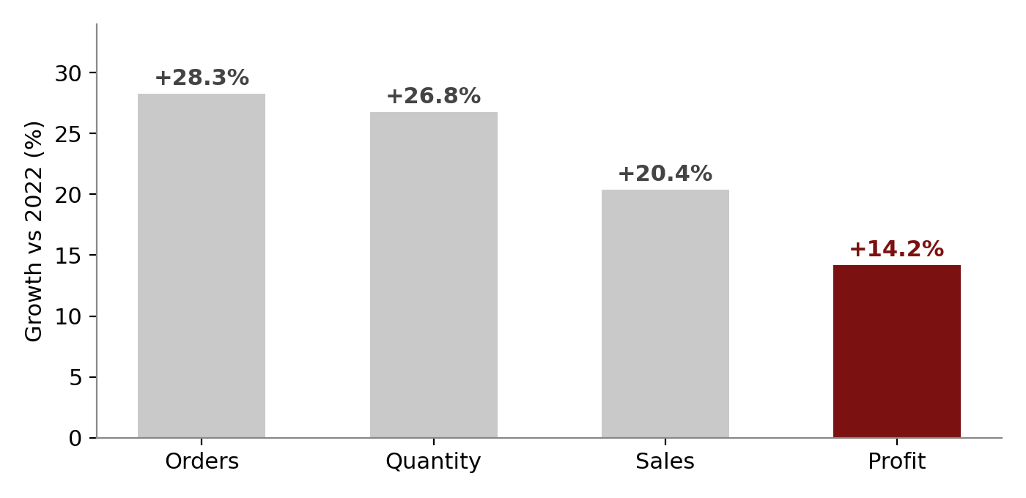
Figure 1. Every measure grew, but profit grew the slowest.
Look at the dark bar. Profit grew 14%, while sales grew 20% and orders grew 28%. This gap is the start of our story. We are selling more, but each sale is leaving us with a little less.
So what? Growth alone is not enough. If the gap keeps widening, higher sales will not turn into higher profit.

2. The calendar: Q4 carries the year
Sales are not spread evenly. September to December brought in about 50% of yearly sales. November was our best month at €118K. February was the weakest at €20K.
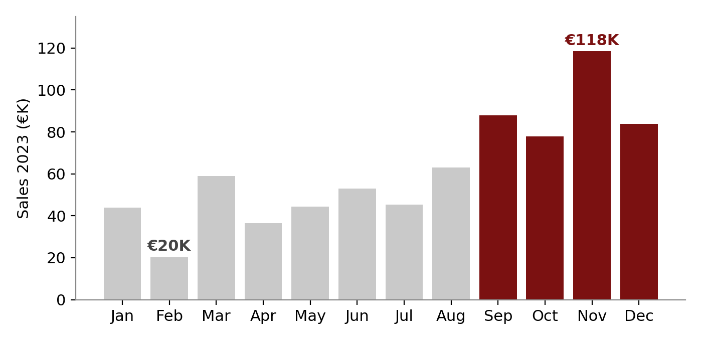
Figure 2. The last four months (dark) deliver half of the year.
The year also started well. January sales (€44K) were more than double January 2022 (€19K). The quiet spots are February and April. April had the lowest profit of the year (€0.9K), and week 16 had the worst weekly result with a loss of about €3K.
So what? We depend heavily on the holiday season. Stock, staff and campaigns must be ready by September, and we need a plan for the slow months.

3. The hidden cost: heavy discounting
This is the most important finding. When we sort orders by the discount given, the picture is clear.
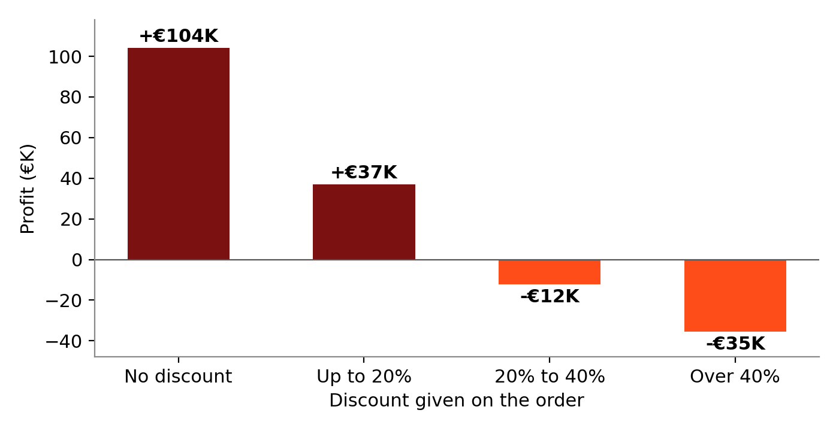
Figure 3. Profit turns negative once the discount goes above 20%.
Orders with no discount made €104K profit. Orders with a discount above 20% lost €47K combined (€12K in the 20% to 40% band and €35K above 40%). If we had simply broken even on those orders, profit would have been about 50% higher.

The same pattern shows up by state
States that discount heavily lose money. States that discount lightly make strong profit.
State | Average discount | Profit 2023 | Result
Texas | 38% | -€8.8K | Loss
Illinois | 38% | -€6.7K | Loss
Pennsylvania | 33% | -€5.1K | Loss
North Carolina | 28% | -€5.1K | Loss
California | 7% | +€29.4K | Strong profit
New York | 5% | +€24.4K | Strong profit
Washington | 6% | +€17.3K | Strong profit

This also explains the Central region. It has the highest average discount (24%) and the lowest margin (5%). The West region discounts only 11% and earns a 17.5% margin.
So what? Discounting is our biggest lever. A clear discount limit would protect profit faster than any other single action.

4. The products: winners and losers
Profit is not shared evenly across products. Copiers, Accessories, Phones and Paper earn the most. Four sub-categories lose money.
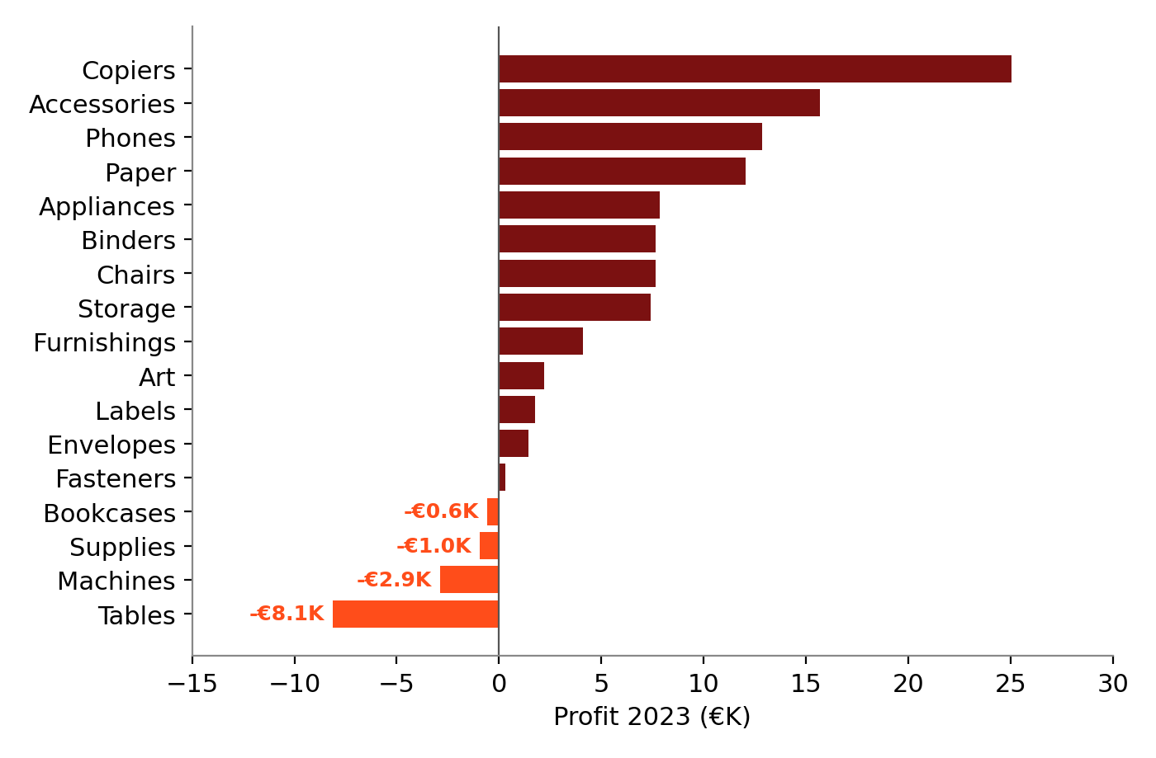
Figure 4. Tables, Machines, Supplies and Bookcases made a loss in 2023.
- Tables is the biggest problem. It is our sixth-largest line by sales (€61K) but lost €8.1K.
- Machines is shrinking (sales down 22%) and losing money at the same time.
- Furniture as a whole sold €215K but made only €3K profit, a 1.4% margin. Technology made €51K on €272K.
- Growing fast: Appliances (+65%), Art (+49%), Binders (+47%) and Accessories (+43%).
So what? Fix or reduce the loss-making lines, and push the high-margin ones in promotions and cross-sell offers.

5. The customers: loyal, but not loyal enough
Customers grew 8.6%, but orders grew 28.3%. This means our customers are buying more often. On average, each customer placed 2.4 orders in 2023, up from 2.1 in 2022. Average spend per customer rose 10.8% to about €1,058.
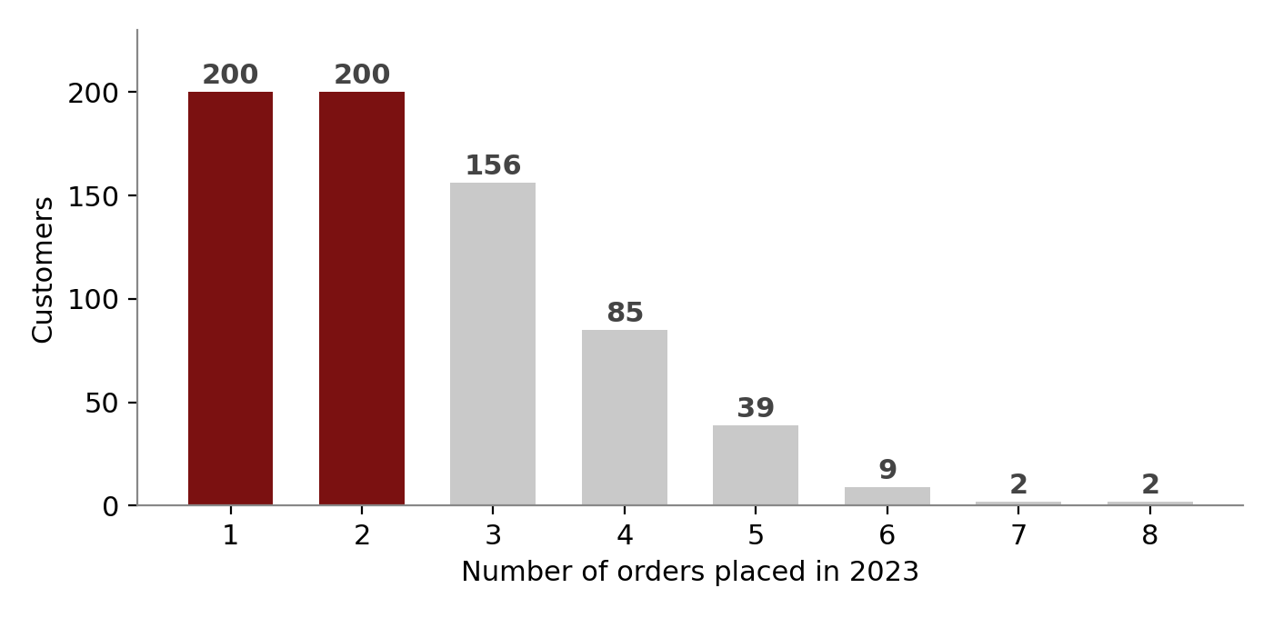
Figure 5. Most customers (dark) placed only one or two orders.
The good news is clear. The risk is just as clear: 400 of 693 customers (58%) ordered only once or twice, and only 52 customers (7.5%) ordered five times or more.

A small group drives a big share of profit
- The top 10 customers made about €30K profit. That is 32% of total profit.
- The top 3 alone made €16.4K, almost 18% of total profit.
- Raymond Buch and Hunter Lopez earn about 48% margin, nearly four times the company average of 12.7%.
- Steven Roelle (rank 10) ordered only once and has not ordered since June. He is a clear win-back target.
So what? Moving one-time buyers to repeat buyers is our biggest growth chance. Protecting our top customers is our biggest risk.

6. What we recommend
Actions are ordered by expected effect on profit.
Priority | Action | Why
High | Set a discount limit of 20%, with approval needed above it | Orders above 20% discount lost about €47K. This is the quickest profit gain.
High | Review Tables and Machines | Both lose money. Check pricing, supplier cost and discount levels, or reduce the range.
High | Review discounting in Texas, Illinois and Pennsylvania | All three discount around 33% to 38% and lose money.
Medium | Prepare for Q4 early | Q4 brings half of the yearly sales. Be ready by September.
Medium | Run focused offers in February and April | Both months are weak. Use bundles or loyalty perks instead of deep discounts.
Medium | Turn one-time buyers into repeat buyers | 200 customers ordered once. Use follow-up emails, loyalty points or bundles.
Medium | Look after the top 10 customers | They bring 32% of profit. Add personal contact and check in when orders slow down.
Low | Promote high-margin products | Copiers, Accessories, Paper and Appliances earn well and can lead cross-sell offers.

7. What to watch next
Three numbers will tell us quickly whether these actions work.
- Profit margin: target a return to 13.4% or higher.
- Share of orders with more than 20% discount: this should fall.
- Repeat customer rate: the share of customers with three or more orders should rise.

Appendix: key terms and notes
Term | Meaning
Profit margin | Profit divided by sales. A 12.7% margin means we keep about 13 cents of every euro sold.
YoY (year over year) | Change compared with the same period in the previous year (2023 vs 2022).
Repeat customer | A customer who placed more than one order in the year.
Win-back | An effort to bring back a customer who has stopped ordering.
Cross-sell | Offering a related product to a customer who is already buying.

All figures are for 2023 unless stated, and percent changes compare with 2022. Amounts are shown in euros, as on the dashboards. Figures were checked against the source data and match the dashboards.

