SUMMARY

USC ID/s: 6992229916, <USC ID>

Datapoints
M+N | Time in MS (Basic) | Time in MS (Efficient) | Memory in KB (Basic) | Memory in KB (Efficient)
16 | 0.299 | 1.173 | 33780 | 33824
64 | 3.202 | 9.470 | 33668 | 33412
128 | 8.171 | 16.698 | 33784 | 33584
256 | 39.891 | 56.085 | 33888 | 33444
384 | 80.517 | 127.605 | 34040 | 33488
512 | 133.161 | 234.343 | 34296 | 33692
768 | 310.479 | 486.038 | 34932 | 33820
1024 | 560.541 | 900.299 | 35832 | 33576
1280 | 904.262 | 1431.120 | 36988 | 33648
1536 | 1258.838 | 2004.242 | 38396 | 33816
2048 | 2350.609 | 3676.181 | 41976 | 33560
2560 | 4048.067 | 3144.777 | 46584 | 33816
3072 | 5403.797 | 8095.509 | 52212 | 33816
3584 | 7185.061 | 11255.246 | 58872 | 33996
3968 | 8802.497 | 11010.766 | 64492 | 33952

Insights

Graph1 – Memory vs Problem Size (M+N)

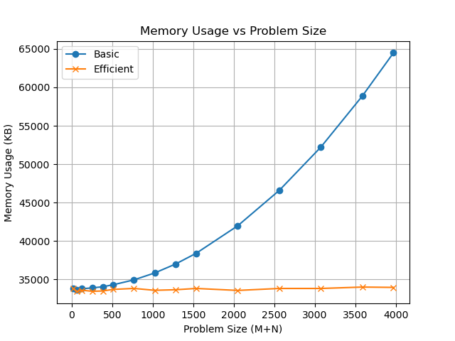

Nature of the Graph (Logarithmic/ Linear/ Polynomial/ Exponential)
Basic:
Efficient:

Explanation:

Graph2 – Time vs Problem Size (M+N)

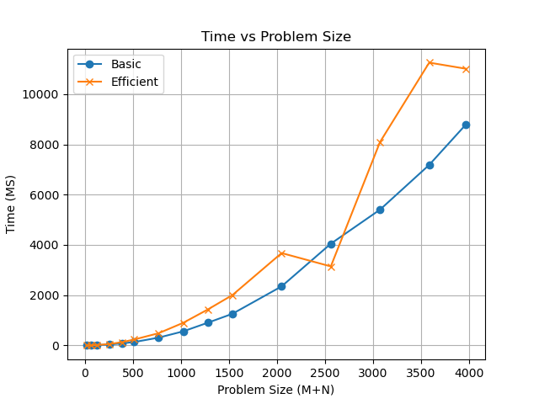

Nature of the Graph (Logarithmic/ Linear/ Polynomial/ Exponential)
Basic:
Efficient:

Explanation:

Contribution
6992229916: Equal Contribution
<USC ID>: Equal Contribution

