**Answer of HW1**

**Group 5**

Liang Yi 1901212608 Yao Surui 1901212660

Wang Zilei 19012212645 Liu Xin 1901212615

Zhang Ying 1901212674

Q1:

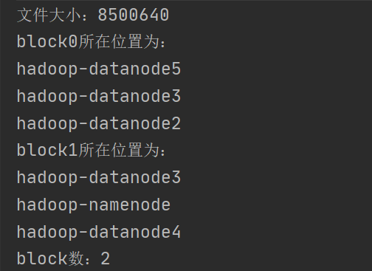

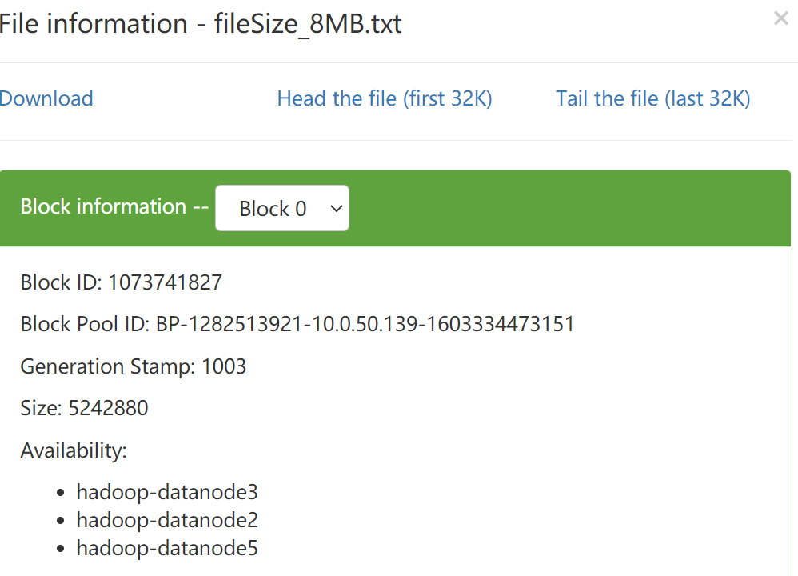

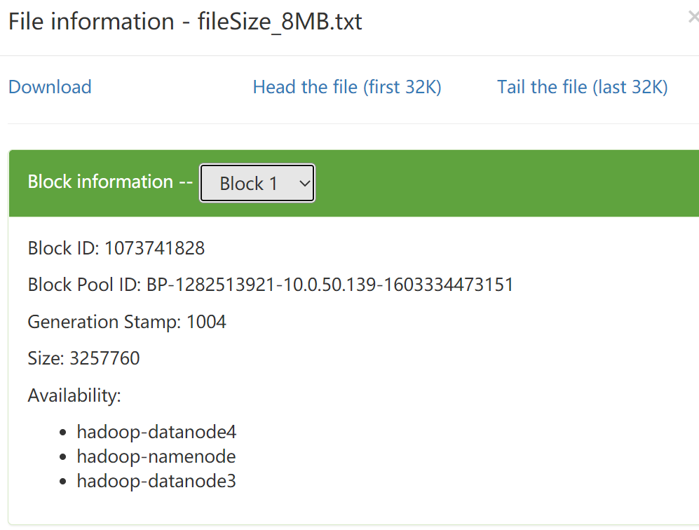

Q2:

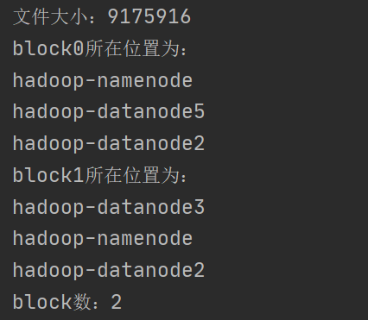

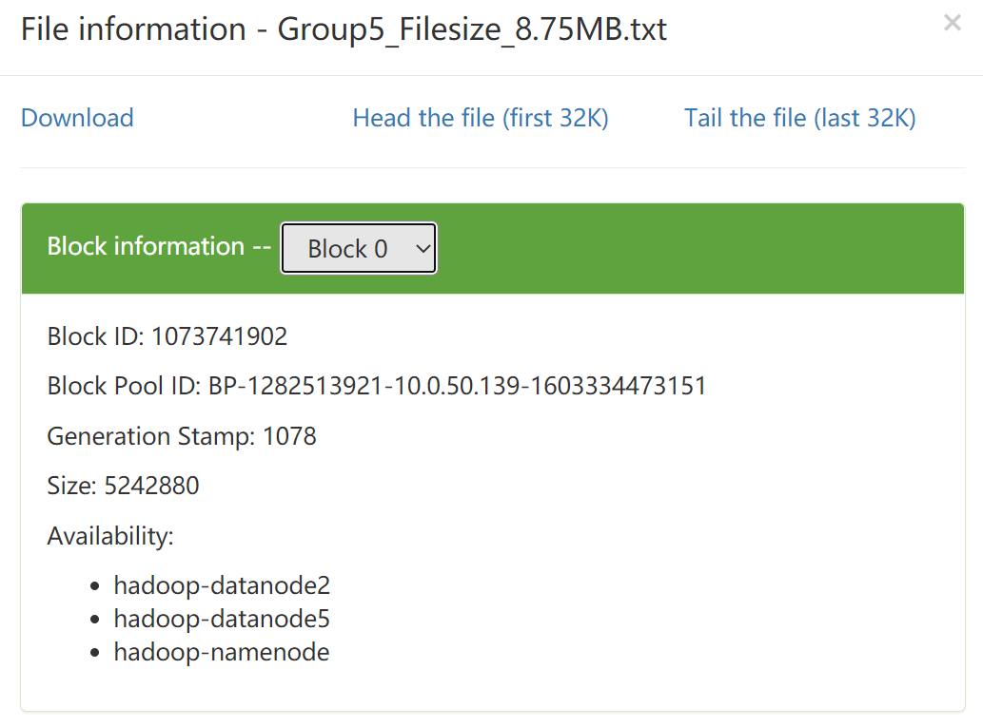

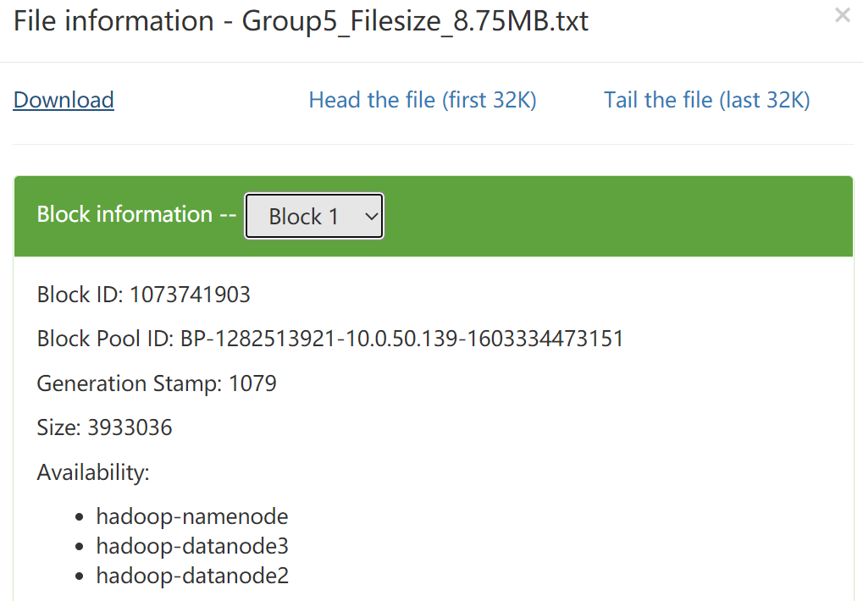

Q3

Document：PRSA_Data_20130301-20170228

****************

Filename: PRSA_Data_Aotizhongxin_20130301-20170228.csv

File path: F:\airQuality\PRSA_Data_20130301-20170228\PRSA_Data_Aotizhongxin_20130301-20170228.csv

Five rows：

"No","year","month","day","hour","PM2.5","PM10","SO2","NO2","CO","O3","TEMP","PRES","DEWP","RAIN","wd","WSPM","station"

"No","year","month","day","hour","PM2.5","PM10","SO2","NO2","CO","O3","TEMP","PRES","DEWP","RAIN","wd","WSPM","station"

"No","year","month","day","hour","PM2.5","PM10","SO2","NO2","CO","O3","TEMP","PRES","DEWP","RAIN","wd","WSPM","station"

"No","year","month","day","hour","PM2.5","PM10","SO2","NO2","CO","O3","TEMP","PRES","DEWP","RAIN","wd","WSPM","station"

"No","year","month","day","hour","PM2.5","PM10","SO2","NO2","CO","O3","TEMP","PRES","DEWP","RAIN","wd","WSPM","station"

****************

Filename: PRSA_Data_Changping_20130301-20170228.csv

File path: F:\airQuality\PRSA_Data_20130301-20170228\PRSA_Data_Changping_20130301-20170228.csv

Five rows：

"No","year","month","day","hour","PM2.5","PM10","SO2","NO2","CO","O3","TEMP","PRES","DEWP","RAIN","wd","WSPM","station"

"No","year","month","day","hour","PM2.5","PM10","SO2","NO2","CO","O3","TEMP","PRES","DEWP","RAIN","wd","WSPM","station"

"No","year","month","day","hour","PM2.5","PM10","SO2","NO2","CO","O3","TEMP","PRES","DEWP","RAIN","wd","WSPM","station"

"No","year","month","day","hour","PM2.5","PM10","SO2","NO2","CO","O3","TEMP","PRES","DEWP","RAIN","wd","WSPM","station"

"No","year","month","day","hour","PM2.5","PM10","SO2","NO2","CO","O3","TEMP","PRES","DEWP","RAIN","wd","WSPM","station"

****************

Filename: PRSA_Data_Dingling_20130301-20170228.csv

File path: F:\airQuality\PRSA_Data_20130301-20170228\PRSA_Data_Dingling_20130301-20170228.csv

Five rows：

"No","year","month","day","hour","PM2.5","PM10","SO2","NO2","CO","O3","TEMP","PRES","DEWP","RAIN","wd","WSPM","station"

"No","year","month","day","hour","PM2.5","PM10","SO2","NO2","CO","O3","TEMP","PRES","DEWP","RAIN","wd","WSPM","station"

"No","year","month","day","hour","PM2.5","PM10","SO2","NO2","CO","O3","TEMP","PRES","DEWP","RAIN","wd","WSPM","station"

"No","year","month","day","hour","PM2.5","PM10","SO2","NO2","CO","O3","TEMP","PRES","DEWP","RAIN","wd","WSPM","station"

"No","year","month","day","hour","PM2.5","PM10","SO2","NO2","CO","O3","TEMP","PRES","DEWP","RAIN","wd","WSPM","station"

****************

Filename: PRSA_Data_Dongsi_20130301-20170228.csv

File path: F:\airQuality\PRSA_Data_20130301-20170228\PRSA_Data_Dongsi_20130301-20170228.csv

Five rows：

"No","year","month","day","hour","PM2.5","PM10","SO2","NO2","CO","O3","TEMP","PRES","DEWP","RAIN","wd","WSPM","station"

"No","year","month","day","hour","PM2.5","PM10","SO2","NO2","CO","O3","TEMP","PRES","DEWP","RAIN","wd","WSPM","station"

"No","year","month","day","hour","PM2.5","PM10","SO2","NO2","CO","O3","TEMP","PRES","DEWP","RAIN","wd","WSPM","station"

"No","year","month","day","hour","PM2.5","PM10","SO2","NO2","CO","O3","TEMP","PRES","DEWP","RAIN","wd","WSPM","station"

"No","year","month","day","hour","PM2.5","PM10","SO2","NO2","CO","O3","TEMP","PRES","DEWP","RAIN","wd","WSPM","station"

****************

Filename: PRSA_Data_Guanyuan_20130301-20170228.csv

File path: F:\airQuality\PRSA_Data_20130301-20170228\PRSA_Data_Guanyuan_20130301-20170228.csv

Five rows：

"No","year","month","day","hour","PM2.5","PM10","SO2","NO2","CO","O3","TEMP","PRES","DEWP","RAIN","wd","WSPM","station"

"No","year","month","day","hour","PM2.5","PM10","SO2","NO2","CO","O3","TEMP","PRES","DEWP","RAIN","wd","WSPM","station"

"No","year","month","day","hour","PM2.5","PM10","SO2","NO2","CO","O3","TEMP","PRES","DEWP","RAIN","wd","WSPM","station"

"No","year","month","day","hour","PM2.5","PM10","SO2","NO2","CO","O3","TEMP","PRES","DEWP","RAIN","wd","WSPM","station"

"No","year","month","day","hour","PM2.5","PM10","SO2","NO2","CO","O3","TEMP","PRES","DEWP","RAIN","wd","WSPM","station"

****************

Filename: PRSA_Data_Gucheng_20130301-20170228.csv

File path: F:\airQuality\PRSA_Data_20130301-20170228\PRSA_Data_Gucheng_20130301-20170228.csv

Five rows：

"No","year","month","day","hour","PM2.5","PM10","SO2","NO2","CO","O3","TEMP","PRES","DEWP","RAIN","wd","WSPM","station"

"No","year","month","day","hour","PM2.5","PM10","SO2","NO2","CO","O3","TEMP","PRES","DEWP","RAIN","wd","WSPM","station"

"No","year","month","day","hour","PM2.5","PM10","SO2","NO2","CO","O3","TEMP","PRES","DEWP","RAIN","wd","WSPM","station"

"No","year","month","day","hour","PM2.5","PM10","SO2","NO2","CO","O3","TEMP","PRES","DEWP","RAIN","wd","WSPM","station"

"No","year","month","day","hour","PM2.5","PM10","SO2","NO2","CO","O3","TEMP","PRES","DEWP","RAIN","wd","WSPM","station"

****************

Filename: PRSA_Data_Huairou_20130301-20170228.csv

File path: F:\airQuality\PRSA_Data_20130301-20170228\PRSA_Data_Huairou_20130301-20170228.csv

Five rows：

"No","year","month","day","hour","PM2.5","PM10","SO2","NO2","CO","O3","TEMP","PRES","DEWP","RAIN","wd","WSPM","station"

"No","year","month","day","hour","PM2.5","PM10","SO2","NO2","CO","O3","TEMP","PRES","DEWP","RAIN","wd","WSPM","station"

"No","year","month","day","hour","PM2.5","PM10","SO2","NO2","CO","O3","TEMP","PRES","DEWP","RAIN","wd","WSPM","station"

"No","year","month","day","hour","PM2.5","PM10","SO2","NO2","CO","O3","TEMP","PRES","DEWP","RAIN","wd","WSPM","station"

"No","year","month","day","hour","PM2.5","PM10","SO2","NO2","CO","O3","TEMP","PRES","DEWP","RAIN","wd","WSPM","station"

****************

Filename: PRSA_Data_Nongzhanguan_20130301-20170228.csv

File path: F:\airQuality\PRSA_Data_20130301-20170228\PRSA_Data_Nongzhanguan_20130301-20170228.csv

Five rows：

"No","year","month","day","hour","PM2.5","PM10","SO2","NO2","CO","O3","TEMP","PRES","DEWP","RAIN","wd","WSPM","station"

"No","year","month","day","hour","PM2.5","PM10","SO2","NO2","CO","O3","TEMP","PRES","DEWP","RAIN","wd","WSPM","station"

"No","year","month","day","hour","PM2.5","PM10","SO2","NO2","CO","O3","TEMP","PRES","DEWP","RAIN","wd","WSPM","station"

"No","year","month","day","hour","PM2.5","PM10","SO2","NO2","CO","O3","TEMP","PRES","DEWP","RAIN","wd","WSPM","station"

"No","year","month","day","hour","PM2.5","PM10","SO2","NO2","CO","O3","TEMP","PRES","DEWP","RAIN","wd","WSPM","station"

****************

Filename: PRSA_Data_Shunyi_20130301-20170228.csv

File path: F:\airQuality\PRSA_Data_20130301-20170228\PRSA_Data_Shunyi_20130301-20170228.csv

Five rows：

"No","year","month","day","hour","PM2.5","PM10","SO2","NO2","CO","O3","TEMP","PRES","DEWP","RAIN","wd","WSPM","station"

"No","year","month","day","hour","PM2.5","PM10","SO2","NO2","CO","O3","TEMP","PRES","DEWP","RAIN","wd","WSPM","station"

"No","year","month","day","hour","PM2.5","PM10","SO2","NO2","CO","O3","TEMP","PRES","DEWP","RAIN","wd","WSPM","station"

"No","year","month","day","hour","PM2.5","PM10","SO2","NO2","CO","O3","TEMP","PRES","DEWP","RAIN","wd","WSPM","station"

"No","year","month","day","hour","PM2.5","PM10","SO2","NO2","CO","O3","TEMP","PRES","DEWP","RAIN","wd","WSPM","station"

****************

Filename: PRSA_Data_Tiantan_20130301-20170228.csv

File path: F:\airQuality\PRSA_Data_20130301-20170228\PRSA_Data_Tiantan_20130301-20170228.csv

Five rows：

"No","year","month","day","hour","PM2.5","PM10","SO2","NO2","CO","O3","TEMP","PRES","DEWP","RAIN","wd","WSPM","station"

"No","year","month","day","hour","PM2.5","PM10","SO2","NO2","CO","O3","TEMP","PRES","DEWP","RAIN","wd","WSPM","station"

"No","year","month","day","hour","PM2.5","PM10","SO2","NO2","CO","O3","TEMP","PRES","DEWP","RAIN","wd","WSPM","station"

"No","year","month","day","hour","PM2.5","PM10","SO2","NO2","CO","O3","TEMP","PRES","DEWP","RAIN","wd","WSPM","station"

"No","year","month","day","hour","PM2.5","PM10","SO2","NO2","CO","O3","TEMP","PRES","DEWP","RAIN","wd","WSPM","station"

****************

Filename: PRSA_Data_Wanliu_20130301-20170228.csv

File path: F:\airQuality\PRSA_Data_20130301-20170228\PRSA_Data_Wanliu_20130301-20170228.csv

Five rows：

"No","year","month","day","hour","PM2.5","PM10","SO2","NO2","CO","O3","TEMP","PRES","DEWP","RAIN","wd","WSPM","station"

"No","year","month","day","hour","PM2.5","PM10","SO2","NO2","CO","O3","TEMP","PRES","DEWP","RAIN","wd","WSPM","station"

"No","year","month","day","hour","PM2.5","PM10","SO2","NO2","CO","O3","TEMP","PRES","DEWP","RAIN","wd","WSPM","station"

"No","year","month","day","hour","PM2.5","PM10","SO2","NO2","CO","O3","TEMP","PRES","DEWP","RAIN","wd","WSPM","station"

"No","year","month","day","hour","PM2.5","PM10","SO2","NO2","CO","O3","TEMP","PRES","DEWP","RAIN","wd","WSPM","station"

****************

Filename: PRSA_Data_Wanshouxigong_20130301-20170228.csv

File path: F:\airQuality\PRSA_Data_20130301-20170228\PRSA_Data_Wanshouxigong_20130301-20170228.csv

Five rows：

"No","year","month","day","hour","PM2.5","PM10","SO2","NO2","CO","O3","TEMP","PRES","DEWP","RAIN","wd","WSPM","station"

"No","year","month","day","hour","PM2.5","PM10","SO2","NO2","CO","O3","TEMP","PRES","DEWP","RAIN","wd","WSPM","station"

"No","year","month","day","hour","PM2.5","PM10","SO2","NO2","CO","O3","TEMP","PRES","DEWP","RAIN","wd","WSPM","station"

"No","year","month","day","hour","PM2.5","PM10","SO2","NO2","CO","O3","TEMP","PRES","DEWP","RAIN","wd","WSPM","station"

"No","year","month","day","hour","PM2.5","PM10","SO2","NO2","CO","O3","TEMP","PRES","DEWP","RAIN","wd","WSPM","station"