**ESOTERIC**

**IDEAS**

**OF**

**THE**

**AMERIKAN**

**REMANT**

**GRIMORE ZERO**

Technique Z017

[Theta Binaural] [F/LS] [F/HSE]

The Fears. The Overthinking. The worries. You have to let it go. There is another pathway. Convert your mind as if the tabula rasa. The blank slate. Once experienced, Gnosis is easy to identify. It is from this state that one truly becomes open. As we go through this exercise one will begin to feel more relaxed. Take this opportunity to embrace the change and become more relaxed. If one must, take each muscle and unwind it mentally, physically and spiritualty.

One may start from the toes to the heels and up the body or start in the face and make their way down. The face and the eyes carry undue tension. Unwind everything. Advanced practitioners my alternate sides of the body either choosing to alternate hemispheres or forming a horseshoe. Anyone can easily let all their muscles go formless at once. Free your body so your mind will shine. You are feeling the presence of the sacred trinity of mind body and spirit. Embrace that presence and now let your mind go. Focus on your spirit.

Nothing is left. What was once is no more. Transformation has been achieved. Your existence has been transmuted into a singular line that loops upon itself forever. Your relaxed body and mind understand that all things are possible. From your spirit shines a soul of light. Embrace the halo.

You are open now. There is another pathway. And another. And another. Pathways extend into infinity. This is the word they call bliss but means something different. Here all things are possible. Embrace this change.

Let get of spirit. Open yourself even more. The line has become a point that recedes into forever. The deeper you go the more you realize everything minus one. You are the one and the nothing. Fully open yourself. Completely surrender. Be nothing. Be all. Embrace this everything.

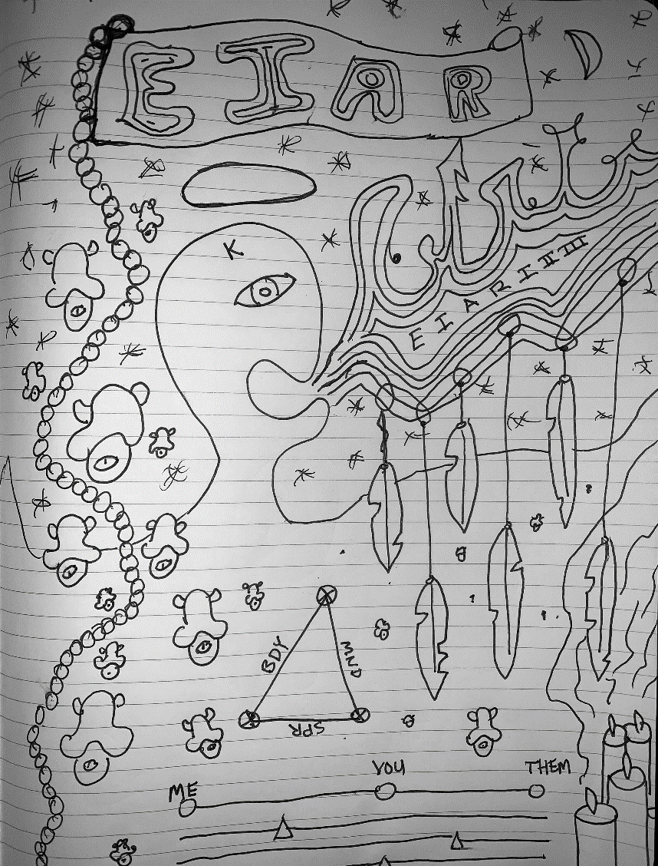

# 90rder7

(SPH ! LSING)

George had told me there was no way in hell he was going to follow through with this and I would have to find someone else. And I did. I told him I would and I thought we had an understanding but evidently there was still some bad blood there. I could feel it. I wanted this so bad and he was merely along for the ride. We both knew it. Somewhere along the way he lost interest or caught feelings and it didn't matter to me one way or the other, I always thought he would follow through and that is why I kept him around. The instant I finally looked up and realized what was so obvious was the same day George was out.

I think I'm growing a little soft. I find myself missing George. However, the few times i've sought answers it has always led me to believe that it was my own lack of awareness and honestly my sheer lack of intellect that allowed myself to get embroiled into relationships. It was a problem I always struggled with, at least the last part.

Nonetheless I had used my time wisely and efficiently, at least the time I was given. Life hurtles a person always forward with little care of our timelines. The problem was George felt like life and maybe I had stolen a little from him. I was never one to cook or clean but George was always there to pick up the slack. Mundane as it was.

Committed is maybe the best word to fit my endeavor. Others tanned in bikinis and smiles while I studied and planned my vacations around old dusty libraries. Such sacrifices rarely go unanswered and I finally found the key that had eluded so many others.

These being my personal memoirs, I omit the plans but they can be found in Grimoire Nine Order Seven.

My new assistant, whom I shall leave nameless, will soon help me disrobe and begin the experiment. She is a fine assistant but one still has doubt that maybe only with George could should a task succeed. I had once believed that but now I am unsure. Doubt can only sow doubt. Getting caught up in your own experiment is always weird but even I would have to admit that maybe I had gone a little too far this time.