**Contact us**

* **Mail List**

Comments@e-iceblue.com for any comments.

[Sales@e-iceblue.com](mailto:Sales@e-iceblue.com) for sales, marketing or resellers related inquiry.

Webmaster@e-iceblue.com for web-site related inquiry.

[Support@e-iceblue.com](mailto:Support@e-iceblue.com) for any technique problem.

[Bugs@e-iceblue.com](mailto:Bugs@e-iceblue.com) for bug report or suggestions.

* **Free Customized Demo**

To ensure our products to be easier to use, we offer free customized demos to our customers. Please contact [support@e-iceblue.com](mailto:support@e-iceblue.com) for the free demo. Make sure the demo you want meets the following requirements.

* It relates to our components stored on E-iceblue online store.
* It costs less than 2 hours for us to complete it. If it costs
* more than 2 hours, please contact our [sales@e-iceblue.com](mailto:sales@e-iceblue.com)

**The Origin of Christmas**

Christmas Day, December 25, which celebrates the birth of Jesus Christ, the founder of the Christian religion, is the biggest and best-loved holiday in the United States.

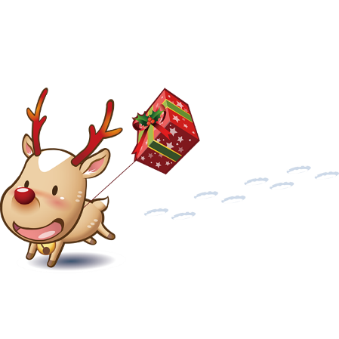　According to the Bible, the holy book of Christians, God decided to allow his only son, Jesus Christ, to be born to a human mother and live on earth so that people could understand God better and learn to love God and each other more. "Christmas"- meaning "celebration of Christ"- honors the time when Jesus was born to a young Jewish woman Mary.

Mary was engaged to be married to Joseph, a carpenter, but before they came together, she was found to be with child. Because Joseph, her husband, was a righteous man and did not want to expose her to public disgrace, he had in mind to divorce her quietly. But after he had considered this, an angel of the Lord appeared to him in a dream and said, "Do not be afraid to take Mary home as your wife, because what is conceived in her is from the Holy Spirit. She will give birth to a son, and you are to give him the name Jesus, because he will save his people from their sins.

# Summary of Science

(All text and picture from [Wikipedia](http://en.wikipedia.org/wiki/Science), the free encyclopedia)

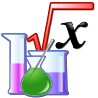Science is an enterprise that builds and organizes knowledge in the form of testable explanations and predictions about the natural world. An older meaning still in use today is that of Aristotle, for whom scientific knowledge was a body of reliable knowledge that can be logically and rationally explained.

Since classical antiquity science as a type of knowledge was closely linked to philosophy, the way of life dedicated to discovering such knowledge. And into early modern times the two words, "science" and "philosophy", were sometimes used interchangeably in the English language. By the 17th century, "natural philosophy" (which is today called "natural science") could be considered separately from "philosophy" in general. But "science" continued to also be used in a broad sense denoting reliable knowledge about a topic, in the same way it is still used in modern terms such as library science or political science.

The more narrow sense of "science" that is common today developed as a part of science became a distinct enterprise of defining "laws of nature", based on early examples such as Kepler's laws, Galileo's laws, and Newton's laws of motion. In this period it became more common to refer to natural philosophy as "natural science". Over the course of the 19th century, the word "science" became increasingly associated with the disciplined study of the natural world including physics, chemistry, geology and biology.

**Statistical Table**

|  |  |  |  |
| --- | --- | --- | --- |
| Country | City | Population | Area/km² |
| 1. China | Chengdu | 15918000 | 14312 |
| 1. Germany | Munich | 3100000 | 270 |
| 1. Thailand | Bangkok | 15680000 | 1197 |
| 1. China | Beijing | 21729000 | 16807.8 |
| 1. Russia | Moscow | 14150000 | 2511 |
| 1. Russia | Moscow | 14150000 | 2511 |
| 1. China | Beijing | 21729000 | 16807.8 |
| 1. Russia | Moscow | 14150000 | 2511 |
| 1. Russia | Moscow | 14150000 | 2511 |
| 1. China | Beijing | 21729000 | 16807.8 |
| 1. Russia | Moscow | 14150000 | 2511 |
| 1. Russia | Moscow | 14150000 | 2511 |
| 1. China | Beijing | 21729000 | 16807.8 |
| 1. Russia | Moscow | 14150000 | 2511 |
| 1. China | Beijing | 21729000 | 16807.8 |
| 1. Russia | Moscow | 14150000 | 2511 |
| 1. China | Beijing | 21729000 | 16807.8 |
| 1. Russia | Moscow | 14150000 | 2511 |
| 1. China | Beijing | 21729000 | 16807.8 |