TITLE | Magnet Conventions for EIC Magnetics
PREPARER | Bailey Rosmarin
NUMBER | EIC-ROD-053
DATE | 3/11/2026
AFFECTED WBS/PROJECT AREA | 6.02 Accelerator Physics, 6.04 Electron Storage Ring,  6.02 Accelerator Development and R&D, 6.06 Interaction Region, 6.05.02 Hadron Ring Straight Section Modifications, 6.05.03 Hadron Ring Injection System Upgrades, 6.03 Electron Injector.
STATEMENT OF DECISION:
Establish nomenclature and polarity conventions for EIC magnets and solenoids to be designed, constructed, and installed.

Description/Purpose:

This document will lay out the nomenclature and magnetic polarity conventions that shall be followed for all EIC facilities, which include the ESR, HSR, RCS, and transfer lines. The importance of establishing and following these conventions is paramount, as it will define how magnets are designed, built, and installed, and ultimately determine how successful the construction and first power up of EIC is.

Background:

The first point of confusion will stem from having to manage both a positively and negatively charged beam in the same accelerator system. This document will address this by standardizing magnet nomenclature so that no matter the polarity of the beam, magnets will be designed and installed in a uniform manner. When speaking about the magnetic field created by current in a wire, which is described as the flow of positive charge carriers, engineers typically use the right-hand rule. In a positive beam system, the right-hand rule can be used with the slight modification that the current vector is represented by beam direction. However, in an e-beam system the left-hand rule must be used to determine vector directions since negative charge carriers will be affected inversely when compared to positive carriers. This must be kept in mind when determining how magnetic fields act on a beam, but it is not of much concern to the engineers designing the magnets.
A magnet is defined as an object that has no magnetic field component along its horizontal midplane (through the magnet aperture in the beam direction). A skew magnet is defined as a magnet that has been rotated clockwise an angle equal to one half of the angle between two adjacent poles as viewed from the lead end. For each n-pole magnet, the normal and skew configurations are shown below. When observing a magnet from the lead end, a magnet is defined as being in its normal configuration when the right-hand pair of poles has the north pole above the south pole. Additionally, a magnet in its normal configuration does not have any poles on the horizontal midplane. A magnet is in its skew configuration when the north pole is on the right side of the horizontal midplane.
To facilitate uniform magnet wiring, each magnet shall be constructed with an “A” terminal and a “B” terminal. These terminals shall be permanently stamped or engraved to prevent misidentification. The electrical connection from the magnet terminals to the coils shall be permanently marked through insulation color or some other distinguishable feature for the same reason. Every direct current power supply has two terminals which are commonly labelled “+” and “- “. For bipolar supplies, the “+” terminal is the one which outputs a positive current when a positive control signal is applied.
The direction a magnet is oriented determines how a magnet will affect a beam travelling through it. The lead end of a magnet is a physical property of the magnet and shall be identified in the magnet drawings. Lead ends shall be permanently indicated through engraving or stamping. The final orientation of the magnets will be determined by the mechanical engineers, and this information must be stored in the system database for future reference. The attached figures of the n-pole magnets all depict the beam travelling into the page as viewed from the lead end.
The importance of careful documentation of final magnet orientation can be seen when rotating a skew dipole, quadrupole, and skew sextupole 180° about its vertical axis (horizontally mirrored), which will reverse the force on the beam. Dipoles, sextupoles, and skew quadrupoles apply the same force on the beam when mirrored, assuming the wiring to the power supply does not change. Specifying beam direction, magnet direction, and field polarity for all devices is required.
Secondary or trim coils are handled the same way as the main magnets they are included with. Trim coils shall have distinctly marked electrical terminals and shall be constructed so the terminals follow the previously established conventions. Trim coil terminals shall be labelled “ATx” and “BTx” where “x” is the identifying number if there are multiple trims in a single magnet assembly. The trim coil orientation shall be clearly documented by magnet designers.
A solenoid is a helical coil of wire that generates a uniform magnetic field when current is applied. Figure 4 shows a solenoid as viewed from the lead end creating a magnetic field that travels into the page. Solenoids shall be constructed with an “A” and “B” terminal following the same conventions as previously stated. Solenoids shall be designed so that positive current on the “A” terminal produces a magnetic field into the plane, when viewed from the lead end.
Figure 1 - Dipole Magnet
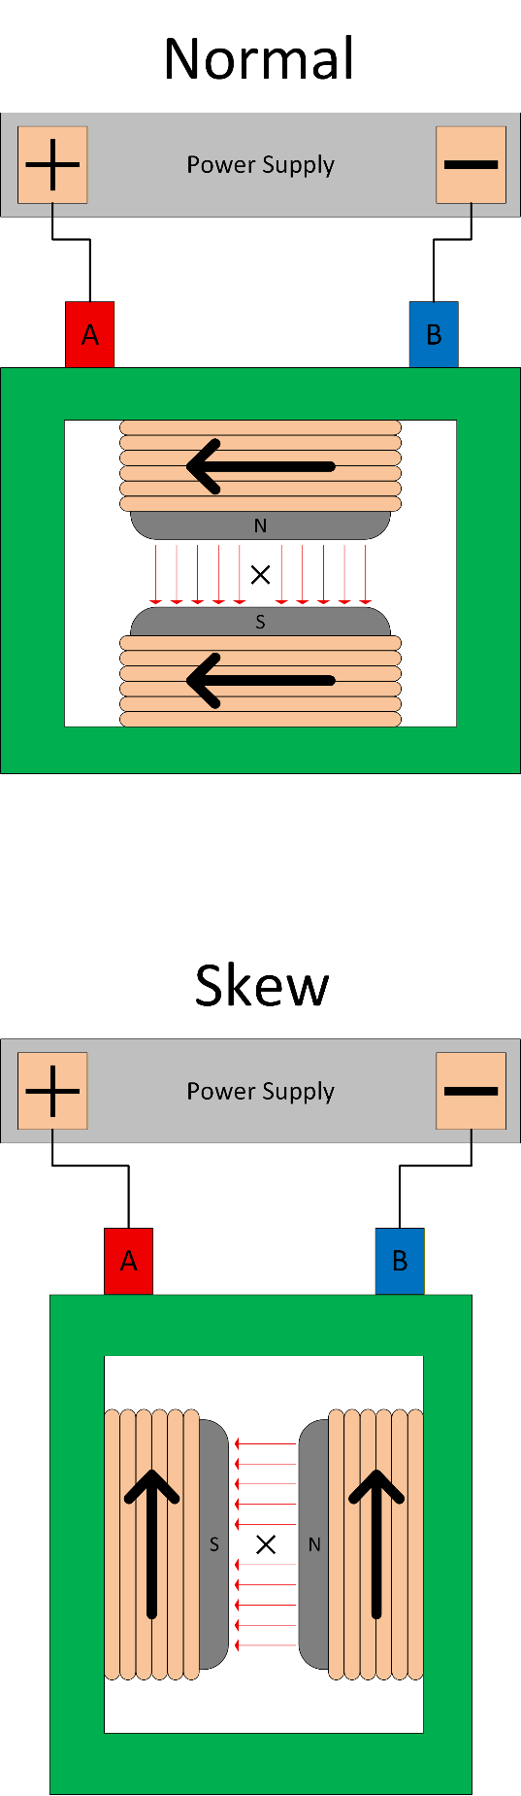

Figure 2 - Quadrupole Magnet
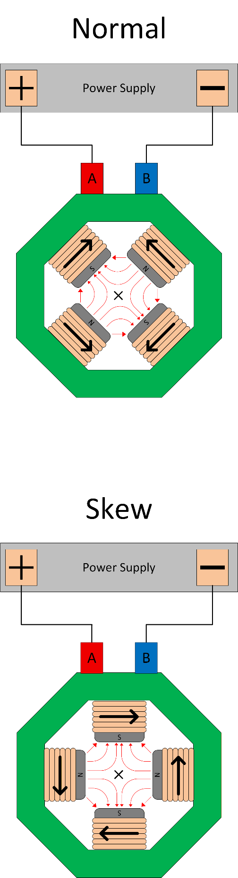
Figure 3 - Sextupole Magnet
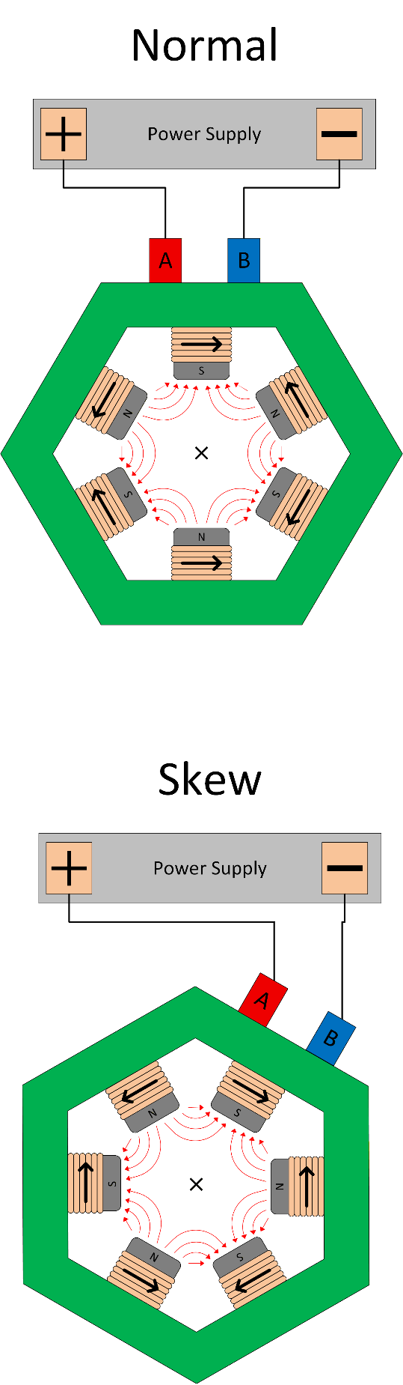

Figure 4 - Solenoid Magnetic Field
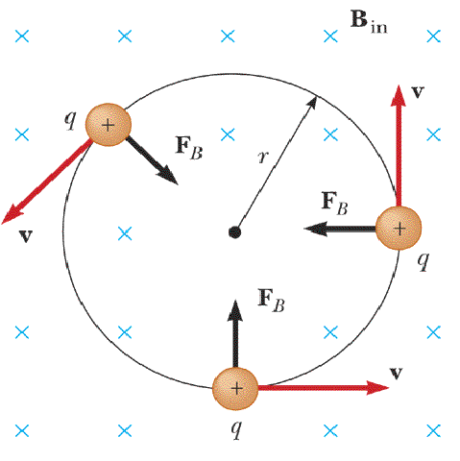

References:

Booster Polarity Standards, Ed Bleser, 1990

Approvals:
 | NAME | TITLE | DIGITAL SIGNATURE
Preparer | Bailey Rosmarin | Engineer
Reviewer | Thomas Russo | Chief Systems Engineer
Reviewer | Robert Lambiase | Principal Electrical Engineer
Reviewer | Don Bruno | Power Supply Subsystems, Group Leader
Reviewer | George Mahler | Magnet Systems, Deputy Group Leader
Reviewer | Joseph Tuozzolo | Chief Project Engineer
Reviewer | Jim Rochford | Systems Engineer
Reviewer | Kevin Smith | Deputy Technical Director
Approver | Sergei Nagaitsev | Technical Director

Acronym List
EIC | Electron-Ion Collider
ESR | Electron Storage Ring
HSR | Hadron Storage Ring
RCS | Rapid Cycling Synchrotron

