Electron-Ion Collider Requirements, Specifications, and Interfaces
Controls Software Functional and Performance Requirements Document
October 28, 2025

Prepared by:
__________________________________________ Date: __________________
Zhijian Yin, Systems Engineer

Reviewed by:
__________________________________________ Date: ___________________

Seth Nemesure, Controls Software WBS Manager

__________________________________________ Date: ___________________
James Jamilkowski, Controls CAM

__________________________________________ Date: ____________________
Thomas Russo, EIC Chief Systems Engineer

Approved by:
__________________________________________ Date: ____________________
Joseph Tuozzolo, EIC Accelerator Support Systems Manager

REVISION HISTORY
Revision # | Effective Date | Additional Reviewers | Summary of Change
00 |  |  | Initial release

TABLE OF CONTENTS
1. Purpose and Scope 7
2. Introduction 8
3. Controls Software Design 10
3.1 Overview of Design 10
3.2 Design Scope 12
4. Controls Software REQUIREMENTS 13
5. Applicable Documents 29
6. Detailed change Log 31
7. REFERENCES 31

LIST OF ACRONYMS
ADO | Accelerator Device Object
ADOBR | ADO (Accelerator Device Object) Bridge
API | Application Programming Interface
BLIP | Brookhaven Linac Isotope Producer
BSA | Brookhaven Science Associates
CI | Continuous Integration
CRUD | Create/Read/Update/Delete
CSV | Comma-Separated Values
DB | Database
DEV | Development
DOE | Department of Energy
EIC | Electron Ion Collider
EPICS | Experimental Physics and Industrial Control System
ESH | Environmental Safety and Health
ESR | Electron Storage Ring
FEC | Front End Computer
FPGA | Field Programmable Gate Array
GDD | Global Design and Development
GUI | Graphical User Interface
HLA | High Level Applications
HSR | Hadron Storage Ring
IOC | Input Output Controller
IR | Interaction Region
JSON | JavaScript Object Notation
LLRF | Low Level Radio Frequency
MCR | Main Control Room
ODH | Oxygen Deficiency Hazard
PPS | Personal Protection Systems
PRD | Performance Requirements Document
PV | Process Variable
RCS | Rapid Cycling Synchrotron
RF | Radio Frequency
RHIC | Relativistic Heavy Ion Collider
SBMS | Subject-Based Management System
SEG | Systems Engineering Group
SR | Save and Restore
SW | Software
TAPE | Tool for Automated Procedure Execution
WBS | Work Breakdown Structure

Controls Software Functional and Performance Requirements Document

Purpose and Scope
This document presents the functional and performance requirements for the Controls Software subsystems of the Electron Ion Collider Project [5.1]. The requirements are managed in accordance with Systems Engineering and Requirement Management Plans [5.2, 5.3, 5.4, 5.5]. The requirements for all systems in the EIC flow down from the system top level Global Requirements [5.6] to the General and Functional Requirements [5.7, 5.8] and finally to the Performance Requirements Document (PRD). These performance requirements are necessary to integrate these sub-systems as part of the Electron Ion Collider (EIC) Project.

The performance requirements (indicated by SHALL) and guidance (indicated by SHOULD) provided for the design have been defined based upon the reference physics design performed by Brookhaven Science Associates (BSA) and the spatial restrictions of the building which it will reside.

The EIC controls WBS is divided into several subsections, as shown in Figure 1-1. It consists of: Global Design and Development (GDD) for hardware device control, High-Level Applications for control software, Networking, and support for other accelerator subsystems, such as Power Supplies, Instrumentation, RF, vacuum etc. This document focuses on the control software requirements.

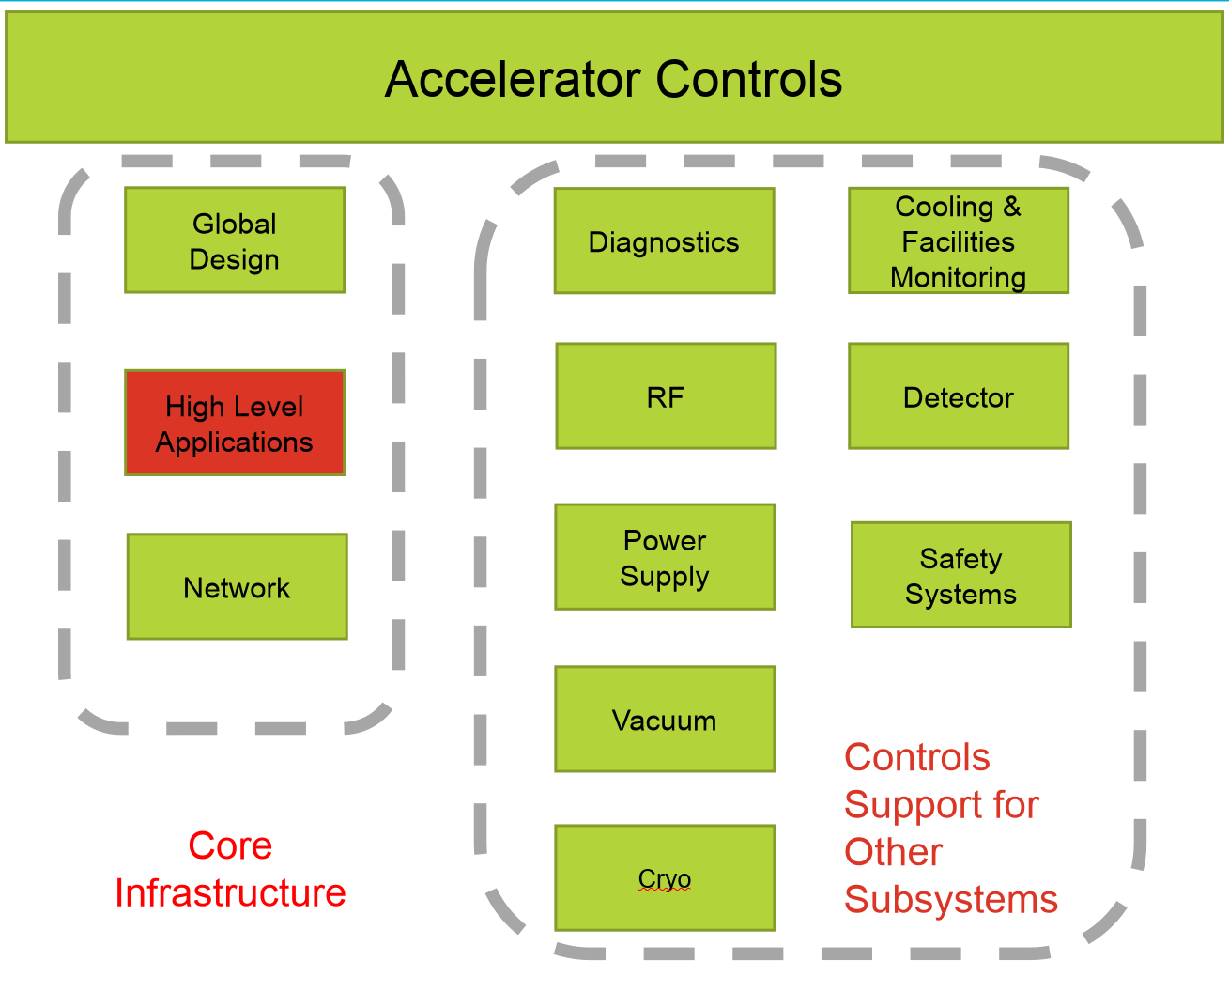
Figure 1-1 Accelerator control work breakdown structure

Introduction

The EIC (Electron Ion Collider) will be using the yellow ring of RHIC (Relativistic Heavy Ion Collider) as its Hadron Storage Ring (HSR), while building a new Electron Storage Ring (ESR) in the RHIC tunnel. The two rings intersect at several Interactive Regions (IR), where detectors will be installed to record electron ion collisions. For the injection systems, a new electron injector comprising a Linac and a Rapid Cycling Synchrotron (RCS) will be built outside the RHIC tunnel. The RHIC injection system remains to serve the hadron storage ring. See Figure 2-1 for a schematic.
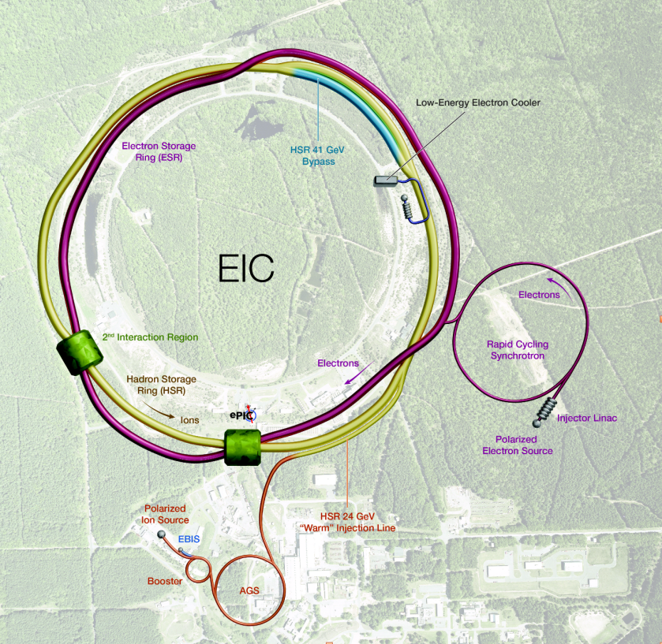

Figure 2-1 illustrates the overall layout of the EIC. The HSR is shown as the yellow line, the ESR as a wide red line and the RCS as the thin red line.

This brings unique challenges and opportunities for controls.

RHIC was built in the early 90s, the controls mostly made use of the then state-of-the-art technologies. Architecturally, it is a network based distributed accelerator control system with standard two level architecture: The high-level system handles operator interfaces, automatic sequences, alarms, data archiving and electronic logbook etc., while the low-level system directly controls the hardware components like magnets and vacuum systems using mostly VME hardware, with locally-developed ADO (Accelerator Device Objects) applications running on the real-time operating system VxWorks. The system has been successfully running the RHIC accelerator complex for 25 years with careful improvements and upgrades (such as FPGA based LLRF systems) along the way to enhance accelerator performance and support science missions.
The existing ADO based control system for the hadron injection, which also serves other facilities such as BLIP (Brookhaven Linac Isotope Producer) and still operates during the EIC construction, will remain.

With about 2 orders of magnitude increase in beam luminosity compared to RHIC, EIC controls need to employ state-of-the-art technologies. On the lower-level device controls, EIC is designing a common hardware platform that includes a modular and scalable FPGA system. The system will be deployed across all EIC machines, providing integrated support for precise timing, LLRF, beam instrumentation, and other subsystems.

On the software side, the EIC project prompts us to survey the current accelerator control landscape, paying close attention to code maintainability, to satisfy the goal that controls shall support EIC for its expected 30+ years of lifetime. It is realized that a proprietary development such as RHIC controls could present difficulty attracting future engineers with dedicated and specialized skills to maintain and upgrade the control system. The trend of many new facilities across the DOE complex (and around the world) is moving towards open-source collaborations such as EPICS. EPICS has been successfully supporting many accelerator and beamline facilities for over 30 years. It has been continually developed and grown as a world-wide open-source collaboration. Using a client-server and publish-subscribe model, EPICS is a robust, scalable and high-performance distributed control system, with a myriad of device support. EIC made the decision to join the EPICS collaboration and will adopt the EPICS framework for EIC controls.

For the HSR injector controls that have existing interfaces in place, the plan is to develop ADO bridge software to bring the ADO devices to global controls as EPICS PVs enabling the Main Control Room (MCR) to operate these devices in the same manner as existing EPICS-controlled equipment. An ADO bridge prototype has been developed.

Controls Software Design

Overview of Design
Figure 3-1 below shows a schematic of the EIC controls software architecture. One of the key components is the Operator Interface subsystem (shown “CS Studio” as example) that serves as the main control console for the MCR and testing workstations. Running in the background are the important control services such as alarm handling, data archiving, save-restore (supports capturing snapshots of control system settings providing capability to restore them on demand), electronic logbook - these services are already built into the existing RHIC controls. EPICS will require a need to adopt or develop the equivalent services. On the client side, support will be provided for high-level physics and modelling applications and bi-directional gateway services to detector system controls. Communication between client and server uses EPICS Channel Access (CA) or PV Access (PVA or PVXS) protocols. HTTP protocol will be used extensively to support services. In addition, project support tools such as e-traveler and inventory control (component database) will be supported. Automatic sequencing control (RHIC TAPE equivalent) and ADO bridge (to serve existing control objects as EPICS PVs) will be developed.

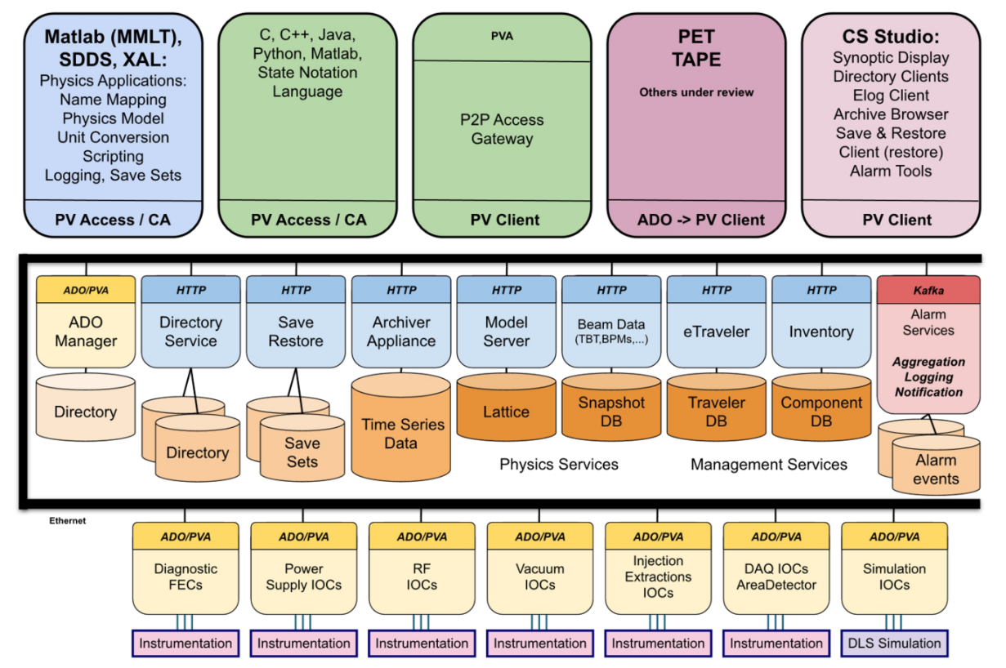

With this architecture in mind, the requirements for the controls software scope flow down to the software subsystems as shown in Table 3-1

Table 3-1: Controls Software Subsystem Functional and Performance Requirements

Table Index | Subsystem Name | Subsystem Description
Table 4-1 | EIC-CTRL-SW-DEV | Controls Software: Development Environment
Table 4-2 | EIC-CTRL-SW-HLA | Controls Software: High Level Physics Applications
Table 4-3 | EIC-CTRL-SW-OPI | Controls Software: Operator Interface
Table 4-4 | EIC-CTRL-SW-ALRM | Controls Software: Alarm Service
Table 4-5 | EIC-CTRL-SW-ARCH | Controls Software: Archiving Service
Table 4-6 | EIC-CTRL-SW-DIR | Controls Software: Directory Service
Table 4-7 | EIC-CTRL-SW-SR | Controls Software: Save and Restore Service
Table 4-8 | EIC-CTRL-SW-ADOBR | Controls Software: ADO Bridge
Table 4-9 | EIC-CTRL-SW-SEQ | Controls Software: Sequencer
Table 4-10 | EIC-CTRL-SW-LOGBK | Controls Software: Electronic Logbook
Table 4-11 | EIC-CTRL-SW-GW | Controls Software: Gateway Service
Table 4-12 | EIC-CTRL-SW-DB | Controls Software: Database Service
Table 4-13 | EIC-CTRL-SW-PROJ | Controls Software: Project Support
IR6

Design Scope
The Controls Software design shall meet all performance requirements as given in Section 4, whilst abiding by the constraints below.

Design Considerations
Constraints:
- The design shall be delivered within the time interval specified in the latest EIC P6 project schedule.
- The design cost shall meet the proposed EIC cost.
- The design shall be able to meet all relevant regulatory requirements.
- The design shall comply with all volume and siting constraints within the RHIC tunnel.
- The designs shall meet all the interface requirements necessitated by the various systems which interface with the controls system
- All technical specifications which can be used to verify that a primary requirement of the component is met at the design stage shall be identified and called out in the Final Design Review (FDR).
- All requirements which can be verified during the FDR shall be satisfied or have a plan in place to satisfy the review team so that the requirements can be met prior to final installation.

Safety and Environmental Considerations
The design of the Controls Software assembly shall demonstrate it will meet all the safety and environmental requirements in line with Brookhaven National Lab (BNL) Standards-Based Management System (SBMS) and the Integrated Safety Management Plan (ISMP) [5.9].

Controls Software REQUIREMENTS
The following section covers the Controls Software functional and performance requirements for operation in the EIC.
The table has the following fields:
    - Unique ID: The performance requirement identifier as defined.
    - Requirement: The performance requirement as defined. “F-” = Functional; “P-” = Performance
    - Verification Method: This attribute defining the method used to verify the requirement. The following methods may be used to verify requirements: Analysis, Inspection, Demonstration, Test

Table 4-1: Subsystem Functional and Performance Requirements for Controls Software : Development Environment

UniqueID | Requirement | Verification Method
F-EIC-CTRL-SW-DEV.1 | The development environment shall support version control, issue tracking, traceability, and collaborative workflows | Inspection
F-EIC-CTRL-SW-DEV.2 | The development environment shall support multiple programming languages and web service development | Inspection
F-EIC-CTRL-SW-DEV.3 | The system shall support extensible build and packaging mechanisms to support reproducibility and fallback strategies | Inspection
F-EIC-CTRL-SW-DEV.4 | Continuous integration (CI) pipelines should be used to perform automated testing where applicable | Inspection
F-EIC-CTRL-SW-DEV.5 | Releases should be versioned and documented with associated changelogs | Inspection

Table 4-2: Subsystem Functional and Performance Requirements for Controls Software: High Level Applications

UniqueID | Requirement | Verification Method
F-EIC-CTRL-SW-HLA.1 | Beam physics support APIs shall be available to interface through custom applications | Inspection
F-EIC-CTRL-SW-HLA.2 | Controls shall provide software tools for packaging standard beam physics applications in a consistent manner | Inspection
F-EIC-CTRL-SW-HLA.3 | Controls shall provide an interface for communication via PV Access | Inspection
F-EIC-CTRL-SW-HLA.4 | Controls shall provide interfaces to physics modeling tools | Inspection

Table 4-3: Subsystem Functional and Performance Requirements for Controls Software: Operator Interface

UniqueID | Requirement | Verification Method
F-EIC-CTRL-SW-OPI.1 | Synoptic displays shall support common, reusable controls widgets with data bindings to controls system variables. | Inspection
F-EIC-CTRL-SW-OPI.2 | Synoptic displays shall support macros and parameterization with preview and test mode capability | Inspection
F-EIC-CTRL-SW-OPI.3 | Synoptic displays (OPI screens) shall be version controlled | Inspection
F-EIC-CTRL-SW-OPI.4 | Synoptic displays shall report live data (with user interface level acceptable update rates) | Inspection
F-EIC-CTRL-SW-OPI.5 | Synoptic displays shall support meta data and timestamp consistency with controlled/monitored parameters | Inspection
F-EIC-CTRL-SW-OPI.6 | Synoptic displays shall clearly report connection status | Inspection
F-EIC-CTRL-SW-OPI.7 | Synoptic displays shall integrate with control system services including PV monitoring and control, archive data retrieval, and alarm display monitoring and acknowledgement. | Inspection
F-EIC-CTRL-SW-OPI.8 | Synoptic displays shall support embedded displays and navigation | Inspection
P-EIC-CTRL-SW-OPI.1 | Widget response latency should be <200ms from data update to onscreen change | Demonstration
P-EIC-CTRL-SW-OPI.2 | Macros should apply and reflect parameterized changes within 1 second | Demonstration
P-EIC-CTRL-SW-OPI.3 | OPI system shall support update rates up to 30Hz | Demonstration
P-EIC-CTRL-SW-OPI.4 | Timestamps shall reflect source data time within <100ms | Demonstration
P-EIC-CTRL-SW-OPI.5 | Connection loss shall be indicated within 5-10 seconds of disconnection | Demonstration
P-EIC-CTRL-SW-OPI.6 | Data retrieval for historical displays shall complete within 3 seconds for 1-hour spans. Alarm acknowledgement <1 second | Demonstration

Table 4-4: Subsystem Functional and Performance Requirements for Controls Software: Alarm Service

UniqueID | Requirement | Verification Method
F-EIC-CTRL-SW-ALRM.1 | Controls shall provide a robust, reliable, and horizontally scalable central alarm management service, with minimal response times from generator to display. | Inspection
F-EIC-CTRL-SW-ALRM.2 | The alarm service shall interface with various notification, logging, and archiving services | Inspection
F-EIC-CTRL-SW-ALRM.3 | The alarm service shall monitor critical hardware, engineering, and software signals using a predefined set of thresholds to generate alarms | Inspection
F-EIC-CTRL-SW-ALRM.4 | The alarm service shall support a dynamic set of alarm levels per PV with timestamps and severity status | Inspection
F-EIC-CTRL-SW-ALRM.5 | The alarm service shall provide a user interface for configuration, viewing, acknowledging, and assigning, with access to historical alarms | Inspection
F-EIC-CTRL-SW-ALRM.6 | The alarm service should support access to alarm response instructions and ability to create alarm management state reports. | Inspection
P-EIC-CTRL-SW-ALRM.1 | Alarm notification shall be visible in the operator interface within 250ms of the triggering condition under normal load | Demonstration
P-EIC-CTRL-SW-ALRM.2 | Logging and archiving actions shall complete within 500ms of alarm detection. Notifications shall be dispatched within 1 second. | Demonstration
P-EIC-CTRL-SW-ALRM.3 | Alarm threshold evaluation shall occur at a minimum rate of 10Hz per monitored signal | Demonstration

Table 4-5: Subsystem Functional and Performance Requirements for Controls Software: Archiving service

UniqueID | Requirement | Verification Method
F-EIC-CTRL-SW-ARCH.1 | The archive service shall support all EPICS scalars, arrays, structures data types with configurable sampling modes (on-change, periodic, event-based) and built-in compression capabilities. | Inspection
F-EIC-CTRL-SW-ARCH.2 | The archive service shall scale to millions of control points with tiered storage architecture, optimized data placement, and expandable capacity for 50-year operations. | Inspection
F-EIC-CTRL-SW-ARCH.3 | The archive service shall provide configurable data aging policies, automated data reduction (min, max, average), and performance optimization through intelligent data culling. | Inspection
F-EIC-CTRL-SW-ARCH.4 | The archive service shall provide well-defined APIs, third-party library support, time-range queries, flexible filtering, and integration with EIC GUI tools. | Inspection
F-EIC-CTRL-SW-ARCH.5 | Users should export data in multiple formats, correlate data across time and events, combine EIC and injector data, and access advanced selection tools. | Inspection
F-EIC-CTRL-SW-ARCH.6 | The archive service should provide intuitive management interfaces, GUI applications for correlated data display (including array visualizations), and comprehensive documentation. | Inspection
P-EIC-CTRL-SW-ARCH.1 | The system shall support sustained write throughput of at least 1-2M control point updates per second with no data loss under nominal load. | Demonstration
P-EIC-CTRL-SW-ARCH.2 | Data reduction and aging routines should process and age out data at a rate of up to a few million samples/hour with <20% CPU usage per archiver appliance. | Demonstration
P-EIC-CTRL-SW-ARCH.3 | Time-range queries of up to one hour of 10Hz data (per signal) shall return results within 3 seconds for up to 1000 signals. | Demonstration
P-EIC-CTRL-SW-ARCH.4 | Export of 1-hour time series (10Hz) for 500 channels should complete within 10 seconds and support streaming formats (e.g., CSV, JSON) | Demonstration

Table 4-6: Subsystem Functional and Performance Requirements for Controls Software: Directory Service

UniqueID | Requirement | Verification Method
F-EIC-CTRL-SW-DIR.1 | Directory Service shall manage a directory of uniquely named entries with enforced naming conventions | Inspection
F-EIC-CTRL-SW-DIR.2 | Entries shall be organized using properties and tags | Inspection
F-EIC-CTRL-SW-DIR.3 | Directory clients shall have capability to add, modify, or delete entries | Inspection
F-EIC-CTRL-SW-DIR.4 | The service shall track support tracking changes to entries with an audit trail including support for backup and redundancy | Inspection
F-EIC-CTRL-SW-DIR.5 | Entries shall be retrieved by name, class, or shared attributes | Inspection
F-EIC-CTRL-SW-DIR.6 | Directory Service should support credential-aware access | Inspection
F-EIC-CTRL-SW-DIR.7 | Directory Service shall support private/sandbox instances | Inspection
F-EIC-CTRL-SW-DIR.8 | Service should be scalable and provide high availability and fault tolerance | Inspection
P-EIC-CTRL-SW-DIR.1 | Directory service clients should support completion of add/modify/delete operations within 100ms | Demonstration
P-EIC-CTRL-SW-DIR.2 | Audit log entries should be written within 250ms of the associated action. Backups should not introduce more than a 10% latency overhead | Demonstration
P-EIC-CTRL-SW-DIR.3 | Directory lookups should complete within 50ms for attribute-based filtering of <10K entries | Demonstration
P-EIC-CTRL-SW-DIR.4 | Authentication checks should add no more than 50ms to request latency under normal load | Demonstration
P-EIC-CTRL-SW-DIR.5 | The service should support at least 5 concurrent read/write clients with 99.9% uptime and recovery within 5 seconds of failover in a replicated configuration | Demonstration

Table 4-7: Subsystem Functional and Performance Requirements for Controls Software: Save and Restore Service

UniqueID | Requirement | Verification Method
F-EIC-CTRL-SW-SR.1 | Users should be able to define, edit, and organize named configurations that specify which values are to be included in a snapshot using common APIs | Inspection
F-EIC-CTRL-SW-SR.2 | The system shall support capturing snapshots that record system state and compare/restore all or part of a snapshot | Inspection
F-EIC-CTRL-SW-SR.3 | The system shall support a storage backend that effectively scales and provide redundancy through regular backups | Inspection
F-EIC-CTRL-SW-SR.4 | All snapshot actions including saves and restores shall be logged with relevant metadata | Inspection
F-EIC-CTRL-SW-SR.5 | The system shall support versioning and history tracking | Inspection
F-EIC-CTRL-SW-SR.6 | The system shall support logical grouping/organization of snapshots. | Inspection
F-EIC-CTRL-SW-SR.7 | The system shall support high availability | Inspection
P-EIC-CTRL-SW-SR.1 | The system should support snapshot storage growth of 10K snapshots/month with retention for >1 year. Backups shall not degrade restore latency by more than about 10% | Demonstration
P-EIC-CTRL-SW-SR.2 | A system snapshot of 10K PVs should be captured in <5 seconds and restored in <10 seconds. Partial restoration of <100 PVs should be completed within 1 second. | Demonstration
P-EIC-CTRL-SW-SR.3 | Metadata logging should complete within 200ms of each save/restore action | Demonstration
P-EIC-CTRL-SW-SR.4 | The service shall failover within 5 seconds and maintain access to all snapshot metadata and latest saved data | Demonstration

Table 4-8: Subsystem Performance Requirements for Controls Software:ADO bridge

Code | Requirement | Verification Method
F-EIC-CTRL-SW-ADOBR.1 | The bridge software shall map legacy device I/O points as EPICS PVs to allow EPICS clients in the main control room to control legacy hardware with ADO control | Inspection
F-EIC-CTRL-SW-ADOBR.2 | ADO bridge software shall be able to handle a set of ADO objects | Inspection
F-EIC-CTRL-SW-ADOBR.3 | Alarms generated by legacy systems shall pass to the EIC controls alarm server | Inspection
F-EIC-CTRL-SW-ADOBR.4 | All meta data shall be preserved through the lifecycle of the ADO to PV translation | Inspection
F-EIC-CTRL-SW-ADOBR.5 | The bridge shall support bi-directional access | Inspection
P-EIC-CTRL-SW-ADOBR.1 | Mapped PVs shall reflect changes in ADO values within 100ms under normal conditions | Demonstration
P-EIC-CTRL-SW-ADOBR.2 | Each ADO Manager/FEC shall support a number of active parameters comparable to an EPICS IOC/PV Server, with overall throughput and latency on par with EPICS PV update performance. The bridge shall introduce no more than 100ms of overhead under normal load. | Demonstration
P-EIC-CTRL-SW-ADOBR.3 | Legacy alarm events shall be transmitted to the alarm server within 250ms of generation | Demonstration
P-EIC-CTRL-SW-ADOBR.4 | The bridge should support bi-directional access with latency < 100ms | Demonstration

Table 4-9: Subsystem Functional and Performance Requirements for Controls Software: Sequencer

Code | Requirement | Verification Method
F-EIC-CTRL-SW-SEQ.1 | The sequencing system shall provide ability to automate well-defined and repeated tasks for multiple EIC Groups | Inspection
F-EIC-CTRL-SW-SEQ.2 | A graphical user interface shall be provided for creating, editing, versioning, viewing, selecting, and running sequences. | Inspection
F-EIC-CTRL-SW-SEQ.3 | Users shall be able to navigate through the execution of sequences for debugging and task error response resolution | Inspection
F-EIC-CTRL-SW-SEQ.4 | Sequence transcript history shall be searchable and provide execution time, location, and user information, including summary report automated delivery to interested parties | Inspection
F-EIC-CTRL-SW-SEQ.5 | Sequences shall support nesting of sub-sequences | Inspection
F-EIC-CTRL-SW-SEQ.6 | Sequences shall provide a test mode option that avoids affecting EIC equipment | Inspection
F-EIC-CTRL-SW-SEQ.7 | Real-time list of actively running sequences including location and user shall be available | Inspection
F-EIC-CTRL-SW-SEQ.8 | Sequence clashing prevention shall be supported to avoid multiple sequences from running simultaneously where applicable | Inspection
P-EIC-CTRL-SW-SEQ.1 | GUI actions such as loading, editing, or saving a sequence should complete within 1 second for sequences up to 10KB or about 100 lines. Execution should be dispatched within 100ms between consecutive steps. | Demonstration
P-EIC-CTRL-SW-SEQ.2 | Queries for execution history should return results within 2 seconds for a period of up to one week and 1K entries. Summary reports shall be generated within 5 seconds. | Demonstration
P-EIC-CTRL-SW-SEQ.3 | Test mode execution should simulate a sequence proportional to non-test mode execution. Logging of additional diagnostics should complete within 2 seconds | Demonstration

Table 4-10: Subsystem Functional and Performance Requirements for Controls Software Electronic Logbook service

Code | Requirement | Verification Method
F-EIC-CTRL-SW-LOGBK.1 | Electronic logbook shall allow users to create, edit, and delete entries maintaining an audit trail | Inspection
F-EIC-CTRL-SW-LOGBK.2 | Entries shall include meta data, support rich text, attachments, and be context aware | Inspection
F-EIC-CTRL-SW-LOGBK.3 | Service shall support grouping/threading of entries and provide advanced search capabilities. | Inspection
F-EIC-CTRL-SW-LOGBK.4 | Service shall support multiple client types through an API that integrates with controls system tools | Inspection
F-EIC-CTRL-SW-LOGBK.5 | Service shall support user-defined views and filters with personal display preferences | Inspection
F-EIC-CTRL-SW-LOGBK.6 | Service shall require authenticated access | Inspection
F-EIC-CTRL-SW-LOGBK.7 | Service shall provide high availability and scalability | Inspection
P-EIC-CTRL-SW-LOGBK.1 | Entry creation, update, or deletion shall complete within 500ms under normal load (up to 10 concurrent users) | Demonstration
P-EIC-CTRL-SW-LOGBK.2 | Search queries for text, author, or tags across one week of data should return results within 2 seconds for up to 1K entries | Demonstration
P-EIC-CTRL-SW-LOGBK.3 | API requests (GET/POST for entries or metadata) should respond within 300ms for typical payloads (10KB) | Demonstration
P-EIC-CTRL-SW-LOGBK.4 | Authentication should complete in less than 1 second for valid sessions. Failures < 500 ms | Demonstration
P-EIC-CTRL-SW-LOGBK.5 | The service shall support >20 concurrent users and remain available during failovers with maximum delay of 5 seconds | Demonstration

Table 4-11: Subsystem Functional and Performance Requirements for Controls Software Gateway service

Code | Requirement | Verification Method
F-EIC-CTRL-SW-GW.1 | Controls shall design and deploy a gateway service to provide read-only access to key machine parameters outside controls network | Inspection
F-EIC-CTRL-SW-GW.2 | Controls shall develop a website to show the EIC operation status outside the controls network | Inspection
P-EIC-CTRL-SW-GW.1 | The website should update displayed status values within 5 seconds of a change to underlying PVs and shall load within 2 seconds for unauthenticated users | Demonstration

Table 4-12: Subsystem Performance Requirements for Controls Software Database service

Code | Requirement | Verification Method
F-EIC-CTRL-SW-DB.1 | Controls system shall implement database services that support read, write, modify, and delete operations on stored values | Inspection
F-EIC-CTRL-SW-DB.2 | Database shall provide user level access for all aspects of database usage, limiting access based on machine, group, and user | Inspection
F-EIC-CTRL-SW-DB.3 | Database encryption should be supported where necessary | Inspection
F-EIC-CTRL-SW-DB.4 | Database service design should account for scalability with consistent developer API | Inspection
F-EIC-CTRL-SW-DB.5 | Database logs, transaction and/or otherwise shall be maintained on a case-by-case basis with justification | Inspection
P-EIC-CTRL-SW-DB.1 | CRUD (Create/Read/Update/Delete) operations on individual entries should complete within 100ms for typical payloads (10KB) under normal system load | Demonstration
P-EIC-CTRL-SW-DB.2 | Encryption overhead for read/write operations shall not exceed 20% latency impact under normal load | Demonstration
P-EIC-CTRL-SW-DB.3 | The service shall maintain CRUD operation latency (250ms) for up to 50 concurrent clients or 1K operations/second | Demonstration

Table 4-13: Subsystem Functional and Performance Requirements for Project Support Software

Code | Requirement | Verification Method
F-EIC-CTRL-SW-PROJ.1 | The Controls System shall provide a standard mechanism for asset tracking | Inspection
F-EIC-CTRL-SW-PROJ.2 | Asset tracking tools will employ a mechanism for generating, maintaining, and utilizing templates for arbitrary device types | Inspection
F-EIC-CTRL-SW-PROJ.3 | Asset tracking tools will support management of data for discrete devices | Inspection
F-EIC-CTRL-SW-PROJ.4 | Asset tracking tools will support management of data for cabling | Inspection
F-EIC-CTRL-SW-PROJ.5 | The Controls System will provide an interface to implement Quality Assurance procedures for acceptance of new equipment | Inspection
F-EIC-CTRL-SW-PROJ.6 | The interface to the system used for acceptance of new equipment will include a mechanism for Non-Conformance Reporting | Inspection
P-EIC-CTRL-SW-PROJ.1 | Applying a template to create or update an asset record should complete within 500ms for "typical" templates of up to 50 fields. Template search/load operations shall return results within 1 second | Demonstration

Applicable Documents
List applicable documents considered to be part of this document. Applicable documents shall be obtained from the EIC SharePoint Document Center.
Applicable documents shall be obtained from the EIC SharePoint.

ID | Document Number | Document Name
 | BNL-221006-2021-FORE | EIC Conceptual Design Report
 | EIC-SEG-PLN-022 | Systems Engineering Management Plan
 | EIC-SEG-PLN-016 | Requirements Management Plan
 | EIC-SEG-PLN-017 | Requirements Management Plan for Detector Systems
 | EIC-SEG-PLN-020 | EIC Interface Management Plan
 | EIC-ORG-PLN-010 | Electron-Ion Collider Global Requirements
 | EIC-SEG-RSI-003 | General and Functional Requirements for the EIC Electron Storage Ring
 | EIC-SEG-RSI-002 | General and Functional Requirements for the EIC Hadron Storage Ring system
 | EIC-ESH-PLN-007 | Integrated Safety Management Plan (ISMP)

Detailed change Log
Revision | Date | Change

REFERENCES
- doi:10.17226/25171., National Academies of Sciences, Engineering, and Medicine, "An Assessment of U.S.-Based Electron-Ion Collider Science", The National Academies Press, Washington, DC, 2018.
- arXiv:2103.05419, Science Requirements and Detector Concepts for the Electron-Ion Collider: EIC Yellow Report

