

**Faculty of engineering - Shoubra**

**Benha University**

**Research Project**

in fulfillment of the requirements of

|  |  |
| --- | --- |
| **Department** | **Engineering Mathematics and Physics** |
| **Division** | **-----------------** |
| **Academic Year** | **2019-2020 Preparatory** |
| **Course name** | **Computer** |
| **Course code** | **ECE006** |

**Title: -**

**Build a website on Big Data**

By:

|  |  |  |  |
| --- | --- | --- | --- |
|  | Name | Edu mail | B.N |
| 1 | عيد عبدالحميد عيد عبدالحميد | Eid195647@feng.bu.edu.eg | 584 |

**Approved by:**

|  |  |
| --- | --- |
| Examiners committee | Signature |
| Dr.Ahmed Bayoumi |  |
| Dr.Shady Elmashad |  |
| Dr. Abdelhamid Attaby |  |

**Table of contents**

|  |  |
| --- | --- |
| **Subject / section** | **Page** |
| Links | 1 |
| Application brief | 2 |
| Screenshots of Webpages | 4 |
| Screenshots of code sources | 7 |

**Links**

|  |  |
| --- | --- |
| **Github-link** |  |
| **Gitub-page (published webpage)** |  |

**Application brief**

Big Data is also data but with a huge size. Big Data is a term used to describe a collection of data that is huge in volume and yet growing exponentially with time. In short such data is so large and complex that none of the traditional data management tools are able to store it or process it efficiently.

Types of Big Data

* Structured data.
* Unstructured data.
* Semi-structured data.

Characteristics of Big Data

1. Volume.
2. Velocity.
3. Variety.
4. Value.
5. Veracity.

Some Advantages of Big Data

- Better decision-making.

- Reduce costs.

- Improved customer service.

- Increased revenue.

- Greater innovation.

Some Advantages of Big Data

- Need for talent.

- Data quality.

- Cyber security risks.

- Hardware needs.

- Costs.

Applications of Big Data

Big Data is used in many Fields for example:

- Fast-Food Industry.

- Casino Business.

- Tourism.

- Ecommerce.

- Agriculture.

- Restaurants.

- Education.

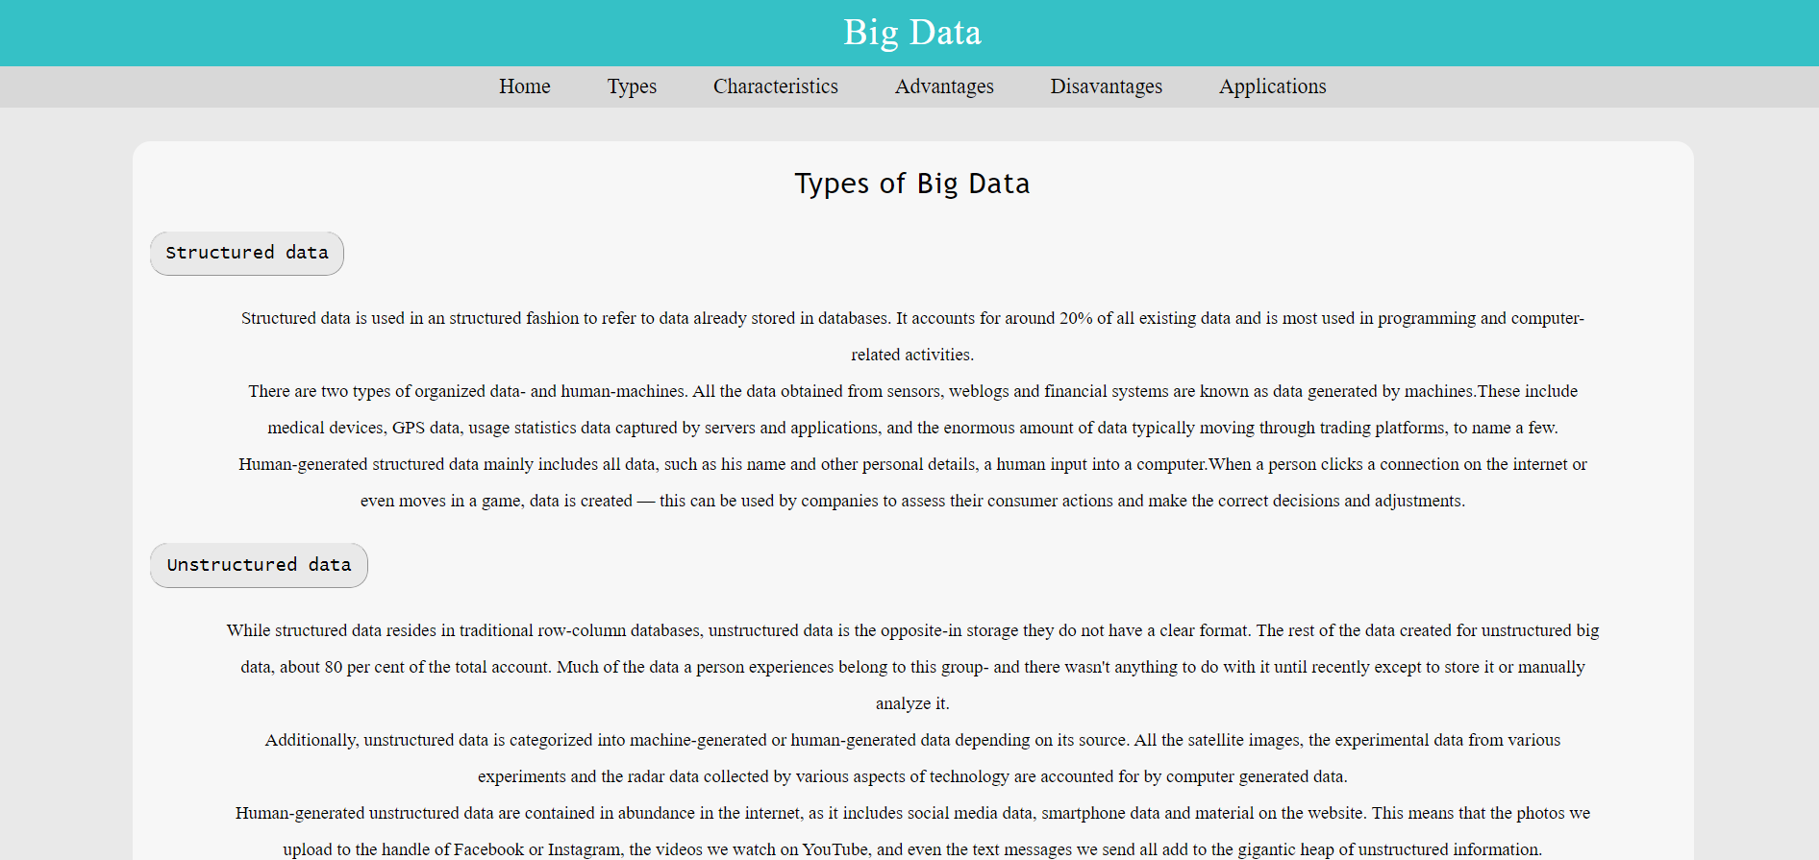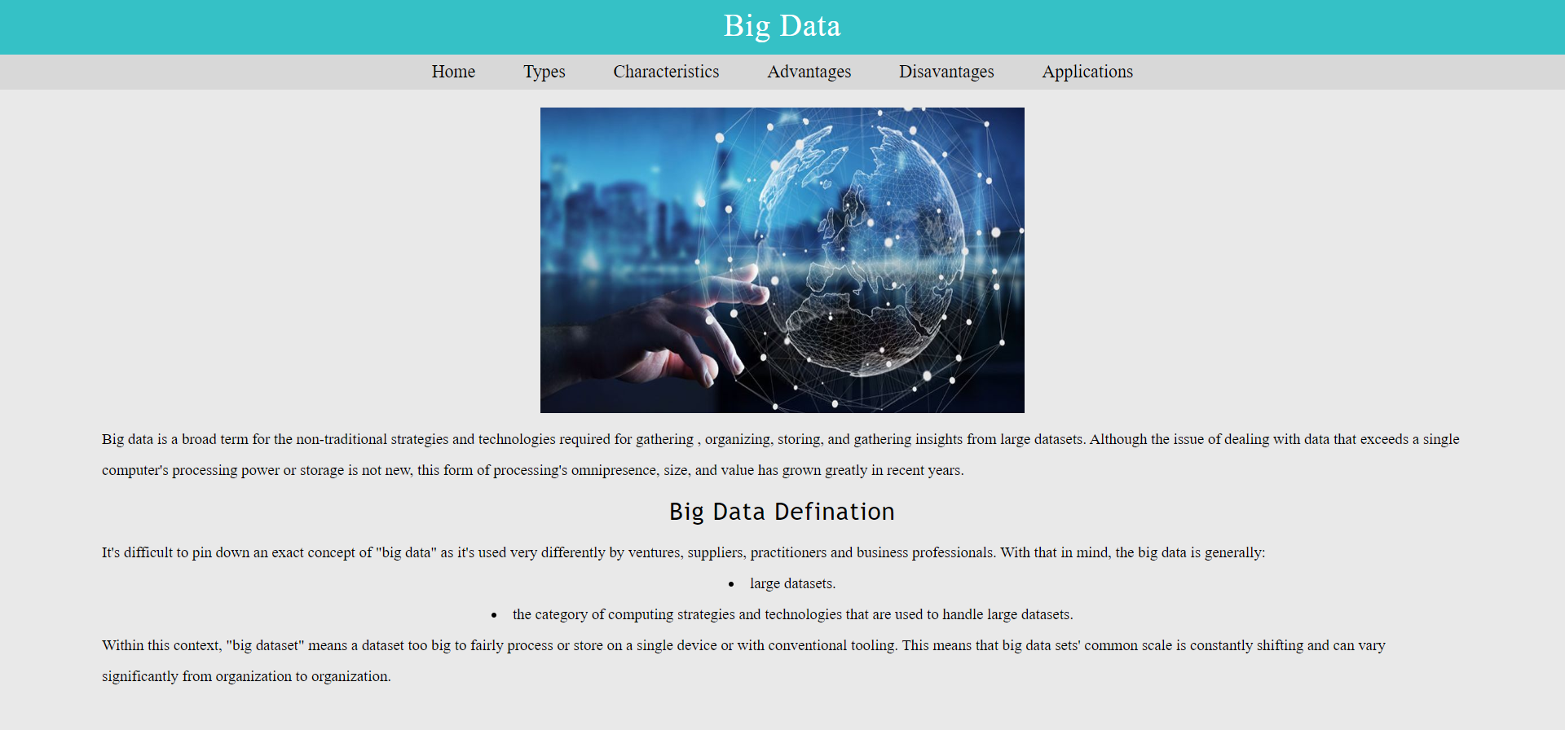Screenshots of Webpages

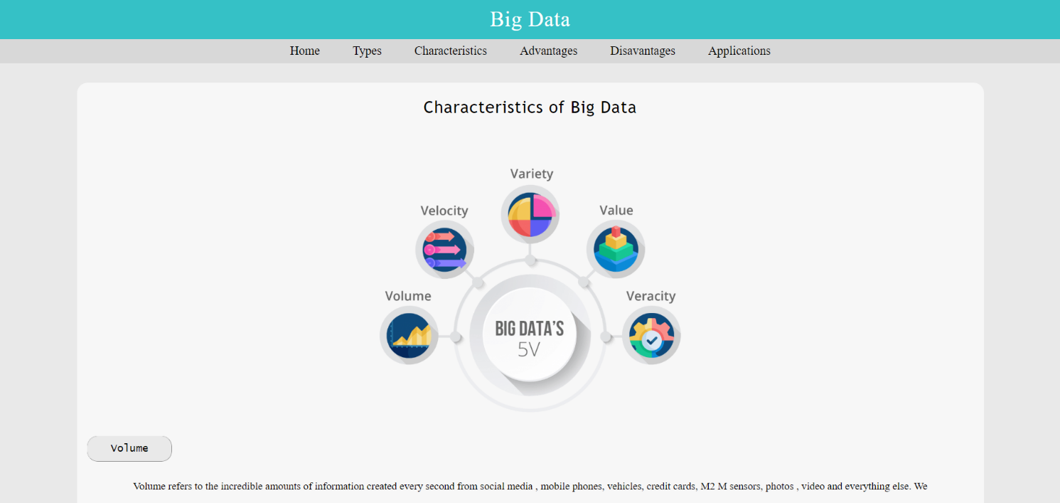

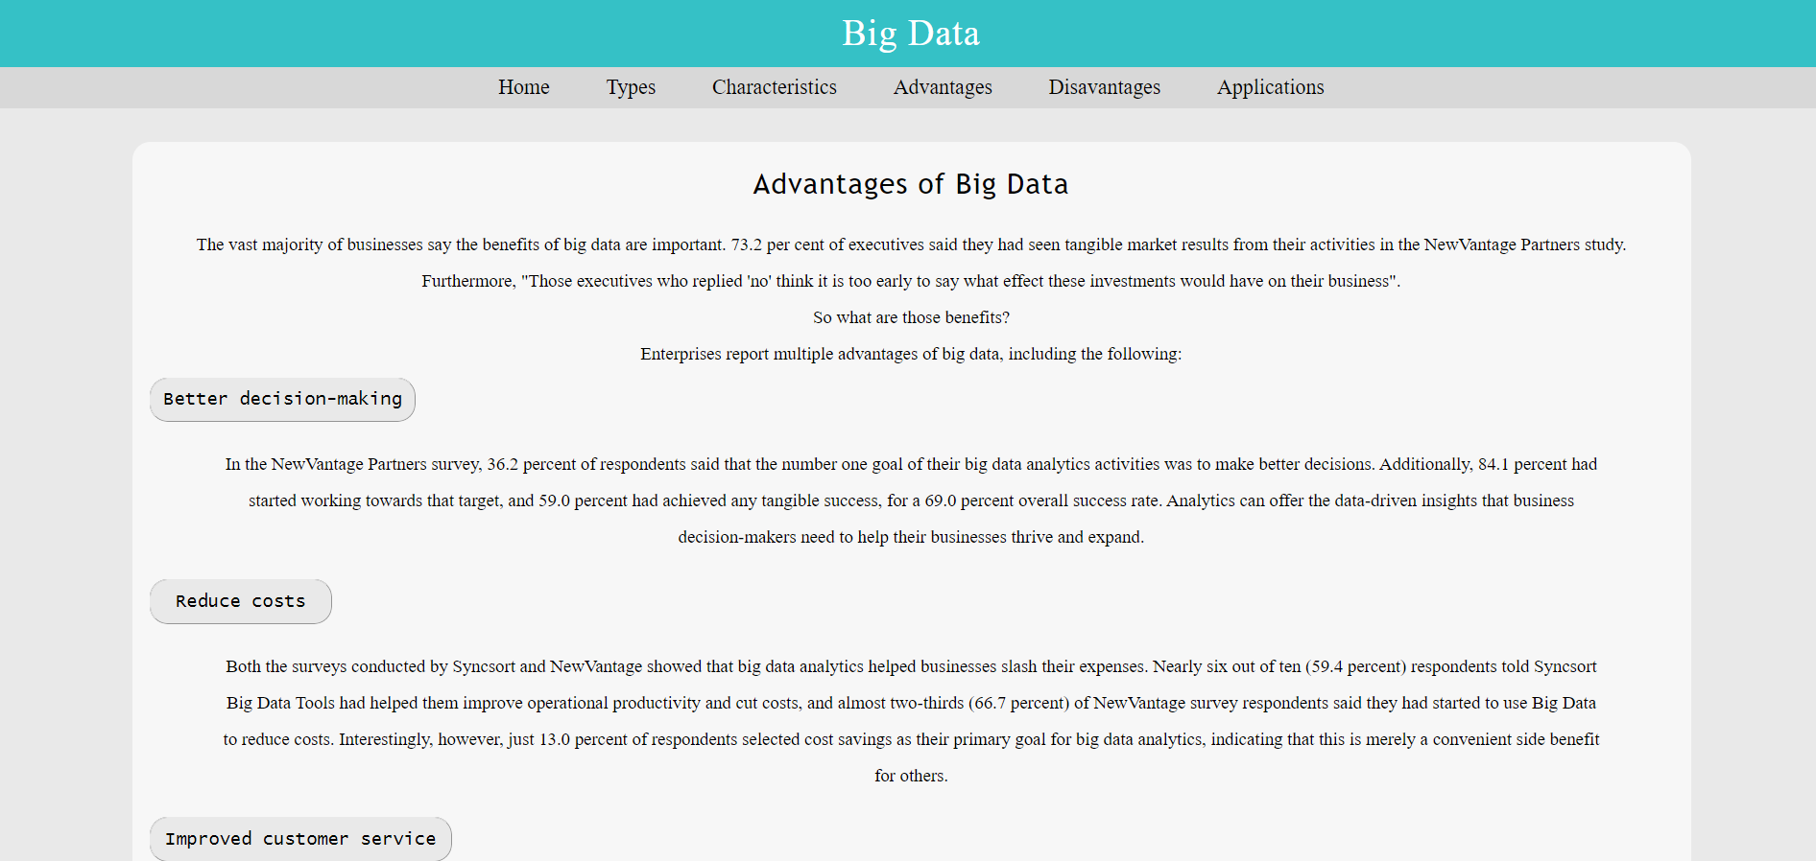

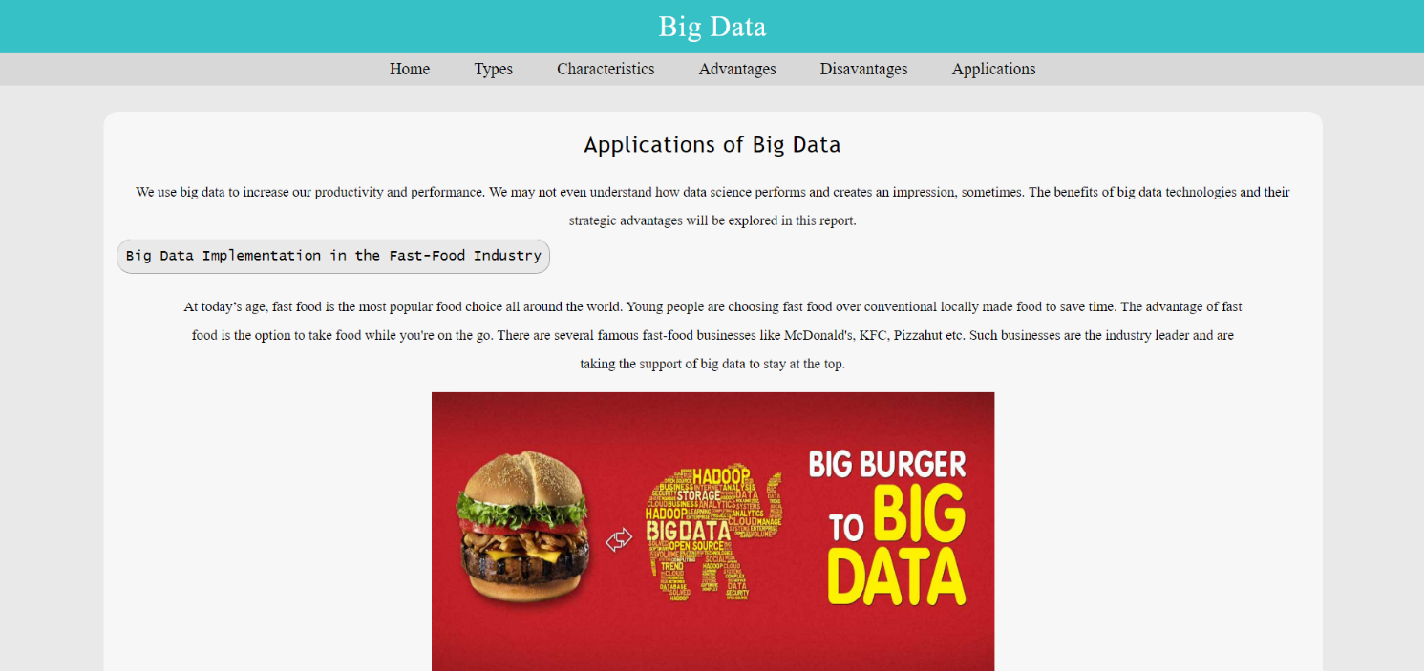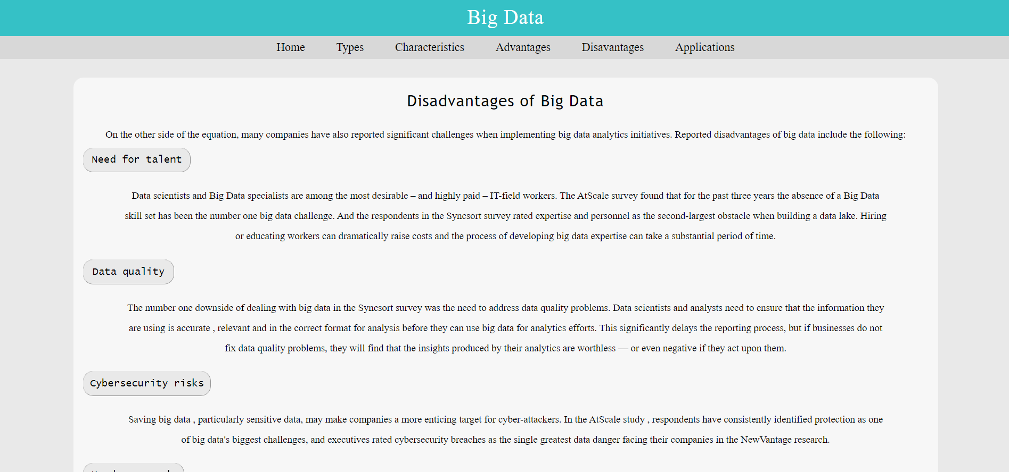

Screenshots of code sources

