**Magnetized Electron: Kinematic of the Motion**

Equation of motion for electron in the homogeneous magnetic field  and central Coulomb field of the ion:

 (1)

where  is a radius-vector of electron and  is a vector from ion to electron. Let’s derive the velocity of electron on two parts:  – the perpendicular to the magnetic field direction , i.e.  is the radius-vector from the center of the electron Larmor circle with radius  ( is the electron Larmor frequency) to the electron and along the magnetic field.

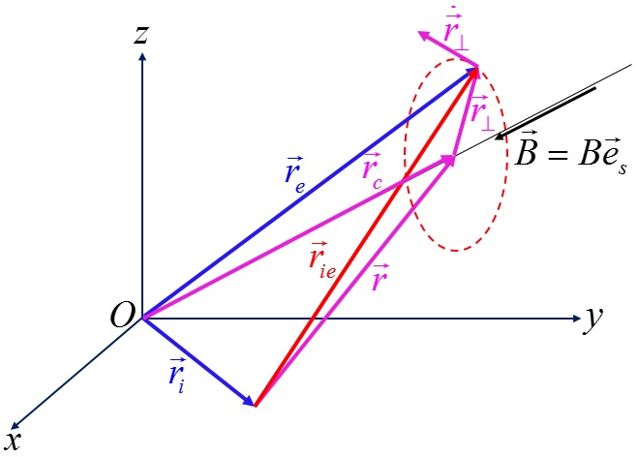The obvious relations between vectors (see left Figure) are

 (2)

and allow to rewrite equation (1):

 (3)

Equation (3b) allows to find the following condition of magnetizing of electron motion: first term in the right part must be much more than second one:

 (4)

where was taking account that “reduced mass”  practically equals . Dependence of  on magnetic field is shown in the next figure.

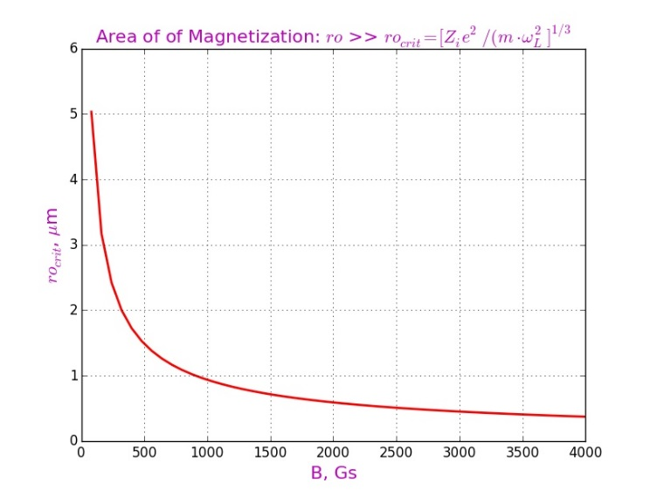Displacement of magnetized electron across the magnetic field, as will be seen from the following, is very small. It means that distance  between ion and electron practically does not change during collision, i.e. , where  is impact parameter. So, equation (3b) rewriting as

 (5)

In a plane perpendicular to the magnetic field with the origin at the center of the Larmor circle, it is convenient to introduce the local coordinate system , so that  and instead equation (5) one has a system

 (6)

where

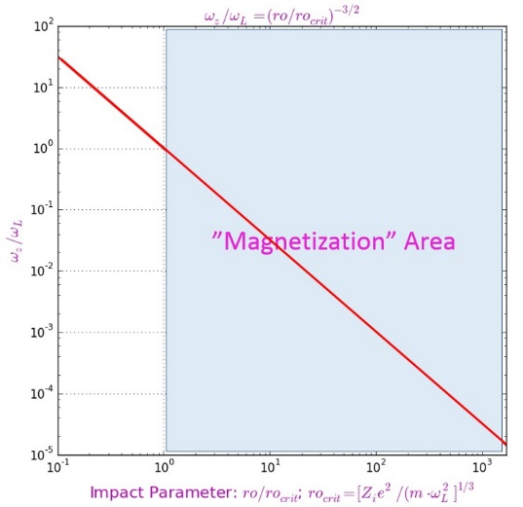 (7)

Left Figure shows the dependence of  on ratio .

System (6) is solved very simply, using substitution . Then equation for  is as follows

 (8a)

and has the obvious solution:

 (8b)

with

 (9)

Here .

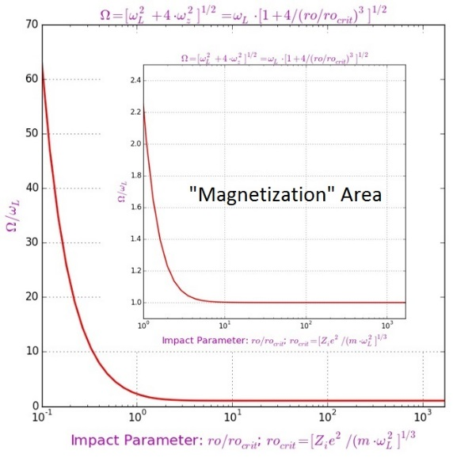Relative frequencies depend on ratio  only. Left Figure shows that in area of magnetization () the frequency  is varies insignificantly and is close to the Larmor frequency. Relations (9) means the similar behavior of the frequencies .

Expressions (8) gives the following solution of the equations (6):

 (10)

It is convenient to rewrite this solution in the dimensionless variables  and to use, without violating the generality of the examination, the following initial conditions:

. (11)

Than equations (10) have very simple form:

 (12)

Equations (12) show very strong dependence the trajectory of electron on level of its magnetizing because all frequencies  depend on value of ratio .

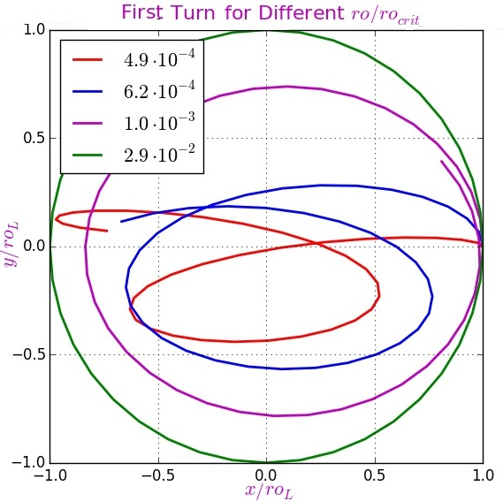In corresponding with condition (4) electron is magnetized  and in opposite case the influence of the ion field will be significant.

Left Figure with first turn for different value of  confirms that. It shows that the trajectory of nonmagnetized electron very significant differs from Larmor circle. Nevertheless, this difference rapidly decreases with increasing impact parameter and at values still lower than the critical value practically disappears (green curve for ).

Next Figures demonstrate first nine turns for different values of , i.e. out of the “magnetization” area. Each turn is shown in a different color: red, blue, magenta, green and black for turns 1 – 5 correspondingly and the same sequence of colors with sign “X” for turns 6 – 9.

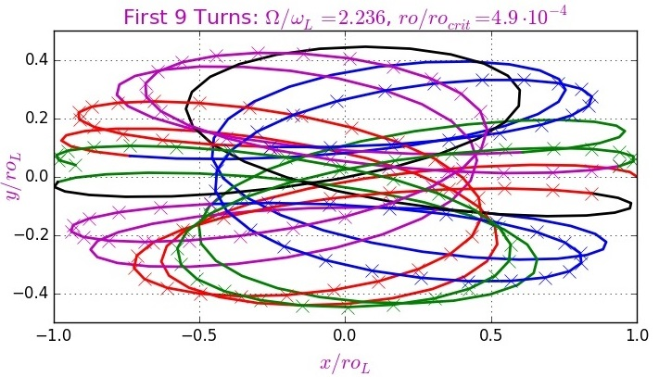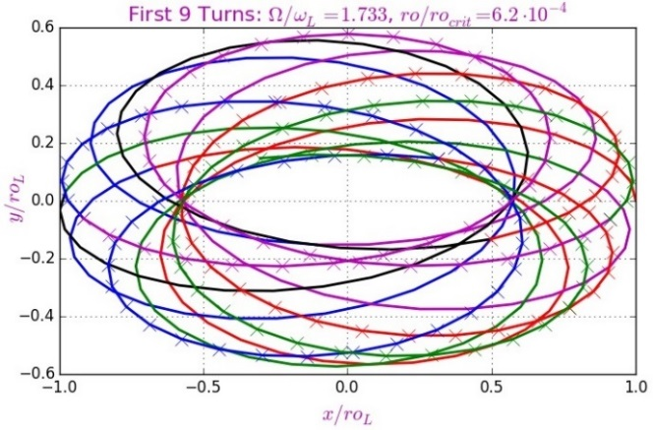

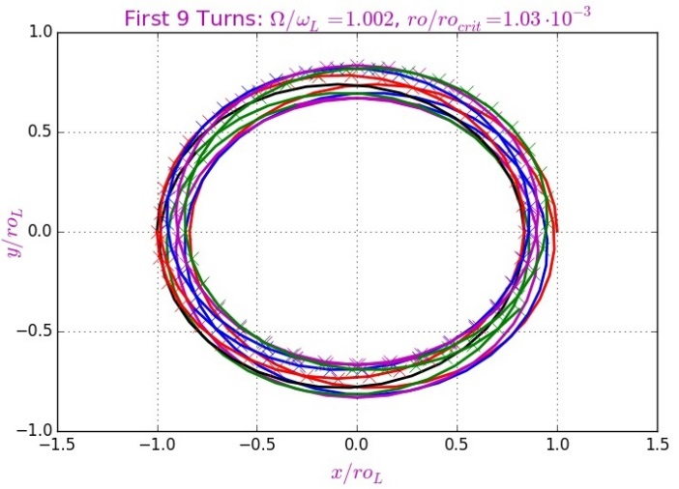 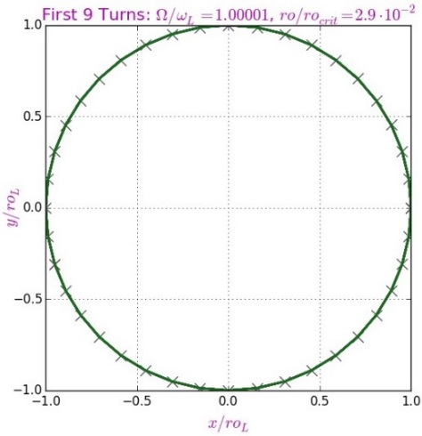

It can be seen, that the radial size of trajectory  oscillates in time:

. (13)

This behavior is shown in the following Figures for the impact parameter values  used in the previous Figures.

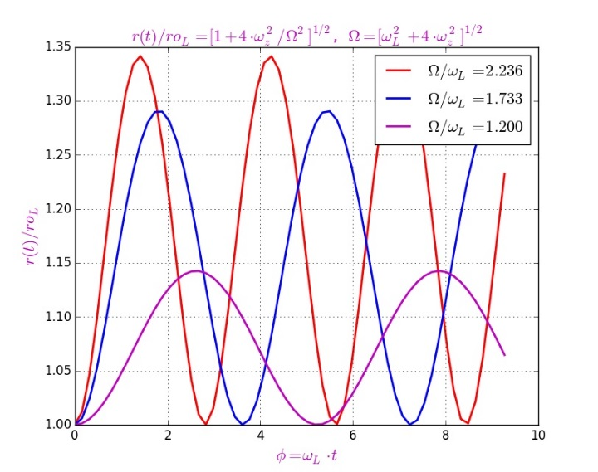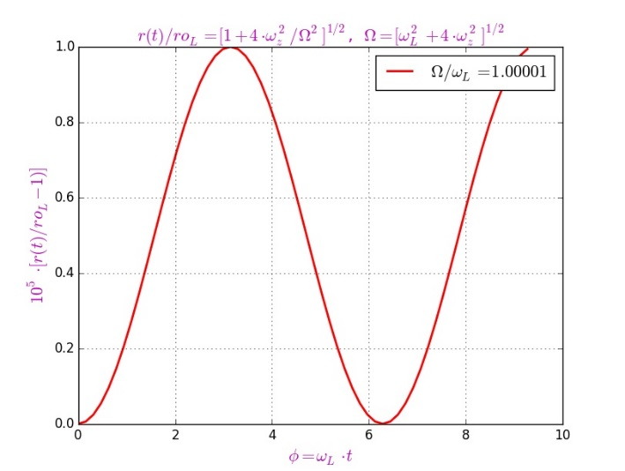

All last Figures confirm the conclusion made earlier that even with values of the impact parameter smaller than the critical one, the motion of electron can be regarded as strong magnetized.

**Conclusion: the region of magnetization of motion begins at the values of impact parameter, much smaller than the critical value . Therefore, in calculating the parameter-dependent quantities, such as, for example, the friction force (acting on an ion moving in an electron medium), the critical value of the impact parameter is a good lower boundary.**