**Maximal Impact Parameter**

As is known, maximal impact parameter is determined by relation of several quantities: radius  of neutralization, Debye screening radius , “flight radius” , characterized by the time flight through the region of interaction of an electron with an ion, as well the radius  of the beam:



Radius of neutralization depends only on density  of the electrons in the cooling beam:



Its typical values are . This leads for collision with protons to the corresponding values for  correspondingly.

Debye screening radius  depends on plasma frequency  and relative velocity ion and electron :



Usually , so that  and then



In these formulae  is the longitudinal mean square velocity, which is determined by the longitudinal temperature , and dimensional (length) slope coefficient  characterizes the slope of linear dependences  on dimensionless ion velocity .

If , so that  and then



For typical value of longitudinal temperature the values of slope coefficient  are  for  correspondingly.

The next set of Figures shows dependences of the radiuses  (for ) and  on relative ion velocity for tree values of the beam density , the corresponding shielding radius , as well 3D plot of  as function of the relative ion velocity and the beam density (in two intervals of the density).

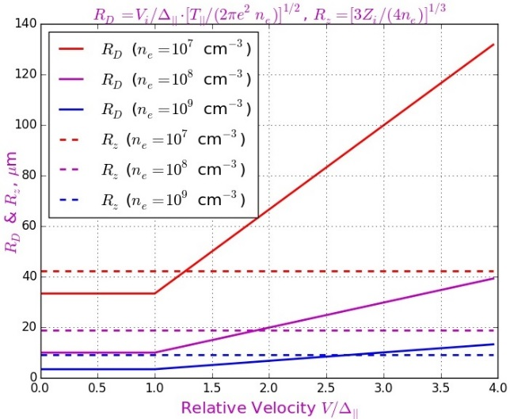 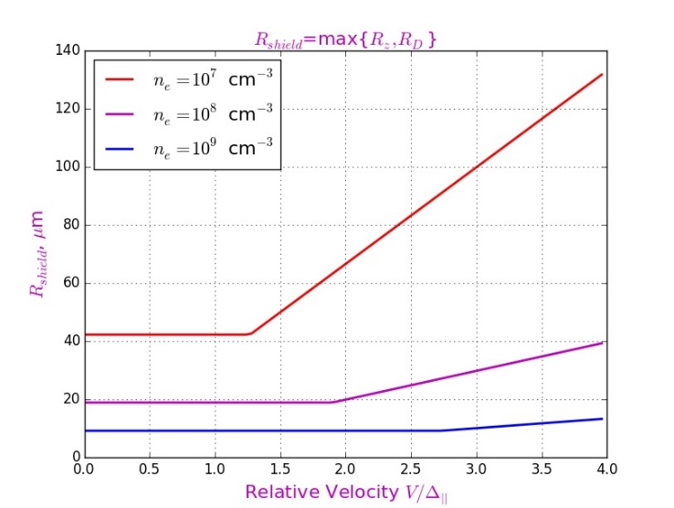

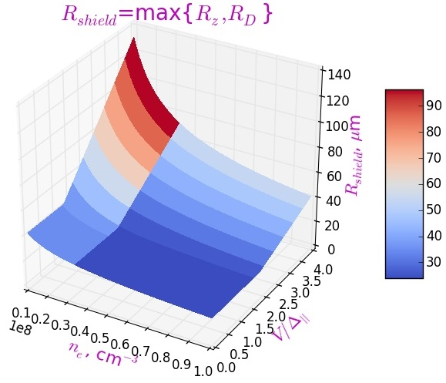 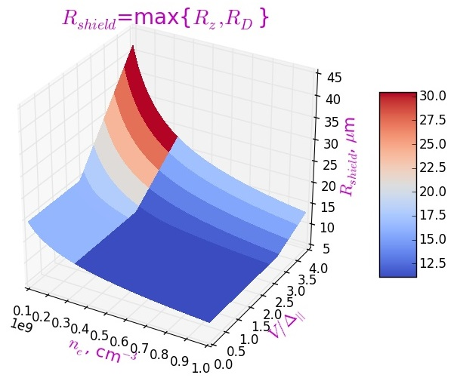

All these Figures show that the shielding radius  exceeds the level  only at very high beam densities and is usually less than about .

Let’s compare these values with the beam radius  and “flight radius” .

First of them usually exceeds a value of the order of several mm and is extremely rarely below 1mm (). **Thus, the beam size never determines the value of the maximum of the impact parameter .**