4.1开发包图

物流系统的最终开发包设计如表1所示

表1物流系统的最终开发包设计

|  |  |
| --- | --- |
| 开发（物理包） | 依赖的其他开发包 |
| mainui | informationui,sendui,judgementui,shipmentui,receivementui,commodityui,moneyui,reportui,staffui,vo |
| informationui | informationblservice,界面库类包 |
| informationblservice |  |
| informationbl | informationblservice,sendbl,po, informationdataservice |
| informationdataservice | Java RMI,po |
| informationdata | informationdataservice, databaseutility |
| sendui | sendblservice,界面类库包 |
| sendblservice |  |
| sendbl | sendblservice,po, senddataservice |
| senddataservice | Java RMI,po |
| senddata | senddataservice,databaseutility |
| judgementui | judgementblservice,界面类库包 |
| judgementblservice |  |
| judgementbl | judgementblservice, sendbl ,po, judgementdataservice |
| judgementdataservice | Java RMI,po |
| judgementdata | judgementdataservice, databaseutility |
| shipmentui | shipmentblservice,界面类库包 |
| shipmentblservice |  |
| shipmentbl | shipmentblservice, sendbl ,po, shipmentdataservice |
| shipmentdataservice | Java RMI,po |
| shipmentdata | shipmentdataservice, databaseutility |
| receivementui | receivementblservice,界面类库包 |
| receivementblservice |  |
| receivementbl | receivementblservice，sendbl ,po, receivementdata |
| receivementdataservice | Java RMI,po |
| receivementdata | receivementdataservice, databaseutility |
| commodityui | commodityblservice,界面类库包 |
| commodityblservice |  |
| commoditybl | commodityblservice,sendbl ,shipmentbl,po,commoditydataservice |
| commoditydataservice | Java RMI,po |
| commoditydata | commoditydataservice, databaseutility |
| moneyui | moneyblservice,界面类库包 |
| moneyblservice |  |
| moneybl | moneyblservice,sendbl ,po, moneydataservice |
| moneydataservice | Java RMI,po |
| moneydata | moneydataservice, databaseutility |
| reportui | reportblservice,界面类库包 |
| reportblservice |  |
| reportbl | reportblservice，moneybl,po, reportdataservice |
| reportdataservice | Java RMI,po |
| reportdata | reportdataservice, databaseutility |
| staffui | staffblservice,界面类库包 |
| staffblservice |  |
| staffbl | staffblservice,po, staffdataservice |
| staffdataservice | Java RMI,po |
| staffdata | staffdataservice, databaseutility |
| vo |  |
| po |  |
| utilitybl |  |
| 界面类库包 |  |
| Java RMI |  |
| databaseutility |  |

物流系统客户端开发包图如图3所示，服务器端开发包图如图4所示。

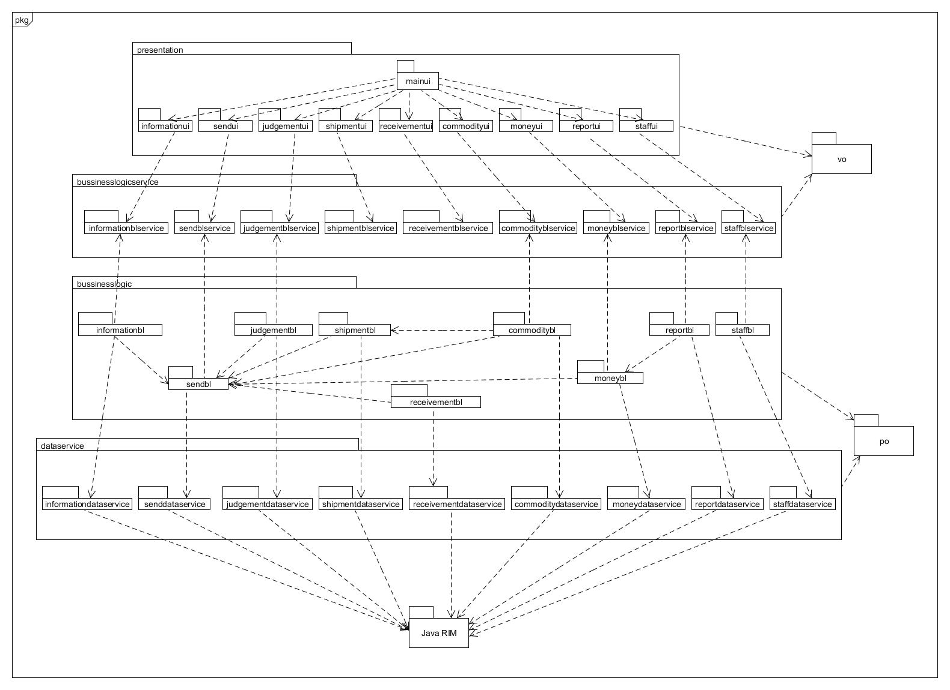

图3快递系统客户端开发包图

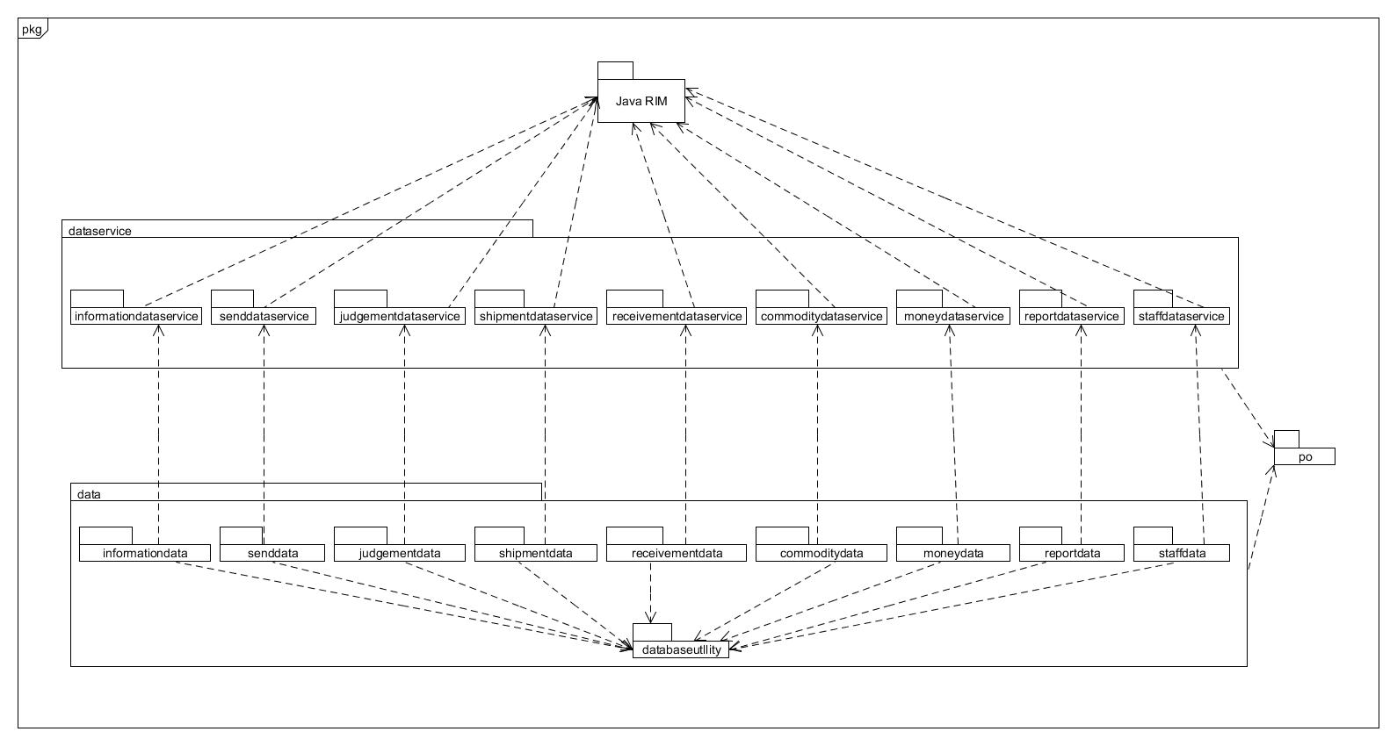

物流系统服务器端开发包图