Draft tutorial for Eidors e.g..:

http://eidors3d.sourceforge.net/tutorial/lung_EIT/serial_correct_get208.shtml

**Correction tool for effect of serial data collection.**

Electrical impedance tomography (EIT) is increasingly being used as a bedside tool for monitoring regional lung ventilation. However, most clinical systems use serial data collection which, if uncorrected, results in image distortion, particularly at high breathing rates.

This tutorial demonstrates use of the correction tool documented in two published papers (development, and testing):

* Yerworth, R., Frerichs, I. & Bayford, R., 2016. Analysis and compensation for errors in electrical impedance tomography images and ventilation-related measures. *Journal of Clinical Monitoring and Computing,* doi:10.1007/s10877-016-9920-y
* Yerworth, R. & Bayford, R. 2013. The effect of serial data collection on the accuracy of electrical impedance tomography images. *Physiological Measurement* 34:6 p659-669

This tool corrects serially collected *.get data so that each frame appears to come from an instantaneous point in time.

This function is set up for use with the standard 16 electrode, 208 measurements per frame protocol, with any frame rate and number of frames.

CITATION_REQUEST:

AUTHOR: Rebecca Yerworth and Richard Bayford

TITLE: The effect of serial data collection on the accuracy of electrical impedance tomography images

JOURNAL: Physiological Measurement

VOL: 34

NUM: 6

YEAR: 2013

PAGE: 659-669

LINK: http://iopscience.iop.org/0967-3334/34/6/659/pdf/0967-3334_34_6_659.pdf

DOI: 10.1088/0967-3334/34/6/659

PUBMED: 23719130

**Use**

1. **Download**the Tool and save it to your working directory. Either:
   * **Standalone version** (Serial_Correct_get208.exe) & [Matlab Compiler Runtime](http://uk.mathworks.com/supportfiles/downloads/R2013b/deployment_files/R2013b/installers/win64/MCR_R2013b_win64_installer.exe) (available for free from the MathWorks Web site, if not already installed, see Prerequisites box below)

Or

* + **Matlab script** (Serial_Correct.m)

1. Double click *Serial_correct_get208.exe* (Standalone version) or type Serial_Correct at Matlab prompt (Matlab script)
2. Choose data file (*.get), using the dialog box which pops up.

Depending on computer speed, it can take a few minutes to process the data, before a confirmation message pops up.

Outputs: *_corrected.get & associated *_corrected.prl files (if the original *.prl file is in the same directory). These can now be reconstructed with using your normal method.

The absolute percentage difference between original and corrected data as mean (+/- std) of all electrode combinations is displayed in a pop up box.

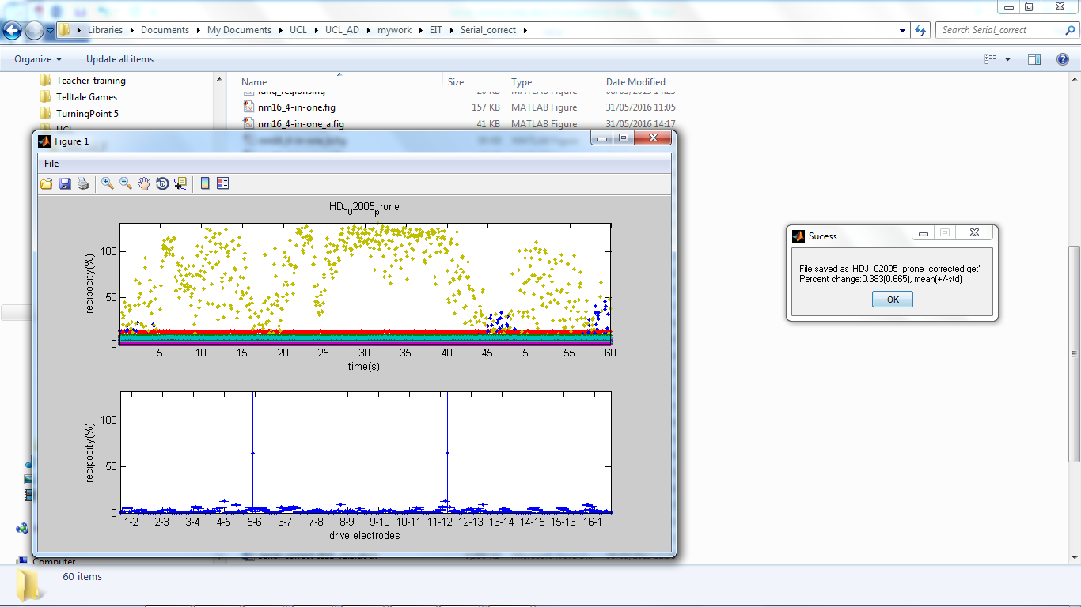

In addition, the function checks for reciprocity errors. Reciprocity is a measure of the quality and reliability of the data, including the improvement in quality due to lag correction (see Reciprocity theory box, below). If any electrode combination has a median reciprocity error greater than a predetermined threshold a message box pops up, stating the percentage of electrode combinations affected, and optionally provides a graphical representation of the reciprocity errors (click display).

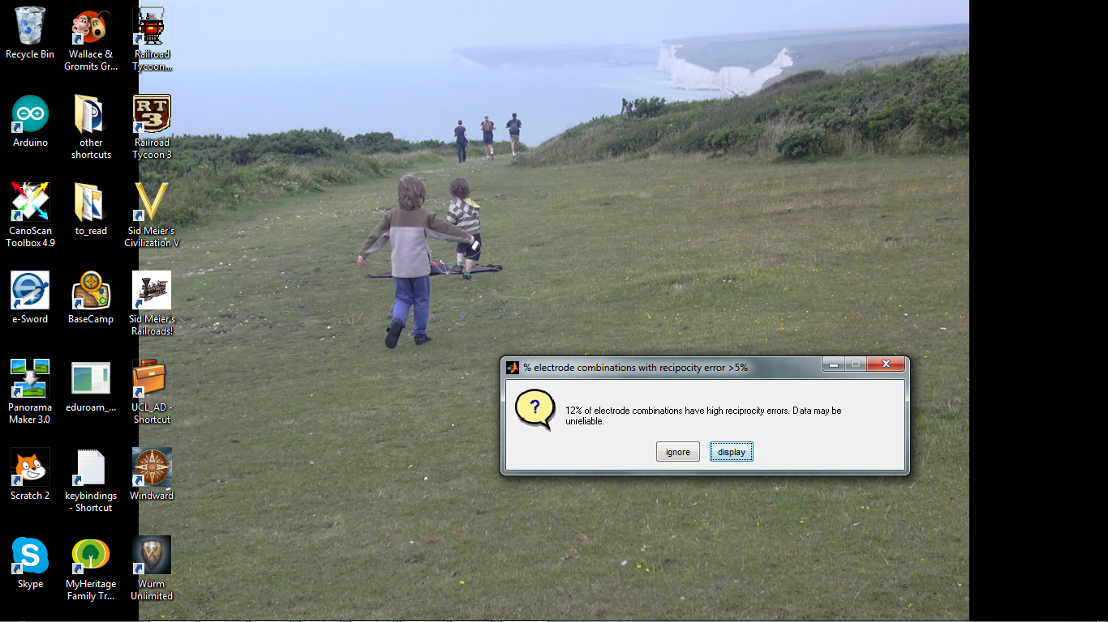

The threshold is currently set at the arbitrary value of 5%, based in experience that human data with errors less than this, on most electrode combinations, can usually be obtained.

The upper plot, of the graphical representation, is reciprocity errors as a function of time and would show, for example, an electrode developing a permanent or temporary fault during the experiment, and when this occurred. The lower plot shows the mean (+/- std) for each electrode combination. Electrode combinations using the same drive pair are grouped together, and the x-axis is labelled to reflect this. The number of electrodes exceeding the threshold will always be zero or an even number, since each electrode combination has a reciprocal pair, and it is not know which of them is most accurate.



In this example one pair of electrode combinations have a very high reciprocity error, which is variable over time, with a few other combinations with reciprocities between 5% & 9%.

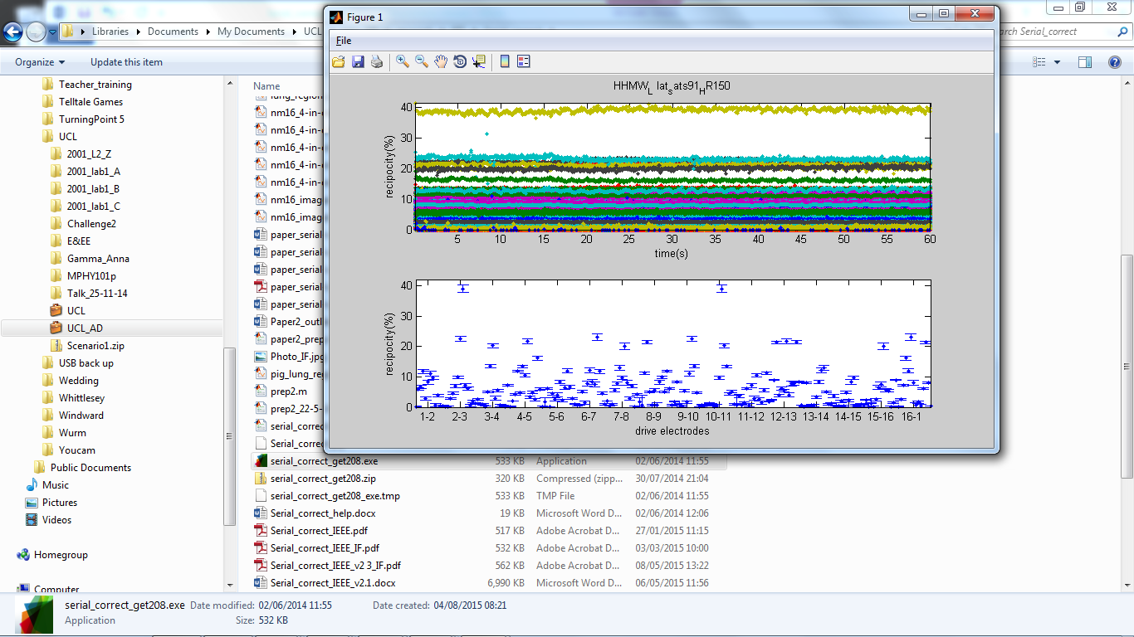

In this 2nd example, all reciprocities are stable over time, with one pair of combinations at ~40% error and a few around 25%.

**Example**

1. **Download** example [data](http://eidors3d.sourceforge.net/data_contrib/if-neonate-ventilated/if-neonate-ventilated.zip) set ([mechanical ventilated neonate](http://eidors3d.sourceforge.net/data_contrib/if-neonate-ventilated/index.shtml)) and unzip to a known location.
2. **Correct data** using either Serial_Correct_get208.exe or Serial_Correct.m as described above.

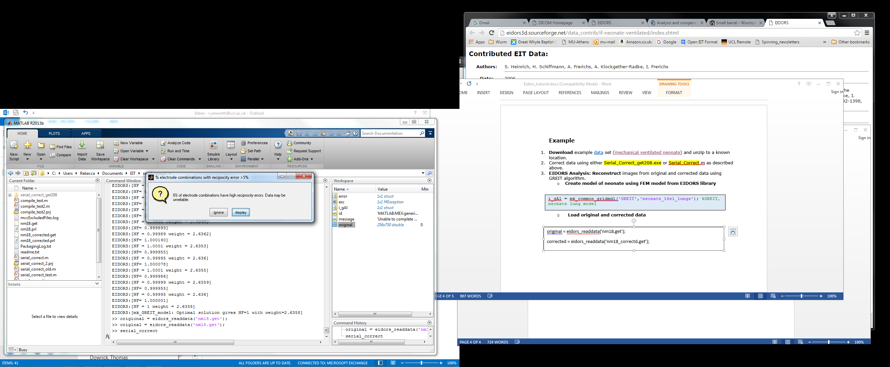

The pop up box states that, for this data set, 8% of ectrode combinations have reciprocity errors of greater than 5%. Using the display option we see that all reciprocities are stable over time, with one pair of combinations having an error of approximately ~20% and 10 other pairs having errors between 5% and 10%.

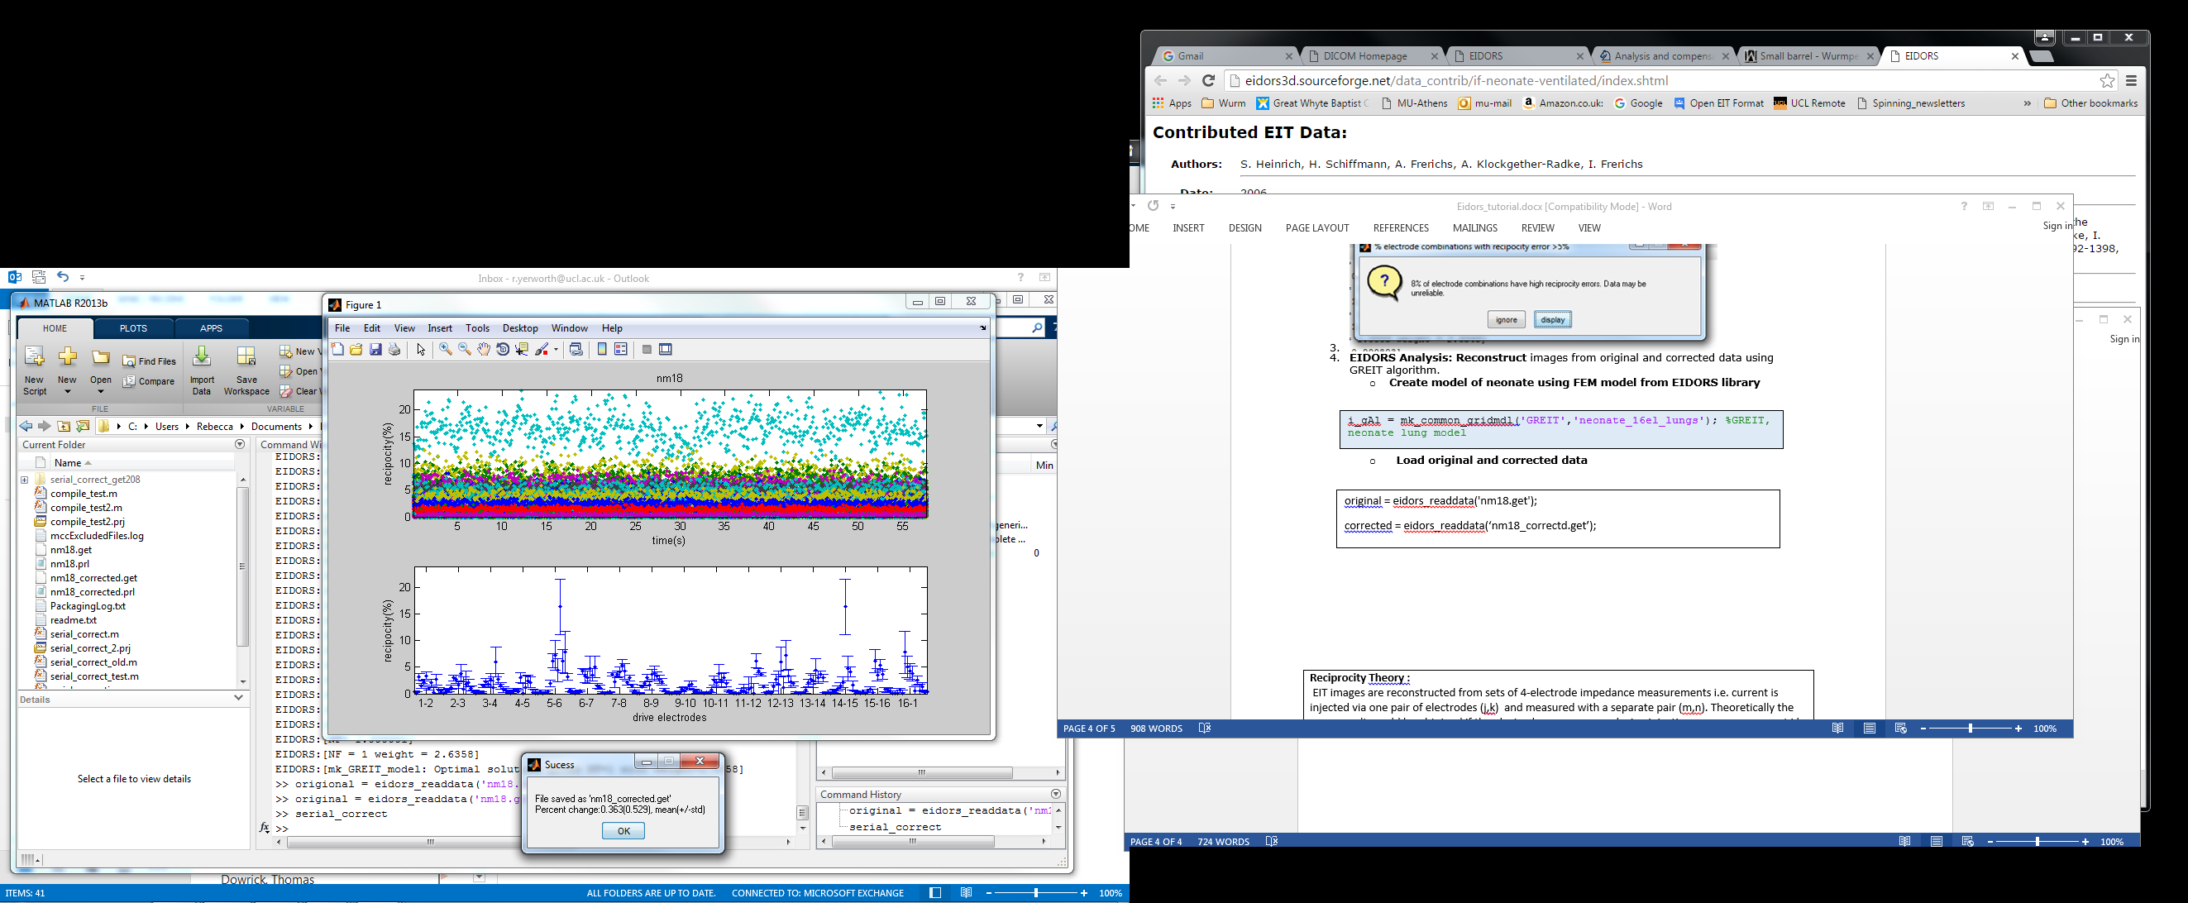

The corrected file has been saved as nm18_corrected.get, in the same directory as the original file, and the mean different from the original data by 0.36 percent – a small but significant amount.

1. **EIDORS Analysis: Reconstruct** images from original and corrected data using GREIT algorithm (Matlab users only)
   * **Create inverse model of neonate using FEM model from EIDORS library**

fmdl = mk_library_model('neonate_16el_lungs');

[fmdl.stimulation fmdl.meas_select] = mk_stim_patterns(16,1,'{ad}','{ad}');

fmdl = mdl_normalize(fmdl, 1); % Use normalized difference imaging

opt.noise_figure = 0.1; opt.target_size = 0.1;

opt.square_pixels = 1; opt.distr = 3;

inv_mdl = mk_GREIT_model(fmdl, 0.25,5, opt);

* + **Load original and corrected data, and reconstruct images of last breath, using the average of all frames as the reference.**

figure

show_slices(Orig_imag);

title ‘Original’

figure

show_slices(Corr_imag)

title ‘Corrected’

Original = eidors_readdata('nm18.get');

Orig_ref = mean(Original,2); % reference frame - average of all frames

Orig_imag=inv_solve(inv_mdl,Original(:,691:717),Orig_ref); %reconstruct difference images

Corrected = eidors_readdata('nm18_corrected.get');

Corr_ref = mean(Corrected,2); % reference frame - average of all frames

Corr_imag=inv_solve(inv_mdl,Corrected(:,691:717),Corr_ref); %reconstruct difference images

* + **Display images from last breath**

 

The first image is the top left, continuing in normal reading order to the bottom row, right hand image. Red indicates relative impedance increases (inspiration) and blue relative impedance decreases (expiration). Changes in the upper left of each image occur sooner in the original than the corrected series, and the left and right sides appear more unbalanced in the original series. If a different reconstruction algorithm is used the images will be slightly different, but similar trends should be expected.

**Reciprocity Theory :**

EIT images are reconstructed from sets of 4-electrode impedance measurements i.e. current is injected via one pair of electrodes (j,k) and measured with a separate pair (m,n). Theoretically the same result would be obtained if the electrodes were reversed – i.e. injection m,n, measurement j,k. However this is not so in in practice due to non-idealities in the system and electrode/skin interface. The absolute difference between the two measurements is termed the reciprocity error and is normally expressed as a percentage relative to the mean of the two measurements.

Many EIT systems collect from all electrode combinations, enabling reciprocity to checked after data collection.

**Prerequisites for Deployment of Standalone version**:

• Verify the MATLAB Compiler Runtime (MCR) is installed and ensure you have installed version 8.2 (R2013b) – the simplest way is to attempt to run Serial_correct_get208.exe by double clicking in it, and watching for error messages.

• If the MCR is not installed download the Windows 64-bit version of the MCR for R2013b, for free, from the MathWorks Web site by navigating to

http://www.mathworks.com/products/compiler/mcr/index.html

For more information about the MCR and the MCR Installer, see Distribution to End Users in the MATLAB Compiler documentation in the MathWorks Documentation Center.

NOTE: You will need administrator rights to run MCRInstaller.