# Serial_correct_get208.exe

Electrical impedance tomography (EIT) is increasingly being used as a bedside tool for monitoring regional lung ventilation. However, most clinical systems use serial data collection which, if uncorrected, results in image distortion, particularly at high breathing rates (Yerworth, et al., 2016).

This tool corrects serially collected *.get data so that each frame appears to come from an instantaneous point in time.

This function is set up for use with the standard 16 electrode, 208 measurements per frame protocol, with any frame rate and number of frames.

CITATION_REQUEST:

AUTHOR: Rebecca Yerworth and Richard Bayford

TITLE: The effect of serial data collection on the accuracy of electrical impedance tomography images

JOURNAL: Physiological Measurement

VOL: 34

NUM: 6

YEAR: 2013

PAGE: 659-669

LINK: http://iopscience.iop.org/0967-3334/34/6/659/pdf/0967-3334_34_6_659.pdf

DOI: 10.1088/0967-3334/34/6/659

PUBMED: 23719130

## Use:

To run, double click *Serial_correct_get208.exe* and choose files to be corrected, using the dialog box which pops up. Depending on computer speed, it can take a few minutes to process the data, before a confirmation message pops up.

Outputs: *_corrected.get & associated *_corrected.prl files (if the original *.prl file is in the same directory)

The absolute percentage difference between original and corrected data as mean (+/- std) of all electrode combinations is displayed in a pop up box.

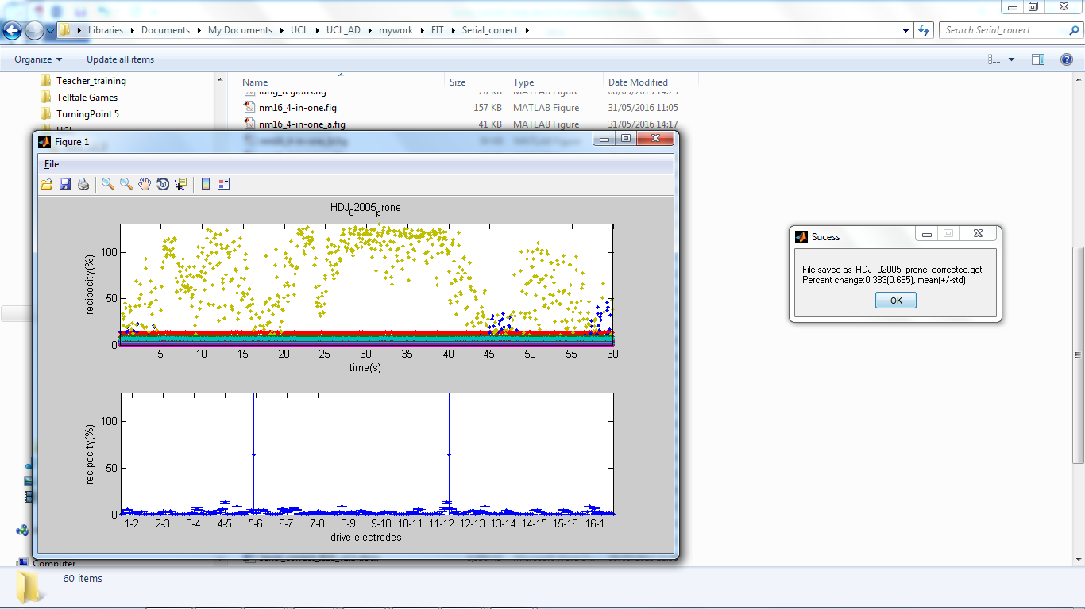

In addition, the function checks for reciprocity errors. Reciprocity is a measure of the quality and reliability of the data, including the improvement in quality due to lag correction (see Reciprocity theory box, below). If any electrode combination has a median reciprocity error greater than a predetermined threshold a message box pops up, stating the percentage of electrode combinations affected, and optionally provides a graphical representation of the reciprocity errors (click display).

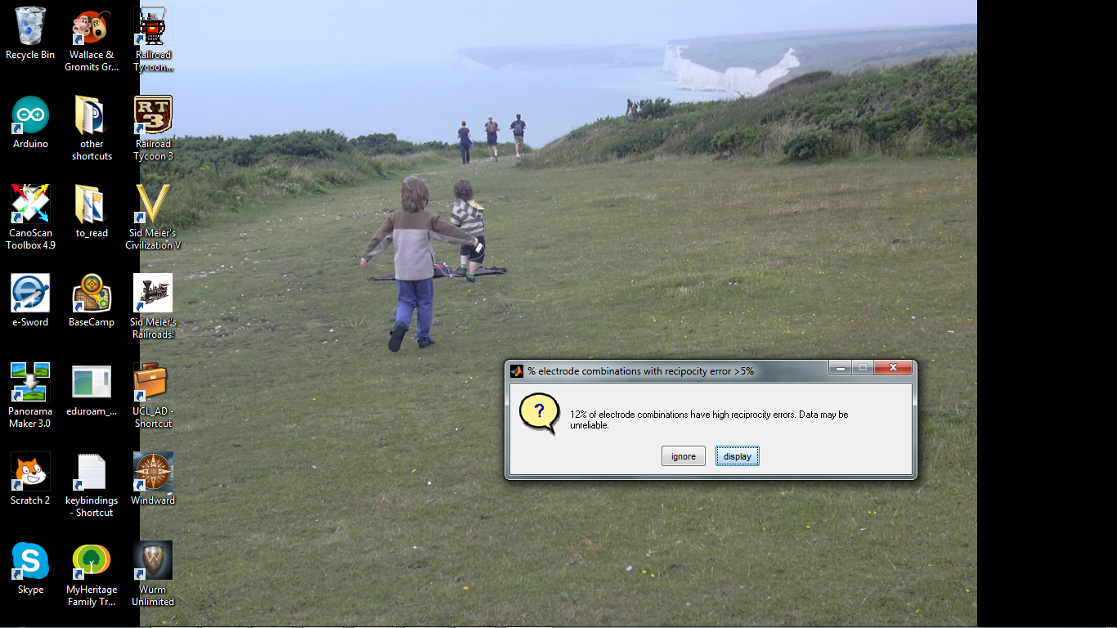

The threshold is currently set at the arbitrary value of 5%, based in experience that human data with most errors less than this can usually be obtained.

The upper plot, of the graphical representation, is reciprocity errors as a function of time and would show, for example, an electrode developing a permanent or temporary fault during the experiment, and when this occurred. The lower plot shows the mean (+/- std) for each electrode combination. Electrode combinations using the same drive pair are grouped together, and the x-axis is labelled to reflect this. The number of electrodes exceeding the threshold will always be zero or an even number, since each electrode combination has a reciprocal pair, and it is not know which of them is most accurate.



In this example one pair of electrode combinations have a very high reciprocity error, which is variable over time, with a few other combinations with reciprocities between 5% 7 9%.

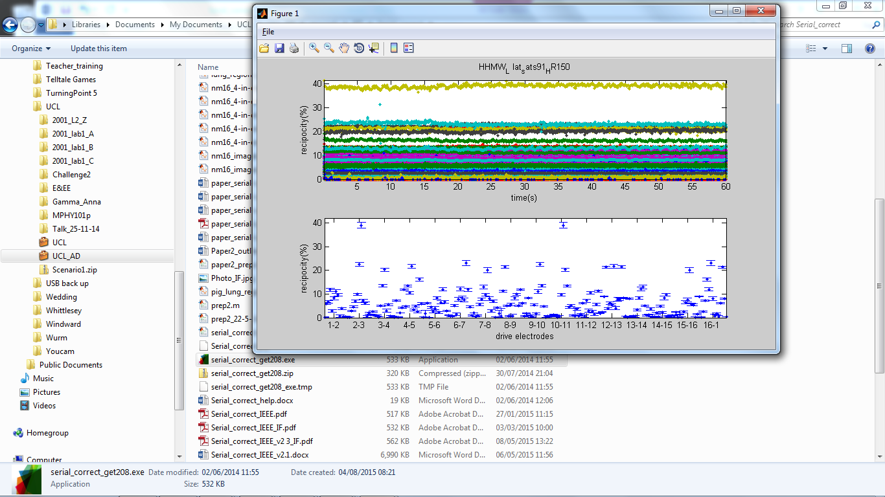

In this 2nd example, all reciprocities are stable over time, with one pair of combinations at ~40% and a few around 25%.

**Reciprocity Theory :**

EIT images are reconstructed from sets of 4-electrode impedance measurements i.e. current is injected via one pair of electrodes (j,k) and measured with a separate pair (m,n). Theoretically the same result would be obtained if the electrodes were reversed – i.e. injection m,n, measurement j,k. However this is not so in in practice due to non-idealities in the system and electrode/skin interface. The absolute difference between the two measurements is termed the reciprocity error and is normally expressed as a percentage relative to the mean of the two measurements.

Many EIT systems collect from all electrode combinations, enabling reciprocity to checked after data collection.

**Prerequisites for Deployment**:

• Verify the MATLAB Compiler Runtime (MCR) is installed and ensure you have installed version 8.2 (R2013b) – the simplest way is to attempt to run Serial_correct_get208.exe by double clicking in it, and watching for error messages.

• If the MCR is not installed, do either of the following:

If Matlab is installed on computer:

(1) enter

>>mcrinstaller

at MATLAB prompt. The MCRINSTALLER command displays the location of the MCR Installer.

(2) run the MCR Installer.

Else download the Windows 64-bit version of the MCR for R2013b, for free, from the MathWorks Web site by navigating to

http://www.mathworks.com/products/compiler/mcr/index.html

For more information about the MCR and the MCR Installer, see Distribution to End Users in the MATLAB Compiler documentation in the MathWorks Documentation Center.

NOTE: You will need administrator rights to run MCRInstaller.

# References

Yerworth, R., Frerichs, I. & Bayford, R., 2016. Analysis and compensation for errors in electrical impedance tomography images and ventilation-related measures. *Journal of Clinical Monitoring and Computing,* p. (in press).