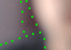

“Blur” from a visual point of view, a good explanation would be that **a blurry image doesn’t have clear edges**. It is related to the sharpness of the edges of an image.