Office move proposal
Approve the office move plan so your team can prepare desks, test equipment, and resume work on schedule. Use the schedule below to check each step before the move. Confirm that every desk has power and network access before staff arrive.

Move schedule
Step | Owner | Target
Pack equipment | Move coordinator | Day 1
Install desks | Facilities team | Day 2
Test connections | Support team | Day 3

Desk arrangement
Use this arrangement to leave a clear route between the desks.
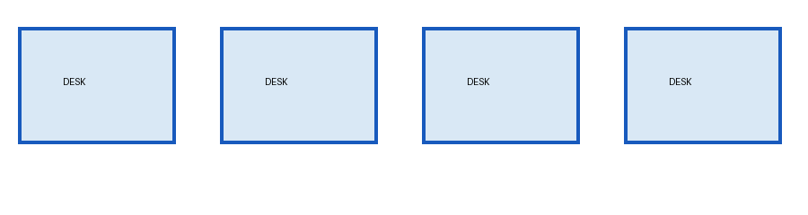
Check the schedule and confirm the move coordinator before work starts.

