Image Filters with MPI and Pthread
Santi Pagola
Hao-Hsiang Liao

Version 1.0
PROJECT IDENTITY
04/22/2018, ISY, LiU

Participants of the group
Name | Phone | E-mail
Hao-Hsiang Liao | 0734845666 | haoli436@student.liu.se
Santi Pagola | 0727239400 | sanpa993@student.liu.se

Contents
1 First Lab – Blurry filter 1
1.1 Question 1
1.2 Solution for MPI 1
1.3 Results for MPI 2
1.4 Solution for PThreads 3
1.5 Results for PThreads 3
2 Second Lab – Thresholding filter 4
2.1 Question 4
2.2 Solution for MPI 4
2.3 Results for MPI 4
2.4 Solution for PThread 5
2.5 Results for PThread 5

First Lab – Blurry filter

Question
Make a blurry filter with a parallel implementation via the platform of MPI and POSIX Threads.

Solution for MPI
First of all, assume that an image has M rows and M columns, and we applied N nodes to process the image. We assigned M/N rows of the image to each node for processing. Fig. 1-1 is an example that M/N is 3, so each node process three rows of data. Based on this example, we can find that every core can process data in parallel.
After that, we needed to process vertical columns’ pixels. To make this problem easier, we converted Fig. 1-1 to Fig. 1-2 by calculating the adjoint matrix of the original image array. By doing so, we can get the data array shown in Fig. 1-3. Then, we applied the same horizontal filter again to process horizontal data in the image shown in Fig. 1-2.
Finally, we transpose back the calculated adjoint matrix and convert it back to a pixel array in order for the root process to write the image to disk.

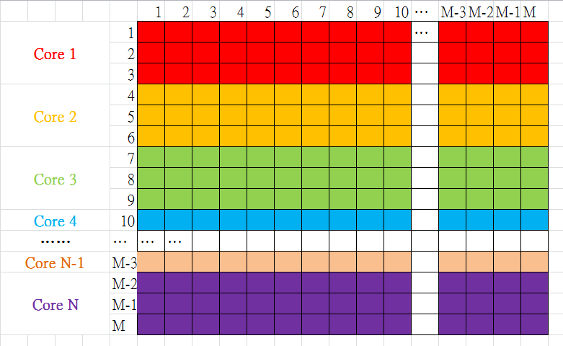
Figure 1-1 An example of horizontal processing.

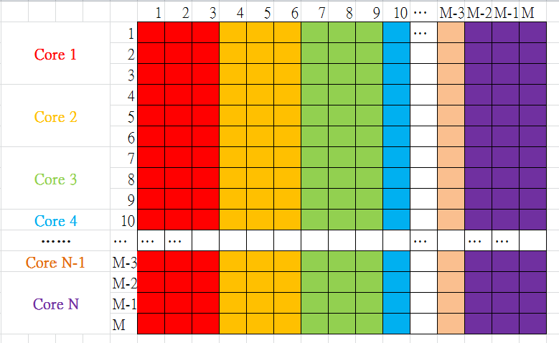
Figure 1-2 An example of horizontal processing

Figure 1-3 The arrangement of the image in the platform of MPI

Results for MPI
Fig. 1-4 demonstrates execution time for different number of cores. We can find that when the number of cores is increasing, then execution time is decreasing. Besides, we applied exponential number to be the number of cores. In other words, we applied 1, 2, 4, 8, 16, and 32 cores to run the program instead of 0, 1, 2, 3, and 4 cores.

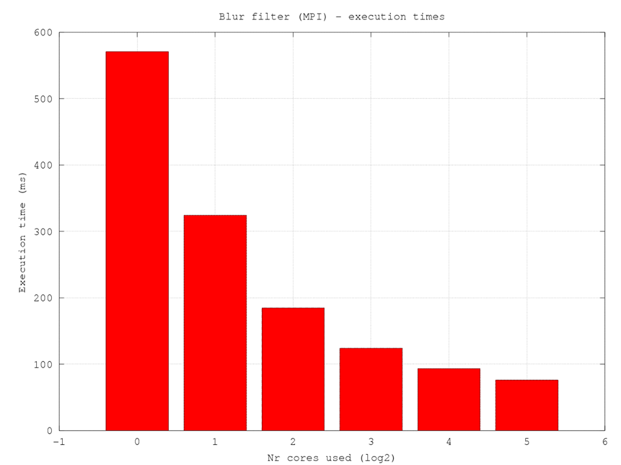
Figure 1-4 Execution time for different number of cores in exponential unit

Solution for PThreads
To process the image via PThreads, we split the “blurfilter.c” into two subsystems, a blurfilter_x and a blurfilter_y, to process horizontal data and vertical data.
We use a critical section to protect printf() since every thread is going to collide if we do not do that. For example, assume that thread 0 finished its task and it is writing its results with printf(). In the meantime thread 5 finished its task as well, so it may start writing to the standard output while thread 0 is doing the same thing, thus resulting in messy interleaved printouts. That’s why we needed protect the critical section with mutexes to prevent collisions from happening.
To maximize the usage of PThreads, we divided y_size by the number of threads so that every thread can process an analogous number of horizontal data. The same applies for the “vertical” filter, where each thread processed a group of columns specified by the number of threads and x_size.

Results for PThreads
Fig. 1-4 shows execution time for different number of threads. We can find that if we run the filter sequentially without thread (i.e. 0 thread), then it is going to take a long time to execute. However, we can decrease time consumption via increase the number of threads. Besides, we applied exponential number to be the number of cores. In other words, we applied 1, 2, 4, 8, 16, and 32 threads to run the program instead of 0, 1, 2, 3, and 4 threads.
Also, we can also find that the program is saturated when we apply 4 threads to run the program.

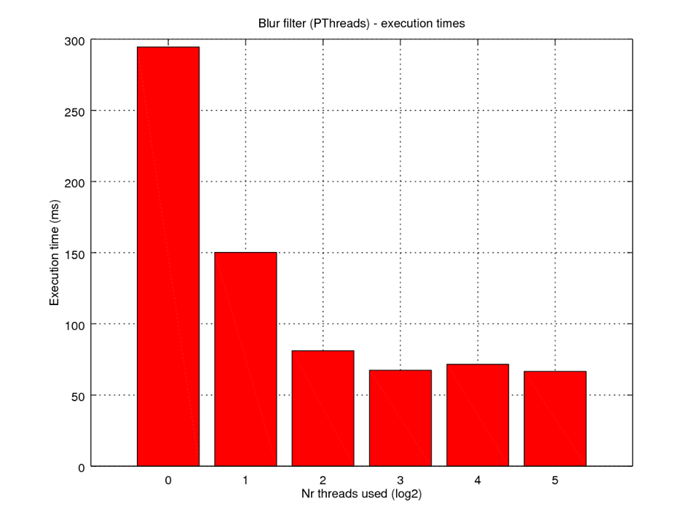
Figure 1-5 Execution time for different number of threads in exponential unit

second Lab – thresholding filter

Question
Make a thresholding filter with a parallel implementation via the platform of MPI and PThread.

Solution for MPI
In this case, we split this task into two parts. First one was to sum every pixel in order to calculate an average, and the other subtask was to do the comparison between image pixels and the average.
Assume a picture has N pixels. To sum every pixel value, we applied MPI_Scatter to assign N/M pixels’ value to each node, where M is the number of nodes. Then, we utilized MPI_Reduce to sum these values up. By doing so, we can get the average, or threshold.
We then applied MPI_Scatter to send image data and average to all other processes. The input image pixels become white or black if they are lighter or darker than the threshold. After that, we applied MPI_Gather to gather new pixel data and get a new image.

Results for MPI
Fig. 2-6 shows execution time for different number of cores. We can find that when the number of cores increased, then the execution time decreased. Besides, we applied exponential number to be the number of cores. In other words, we applied 1, 2, 4, 8, 16, and 32 cores to run the program instead of 0, 1, 2, 3, and 4.

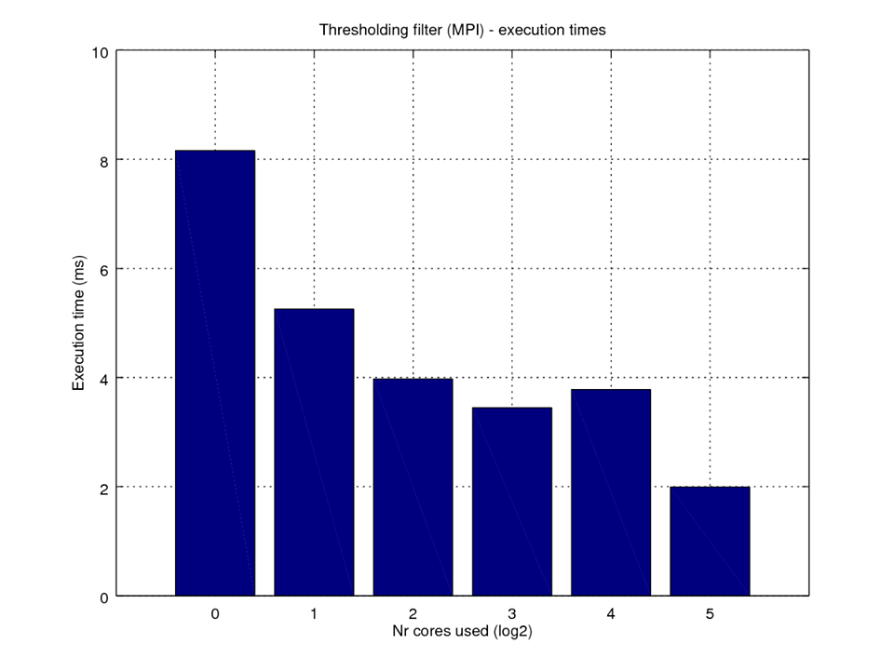
Figure 2-6 Execution time for different number of cores in exponential unit

Solution for PThreads
To run the program parallel, we set some threads to compute partial sums. Assume “nr_elems” means the number of elements that will be processed by each thread, and the number of threads is “nr_threads.” Thus, we can know that the number of all image pixels = nr_elems * nr_threads. Besides, it is worth mentioning that we assumed that thread 0 is the main thread, or ROOT. We then used ROOT to calculate the average from the partial sums.
Besides, we set pthread_mutex_lock and pthread_mutex_unlock to protect printf() and g_sum, where g_sum is global sum. The reason that why we have to protect printf() has been discussed before, or Ch. 1.4. The variable g_sum is necessary to protect since its value would be error if two or more threads write their partial sum into g_sum at the same time. Thus, we needed to lock the mutex to ensure that every thread writes its result into g_sum orderly.
After we got the average, we created threads again to filter the image. Every thread processed partial pixels in the image.

Results for PThreads
Fig. 2-2 shows execution time for different number of threads. We can find that 2, 4, and 8 threads’ execution time are analogous.
Besides, we applied exponential number to be the number of cores. In other words, we applied 1, 2, 4, 8, 16, and 32 cores to run the program instead of 0, 1, 2, 3, and 4.

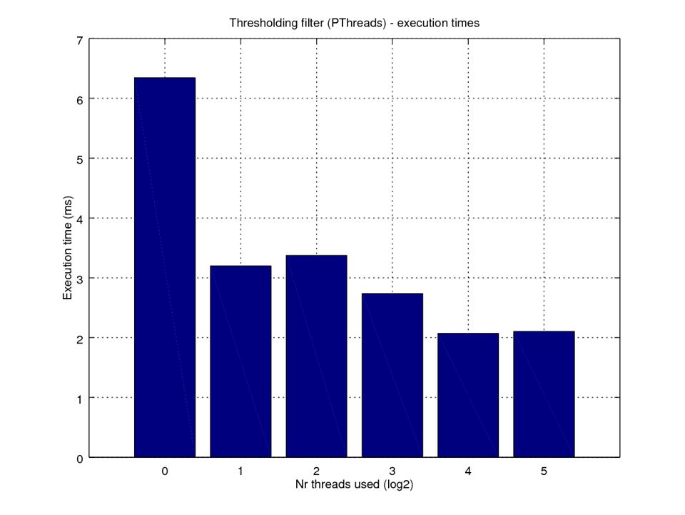
Figure 2-7 Execution time for different number of threads in exponential unit

