Image Filters with MPI and PthreadS
Santiago Pagola
Hao-Hsiang Liao

Version 1.1
PROJECT IDENTITY
04/22/2018, ISY, LiU

Participants of the group
Name | Phone | E-mail
Hao-Hsiang Liao | 0734845666 | haoli436@student.liu.se
Santiago Pagola | 0727239400 | sanpa993@student.liu.se

Table of Contents
1 First Lab – Blurry filter 1
1.1 Question 1
1.2 Solution for MPI 1
1.3 Results for MPI 2
1.4 Solution for PThreads 3
1.5 Results for PThreads 4
2 Second Lab – Thresholding filter 4
2.1 Question 4
2.2 Solution for MPI 5
2.3 Results for MPI 5
2.4 Solution for PThreads 6
2.5 Results for PThreads 6

First Lab – Blurry filter

Question
The purpose of this first assignment is to make a blurry filter with a parallel implementation by using MPI and POSIX Threads.

Solution for MPI
First of all, we assume that an image has M rows and M columns, and we have N cores to process the image. We assign M/N rows of the image to each core for processing. Fig. 1-1 is an example where M/N is 3, so each core processes three rows of data. This example shows that every core can process different parts of the same image in parallel.
After that, we need to process vertical pixel columns. To make this problem easier, we convert Fig. 1-1 to Fig. 1-2 by calculating the adjoint matrix of the original image array. By doing so, we can get the data array shown in Fig. 1-3. Then, we apply the same horizontal filter again to process horizontal data in the image shown in Fig. 1-2.
Finally, we transpose back the calculated adjoint matrix and convert it back to a pixel array in order for the root process to write the image to disk.

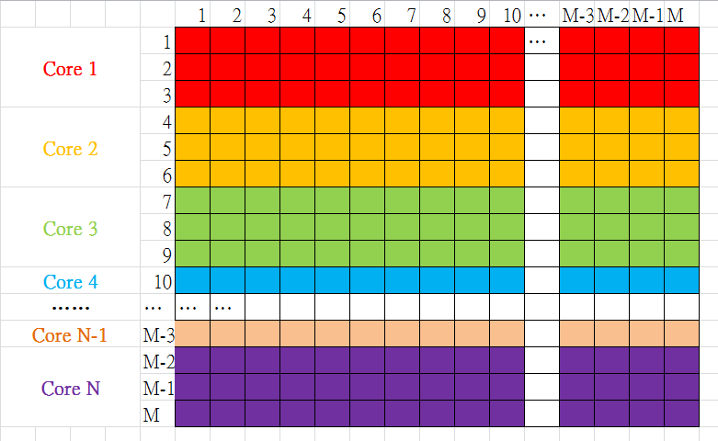
Figure 1-1 An example of horizontal processing.

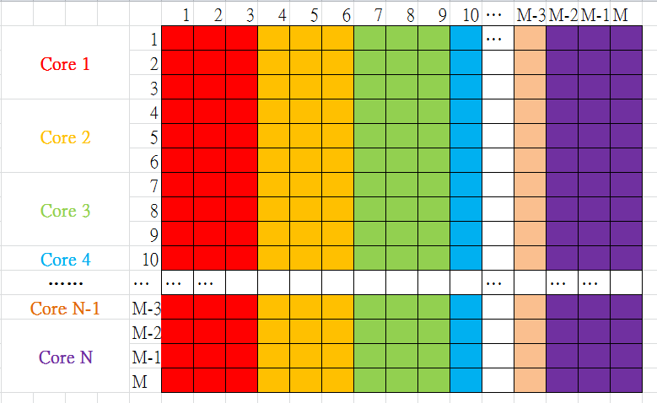
Figure 1-2 An example of horizontal processing

Figure 1-3 The arrangement of the image in the platform of MPI

Results for MPI
Fig. 1-4 demonstrates execution time for different number of cores. We can find that while the number of cores is increasing, then execution time decreases. We use cores, with k = 0, 1, 2, 3, 4, 5.
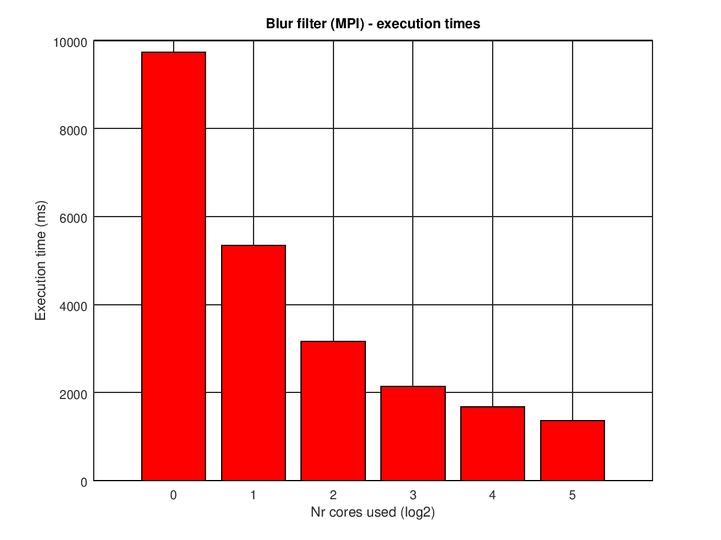
Figure 1-4 Execution time for different number of cores in exponential unit using the largest image, i.e., im4.ppm

Solution for PThreads
To process the image via PThreads, we split the filter into two parts, a blurfilter_x and a blurfilter_y, to process horizontal data and vertical data. In order for each thread to know where to start processing its portion of the image, starting points in both x and y axis are provided to the thread start routines in a tdata_t structure, which contains, among other fields, the ID of each thread, a pointer to the image to process and these starting points.
We use a critical section to protect printf() to avoid race conditions on printouts to stdout. For example, assume that thread 0 finishes its task and it is writing its results with printf(). In the meantime, thread 5 finishes its task as well, so it may start writing to the standard output while thread 0 is doing the same thing, thus resulting in messy interleaved printouts. That’s why we needed protect the critical section with mutexes to prevent collisions from happening.
To maximize the usage of PThreads, we divide the number of rows, i.e. y_size, by the number of threads so that every thread can process an analogous number of horizontal pixels. The same applies for the “vertical” filter, where each thread processes a group of pixel specified by the number of threads and x_size, that is, the number of columns.

Results for PThreads
Fig. 1-4 shows execution time for different number of threads. We can see that if we run the filter sequentially (i.e. with the main thread of the current process), then it is going to take a long time to execute. However, we can decrease time consumption via increase the number of threads. We use threads, with k = 0, 1, 2, 3, 4, 5. It is interesting to point out that since the execution of this program is going to run on a single Triolith node, where there are 16 cores, that means that we will have a maximum of 16 hardware threads available, so a number of threads above 16 will only add overhead to the execution. This can be seen in Fig 1-5, were the exeuction times when using and is almost the same (~800ms).

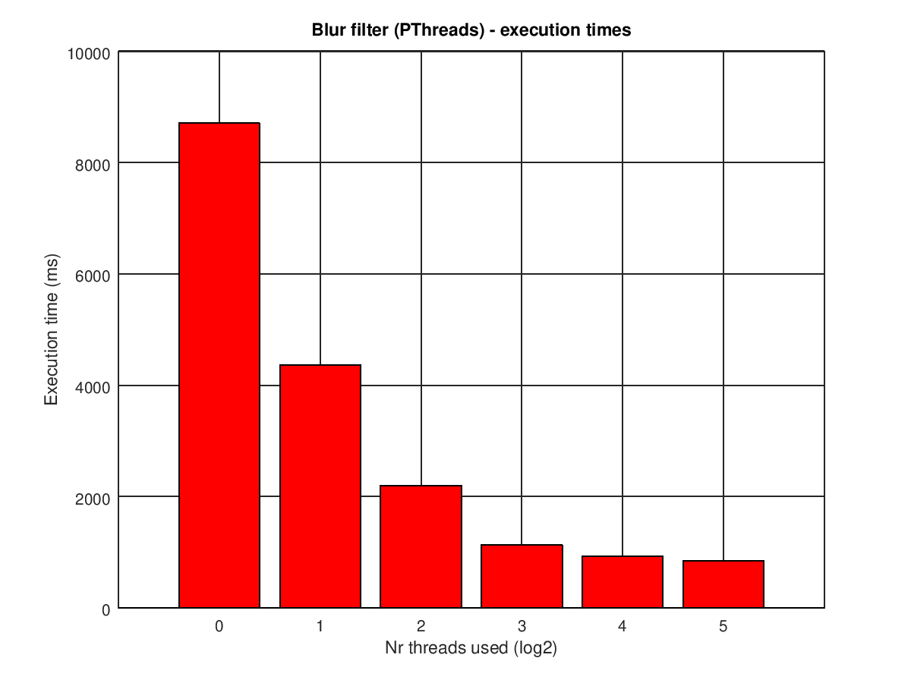
Figure 1-5 Execution time for different number of threads in exponential unit using the largest image, i.e., im4.ppm

Second Lab – Thresholding filter

Question
The purpose of this first assignment is to make a thresholding filter with a parallel implementation by using MPI and POSIX Threads.

Solution for MPI
In this case, we split this task into two parts. First one is to sum every pixel in order to calculate an average, and the other subtask is to do the comparison between image pixels and the average.
Assume a picture has N pixels. To sum every pixel value, we apply the MPI_Scatter function to assign N/M pixels to each core, where M is the available number of cores. Then, we use MPI_Reduce to sum these values up. By doing so we get the average, or threshold.
We then apply MPI_Scatter to send image data and average to all other processes. The input image pixels become white or black if they are lighter or darker than the threshold. After that, we apply MPI_Gather again to gather new pixel data and get the filtered image.

Results for MPI
Fig. 2-6 shows execution time for different number of cores. We can see that when the number of cores increases, then the execution time decreases. We use cores, with k = 0, 1, 2, 3, 4, 5.

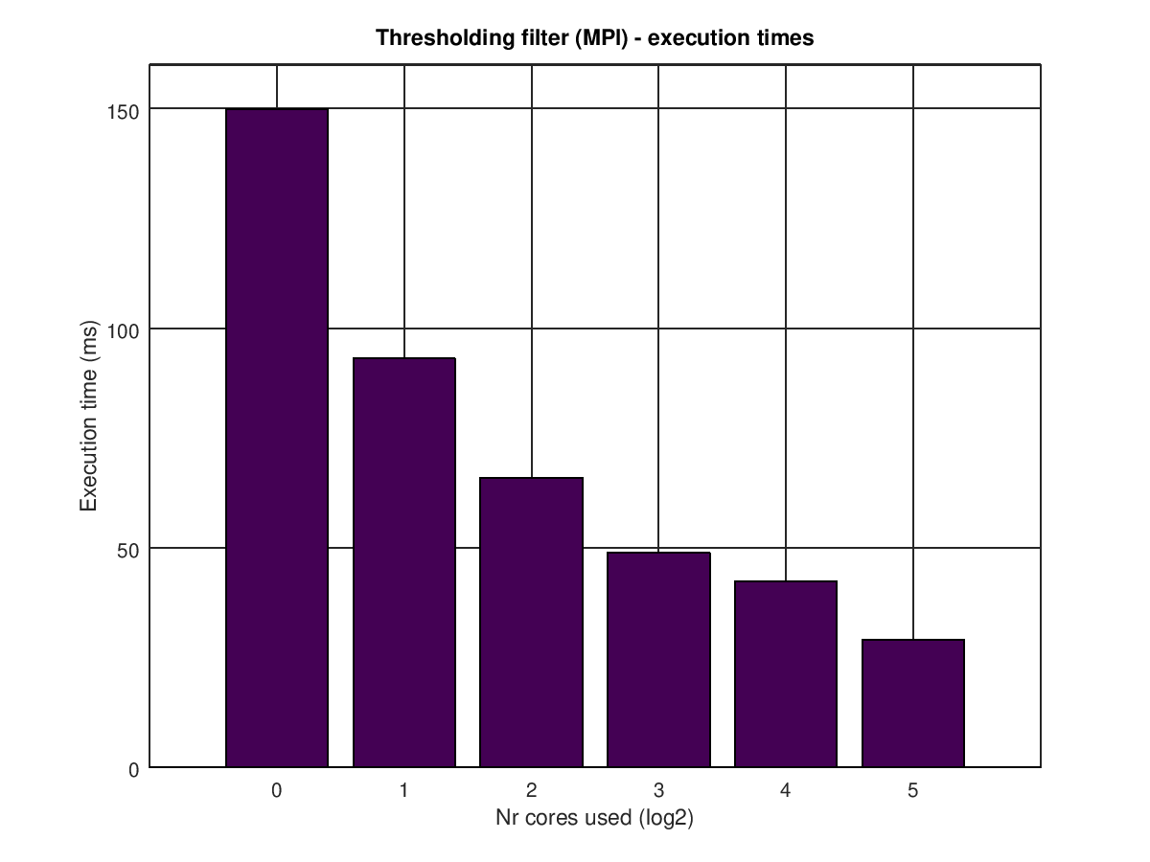
Figure 2-6 Execution time for different number of cores in exponential unit using the largest image, i.e., im4.ppm

Solution for PThreads
To run the program in parallel, we set some threads to compute partial sums. Assume nr_elems means the number of elements that will be processed by each thread, and the number of threads is nr_threads. Thus, we can know that the number of all image pixels = nr_elems * nr_threads. Besides, it is worth mentioning that we assume that thread 0, i.e. the main thread, or ROOT, won’t be performing any filtering at all. It will only be responsible of creating the child threads and making sure they return to the main thread when calling pthread_join routine. Moreover, we use ROOT to calculate the average from the partial sums.
Similarly as in the blurry filter, we set a critical section to protect calls to printf() and g_sum, where g_sum is global sum. The reason that why we have to protect printf() has been discussed before, or Ch. 1.4. The variable g_sum is necessary to protect since its value would be wrong if two or more threads write their partial sum into g_sum at the same time. Thus, we need to lock the mutex to ensure that every thread writes its result into g_sum orderly.
After we get the average, we create threads again to filter their portion of the image.

Results for PThreads
Fig. 2-2 shows execution time for different number of threads. We can find that 2, 4, and 8 threads’ execution times are similar.
We use threads, with k = 0, 1, 2, 3, 4, 5. As explained above, by using 32 threads we are only adding overhead to the execution, as it is shown in Fig 2-7.

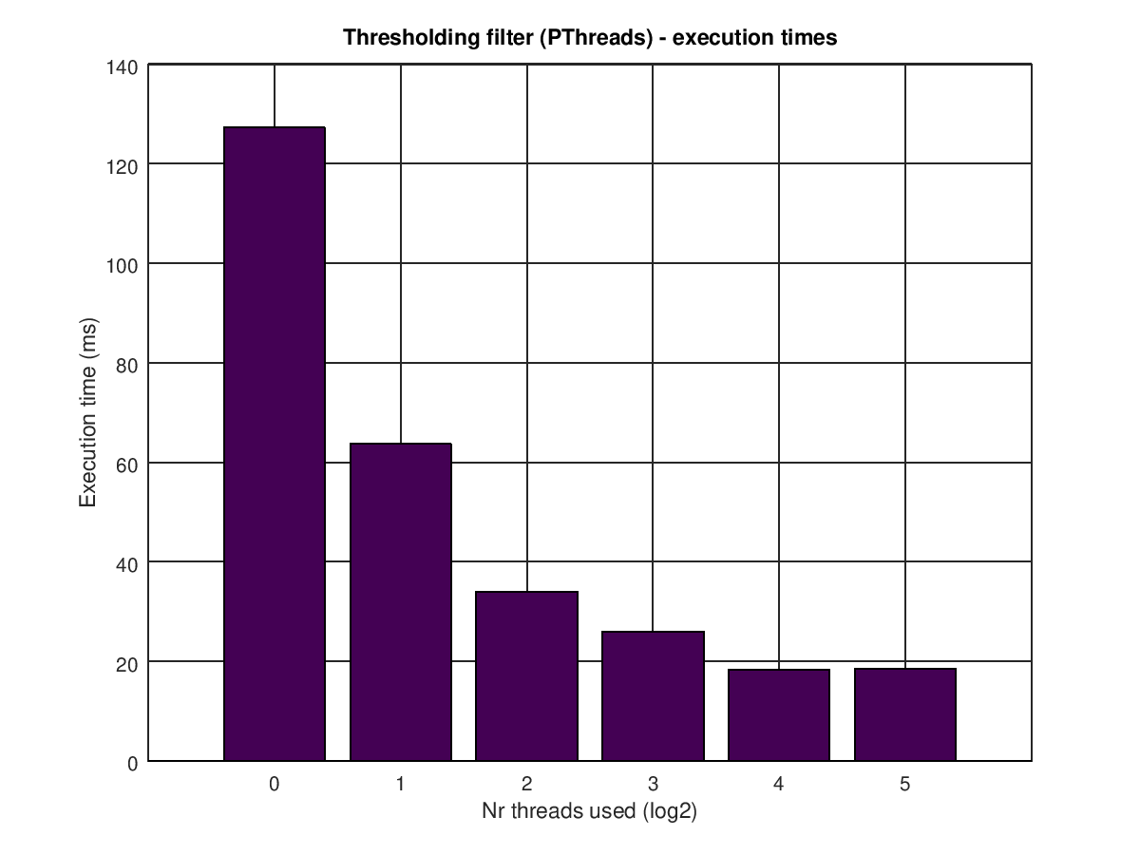
Figure 2-7 Execution time for different number of threads in exponential unit using the largest image, i.e., im4.ppm

We could have used MPI_AllReduce in order to skip a third blocking MPI_Send to all non-root processes with the calculated average.

