Stationary Heat Conduction Using OpenMP
Santi Pagola
Hao-Hsiang Liao

Version 1.0

PROJECT IDENTITY
05/14/2018, ISY, LiU

Participants of the group
Name | Phone | E-mail
Hao-Hsiang Liao | 0734845666 | haoli436@student.liu.se
Santi Pagola

1. Question:
In this assignment, you will solve a stationary heat conduction problem on a shared memory computer (a single compute node on triolith.nsc.liu.se), using OpenMP. A serial code for solving the problem is given in the file laplsolv.f90, which is found on the course home page4, and should be used as a starting point for your implementation. Your final parallel program should produce the same results as the serial code does.

2. Solution:
In order to implement this program in parallel, we split a serial process to nr_thread parallel processes. Every process is implemented by a thread. In other words, this program has a higher efficiency if we have a higher nr_threads.
First of all, we set a variable, ratio, to express how many columns should be implemented by a thread. And then we set start_pos and stop_pos to every thread so that every thread can know which column should start/stop. For example, assume n = 60, nr_threads = 3, then we can get start_pos(0) = 1, stop_pos(0) = 20, start_pos(1) = 21, stop_pos(1) = 40, start_pos(2) = 41, and stop_pos(2) = 60.
Secondly, we set tmp1 and tmp3 to store previous column’s data of start_pos and next column’s data of stop_pos so that we can do the calculation correctly. Besides, it is worth to mentioning that when every thread is processing its final column, or stop_pos(my_id), it should be separated out because T(1:n,j+1) has been changed by next thread. Thus, we have to use tmp3 to describe the equation T(1:n,j)=(T(0:n-1,j)+T(2:n+1,j)+tmp3(0:n-1,my_id)+tmp1(0:n-1,my_id))/4.0D0.
In this system, we set tmp2 and my_id as private valuable and T, tmp1, and tmp3 as shared variable.

3. Result:
Fig. 1 shows time consumption in different nr_threads. In this case, the unit of nr_threads is in exponential mode. In other words, 1, 2, 3, 4, and 5 mean nr_threads = 1, 2, 4, 8, and 16, respectively. Based on this figure, we can find that our code works well.

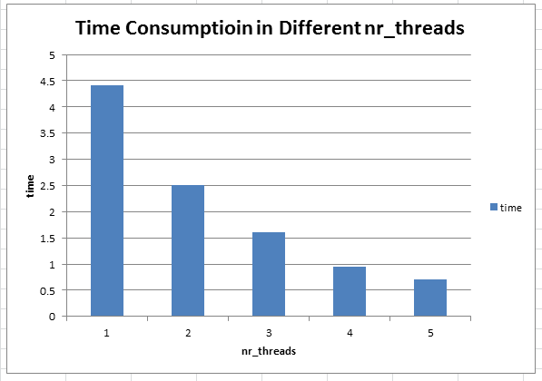Fig. 1: Time consumption in different nr_threads in exponential unit

